Attendance System (G10 & 4) 2024

CURRENT ATTENDANCE "PROCEDURE”

Problem Statement

Attendance is tracked via Biometrics system which does exactly what we want to do but it is not doing it well, with the Bio system the admin still have to ask for a spreadsheet from the IT department to check attendance and update the spreadsheet if some learners were on leave then submit to HR

-The system is not G4L system so it might comply with some of the G4L rule for example

> The leave system must communicate with the attendance system but with a third party system that won’t be archived

With the Biometrics system stealing company working hours can be archived.

Proposed Solution

An Attendance system must be developed specifically for G4L a system which will have all the rules and policies that G4L have.

* The purpose of the G4L attendance system is to keep track of the presence and/or absence of Geeks in the workplace.
* An attendance system is typically used by organizations to monitor the attendance of their employees (who are the Geeks in our case) and to ensure that they are complying with attendance policies.
* This system also assists the trainers and administrators to keep up to date with the factors that could affect the Geeks progress.

Objectives

Comprehensive Rule Integration: Develop an attendance system that aligns with and fully integrates G4L rules and policies, ensuring compliance and consistency.

Efficient Leave Management: Create a seamless interface between the attendance system and the leave management system, eliminating the need for manual interventions and third-party systems.

Real-time Attendance Monitoring: Implement features for real-time attendance tracking, allowing administrators to monitor Geeks' presence or absence instantly.

Automated Reporting: Integrate automated reporting functionalities to generate attendance reports without requiring additional manual effort. This will streamline administrative processes and enhance data accuracy.

Benefits:

Time Savings: Eliminate the need for manual spreadsheet updates, reducing administrative overhead and saving valuable time.

Rule Compliance: Ensure strict adherence to G4L rules and policies, promoting transparency and accountability.

Improved Accuracy: Minimize errors associated with manual attendance tracking, enhancing the overall accuracy of attendance records.

Streamlined Processes: Implement a user-friendly interface and automated features to streamline attendance-related processes for both administrators and Geeks.

Use case diagram

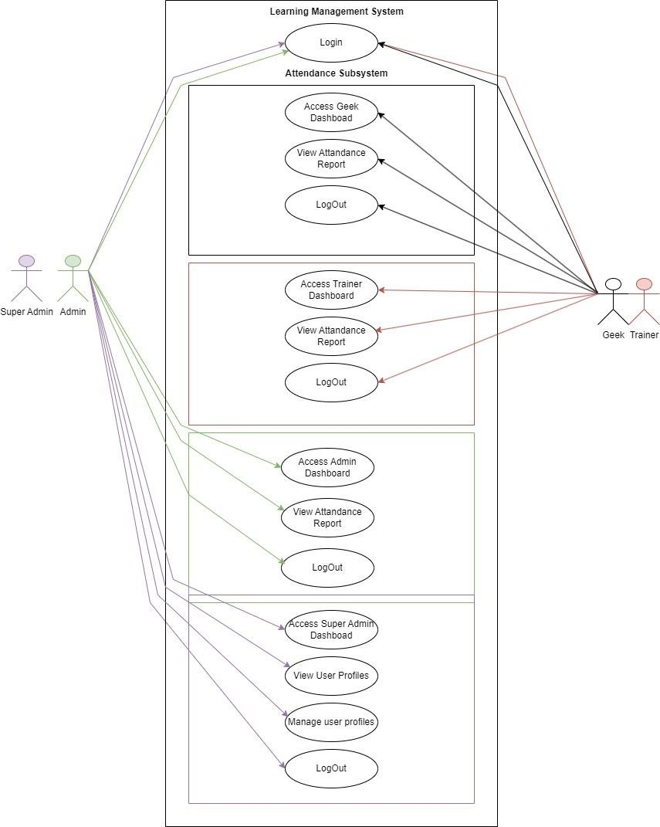

Class Diagram

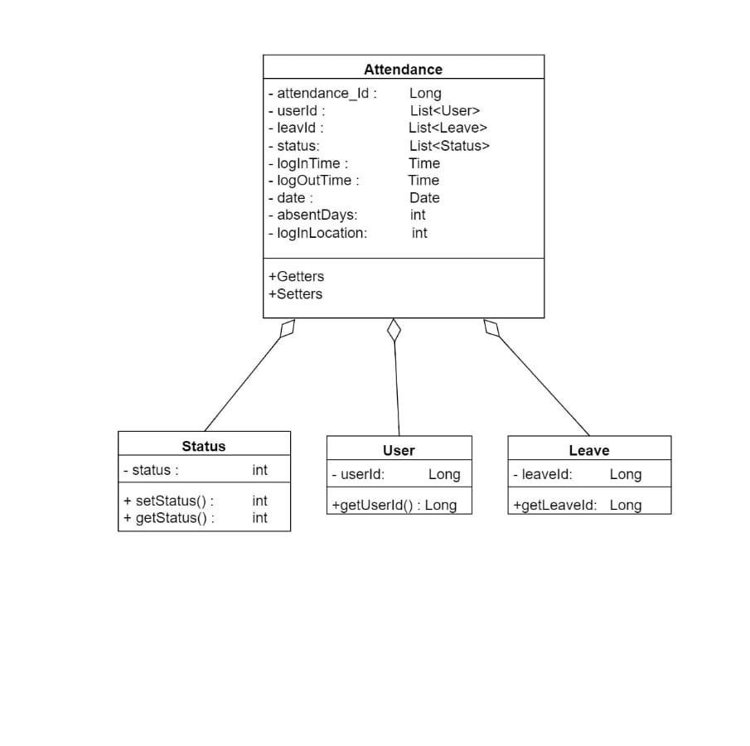

Activity Diagram

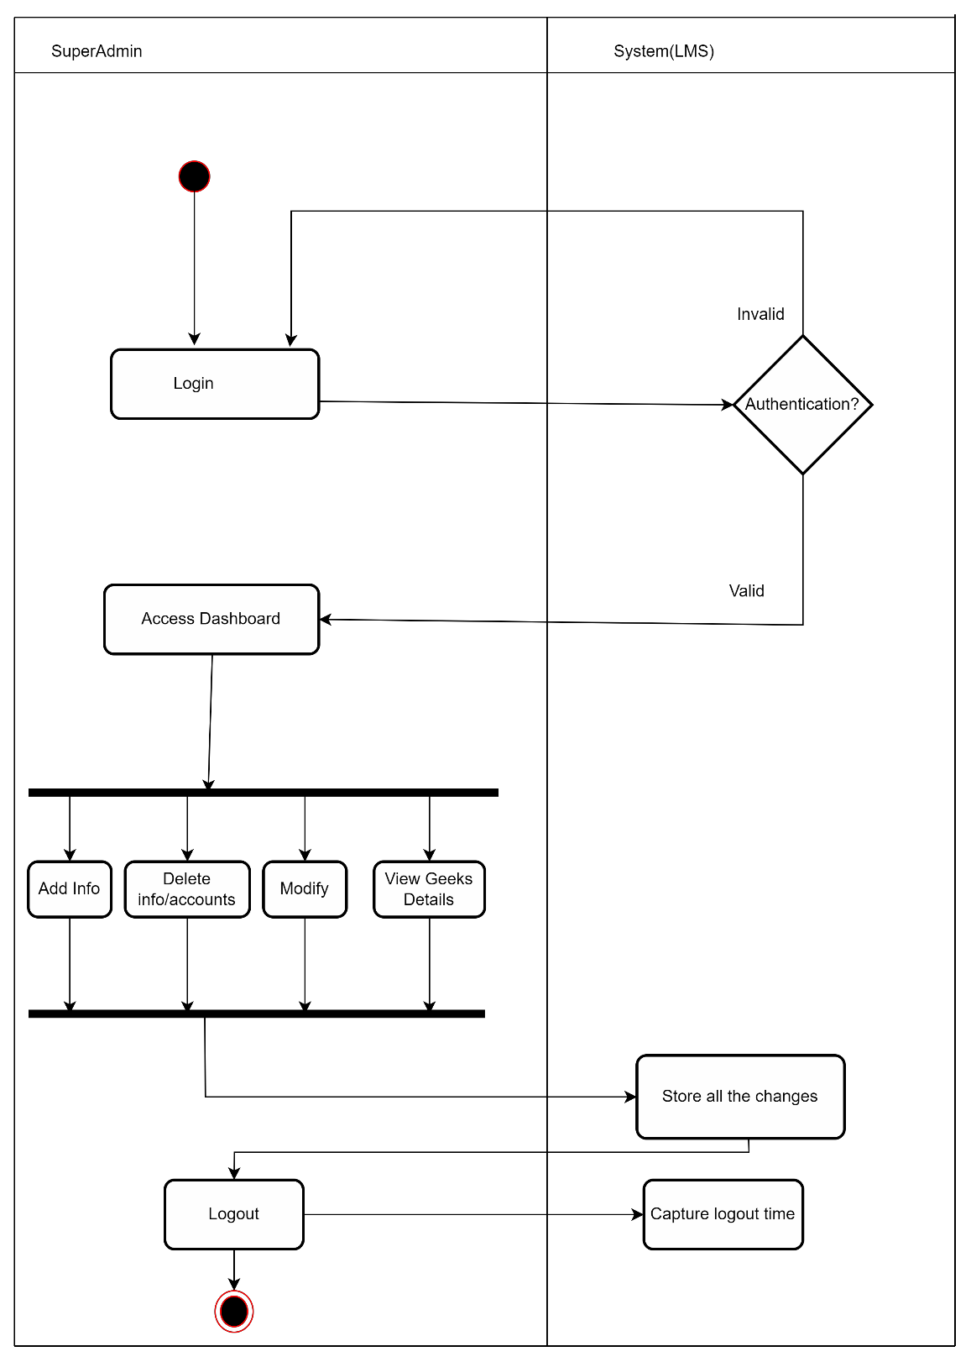

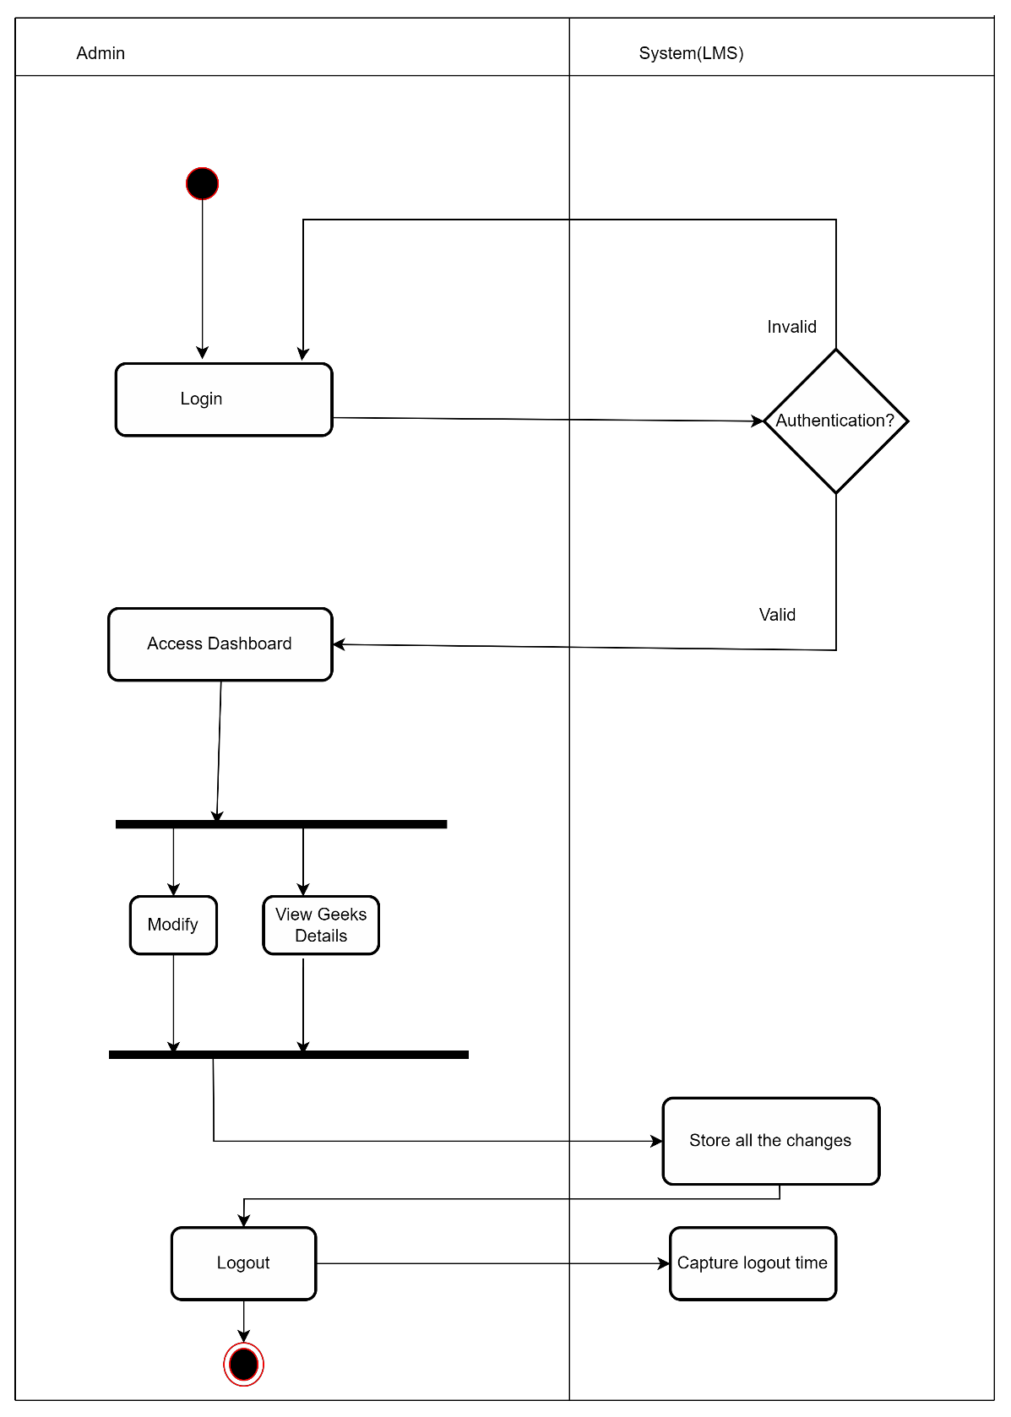

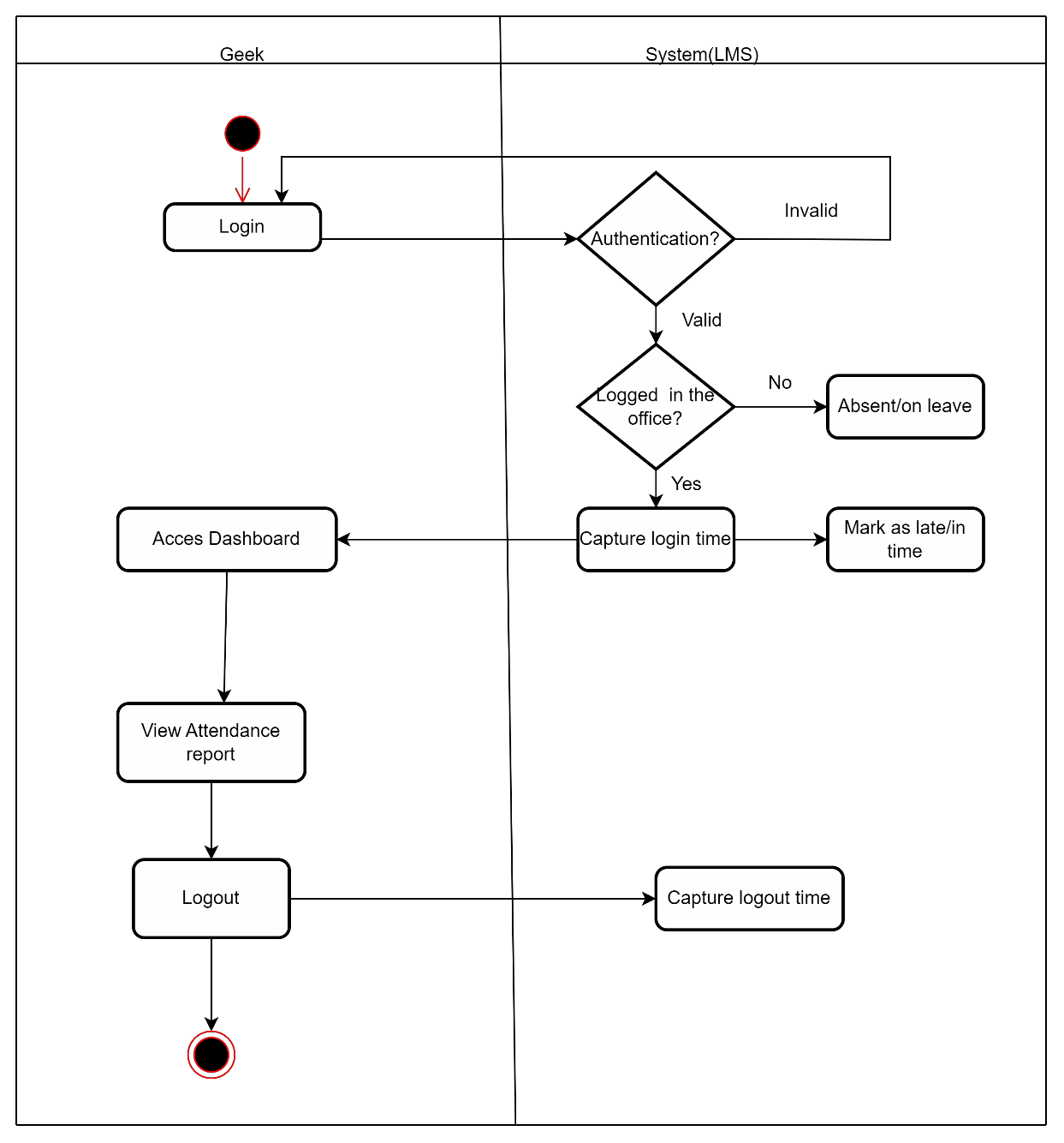

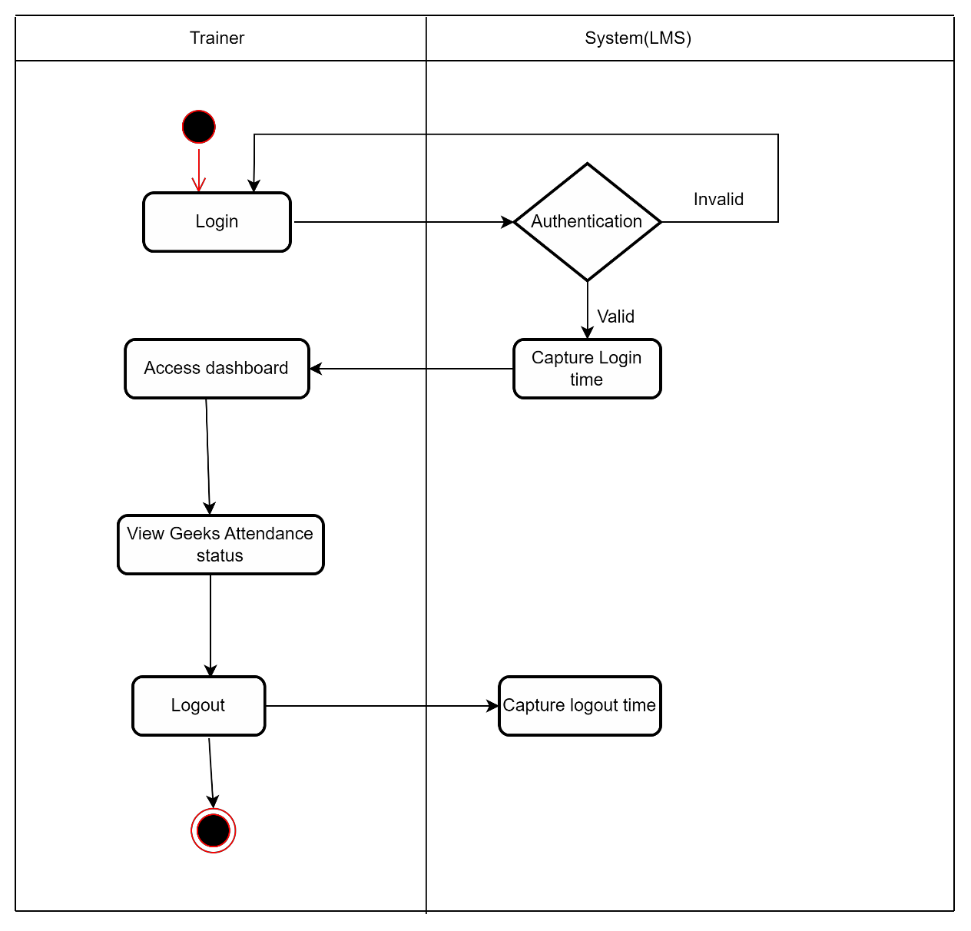

ERD

