A PROJECT REPORT ON
AN ADAPTIVE MULTI-AGENT GRAPHRAG FRAMEWORK FOR CONTEXTUAL HALLUCINATION MITIGATION USING AUTOMATED POLICY SWITCHING AND SELF-CORRECTION LOOPS
SUBMITTED TO THE SAVITRIBAI PHULE PUNE UNIVERSITY, PUNE
IN PARTIAL FULFILLMENT OF THE REQUIREMENTS
FOR THE AWARD OF THE DEGREE OF
BACHELOR OF ENGINEERING
(COMPUTER ENGINEERING)
SUBMITTED BY
Student Name: Aryan Yadav Exam No: 112023204
Student Name: Ashirwad Sharma Exam No: 112023220
Student Name: Hari Darade Exam No: 112023168
Student Name: Gaurav Malviya Exam No: 112023
UNDER THE GUIDANCE OF
Dr. Ankita V. Karale
DEPARTMENT OF COMPUTER ENGINEERING
Sandip Institute of Technology and Research Centre, Nashik
Nashik - 422213
SAVITRIBAI PHULE PUNE UNIVERSITY
2026 – 2027

CERTIFICATE
This is to certify that the project report entitled
"AN ADAPTIVE MULTI-AGENT GRAPHRAG FRAMEWORK FOR CONTEXTUAL HALLUCINATION MITIGATION USING AUTOMATED POLICY SWITCHING AND SELF-CORRECTION LOOPS"
Submitted by
Student Name: Aryan Yadav Exam No: 112023204
Student Name: Ashirwad Sharma Exam No: 112023220
Student Name: Hari Darade Exam No: 112023168
Student Name: Gaurav Malviya Exam No: 112023
are bonafide students of this institute and the work has been carried out by them under the supervision of Dr. Ankita V. Karale. It is approved for the partial fulfillment of the requirement of Savitribai Phule Pune University, for the award of the degree of Bachelor of Engineering (Computer Engineering).
Dr. Ankita V. Karale  Guide & Head  Department of Computer Engineering | Dr. Amol D. Potgantwar  Principal  Sandip Institute of Technology and Research Centre | Project External
DEPARTMENT OF COMPUTER ENGINEERING
Sandip Institute of Technology and Research Centre, Nashik
Nashik - 422213
SAVITRIBAI PHULE PUNE UNIVERSITY
2026 – 2027

ACKNOWLEDGEMENT
It gives us immense pleasure to present this preliminary Stage 1 project report titled "AN ADAPTIVE MULTI-AGENT GRAPHRAG FRAMEWORK FOR CONTEXTUAL HALLUCINATION MITIGATION USING AUTOMATED POLICY SWITCHING AND SELF-CORRECTION LOOPS." We take this opportunity to express our profound gratitude to our project guide and Head of the Department, Dr. Ankita V. Karale, for her invaluable guidance, insightful technical recommendations, continuous encouragement, and intellectual leadership throughout the conceptualization and formulation of this project. Her extensive expertise in artificial intelligence, clinical decision support architectures, and machine learning systems has been instrumental in shaping our research vision and establishing rigorous academic standards.
We are deeply grateful to Dr. Amol D. Potgantwar, Principal of Sandip Institute of Technology and Research Centre, Nashik, for providing world-class infrastructure, access to advanced high-performance computational facilities, and an institutional environment that actively fosters cutting-edge innovation and academic inquiry.
We extend our sincere thanks to Prof. Anmol Budhewar, Project Coordinator, Department of Computer Engineering, for his structured coordination, meticulous timeline reviews, and persistent encouragement. We also express our appreciation to all the faculty members, technical laboratory assistants, and administrative staff of the Department of Computer Engineering for their cooperative assistance throughout this academic phase.
Finally, we express our heartfelt appreciation to our parents, family members, and peers for their continuous moral support, patience, and unwavering belief in our endeavors.
Project Group Members:
Aryan Yadav (Exam No: 112023204)
Ashirwad Sharma (Exam No: 112023220)
Hari Darade (Exam No: 112023168)
Gaurav Malviya (Exam No: 112023)
Department of Computer Engineering,
Sandip Institute of Technology and Research Centre, Nashik

ABSTRACT
Large Language Models (LLMs) have emerged as pivotal engines for enterprise automation, analytical reasoning, and synthesized intelligence across mission-critical domains including clinical decision support, regulatory compliance, and statutory legal auditing. However, the stochastic nature of auto-regressive generation exposes these models to factual hallucinations—generating plausible yet ungrounded and logically corrupt claims—which poses severe operational and legal risks in regulated environments. Retrieval-Augmented Generation (RAG) seeks to anchor model responses in verifiable external knowledge bases. Nonetheless, conventional vector-based RAG architectures exhibit fundamental failure modes: dense semantic embeddings operate within unlinked geometric latent spaces, suffering from semantic dilution, chunk fragmentation, and an inherent inability to execute multi-hop relational reasoning across dispersed documents.
To overcome the relational blindness of latent vector embeddings, recent research has explored Knowledge Graph-Augmented RAG (GraphRAG) and Agentic RAG. However, current deployments deploy these paradigms in isolation, exposing fatal limitations: standard GraphRAG introduces heavy computational overhead for simple queries and remains vulnerable to LLM extraction noise and temporal invalidation, while agentic self-reflection frameworks succumb to the "Self-Correction Paradox" wherein an LLM cannot reliably identify its own logical or factual reasoning errors without deterministic extrinsic feedback.
This report presents Stage 1 of the design and implementation of an Adaptive Multi-Agent GraphRAG Framework for Contextual Hallucination Mitigation Using Automated Policy Switching and Self-Correction Loops. The framework is architected upon a deterministic LangGraph state machine orchestrating specialized autonomous agents over a hybrid dual-backend knowledge repository (ChromaDB vector store and Neo4j property knowledge graph). A dynamic Query Complexity and Topology Routing Model evaluates semantic embedding vectors, entity depth, and subgraph density to dynamically route sub-queries to vector, graph, or hybrid modalities, optimizing computational cost. A continuous Temporal Decay Graph Pruning Model mitigates extraction noise by exponentially down-weighting stale factual edges. Crucially, the framework resolves the self-correction paradox by instituting an Extrinsic Verifier Agent that computes a composite factual verification score incorporating RAGAS faithfulness, FActScore atomic claim precision, and temporal validity. Failed verification triggers bounded reflection loops with negative feedback constraints, terminating deterministically to satisfy enterprise Service Level Agreements. This document establishes the Software Requirements Specification (SRS), formal mathematical models, multi-agent system design, and algorithmic execution mechanics for the system.
Keywords: Retrieval-Augmented Generation (RAG), GraphRAG, Multi-Agent Systems, Knowledge Graphs, Hallucination Mitigation, Self-Correction Paradox, Automated Policy Switching, LangGraph, Extrinsic Verification.

TABLE OF CONTENTS
CERTIFICATE | i
ACKNOWLEDGEMENT | ii
ABSTRACT | iii
LIST OF ABBREVIATIONS | v
LIST OF FIGURES | vi
LIST OF TABLES | vii
CHAPTER 1: INTRODUCTION | 1
1.1 Background and Motivation | 1
1.2 Problem Definition | 3
1.3 Objectives of the Project | 4
1.4 Scope of Work | 5
1.5 Organization of the Report | 6
CHAPTER 2: LITERATURE SURVEY | 7
2.1 Current Trends in Research | 7
2.1.1 Traditional and Advanced Vector RAG Pipelines | 7
2.1.2 Structural Knowledge Retrieval and GraphRAG | 8
2.1.3 Agentic Orchestration and Iterative Reasoning | 9
2.1.4 Verification Paradigms and the Self-Correction Paradox | 10
2.2 Comparative Analysis | 11
2.3 Critical Analysis of Existing Literature | 13
2.4 Research Gap Identification | 14
CHAPTER 3: SOFTWARE REQUIREMENTS SPECIFICATION (SRS) | 18
3.1 Introduction & System Overview | 18
3.2 Functional Requirements | 19
3.3 External Interface Requirements | 21
3.4 Non-Functional Requirements | 21
3.5 System Requirements | 22
3.6 Analysis Models & SDLC Implementation Plan | 23
CHAPTER 4: SYSTEM DESIGN | 25
4.1 System Architecture | 25
4.2 Data Flow Diagrams (DFD) | 27
4.3 Entity Relationship Diagram (ERD) | 29
4.4 UML Diagrams | 30
CHAPTER 5: MATHEMATICAL MODEL & ALGORITHMIC MECHANICS | 35
5.1 Mathematical Formulations | 35
5.2 Algorithmic Pseudocode & Execution Strategy | 38
CHAPTER 6: EXPECTED OUTCOMES & APPLICATIONS | 43
6.1 Expected Outcomes & Performance Benchmarks | 43
6.2 Edge-Case Handling and System Resilience | 43
6.3 Enterprise Applications & Domain Impact | 44
6.4 Limitations of Stage 1 | 45
CHAPTER 7: CONCLUSION & FUTURE SCOPE | 46
7.1 Conclusion | 46
7.2 Future Scope & Semester VIII Milestones | 46
CHAPTER 8: REFERENCES | 48

LIST OF ABBREVIATIONS
Abbreviation | Full Form / Standard Illustration
LLM | Large Language Model
RAG | Retrieval-Augmented Generation
GraphRAG | Knowledge Graph Augmented Retrieval-Augmented Generation
KG | Knowledge Graph
GNN | Graph Neural Network
CoT | Chain-of-Thought Prompting
ReAct | Reasoning and Acting Framework
RAGAS | Retrieval Augmented Generation Assessment System
FActScore | Fine-grained Atomic Evaluation of Factual Precision
RRF | Reciprocal Rank Fusion
Cypher | Declarative Graph Query Language for Property Graphs
DAG | Directed Acyclic Graph
API | Application Programming Interface
REST | Representational State Transfer
SLA | Service Level Agreement
HyDE | Hypothetical Document Embeddings
CRAG | Corrective Retrieval-Augmented Generation
Self-RAG | Self-Reflective Retrieval-Augmented Generation
IRCoT | Interleaving Retrieval with Chain-of-Thought Reasoning
QA-GNN | Question Answering with Graph Neural Networks
NLP | Natural Language Processing
FAISS | Facebook AI Similarity Search
JSON | JavaScript Object Notation
AST | Abstract Syntax Tree
SDLC | Software Development Life Cycle
SRS | Software Requirements Specification
DFD | Data Flow Diagram
ERD | Entity Relationship Diagram
UML | Unified Modeling Language
BLEU | Bilingual Evaluation Understudy
ROUGE | Recall-Oriented Understudy for Gesting Evaluation
AI RMF | Artificial Intelligence Risk Management Framework (NIST)
CDSS | Clinical Decision Support System
RBAC | Role-Based Access Control

LIST OF FIGURES
Figure 1.1: Taxonomy of LLM Hallucinations and Grounding Mechanisms
Figure 2.1: Evolution of Retrieval-Augmented Generation Architectures
Figure 2.2: Agentic GraphRAG Workflow with Verification and Reflection Loop
Figure 2.3: Mapping of Research Gaps to Proposed Solutions in the Adaptive GraphRAG Framework
Figure 4.1: Comprehensive System Architecture Diagram of the Adaptive Multi-Agent GraphRAG Framework
Figure 4.2: DFD Level 0 — System Context Diagram
Figure 4.3: DFD Level 1 — Data Flow Across Multi-Agent and Storage Layers
Figure 4.4: DFD Level 2 — Detailed Sub-Process Flow of Policy Routing and Extrinsic Verification
Figure 4.5: Entity Relationship Diagram (ERD) of the Hybrid Knowledge and Verification Platform
Figure 4.6: UML Use Case Diagram for the Adaptive GraphRAG System
Figure 4.7: UML Class Diagram Representing the Object-Oriented Multi-Agent Architecture
Figure 4.8: UML Activity Diagram of the Complete Adaptive Query Resolution Lifecycle
Figure 4.9: UML Sequence Diagram of End-to-End Query Orchestration and Gated Verification
Figure 4.10: UML Component Diagram of the Containerized Microservice Infrastructure
Figure 5.1: LangGraph Stateful Execution Graph with Cyclic Self-Correction Boundaries

LIST OF TABLES
Table 2.1: Retrieval Architecture and Scalability Profile Comparison
Table 2.2: Hallucination Mitigation and Verification Mechanisms Across Existing Paradigms
Table 2.3: Summary of Research Gaps, Impact, and Proposed Mitigation Strategies
Table 3.1: Hardware Requirements Specification
Table 3.2: Software Environment and Middleware Specifications
Table 3.3: Two-Semester Agile Implementation Plan (Stage 1 & Stage 2 Milestones)
Table 5.1: Mathematical Notation, Symbol Definitions, and Tensor Dimensions

CHAPTER 1
INTRODUCTION
1.1 BACKGROUND AND MOTIVATION
The rapid advancement of deep neural architectures, particularly the self-attention transformer mechanism pioneered by Vaswani et al., has catalyzed a paradigm shift across artificial intelligence and natural language processing. Modern Large Language Models (LLMs)—spanning proprietary frontiers such as OpenAI GPT-4, Anthropic Claude 3.5, and Google Gemini 1.5, to open-weight foundations like Meta LLaMA 3.1 and Mistral Large—exhibit unprecedented capabilities in natural language understanding, programmatic code synthesis, multi-turn dialogue, and zero-shot reasoning. By pre-training over multi-terabyte web-scale textual corpora using next-token self-supervised objectives, these models internalize immense linguistic competencies and broad parametric knowledge. Consequently, enterprise organizations across global industries have accelerated the adoption of LLMs to automate mission-critical workflows, synthesize analytical reports, summarize technical literature, and drive automated decision-making pipelines.
Despite these formidable linguistic strengths, fundamental architectural limitations inherently constrain the reliability of generative transformers when deployed in regulated and high-stakes enterprise settings. Foremost among these vulnerabilities is the phenomenon of factual hallucination—the stochastic generation of text that is grammatically articulate, contextually confident, and semantically plausible, yet fundamentally ungrounded in empirical truth, contradictory to source documentation, or logically invalid [5], [16], [22]. In consumer-facing conversational applications, minor factual hallucinations may cause trivial misunderstandings; however, in regulated domains such as Clinical Decision Support Systems (CDSS) [39], [40], statutory legal analysis, regulatory financial auditing, and aerospace engineering, ungrounded model outputs carry catastrophic consequences, including medical malpractice, severe financial penalties, and breaches of regulatory safety frameworks such as the NIST AI Risk Management Framework [37] and the European Union Artificial Intelligence Act [38].
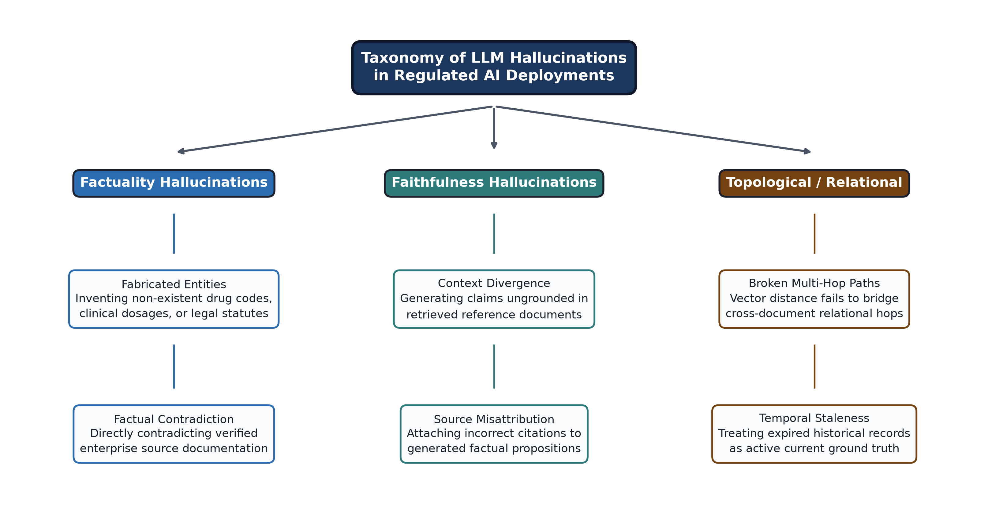
Figure 1.1: Taxonomy of LLM Hallucinations and Grounding Mechanisms in Regulated AI Deployments.
The root cause of factual hallucination stems from the mathematical reality that auto-regressive transformers optimize for statistical token probabilities rather than deterministic truth verification. An LLM's parametric memory is static, fixed at the point of training cutoff, and inherently lossy. As observed by Alkaissi and McFarlane [5], when queried regarding obscure domain entities, complex relational structures, or information beyond their parametric horizon, transformers reliably confabulate citations, invent nonexistent biological compounds, or synthesize fabricated legal precedents. Furthermore, fine-tuning techniques (such as Supervised Fine-Tuning and Reinforcement Learning from Human Feedback) fail to eliminate hallucinations completely; while RLHF aligns conversational tone and suppresses toxic generations, it often incentivizes 'sycophancy'—where the model confidently validates erroneous user premises—and exacerbates covert factual hallucinations under subtle, multi-hop reasoning prompts.
1.1.1 The Paradigm of Retrieval-Augmented Generation (RAG)
To address the static and ungrounded nature of parametric LLMs without incurring the prohibitive computational expenditures of continuous model pre-training, Lewis et al. [7] and Borgeaud et al. [17] introduced the paradigm of Retrieval-Augmented Generation (RAG). RAG bifurcates the generative architecture into two distinct subsystems: a non-parametric external knowledge index (typically housing enterprise documents, operational guidelines, or medical records) and a parametric neural language model. When a user issues a prompt, a neural retriever identifies contextually relevant document passages from the non-parametric index and injects them directly into the LLM's input prompt context window. The generator LLM is then conditioned to synthesize its final response strictly grounded upon the provided context.
Conventional 'Naive RAG' pipelines rely predominantly on dense vector embeddings and approximate nearest neighbor (ANN) vector search. Under this architecture, unstructured textual corpora are split into discrete text chunks (typically 256 to 512 tokens), transformed into dense continuous vectors using pre-trained bi-encoders (such as text-embedding-ada-002, BGE-Large, or E5), and stored in high-dimensional vector databases (e.g., ChromaDB, Milvus, FAISS). At query execution, the user's natural language input is embedded into the same vector space, and top-k candidate chunks are retrieved based on cosine similarity or inner product metrics.
1.1.2 The Failure Modes of Vector-Only Semantic Retrieval
While vector-based RAG has achieved widespread enterprise adoption for simple, single-hop factual lookups, comprehensive empirical benchmarks—including RAGTruth [3] and FinanceBench [2]—reveal severe, systemic failure modes when vector pipelines are applied to complex analytical tasks. The fundamental vulnerabilities of dense vector retrieval include:
1. Semantic Dilution and Geometric Blindness: Dense vectors represent text passages as single spatial coordinates in an unlinked high-dimensional geometric space (e.g., R^1536). While effective at capturing broad topical similarity, cosine proximity is fundamentally blind to logical hierarchy, causal directionality, and temporal validity. Two passages discussing diametrically opposed legal conditions or clinical dosages often exhibit high cosine similarity due to overlapping vocabulary, leading to incorrect context retrieval.
2. Context Fragmentation Across Dispersed Documents: Standard semantic chunking arbitrarily fractures connected knowledge across document boundaries. When an enterprise inquiry requires synthesizing relationships spanning multiple reports—for example, tracing a corporate parent-subsidiary ownership chain or identifying contraindications across disparate pharmacological clinical trial documents [40]—dense retrievers return disjointed fragments. As established by Trivedi et al. [14], dense similarity search is incapable of bridging multi-hop associative chains where intermediate entities are not explicitly mentioned in the initial query prompt.
3. The 'Lost in the Middle' Phenomenon: As investigated by Liu et al. [26], contemporary LLMs fail to uniformly attend across their extended context windows. When dense retrievers flood the context with top-k text chunks, relevant factual nuggets positioned in the middle of long contexts are ignored by the model's self-attention heads, precipitating contextual hallucinations where the model generates assumptions despite contradictory evidence residing within the retrieved text.
1.1.3 Emergence of Knowledge Graphs and GraphRAG
To resolve the geometric limitations of flat vector spaces, researchers have converged upon Knowledge Graphs (KGs) as an explicit, interpretable knowledge substrate [10], [13]. Knowledge Graphs represent factual domains as formal topological networks composed of typed entity nodes (e.g., Clinical Compound, Corporate Entity, Regulatory Statute) interconnected by directed, semantic relation edges (e.g., INHIBITS, OWNS_SUBSIDIARY, OVERRULES). By codifying relationships into explicit subject-predicate-object triplets (u, r, v), knowledge graphs enforce deterministic relational constraints that cannot be diluted by vector proximity.
The integration of KGs into generative pipelines gave birth to Knowledge Graph-Augmented RAG (GraphRAG), exemplified by Edge et al. [8] and Yasunaga et al. [18]. Edge et al. proposed Microsoft GraphRAG, which utilizes hierarchical community detection algorithms (specifically the Leiden algorithm) to group dense subgraphs into modular thematic clusters, generating multi-level community summaries. GraphRAG enables global, corpus-wide sensemaking queries (e.g., 'What are the main systemic supply chain risks across all regional vendors?') that flat vector databases fail catastrophically to address. Relational paths traversed through explicit property graphs (via declarative query languages like Cypher) provide inspectable, auditable reasoning chains essential for compliance.
1.1.4 The Agentic Orchestration Shift and the Self-Correction Paradox
In parallel with graph-based representations, the natural language processing domain has witnessed a rapid transition toward Agentic RAG [1]. Rather than treating retrieval as an immutable, single-pass feedforward step, agentic frameworks—including Self-RAG [28], Corrective RAG (CRAG) [29], and multi-agent coordination architectures such as LangGraph [12] and AutoGen [31]—deploy LLMs as autonomous reasoning agents equipped with planning, tool invocation, and reflection capabilities. Agentic RAG allows dynamic query decomposition, multi-hop iterative searching, and cyclic post-generation critiques.
However, the convergence of GraphRAG and Agentic RAG in existing literature has uncovered critical, unresolved paradoxes. Foremost is the 'Self-Correction Paradox' uncovered empirically by Huang et al. [34]. Huang et al. demonstrated that when an LLM is prompted to critique and refine its own generated responses without external ground truth, it systematically fails to recognize its own logical flaws. An LLM that has hallucinated a factual assertion is predisposed by its own internal token distribution to validate that same hallucinated premise during self-evaluation. Furthermore, multi-agent frameworks operating without rigid state boundaries frequently spiral into infinite conversational loops, incurring massive token costs and unbounded latency that violate enterprise Service Level Agreements (SLAs) [1], [31].
1.2 PROBLEM DEFINITION
The primary problem addressed in this project is the prevalence of unmitigated contextual hallucinations, computational inefficiency, and non-deterministic execution failures in enterprise generative intelligence systems. Specifically, existing retrieval-augmented systems suffer from four interrelated technical failure modes:
1. The Relational-Topological Reasoning Deficit: Existing vector-based RAG implementations represent domain knowledge exclusively through unlinked dense vector embeddings. In complex domain queries requiring multi-hop synthesis across hierarchical enterprise documents, vector proximity results in context fragmentation, leaving the generative LLM to hallucinate missing logical dependencies.
2. Disjointed, Static Modality Routing: Current knowledge architectures enforce a rigid, 'one-size-fits-all' retrieval paradigm. System architectures either force all queries through flat vector search (which fails on complex relational tasks) or execute costly global graph traversals and community summarizations (which wastes immense computational and financial resources on trivial single-hop lookups).
3. Knowledge Graph Extraction Noise and Temporal Stagnation: Knowledge graphs constructed automatically via zero-shot LLM entity-relationship extraction inherit the generative model's baseline hallucinations, encoding false triplets into the graph structure. Moreover, existing property graphs lack mathematical temporal decay mechanisms, resulting in stale historical facts overriding valid current information.
4. The Verification Deficit and Runaway Multi-Agent Execution: Modern agentic architectures rely on intrinsic self-reflection for factual validation, which fails due to the Self-Correction Paradox. Concurrently, unconstrained multi-agent dialogue loops lead to non-deterministic execution times, context window overflow, and runaway API expenditure, making them unviable for production enterprise deployment.
Therefore, there is an urgent scientific and engineering need for an integrated framework that unifies hybrid knowledge representations (Vector + Graph) through an adaptive, complexity-aware policy routing engine, enforces strict temporal edge decay pruning, and guarantees hallucination-free generation via an extrinsic algorithmic verification state machine with bounded self-correction loops.
1.3 OBJECTIVES OF THE PROJECT
The overarching goal of this Stage 1 project is to design, theoretically formulate, mathematically model, and engineer the baseline architectural components of an Adaptive Multi-Agent GraphRAG Framework for contextual hallucination mitigation. To achieve this overarching goal, the project pursues six specific, measurable technical objectives:
1. Design an Adaptive Modality Routing Subsystem: Develop a mathematical Query Complexity and Topology Routing Model that calculates a continuous multi-hop complexity score C(Q) across semantic embeddings, entity counts, traversal depth, and subgraph density, dynamically dispatching queries to Vector, Knowledge Graph, or Hybrid backends.
2. Establish a Dual-Backend Hybrid Knowledge Repository: Engineer an integrated knowledge ingestion pipeline that synchronizes high-dimensional dense vector embeddings in ChromaDB/Milvus with an explicit property Knowledge Graph in Neo4j, enabling simultaneous semantic similarity search and multi-hop Cypher traversal.
3. Formulate and Implement Temporal Graph Pruning: Formulate a mathematical continuous exponential decay pruning model to weight and filter graph edges based on extraction confidence and chronological recency, dynamically eliminating obsolete facts and extraction noise.
4. Circumvent the Self-Correction Paradox via Extrinsic Gating: Architect an autonomous Verifier Agent that evaluates candidate responses using an extrinsic composite verification score Stotal combining programmatic RAGAS faithfulness, FActScore atomic fact decomposition, answer relevance, and context temporal validity.
5. Implement Deterministic State Machine Orchestration: Model and structure the multi-agent reasoning lifecycle using a strict LangGraph state machine, enforcing deterministic state transitions, auditable execution traces, and rigid retry boundaries (N_max <= 3) to guarantee enterprise SLA compliance.
6. Develop Comprehensive System Models and SRS: Establish complete Software Requirements Specifications (SRS), Data Flow Diagrams (Level 0, 1, 2), Entity Relationship Diagrams (ERD), and Unified Modeling Language (UML) specifications to serve as the rigorous blueprint for Stage 2 empirical implementation.
1.4 SCOPE OF WORK
The scope of this project is structured across two distinct academic phases (Stage 1 and Stage 2) to ensure rigorous theoretical foundations prior to full-scale enterprise software deployment:
In-Scope Boundaries (Stage 1):
• In-depth literature survey and comparative benchmarking of Traditional RAG, Advanced RAG, GraphRAG, and Agentic RAG architectures.
• Formal mathematical derivation of the Query Complexity Routing Model, Temporal Decay Graph Pruning Model, and Composite Extrinsic Verification Scoring Model.
• Comprehensive Software Requirements Specification (SRS) detailing functional, non-functional, interface, and hardware/software constraints.
• Complete system design modeling including Multi-Tier System Architecture, DFD (Levels 0, 1, 2), Entity Relationship Model, and UML diagrams (Use Case, Class, Activity, Sequence, and Component diagrams).
• Architectural definition of agent prompt contracts, state schemas, and LangGraph workflow transitions.
• Formulation of standard evaluation protocols across benchmark corpora (HotpotQA, TruthfulQA, FinanceBench).
Out-of-Scope Boundaries (Reserved for Stage 2):
• Full-scale production deployment on distributed multi-node GPU clusters.
• Supervised fine-tuning of domain-specific Small Language Models (SLMs) for on-premise edge inference.
• Integration of native voice/multimodal input streams.
1.5 ORGANIZATION OF THE REPORT
This Stage 1 Project Report is structured into eight logically sequenced chapters designed to provide a comprehensive technical and academic exposition of the proposed research:
• CHAPTER 1: INTRODUCTION provides the foundational background of LLMs, contextual hallucination risks in regulated domains, limitations of vector RAG, motivation for graph-augmented agentic architectures, formal problem definition, project objectives, and project scope.
• CHAPTER 2: LITERATURE SURVEY presents a rigorous, structured review of existing literature across four key themes, provides detailed comparative analysis tables, critically analyzes technical bottlenecks, and articulates four core research gaps.
• CHAPTER 3: SOFTWARE REQUIREMENTS SPECIFICATION (SRS) details the operational requirements, user classes, nine granular functional requirements, external interface constraints, non-functional performance benchmarks, system hardware/software specifications, and the two-semester Agile SDLC plan.
• CHAPTER 4: SYSTEM DESIGN presents the multi-tier architectural design, Data Flow Diagrams (Levels 0, 1, 2), Entity Relationship Diagram (ERD), and five comprehensive UML diagrams modeling agent interactions, data lifecycles, and containerized deployment.
• CHAPTER 5: MATHEMATICAL MODEL & ALGORITHMIC MECHANICS details the formal mathematical formulations governing query complexity routing, temporal edge decay pruning, composite extrinsic verification, Reciprocal Rank Fusion, and presents four complete algorithmic procedures in formal pseudocode.
• CHAPTER 6: EXPECTED OUTCOMES & APPLICATIONS analyzes anticipated benchmark performance, edge-case mitigation mechanisms, domain impacts in clinical and regulatory environments, and Stage 1 constraints.
• CHAPTER 7: CONCLUSION & FUTURE SCOPE summarizes the architectural achievements of Stage 1 and establishes the granular technical implementation roadmap for Semester VIII (Stage 2).
• CHAPTER 8: REFERENCES / BIBLIOGRAPHY compiles all academic literature citations in strict IEEE formatting.

CHAPTER 2
LITERATURE SURVEY
2.1 CURRENT TRENDS IN RESEARCH
The rapid intersection of neural language modeling, information retrieval, structural knowledge engineering, and multi-agent systems has established Retrieval-Augmented Generation (RAG) as one of the most prolific frontiers in modern artificial intelligence. Over the past five years, the research community has witnessed four distinct evolutionary phases: (1) Traditional and Advanced Vector-based Pipelines, (2) Structural Knowledge Retrieval via Knowledge Graphs (GraphRAG), (3) Autonomous Multi-Agent Orchestration, and (4) Algorithmic Verification and Self-Correction. This literature survey provides a comprehensive, rigorous examination of the seminal publications, structural paradigms, and unresolved tensions across these four domains.
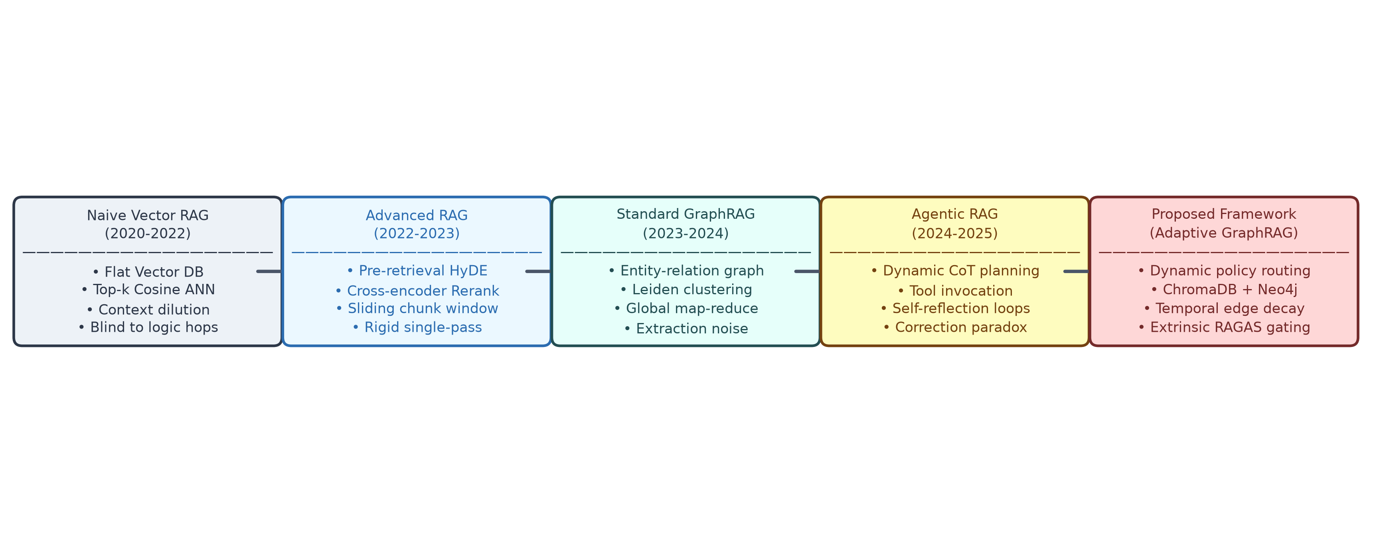
Figure 2.1: Evolution of Retrieval-Augmented Generation Architectures: From Naive Vector Pipelines to Adaptive Agentic GraphRAG.
2.1.1 Traditional and Advanced Vector RAG Pipelines
The foundational blueprint of Retrieval-Augmented Generation was established by Lewis et al. [7] and Borgeaud et al. [17]. In their seminal formulation, Lewis et al. combined a pre-trained sequence-to-sequence neural model (BART) with a Dense Passage Retriever (DPR) utilizing dual-encoder architectures. Unstructured textual passages were mapped into a continuous latent vector space, enabling non-parametric factual retrieval via maximum inner product search. Borgeaud et al. [17] scaled this concept to trillion-token corpora with the RETRO architecture, demonstrating that retrieval-enhanced models achieve competitive perplexity compared to massive dense models an order of magnitude larger.
Gao et al. [11] systematically categorized the progression of retrieval-augmented architectures into Naive, Advanced, and Modular RAG. Naive RAG operates as a static, feed-forward three-stage pipeline: chunking, indexing, and retrieve-then-generate. However, empirical studies rapidly identified severe precision bottlenecks in Naive RAG. Because dense vector embeddings compress complex textual semantics into fixed-dimensional vectors, they suffer from semantic dilution—loss of fine-grained numeric, relational, and contextual nuances. Furthermore, when documents are split into static token chunks (e.g., 256 or 512 tokens), interconnected concepts spanning adjacent paragraphs or distinct corporate documents are severed.
To alleviate these limitations, researchers formulated Advanced RAG paradigms [11]. Gao et al. [27] developed Hypothetical Document Embeddings (HyDE), which prompts an LLM to generate a hypothetical answer passage prior to retrieval, utilizing the embedding of the hypothetical text to locate authentic documents in vector space. Other advanced enhancements introduced sliding-window chunking with sentence-window retrieval, bi-encoder cross-encoder re-ranking hierarchies (e.g., Cohere Rerank, BGE-Reranker), and metadata filtering. In parallel, Liu et al. [26] exposed the critical 'Lost in the Middle' failure mode, proving that when long candidate passages are injected into transformer context windows, the model's multi-head attention mechanism systematically prioritizes tokens located at the extreme beginning and end of the context, while failing to retrieve critical facts positioned in the middle. While Advanced RAG significantly elevates single-hop lookup precision, it remains structurally constrained: its rigid, single-pass pipeline is incapable of dynamic query reformulation or multi-hop logical reasoning [14].
2.1.2 Structural Knowledge Retrieval and GraphRAG
Recognizing that unlinked geometric vector spaces cannot represent explicit relational dependencies, researchers turned to Knowledge Graphs (KGs) [10], [13] to impart deterministic structural topology to retrieval architectures. Robinson, Webber, and Eifrem [13] established the computational advantages of labeled property graphs for multi-hop traversals, demonstrating that graph databases (e.g., Neo4j) achieve index-free adjacency, allowing relationship traversal at O(1) complexity per edge hop regardless of the global database size. Ji et al. [10] surveyed knowledge graph representations, detailing how knowledge triplets (u, r, v)—consisting of head entity, relation predicate, and tail entity—provide formal, explainable knowledge substrates.
The integration of knowledge graphs into generative AI achieved a major breakthrough with Edge et al.'s [8] Microsoft GraphRAG. Edge et al. identified that vector RAG fails completely on global sensemaking queries that require synthesizing thematic concepts across entire corpora (e.g., 'What are the main systemic fraud indicators across all auditing transcripts?'). Microsoft GraphRAG constructs a corpus-wide knowledge graph by prompting an LLM to extract all entity-relationship triplets, creates a hierarchical community structure using the Leiden community detection algorithm, and generates pre-computed community summaries. During retrieval, the system performs a map-reduce summarization across relevant community levels to produce comprehensive responses. In parallel, Yasunaga et al. [18] developed QA-GNN, which bridges language models and knowledge graphs through joint reasoning, using Graph Neural Networks (GNNs) with message-passing mechanisms to score graph connectivity. Pan et al. [20] and Wu et al. [24] formulated comprehensive roadmaps for unifying LLMs and KGs, proving that structural graphs ground LLMs in formal logic while LLMs enhance graph completeness.
Despite these compelling advantages, a critical review of the GraphRAG literature reveals profound operational bottlenecks. Primary among these is the 'Knowledge Graph Extraction Bottleneck' [8], [20]. Because automated knowledge graph compilation relies on prompting LLMs to identify entities and relationships across raw text, the initial extraction step is itself highly prone to factual hallucinations. Hallucinated relationships are encoded directly as permanent edges in the property graph, fundamentally poisoning downstream graph traversals. Furthermore, as Cai et al. [30] noted in their survey of temporal knowledge graphs, facts are inherently time-dependent (e.g., corporate executive appointments or clinical drug guidelines change over time). Standard GraphRAG systems treat all extracted triplets as timeless truths, lacking mathematical mechanisms to prune obsolete or temporally invalid edges.
2.1.3 Agentic Orchestration and Iterative Reasoning
To liberate RAG from rigid single-pass feedforward execution, recent literature has championed the paradigm of Agentic RAG [1]. Agentic architectures endow language models with executive agency: the capacity to analyze queries, formulate multi-step plans, autonomously invoke retrieval and calculation tools, evaluate intermediate outputs, and iterate until the objective is satisfied. Singh et al. [1] provided a comprehensive taxonomy of Agentic RAG, highlighting how multi-agent coordination transforms retrieval from a passive data-fetching operation into a proactive reasoning strategy.
Seminal works in this domain include Self-RAG by Asai et al. [28], who trained an open-weight LLM to generate special reflection tokens ([Retrieve], [IsRel], [IsSup], [IsUse]) that trigger retrieval dynamically during generation and critique context relevance. Yan et al. [29] proposed Corrective RAG (CRAG), which evaluates retrieved document confidence using a lightweight heuristic scorer; if confidence is low, CRAG automatically falls back to public web search (e.g., Google or Tavily) to recover missing context. Trivedi et al. [14] introduced Interleaving Retrieval with Chain-of-Thought (IRCoT), demonstrating that complex multi-hop question answering requires interleaving reasoning steps with retrieval steps—using intermediate Chain-of-Thought [21] sentences as targeted search queries for subsequent retrieval rounds.
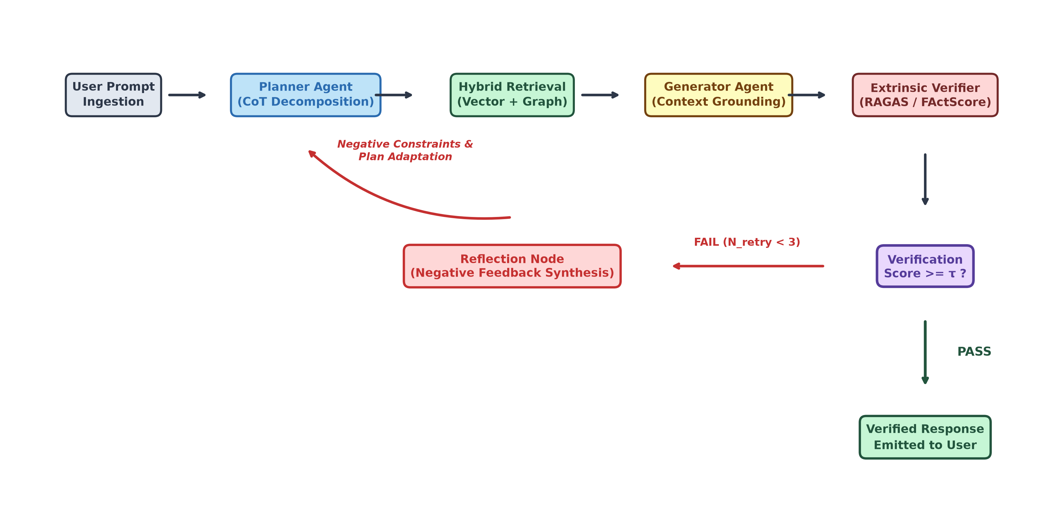
Figure 2.2: Multi-Agent GraphRAG Workflow with Integrated Verification and Reflection Loop.
To enable multi-agent collaboration, generalized orchestration frameworks have proliferated. Wu et al. [31] introduced AutoGen, demonstrating that complex software engineering and analytical tasks can be solved through multi-agent conversational dialogues between specialized agent personas (e.g., Planner, UserProxy, Assistant). Moura [32] developed CrewAI, which coordinates role-playing autonomous agents via sequential and hierarchical processes. Most significantly, Chase et al. [12] introduced LangGraph, a graph-based orchestration framework that models multi-agent workflows as stateful computational state machines. LangGraph structures interactions using Directed Acyclic Graphs (DAGs) and cyclic state graphs, defining individual nodes as agent actions and edges as conditional routing functions. In parallel, Khattab et al. [23] introduced DSPy, a programming framework that compiles declarative LM pipelines into optimized prompt configurations and parameter weights, eliminating heuristic prompt trial-and-error.
2.1.4 Verification Paradigms and the Self-Correction Paradox
In mission-critical, regulated deployments, ensuring factual truthfulness requires rigorous post-generation verification mechanisms [6], [15]. To establish objective standards for grounding, the academic community developed quantitative benchmark suites. Es et al. [9] developed RAGAS (Retrieval Augmented Generation Assessment System), formulating reference-free evaluation metrics including Context Precision, Context Recall, Faithfulness (measuring whether the generated response is strictly derived from retrieved context), and Answer Relevance. In parallel, Min et al. [25] introduced FActScore, an automated evaluation protocol that decomposes long-form text into atomic factual propositions and evaluates the precision of each proposition against authoritative sources.
To automate verification, modern agentic systems initially relied on iterative self-reflection, exemplified by Madaan et al.'s [33] Self-Refine and Wang et al.'s [19] Self-Consistency. These systems prompt the generator LLM to critique its own response and refine errors iteratively. However, this foundational premise was fundamentally invalidated by Huang et al. [34] in their landmark study, 'Large Language Models Cannot Self-Correct Reasoning Yet.' Huang et al. proved empirically that without an external ground-truth feedback signal, LLMs systematically fail to identify their own logical and factual errors. When prompted to self-correct, transformers frequently degrade their answers, change correct assertions to incorrect ones, or hallucinate justifications for their initial mistakes. The root cause of this 'Self-Correction Paradox' is that the LLM evaluating the response shares the identical statistical distributions, training biases, and blind spots as the LLM that generated the error. Consequently, self-reflection without extrinsic, non-LLM algorithmic verification constitutes an illusion of reliability.
2.2 COMPARATIVE ANALYSIS
To establish a rigorous technical baseline, Table 2.1 presents a comprehensive comparative evaluation of existing retrieval architectures regarding knowledge representation, reasoning capabilities, computational cost, and scalability profiles. Furthermore, Table 2.2 analyzes hallucination mitigation and verification mechanisms across these paradigms, exposing their primary architectural vulnerabilities.
Table 2.1: Retrieval Architecture and Scalability Profile Comparison Across Existing Paradigms
Approach | Knowledge Representation | Multi-Hop Capability | Retrieval Adaptivity | Computational Cost | Scalability Profile | Primary Strength | Primary Limitation
Traditional RAG [7] | Dense Embeddings (Vector DB) | Weak (Fails on unlinked hops) | None (Static single-pass) | Low (O(1) ANN search) | High (Sub-second vector lookup) | Low latency, simple operational stack | Fails on cross-document associative reasoning
Advanced RAG [11] | Dense Vectors + Chunk Metadata | Moderate (Reranking dependent) | Pre-retrieval Query Rewrite / HyDE | Medium (Reranker overhead) | High (Parallel ANN execution) | Improved chunk contextual precision | Remains an inflexible, single-pass pipeline
GraphRAG [8] | Knowledge Graph Triplets + Leiden Clusters | Strong (Explicit multi-hop paths) | None (Rigid corpus-wide map-reduce) | High (Heavy LLM graph compilation) | Moderate (High query token footprint) | Excels at global corpus summarization | Vulnerable to LLM extraction noise and stale edges
Self-RAG [28] | Dense Vectors + Reflection Tokens | Moderate (Token triggered) | Token-triggered iterative retrieval | Medium-High (Multi-step generation) | High (Model internal reflection) | Dynamic retrieval triggering during synthesis | Relies heavily on specialized fine-tuned model weights
CRAG [29] | Dense Vectors + External Web Search | Moderate (Fallback dependent) | Binary confidence threshold switching | Medium (External web calls) | High (Heuristic evaluator) | Recovers from poor local vector retrieval | Injects uncontrolled, non-deterministic web noise
IRCoT [14] | Dense Vectors + Chain-of-Thought Steps | Strong (Reasoning-guided search) | Reasoning-guided step-wise retrieval | Medium-High (Multi-turn LLM calls) | Moderate (Sequential query turns) | High precision on multi-hop question answering | Cascading error propagation from early flawed reasoning
Agentic RAG [1], [31] | Flexible / Dual Multi-Tool Stores | Strong (Autonomous tool orchestration) | Dynamic multi-agent planning | Very High (Unbounded conversation turns) | Low-Moderate (Token runaway risks) | Highly adaptive and autonomous planning | High latency, expensive coordination, loop divergence
Proposed Framework | Hybrid: Vectors (ChromaDB) + Neo4j Property KG | Superior (Automated Cypher + Dense fusion) | Continuous Query Complexity Routing Model | Optimized (Dynamic modality gating) | High (Strict state machine bounds) | Eliminates hallucination via extrinsic gating | Initial knowledge graph cold-start compilation

Table 2.2: Hallucination Mitigation and Verification Mechanisms Across Existing Paradigms
Approach | Verification Method | Self-Correction Paradigm | Error Memory & State | Explainability Level | Key Vulnerability & Failure Mode
Traditional RAG [7] | None (Direct prompt conditioning) | None (Immutable feedforward generation) | None (Stateless execution) | None (Black-box neural attention) | Blind to retrieval irrelevance; hallucinates missing facts
GraphRAG [8] | Implicit (Sub-graph community summary) | None (Single-pass map-reduce synthesis) | None (Stateless summarization) | Moderate (Inspectable graph traversal) | Extraction hallucinations become permanent ground truth
CRAG [29] | Lightweight Confidence Scorer | Partial (Rule-based web fallback trigger) | None (Single evaluation point) | Moderate (Scorer threshold logged) | Same-model evaluation bias; web source unreliability
DSPy [23] | Compiler Loss / Metric Optimizer | Algorithmic Prompt Optimization | Compilation trace memory | High (Declarative prompt log) | Overfits prompt instructions to training evaluation set
Agentic RAG [28], [31] | Intrinsic LLM Self-Reflection | Cyclic Iterative Critique Loop | State-based conversation memory | High (Full agent conversation log) | Susceptible to Self-Correction Paradox [34]; loops
Proposed Framework | Extrinsic Algorithmic Gating (RAGAS + FActScore) | Constrained Cyclic State Machine Loop | Global State Schema S with Feedback Memory | Full Auditability (Every routing & Cypher logged) | Cold-start entity extraction requires manual oversight

Analytical Discussion of Comparative Findings:
As synthesized in Tables 2.1 and 2.2, existing retrieval architectures exhibit a fundamental, polarizing dichotomy. Traditional and Advanced Vector RAG architectures [7], [11] deliver outstanding sub-second operational latency and simple infrastructure management; however, they are mathematically blind to relational logic, resulting in severe factual hallucinations whenever an enterprise query demands multi-hop synthesis across distinct documents. Conversely, Knowledge Graph architectures (GraphRAG) [8] excel at structural reasoning and corpus-wide sensemaking, but impose immense computational and financial costs during graph construction, while lacking mechanisms to handle extraction hallucinations and chronological staleness. Agentic frameworks [1], [31] offer unprecedented adaptivity, but their reliance on intrinsic self-reflection falls victim to the Self-Correction Paradox [34], and their unconstrained conversational loops introduce dangerous latency and token runaway risks that violate enterprise Service Level Agreements (SLAs). Therefore, the literature indicates an urgent imperative for an architecture that combines the topological precision of KGs with the adaptive routing of agents, strictly bounded by a state machine and gated by extrinsic algorithmic verification.
2.3 CRITICAL ANALYSIS OF EXISTING LITERATURE
A rigorous critical analysis of the surveyed literature reveals four fundamental technical contradictions that prevent current RAG systems from achieving production reliability in high-stakes enterprise applications:
1. The Failure of Static Geometric Retrieval: The foundational assumption of vector-based RAG [7], [11] is that semantic proximity in latent embedding space correlates directly with factual and logical relevance. This assumption is mathematically flawed. Cosine similarity evaluates the angular alignment of dense vectors, which captures topical congruence but is agnostic to directional relationships, logical negation, and temporal causality. In regulated enterprise scenarios—such as verifying whether a specific pharmaceutical drug interacts adversely with another compound [39], [40]—two passages describing completely opposite clinical outcomes share near-identical dense vector embeddings. Furthermore, dense similarity search cannot perform iterative relational traversal without multiple disjointed queries, resulting in context fragmentation.
2. The Knowledge Graph Extraction and Temporal Stagnation Bottleneck: While GraphRAG [8] successfully imposes topological order over unstructured text, its construction pipeline introduces a systemic vulnerability. Edge et al. rely exclusively on prompting generative LLMs to perform automated Named Entity Recognition and Relation Extraction. Because base LLMs are inherently stochastic, they frequently hallucinate non-existent relations or misclassify entity types during extraction. Because these false triplets are codified permanently into the graph database, the graph itself becomes an authoritative source of corrupted knowledge. Compounding this failure is the complete lack of temporal decay mechanics in modern property graphs [30]. In fast-moving corporate environments, outdated policies, expired contracts, and superseded clinical guidelines remain fully active in the graph, overriding current documentation.
3. Unbounded Non-Determinism in Autonomous Multi-Agent Orchestration: Frameworks such as AutoGen [31] and CrewAI [32] demonstrate impressive emergent reasoning capabilities by enabling free-form conversational exchanges between specialized agent personas. However, from an enterprise software engineering standpoint, free-form multi-agent interaction is fundamentally non-deterministic. Without rigid mathematical state transitions and finite execution boundaries, agents easily enter recursive clarification loops, context window bloat, and infinite token expenditure [1], [12]. In an enterprise environment governed by strict millisecond SLAs and cost quotas, unconstrained agentic orchestration represents an unacceptable operational and financial risk.
4. The Verification Deficit: The Fallacy of Intrinsic LLM Self-Correction: The most glaring vulnerability across modern agentic RAG literature is the pervasive reliance on intrinsic self-reflection [28], [33]. Systems that instruct an LLM to 'review your previous response and fix any hallucinations' operate on the mathematically disproven premise that an autoregressive model can act as an impartial judge of its own output. As Huang et al. [34] empirically proved across rigorous mathematical and factual reasoning benchmarks, an LLM evaluating its own flawed reasoning will reliably re-confirm its hallucinated assumptions because the generative error originated from the model's own statistical weights. Relying on intrinsic self-critique in clinical, legal, or financial applications creates a dangerous illusion of safety while leaving factual vulnerabilities unmitigated.
2.4 RESEARCH GAP IDENTIFICATION
Synthesizing the critical analysis, this project identifies four major, unresolved research gaps in contemporary literature, as visually mapped in Figure 2.3 and detailed in Table 2.3:
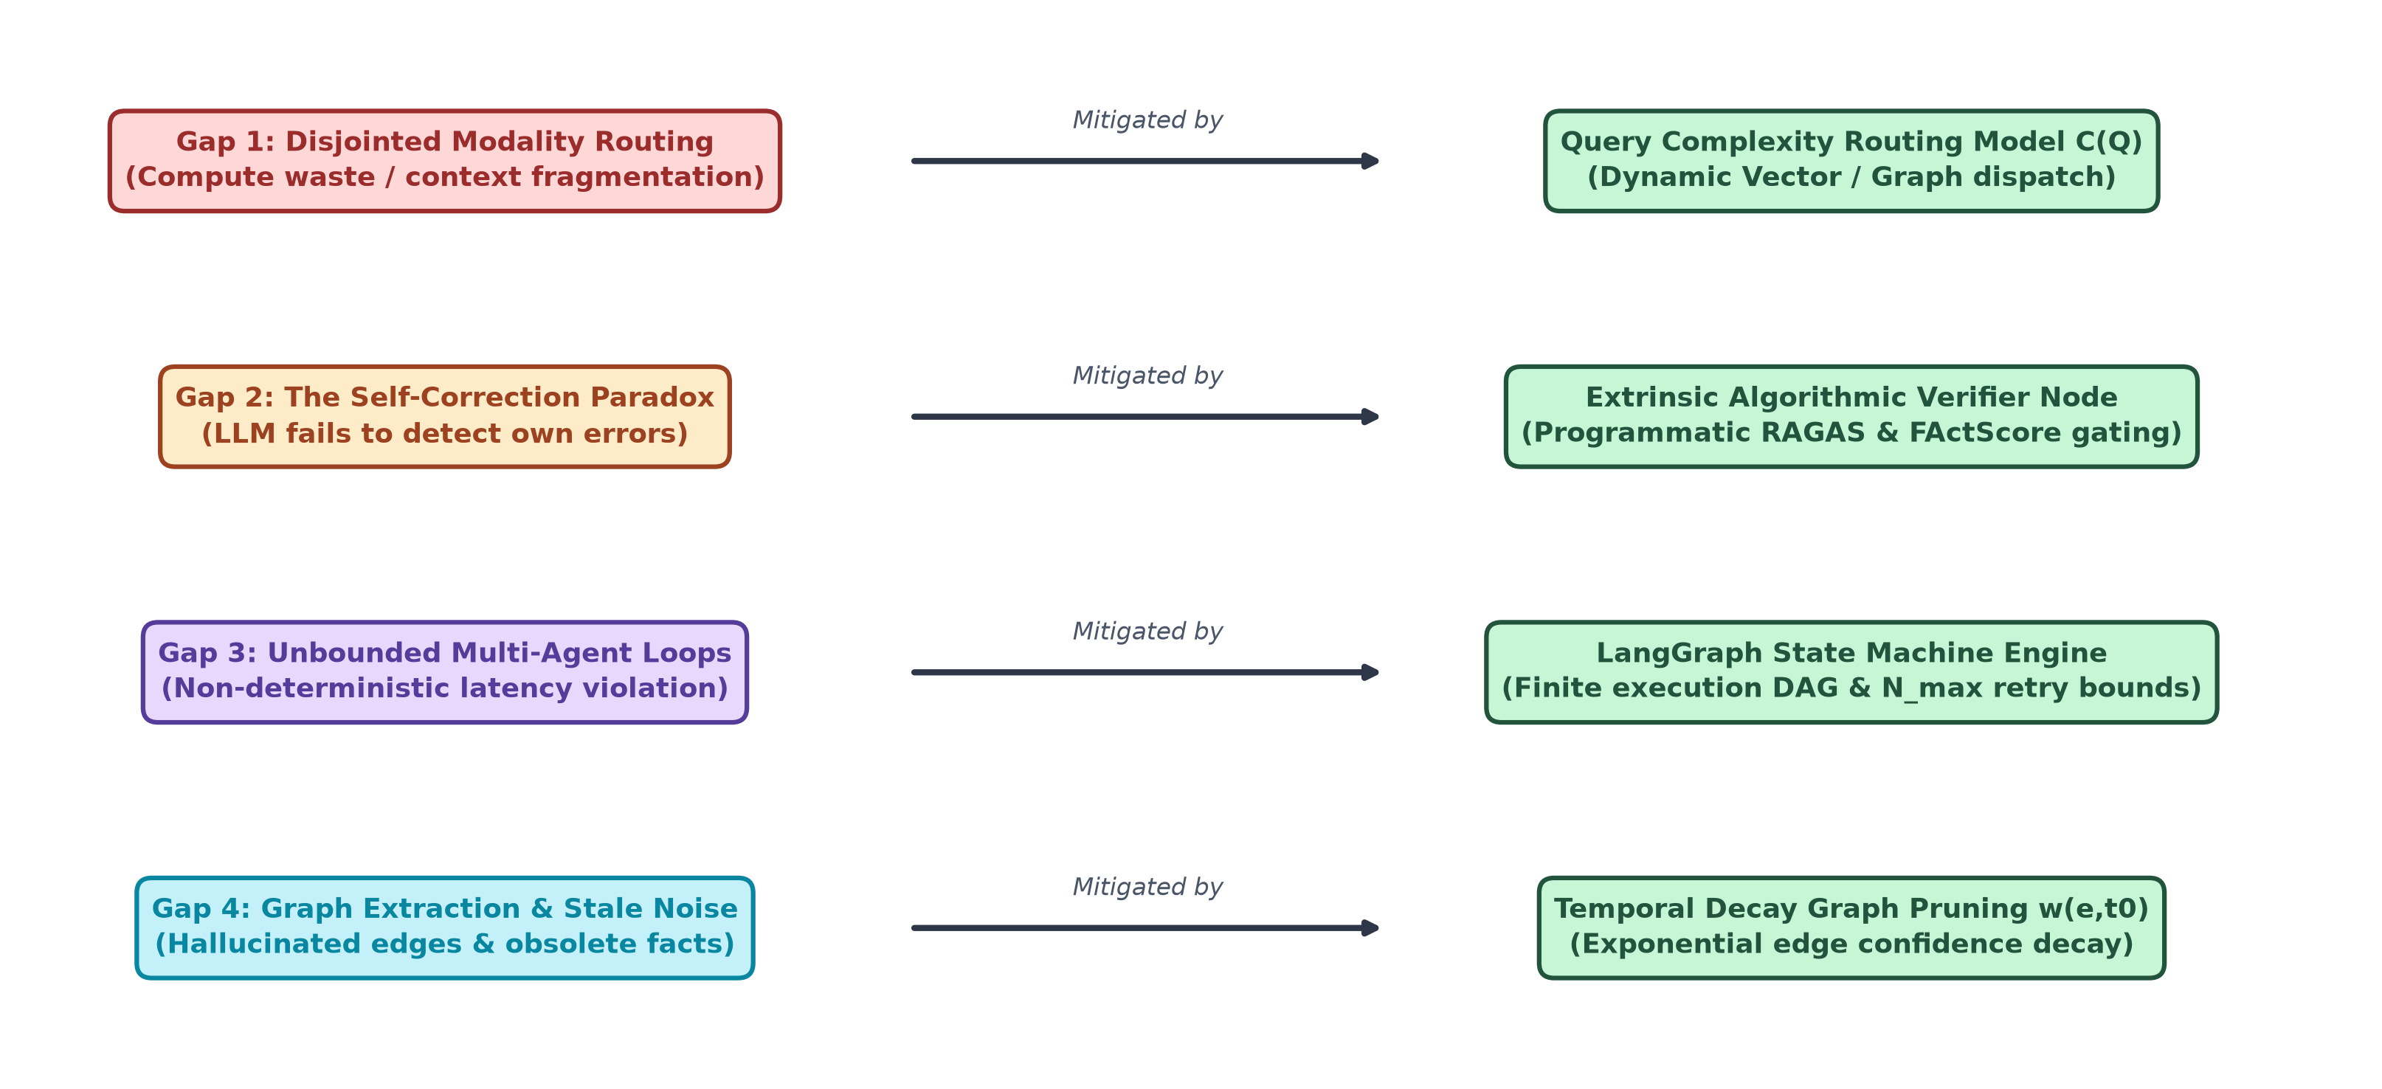
Figure 2.3: Systematic Mapping of Identified Research Gaps to the Architectural Modules of the Proposed Adaptive Multi-Agent GraphRAG Framework.
Research Gap 1: Disjointed Modality Routing (Single-Backend Inefficiency)
• Literature Origin: Identified by Trivedi et al. [14], Singh et al. [1], and Lewis et al. [7].
• Problem Description: Current enterprise architectures treat knowledge retrieval as a monolithic, static modality. Systems either route all queries through flat vector search (which fails on complex multi-hop queries) or execute comprehensive graph traversals and community summarizations (which wastes massive computational resources and incurs excessive latency for simple factual queries).
• Research Opportunity: Development of an automated, complexity-aware Policy Selection Module that computes a continuous mathematical routing score C(Q) across semantic embeddings, entity counts, traversal depth, and subgraph density, dynamically dispatching queries to Vector, Knowledge Graph, or Hybrid backends.
Research Gap 2: The Self-Correction Paradox in Autonomous Agent Workflows
• Literature Origin: Empirically exposed by Huang et al. [34] and Madaan et al. [33].
• Problem Description: Agentic RAG frameworks rely on intrinsic LLM self-reflection to verify outputs. Because the evaluator LLM shares the identical generative blind spots as the generator agent, contextual hallucinations reliably bypass the reflection stage and are emitted to users.
• Research Opportunity: Engineering an extrinsic, non-LLM algorithmic verification gating mechanism that computes composite factual verification scores Stotal based on programmatic RAGAS faithfulness [9] and FActScore atomic claim decomposition [25], directly conditioning cyclic self-correction loops with negative feedback constraints.
Research Gap 3: Unbounded Non-Determinism and Latency in Multi-Agent Systems
• Literature Origin: Discussed by Chase et al. [12], Wu et al. [31], and Moura [32].
• Problem Description: Free-form conversational multi-agent dialogue lacks formal state constraints, leading to runaway execution cycles, unbounded latency, exponential token costs, and catastrophic violations of enterprise Service Level Agreements.
• Research Opportunity: Implementing a deterministic LangGraph state machine orchestrating agent operations within rigid Directed Acyclic Graphs and bounded cyclic transitions, enforcing hard retry limits (N_max <= 3) and deterministic fallback responses.
Research Gap 4: Knowledge Graph Construction Noise and Temporal Invalidation
• Literature Origin: Identified by Edge et al. [8], Cai et al. [30], and Pan et al. [20].
• Problem Description: Automated knowledge graph extraction codifies LLM hallucinations directly into structural triplets, and existing property graphs lack mathematical mechanisms to account for fact expiration, leading to temporal hallucinations where obsolete data overrides current records.
• Research Opportunity: Formulating and implementing a continuous Temporal Decay Graph Pruning Model w(e,t0) that exponentially down-weights structural edges based on factual age and extraction confidence, dynamically filtering noisy and stale triplets prior to retrieval.
Table 2.3: Summary of Research Gaps, Impact, and Proposed Mitigation Strategies
Identified Research Gap | Foundational Literature Citations | Operational & Technical Impact | Proposed Architectural Mitigation | Target Verification Metric
Gap 1: Disjointed Modality Routing | Trivedi et al. [14], Singh et al. [1], Lewis et al. [7] | Simple queries waste massive compute on graphs; complex queries fail due to vector context fragmentation. | Intelligent Policy Selection Module executing a mathematical Query Complexity Routing Model C(Q). | Modality classification accuracy; P95 query latency reduction (>= 40%).
Gap 2: The Self-Correction Paradox | Huang et al. [34], Madaan et al. [33], Es et al. [9] | Autonomous LLM reflection fails to catch reasoning errors, rubber-stamping its own hallucinations. | Extrinsic Verifier Agent computing composite metric Stotal (RAGAS faithfulness + FActScore atomic precision). | RAGAS Faithfulness (>= 0.92); FActScore Precision (>= 0.95).
Gap 3: Unbounded Multi-Agent Non-Determinism | Chase et al. [12], Wu et al. [31], Moura [32] | Conversational agents derail into infinite reasoning cycles, violating enterprise latency SLAs. | LangGraph state machine enforcing strict Directed Acyclic cycles and deterministic retry threshold (N_max <= 3). | SLA compliance rate (100%); Zero runaway token divergence.
Gap 4: Graph Construction Noise & Stale Edges | Edge et al. [8], Cai et al. [30], Pan et al. [20] | LLM triplet extraction introduces hallucinated edges; static graphs encode chronologically obsolete facts. | Continuous Temporal Decay Graph Pruning Model w(e,t0) filtering edges below confidence threshold tau_decay. | Temporal precision; Noise edge pruning rate (>= 25%).

CHAPTER 3
SOFTWARE REQUIREMENTS SPECIFICATION
3.1 INTRODUCTION & SYSTEM OVERVIEW
This Software Requirements Specification (SRS) establishes the foundational functional, operational, and non-functional requirements for the Adaptive Multi-Agent GraphRAG Framework. It serves as the formal engineering contract guiding the system design, algorithmic modeling, component implementation, and verification methodologies across both Stage 1 and Stage 2 of the Bachelor of Engineering project.
3.1.1 Purpose and Intended Audience
The primary purpose of the system is to provide enterprise organizations—particularly those operating in highly regulated, high-liability domains such as healthcare, pharmaceutical research, legal compliance, and financial auditing—with an autonomous, hallucination-resistant knowledge intelligence platform. The intended audience includes software engineers, AI system architects, database administrators, compliance auditors, and academic researchers tasked with evaluating the robustness and deterministic behavior of multi-agent LLM systems.
3.1.2 User Classes and Operational Characteristics
The framework identifies four distinct user classes with varying operational privileges, workflows, and technical expertise:
1. Enterprise Knowledge Worker / End User: Interacts with the system via a web-based conversational interface to submit natural language inquiries regarding complex domain corpora. Requires rapid, accurate, fully grounded answers accompanied by inspectable citation links and confidence metrics.
2. Compliance & Audit Officer: Inspects the decision-making traces of the multi-agent system. Requires access to the Explainability Audit Trail to review the Planner's sub-task decomposition, generated Cypher traversal queries, verification faithfulness scores, and negative reflection constraints to ensure compliance with standards like NIST AI RMF [37] and the EU AI Act [38].
3. System Administrator & Knowledge Engineer: Manages the knowledge ingestion lifecycle, monitors Neo4j graph integrity, inspects ChromaDB embedding health, configures policy routing thresholds (tau_1, tau_2), and tunes temporal edge decay pruning rates (lambda).
4. Research Data Scientist: Evaluates quantitative hallucination benchmarks, conducts ablation experiments across retrieval modalities, evaluates token consumption profiles, and tunes agent prompt contracts and scoring hyperparameters (alpha, beta, gamma).
3.1.3 Assumptions and Technical Dependencies
The development and operation of the framework operate under the following engineering assumptions and external dependencies:
• Host hardware provides access to NVIDIA CUDA-compatible GPU acceleration for low-latency dense vector embedding generation.
• Network connectivity is maintained between the multi-agent state engine, the Neo4j graph database, the vector database, and the external/local LLM inference gateway.
• Enterprise documents ingested into the platform conform to supported unstructured text formats (PDF, DOCX, TXT, Markdown, JSON).
• The underlying LLMs provide structured output generation (JSON schema enforcement) via tool calling or constrained decoding.
3.2 FUNCTIONAL REQUIREMENTS
The functional requirements define the explicit computational capabilities and operational behavior that the framework must deliver across its execution lifecycle:
• FR-1: Document Ingestion and Hybrid Indexing Pipeline
- Ingestion: Ingest heterogeneous documents (PDF, DOCX, TXT, JSON), extract text, and remove formatting artifacts.
- Semantic Chunking: Partition text into overlapping token chunks (chunk_size=512, chunk_overlap=64 tokens).
- Dense Indexing: Transform chunks into dense continuous vectors (d=1536) and store them in ChromaDB with HNSW indexing.
- Graph Compilation: Extract entity-relation triplets (u, r, v) with confidence scores and timestamps, compiling a labeled property graph in Neo4j.
- Acceptance Criteria: Ingest 1,000 pages of enterprise text within 10 minutes, generating aligned vector and graph indices.
• FR-2: Query Pre-Processing and Planning Agent
- Pre-Processing: Normalize input queries, expand domain acronyms, and resolve coreferences.
- Task Decomposition: Execute Chain-of-Thought planning to decompose complex multi-hop queries into an ordered sequence of atomic sub-tasks T = {t1, t2, ..., tn}.
- Acceptance Criteria: Multi-hop queries from HotpotQA decomposed into valid logical sub-tasks with >= 95% semantic consistency.
• FR-3: Adaptive Policy Switching Router
- Complexity Scoring: Compute query complexity score C(Q) in [0, 1] using logistic sigmoid transform over dense query embedding, entity count, traversal depth, and subgraph density.
- Modality Gating: Route sub-tasks based on calibrated thresholds: C(Q) < tau_1 triggers Vector Retrieval; tau_1 <= C(Q) <= tau_2 triggers Hybrid Retrieval; C(Q) > tau_2 triggers Knowledge Graph Traversal.
- Acceptance Criteria: Route single-hop factual queries to vector store within < 50ms, achieving >= 90% routing accuracy against human expert annotations.
• FR-4: Dual Modality Retrieval Engine
- Vector Retrieval: Perform top-k cosine similarity search across ChromaDB embeddings.
- Graph Retrieval: Generate parameterized Cypher queries, execute traversals in Neo4j, and extract relevant subgraphs.
- Hybrid Fusion: Combine vector and graph candidate contexts using Reciprocal Rank Fusion (RRF) with smoothing constant k=60.
- Acceptance Criteria: Retrieve fused context within < 1.2s for hybrid queries, achieving context recall >= 88%.
• FR-5: Temporal Knowledge Pruning Subsystem
- Temporal Weighting: Calculate time-decayed weight w(e,t0) for each graph edge using exponential decay based on factual age (t0 - te) and decay constant lambda.
- Edge Filtering: Prune edges with w(e,t0) < tau_decay dynamically during retrieval traversal.
- Acceptance Criteria: Suppress obsolete or invalid edges from retrieved subgraphs with 100% adherence to defined time cutoffs.
• FR-6: Response Synthesis and Generator Agent
- Constrained Synthesis: Condition the generator LLM strictly upon the retrieved fused context Kfused.
- Citation Anchoring: Require the generator to attach explicit node/chunk source citations for every factual statement.
- Acceptance Criteria: Zero uncited factual assertions in generated output responses.
• FR-7: Extrinsic Verification and Gating Agent
- Algorithmic Gating: Evaluate candidate response Y against context K using extrinsic composite score Stotal combining RAGAS Faithfulness, FActScore atomic claim precision, answer relevance, and context temporal score.
- Gating Threshold: If Stotal >= tau_verify (default 0.85), emit the verified response to the user.
- Acceptance Criteria: Gating decision executed within < 1.5s; block responses containing ungrounded claims with >= 94% precision.
• FR-8: Self-Correction and Reflection Loop
- Feedback Injection: If Stotal < tau_verify, Reflection Agent generates precise negative constraints identifying ungrounded claims and updates retry counter N_retry = N_retry + 1.
- Bounded Execution: Loop back to Planner Agent with negative constraints if N_retry < N_max (N_max=3); otherwise, emit deterministic fallback response indicating verification failure.
- Acceptance Criteria: Zero runaway execution loops; strict termination at N_max <= 3 retries in 100% of test cases.
• FR-9: Audit Trail and Explainability Logger
- Audit Trail: Persist the full execution trace in the Memory Module: raw query, rewritten query, sub-tasks, routing decisions, Cypher queries, retrieved subgraphs, candidate response, verification metrics, and reflection history.
- Compliance Export: Expose structured JSON audit logs via REST API for regulatory compliance audits.
- Acceptance Criteria: Complete execution trace logged for every query with zero data loss.
3.3 EXTERNAL INTERFACE REQUIREMENTS
The framework interacts with external users, hardware, software systems, and communication networks through the following interfaces:
• 3.3.1 User Interfaces: A modern React.js web dashboard providing three primary views: (1) Conversational Query Interface with streaming responses and interactive citations; (2) Interactive Graph Visualizer displaying Neo4j subgraphs traversed during reasoning; and (3) Compliance Audit Explorer visualizing LangGraph state execution traces, verification metric radars, and reflection history.
• 3.3.2 Hardware Interfaces: Interacts with NVIDIA GPU hardware via CUDA 12.x drivers and PyTorch C++ bindings for accelerated embedding generation. High-speed NVMe SSD storage interfaces provide low-latency I/O for database read/write operations.
• 3.3.3 Software Interfaces: Connects to Neo4j via the official Neo4j Python Bolt Driver over bolt://; interfaces with ChromaDB via Python client API; connects to OpenAI/Ollama LLM inference gateways via standard OpenAI-compatible REST APIs; orchestrates agent workflows via LangGraph state machine runtime.
• 3.3.4 Communication Interfaces: Exposes RESTful API endpoints and full-duplex WebSocket connections (RFC 6455) via FastAPI for real-time response token streaming. All network communications are secured using TLS 1.3 encryption with OAuth2 / JWT bearer token authentication.
3.4 NON-FUNCTIONAL REQUIREMENTS
The non-functional requirements define the quality attributes, performance constraints, and regulatory standards governing system operation:
• 3.4.1 Performance Requirements: P95 query response latency shall not exceed 3.5 seconds for vector-routed single-hop queries, 7.0 seconds for multi-hop graph queries, and 12.0 seconds for hybrid queries requiring a single reflection cycle. The system shall support a minimum throughput of 25 concurrent multi-agent query sessions on standard hardware.
• 3.4.2 Safety and Compliance Requirements: The system shall enforce a maximum contextual hallucination rate of < 4.0% across benchmark evaluation sets. In the event of unrecoverable verification failure, the system shall emit a safe, deterministic refusal response rather than an unverified guess, adhering to NIST AI RMF [37] safety guidelines.
• 3.4.3 Security Requirements: All stored data at rest (vector embeddings, graph entities, audit logs) shall be encrypted using AES-256. Role-Based Access Control (RBAC) shall enforce distinct permission tiers for End Users, Auditors, and Administrators. API endpoints shall be protected against prompt injection attacks through input sanitization.
• 3.4.4 Software Quality Attributes: System availability shall maintain >= 99.9% uptime. System architecture shall be modular, allowing pluggable replacement of underlying LLMs or vector databases. All components shall be containerized via Docker to guarantee environment portability across on-premise and cloud infrastructure.
3.5 SYSTEM REQUIREMENTS
The minimum and enterprise production specifications for host hardware and software middleware are formally detailed in Table 3.1 and Table 3.2, respectively.
Table 3.1: Hardware Requirements Specification
Component / Layer | Minimum Development Specification | Recommended Enterprise Production Specification
Host Processor (CPU) | Intel Core i7-13700H / AMD Ryzen 7 7840HS (8 Cores, 16 Threads, >= 3.8 GHz) | Intel Xeon Silver 4410Y / AMD EPYC 9124 (16 Cores, 32 Threads, >= 3.2 GHz)
System Memory (RAM) | 32 GB DDR5 RAM (4800 MHz) | 64 GB - 128 GB ECC Registered DDR5 RAM (5600 MHz)
GPU Acceleration | NVIDIA GeForce RTX 4070 (12 GB GDDR6 VRAM, CUDA Cores: 5888) | NVIDIA RTX A6000 / A100 (48 GB - 80 GB VRAM, Tensor Cores: 336+)
Primary Storage (OS & DB) | 1 TB PCIe 4.0 NVMe M.2 SSD (Read: 5000 MB/s, Write: 4500 MB/s) | 2 TB PCIe 5.0 Enterprise NVMe SSD (Read: 7500 MB/s, Write: 7000 MB/s) RAID-1
Network Interface | 1 Gbps Ethernet NIC / Wi-Fi 6 (802.11ax) | 10 Gbps SFP+ Dedicated Low-Latency Enterprise Fiber NIC
Virtualization / Hosting | Local Bare-Metal Workstation / Docker Desktop 25.0+ | Kubernetes Cluster (Minikube / EKS / On-Premise MicroK8s)

Table 3.2: Software Environment and Middleware Specifications
Software Layer | Technology / Framework Selected | Version | Operational Role & Justification
Operating System | Ubuntu Linux LTS / Windows 11 Enterprise | 24.04 LTS / 23H2 | POSIX-compliant development environment with robust CUDA and container support.
Core Language Runtime | Python | 3.11.8 / 3.12.2 | Native support for asynchronous event loops, typing, and modern AI ecosystem libraries.
Orchestration Engine | LangGraph / LangChain Core | 0.2.x / 0.3.x | State-machine-driven multi-agent execution, cyclic graphs, and state checkpointing.
Knowledge Graph DB | Neo4j Community / Enterprise | 5.18.x LTS | Labeled property graph engine supporting index-free adjacency and declarative Cypher.
Vector Database | ChromaDB / Milvus | 0.4.24 / 2.3.x | High-performance embedding storage, HNSW indexing, and cosine similarity searches.
Backend Web API | FastAPI (Starlette + Pydantic v2) | 0.110.x | High-throughput asynchronous REST endpoints and full-duplex WebSocket hub.
Evaluation Suites | RAGAS & FActScore | 0.1.10 / 0.1.5 | Automated extrinsic evaluation of faithfulness, context relevance, and atomic facts.
Containerization | Docker & Docker Compose | 25.0.3 / 2.24.x | Multi-container microservice packaging ensuring environmental parity and portability.

3.6 ANALYSIS MODELS & SDLC IMPLEMENTATION PLAN
The development lifecycle of the Adaptive Multi-Agent GraphRAG Framework follows an Agile Scrum Software Development Life Cycle (SDLC) tailored for applied artificial intelligence research. The methodology is structured across bi-weekly sprints encompassing iterative cycles of architectural design, mathematical modeling, prototype development, algorithmic benchmarking, and peer review.
The project is executed across two academic semesters (Semester VII and Semester VIII) as detailed in the comprehensive implementation roadmap presented in Table 3.3. Stage 1 (Semester VII) focuses on establishing rigorous theoretical foundations, mathematical formulations, SRS definitions, and baseline architectural modules. Stage 2 (Semester VIII) executes full system implementation, multi-agent LangGraph integration, benchmark evaluations across standardized datasets, and final dissertation defense.
Table 3.3: Two-Semester Agile Implementation Plan (Stage 1 & Stage 2 Milestones)
Academic Phase | Sprint / Milestone | Target Timeline | Key Technical Deliverables & Activities | Status
Semester VII (Stage 1) | Sprint 1: Problem Formulation | Weeks 1 – 4 | Conduct exhaustive literature survey; analyze limitations of vector RAG; formulate problem statement. | Completed
Semester VII (Stage 1) | Sprint 2: Mathematical Modeling | Weeks 5 – 8 | Derive Query Complexity Routing, Temporal Decay Graph Pruning, and Composite Extrinsic Verification models. | Completed
Semester VII (Stage 1) | Sprint 3: SRS & System Architecture | Weeks 9 – 12 | Draft complete SRS; model DFD Levels 0–2, ERD, and UML diagrams (Use Case, Class, Activity, Sequence). | Completed
Semester VII (Stage 1) | Sprint 4: Prototype & Stage 1 Report | Weeks 13 – 16 | Build baseline ingestion module; implement mock LangGraph state schema; submit Stage 1 Project Report. | Completed
Semester VIII (Stage 2) | Sprint 5: Hybrid Backend Deployment | Weeks 17 – 20 | Deploy production Neo4j property graph and ChromaDB; establish Cypher query generation pipeline. | Planned
Semester VIII (Stage 2) | Sprint 6: Multi-Agent Orchestration | Weeks 21 – 24 | Implement Planner, Router, Generator, Verifier, and Reflection agents via LangGraph state machines. | Planned
Semester VIII (Stage 2) | Sprint 7: Verification & Benchmarking | Weeks 25 – 28 | Integrate RAGAS and FActScore evaluators; benchmark on HotpotQA, TruthfulQA, and FinanceBench datasets. | Planned
Semester VIII (Stage 2) | Sprint 8: UI Dashboard & Final Thesis | Weeks 29 – 32 | Develop React web dashboard; execute ablation studies; publish research paper; submit final project thesis. | Planned

CHAPTER 4
SYSTEM DESIGN
4.1 SYSTEM ARCHITECTURE
The architectural foundation of the Adaptive Multi-Agent GraphRAG Framework is engineered upon a modular, decoupled, multi-tier topology designed to provide deterministic execution, high-throughput retrieval, and verifiable grounding. Unlike monolithic RAG pipelines that interleave ingestion, search, and generation into a single continuous call, our system establishes strict operational separation across four distinct tiers: (1) Knowledge Ingestion & Graph Compilation Tier, (2) Dual Storage & Indexing Tier, (3) Multi-Agent Orchestration Tier, and (4) Governance, Memory & Explainability Tier. Figure 4.1 provides a comprehensive visual representation of the end-to-end system architecture.
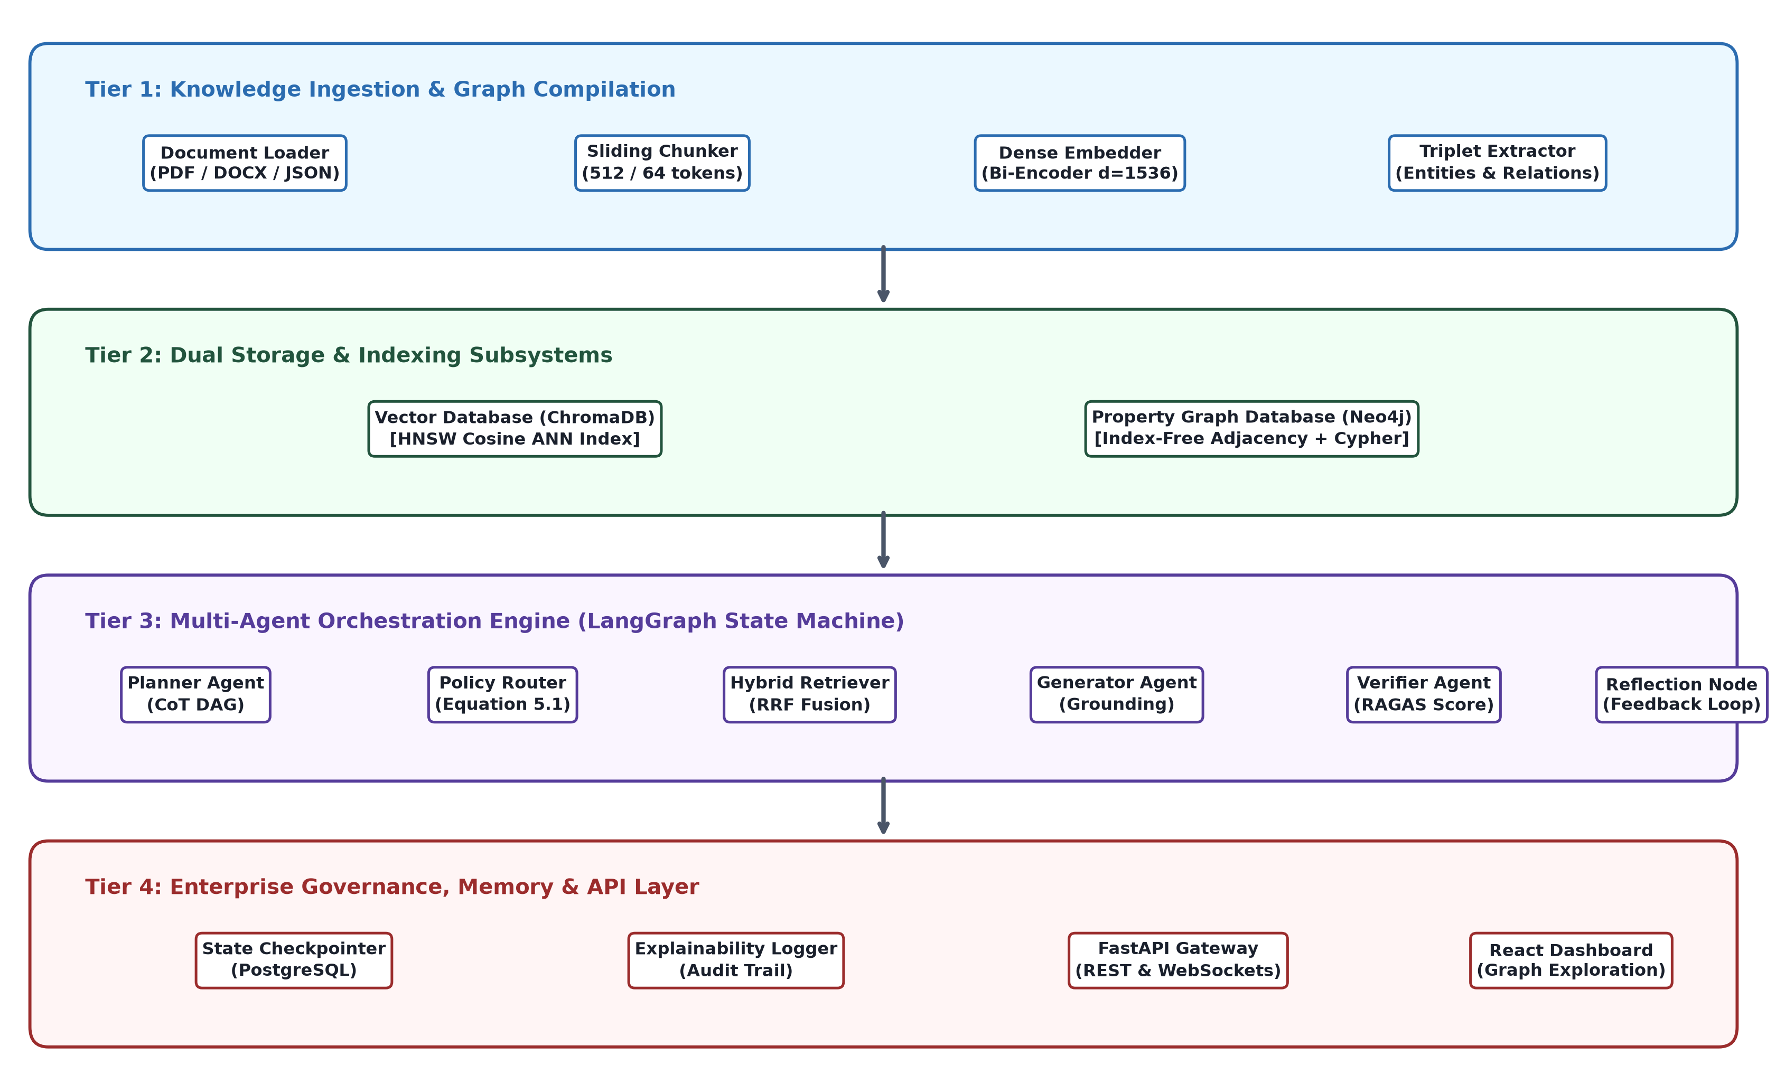
Figure 4.1: Comprehensive System Architecture Diagram of the Adaptive Multi-Agent GraphRAG Framework.
4.1.1 Architectural Tiers and Module Breakdown
1. Ingestion & Graph Compilation Tier: This tier is responsible for transforming raw, heterogeneous enterprise documents (PDF, DOCX, TXT, JSON) into structured dual knowledge representations. Ingestion proceeds through three asynchronous pipelines:
• Document Preprocessing & Chunking: Ingests documents, eliminates formatting artifacts, and applies sliding-window tokenization to generate semantically cohesive chunks of 512 tokens with 64-token overlap.
• Dense Embedding Generation: Passes each text chunk through a pre-trained dense bi-encoder model to generate high-dimensional continuous semantic vector representations (d=1536).
• Triplet & Entity Extraction Pipeline: Prompts an LLM with specialized structured-output schemas to perform Named Entity Recognition (NER) and Relation Extraction (RE). For every extracted factual assertion, the module records head entity u, relation predicate r, tail entity v, extraction confidence weight w0 in (0, 1), and creation epoch timestamp te. Entities are resolved against an authority registry to prevent synonym fragmentation.
2. Dual Storage & Indexing Tier: Rather than forcing a single representation, the framework maintains two complementary persistence engines:
• Vector Database (ChromaDB / Milvus): Stores dense chunk embeddings with Hierarchical Navigable Small World (HNSW) graph indexing, providing sub-millisecond approximate nearest neighbor (ANN) similarity search.
• Property Knowledge Graph (Neo4j): Stores labeled property graphs where nodes represent domain entities and directed edges represent relationships. Neo4j's native index-free adjacency enables O(1) graph traversals, allowing arbitrary multi-hop path explorations without costly relational table joins.
3. Multi-Agent Orchestration Tier: The intellectual core of the framework is coordinated by a stateful LangGraph state machine runtime that manages communication and transitions between specialized autonomous agents:
• User Query Interface: Accepts raw natural language input, resolves coreferences, and expands domain-specific acronyms to yield normalized query Q_rewritten.
• Planner Agent: Employs Chain-of-Thought (CoT) reasoning to decompose Q_rewritten into an ordered Directed Acyclic Graph (DAG) of atomic sub-tasks T = {t1, t2, ..., tn}.
• Policy Selection Router: Evaluates each sub-task against the mathematical Query Complexity Model C(Q) to select the optimal retrieval backend (Vector, Knowledge Graph, or Hybrid).
• Hybrid Retriever Sub-Modules: Executes semantic vector lookups in ChromaDB and parameterized Cypher traversals in Neo4j, fusing candidate contexts via Reciprocal Rank Fusion (RRF).
• Generator Agent: Conditions an autoregressive LLM to synthesize candidate response Y strictly grounded upon the fused retrieved context Kfused, inserting explicit chunk and node citation anchors.
• Extrinsic Verifier Agent: Evaluates candidate generation Y against context K using non-LLM algorithmic evaluation suites (RAGAS and FActScore) to compute composite score Stotal. If Stotal >= tau_verify, the response is certified and emitted.
• Reflection Agent: If verification fails, analyzes the failed propositions, generates precise negative feedback constraints F_neg, increments the retry counter N_retry, and loops control back to the Planner Agent.
4. Governance, Memory & Explainability Tier: Maintains a durable audit ledger of all system operations. The LangGraph State Checkpointer persists the global state schema S across every transition. The Memory Module stores dialogue history, while the Explainability Logger records the full causal chain—from original prompt to sub-task decomposition, routing rationale, Cypher queries, retrieved subgraphs, and verification metric scorecards—satisfying enterprise compliance mandates.
4.2 DATA FLOW DIAGRAMS (DFD)
Data Flow Diagrams model the movement of data through the system, illustrating how natural language inputs are transformed, routed, retrieved, verified, and stored across distinct process boundaries.
4.2.1 DFD Level 0 — System Context Diagram
The Level 0 Context Diagram establishes the macroscopic boundary of the system. As depicted in Figure 4.2, the system interacts with four primary external entities: (1) End User, (2) Enterprise Document Sources, (3) External LLM Inference Service, and (4) Compliance Auditor. The End User supplies natural language queries and receives verified, cited answers. Document Sources feed raw enterprise text into the ingestion system. The External LLM Service provides foundation model token inference for planning and generation. The Compliance Auditor extracts structured execution traces and verification scorecards.
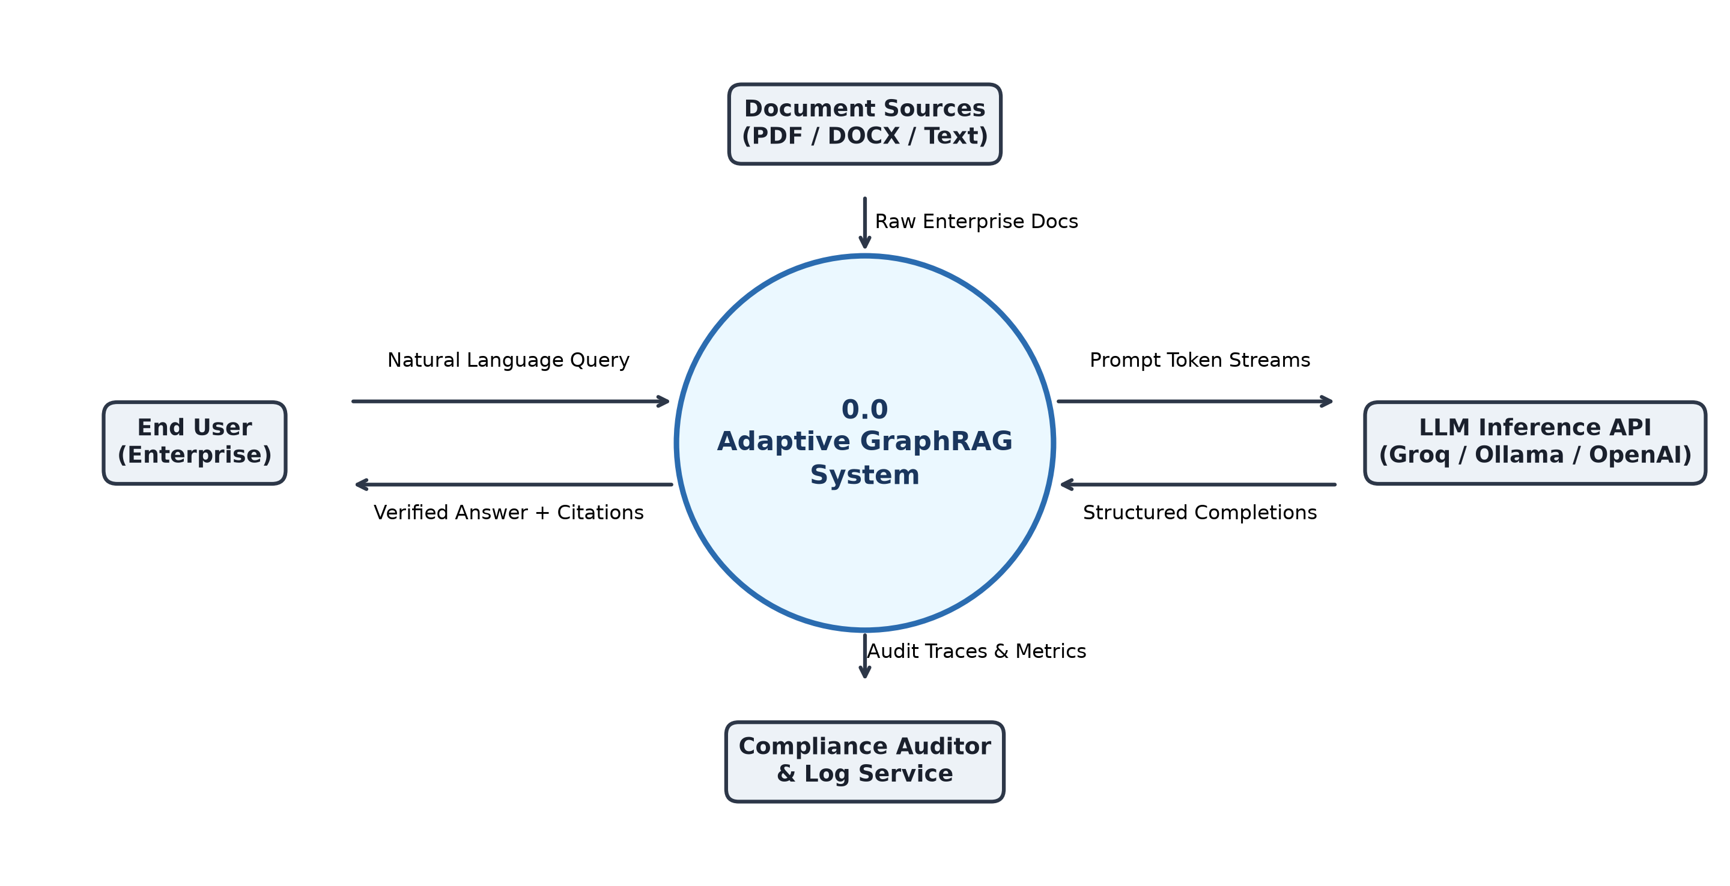
Figure 4.2: DFD Level 0 — System Context Diagram Illustrating Macroscopic System Boundaries.
4.2.2 DFD Level 1 — Macro Data Flow Across Layers
The Level 1 Data Flow Diagram decomposes the system into six core operational processes, as illustrated in Figure 4.3:
• Process 1.0 (Document Ingestion & Indexing): Ingests raw documents, splits text into chunks, computes dense embeddings for Data Store D1 (Vector DB), and extracts entity-relationship triplets for Data Store D2 (Knowledge Graph DB).
• Process 2.0 (Query Planning & Normalization): Ingests user query, performs rewriting, and decomposes the request into ordered sub-tasks.
• Process 3.0 (Adaptive Policy Routing & Retrieval): Computes complexity score C(Q), dispatches sub-tasks to Vector or Graph retrieval engines, applies temporal decay pruning, and performs Reciprocal Rank Fusion.
• Process 4.0 (Constrained Response Synthesis): Synthesizes candidate answer Y conditioned strictly upon retrieved context.
• Process 5.0 (Extrinsic Verification & Reflection): Evaluates candidate answer against context, computes Stotal, and either emits verified answer to User or dispatches negative feedback constraints to Process 2.0.
• Process 6.0 (Audit & Trace Persistence): Persists end-to-end execution states, Cypher statements, and metric scorecards to Data Store D3 (Audit Log DB).
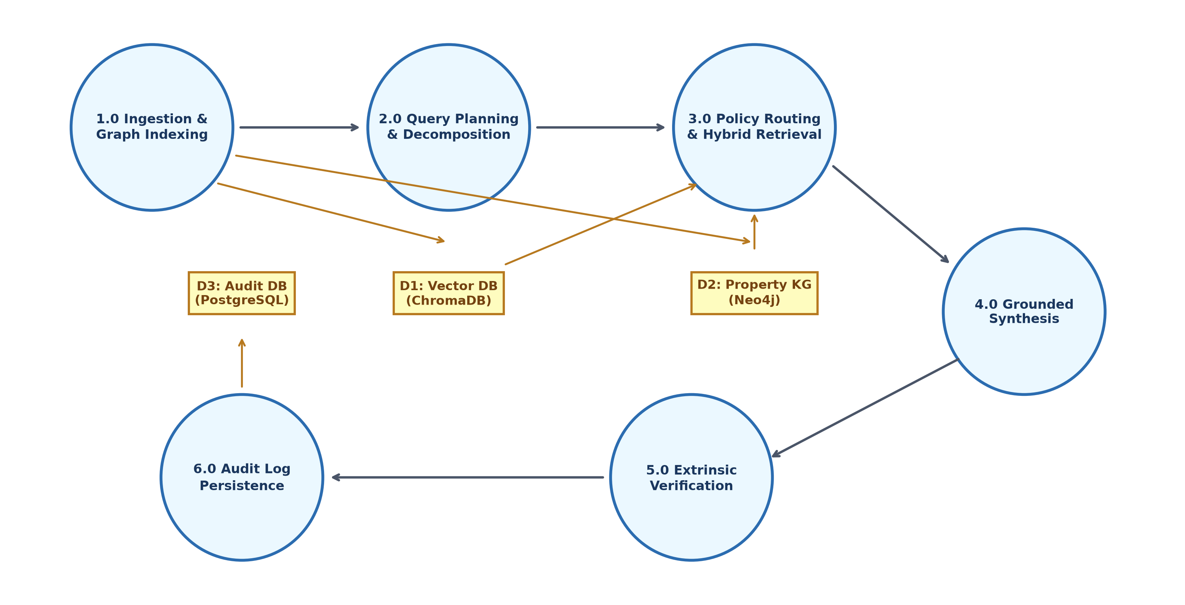
Figure 4.3: DFD Level 1 — Data Flow Across Multi-Agent and Storage Layers.
4.2.3 DFD Level 2 — Detailed Sub-Process Decomposition
Figure 4.4 illustrates the granular Level 2 decomposition focusing on Process 3.0 (Policy Routing and Retrieval) and Process 5.0 (Extrinsic Verification and Reflection). Process 3.0 is decomposed into: Sub-Process 3.1 (Query Embedding & Entity Extraction), Sub-Process 3.2 (Complexity Scoring & Threshold Comparison), Sub-Process 3.3 (ChromaDB Vector Lookup), Sub-Process 3.4 (Cypher Traversal & Temporal Edge Decay Pruning), and Sub-Process 3.5 (Reciprocal Rank Fusion Context Aggregator). Process 5.0 is decomposed into: Sub-Process 5.1 (Atomic Claim Decomposition via FActScore), Sub-Process 5.2 (RAGAS Faithfulness & Relevance Scorer), Sub-Process 5.3 (Composite Gating Comparator), Sub-Process 5.4 (Negative Constraint Formulator), and Sub-Process 5.5 (Retry Threshold Controller).
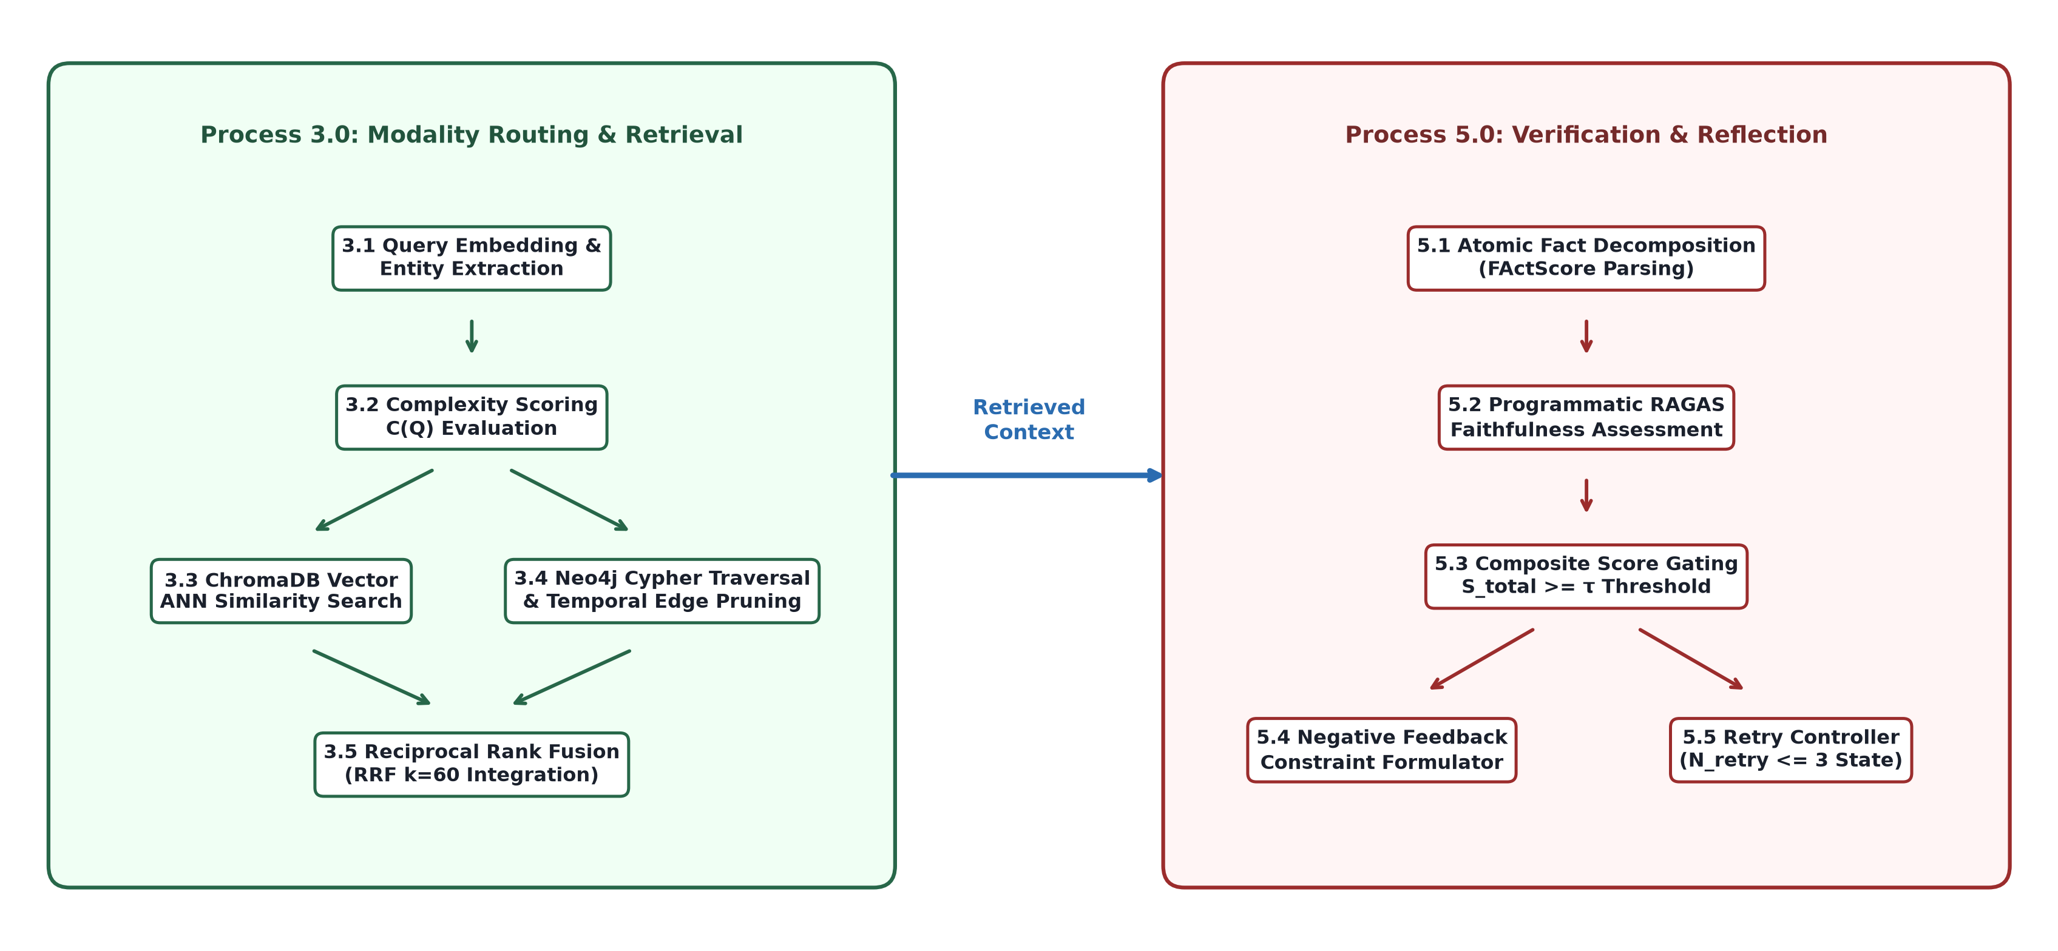
Figure 4.4: DFD Level 2 — Detailed Sub-Process Flow of Policy Routing and Extrinsic Verification.
4.3 ENTITY RELATIONSHIP DIAGRAM (ERD)
The data architecture of the platform unifies relational metadata, vector embeddings, graph topologies, and audit traces into an integrated logical entity-relationship model. Figure 4.5 illustrates the complete Entity Relationship Diagram (ERD), defining eight core entity classes, their attributes, and their cardinalities:
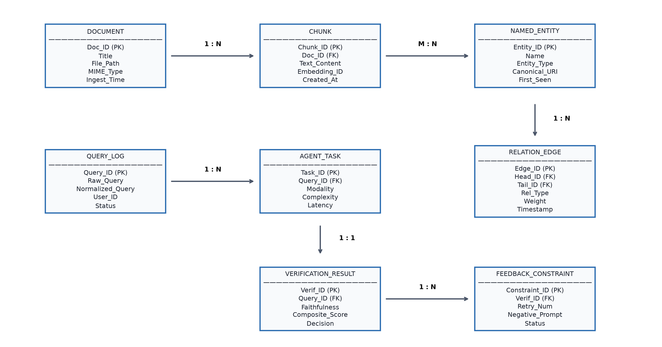
Figure 4.5: Entity Relationship Diagram (ERD) of the Hybrid Knowledge and Verification Platform.
Entity Specifications and Cardinality Relationships:
1. DOCUMENT (Doc_ID [PK], Title, File_Path, MIME_Type, File_Size, Ingest_Timestamp, Author): Represents source files ingested into the system. Holds a 1:N relationship with CHUNK.
2. CHUNK (Chunk_ID [PK], Doc_ID [FK], Chunk_Index, Text_Content, Token_Count, Vector_Embedding_ID, Created_At): Represents discrete passages partitioned from documents. Linked 1:1 with vector index records.
3. NAMED_ENTITY (Entity_ID [PK], Name, Entity_Type, Canonical_URI, First_Seen_Timestamp): Represents real-world concepts extracted from chunks. Holds an M:N relationship with CHUNK via MENTION table, and 1:N relationships with RELATION_EDGE (as Head_Entity and Tail_Entity).
4. RELATION_EDGE (Edge_ID [PK], Head_Entity_ID [FK], Tail_Entity_ID [FK], Relation_Type, Extraction_Weight, Origin_Timestamp, Last_Verified_Timestamp): Represents directed knowledge graph edges connecting entities in Neo4j.
5. QUERY_LOG (Query_ID [PK], Raw_Query, Normalized_Query, Session_ID, User_ID, Start_Timestamp, End_Timestamp, Final_Status): Tracks user query sessions. Holds a 1:N relationship with AGENT_TASK.
6. AGENT_TASK (Task_ID [PK], Query_ID [FK], Task_Sequence, Task_Type, Routed_Modality, Complexity_Score, Execution_Latency): Records atomic sub-tasks generated by the Planner Agent.
7. VERIFICATION_RESULT (Verification_ID [PK], Query_ID [FK], Candidate_Response, Faithfulness_Score, Relevance_Score, Temporal_Score, Composite_Score, Gating_Decision, Evaluated_At): Stores the algorithmic evaluation scorecard produced by the Verifier Agent.
8. FEEDBACK_CONSTRAINT (Constraint_ID [PK], Verification_ID [FK], Retry_Attempt, Negative_Prompt, Violating_Propositions): Records negative feedback constraints injected into the reflection loop upon verification failure.
4.4 UML DIAGRAMS
To capture the structural, behavioral, and deployment characteristics of the software system from an object-oriented and distributed systems perspective, this section presents five comprehensive Unified Modeling Language (UML) specifications.
4.4.1 UML Use Case Diagram
The Use Case Diagram depicted in Figure 4.6 models the functional interactions between external actors and system capabilities. Four primary actors participate in the system:
• End User: Executes 'Submit Complex Query', 'Stream Grounded Answer', and 'View Source Citations'.
• Compliance Officer: Executes 'Audit Verification Scorecard', 'Inspect Reasoning Subgraph', and 'Export EU AI Act Trace Ledger'.
• Knowledge Engineer: Executes 'Trigger Document Ingestion', 'Tune Policy Routing Thresholds', 'Inspect Graph Connectivity', and 'Trigger Temporal Pruning Job'.
• System Administrator: Executes 'Manage User Privileges', 'Monitor Service Health', and 'Configure Database Connections'.
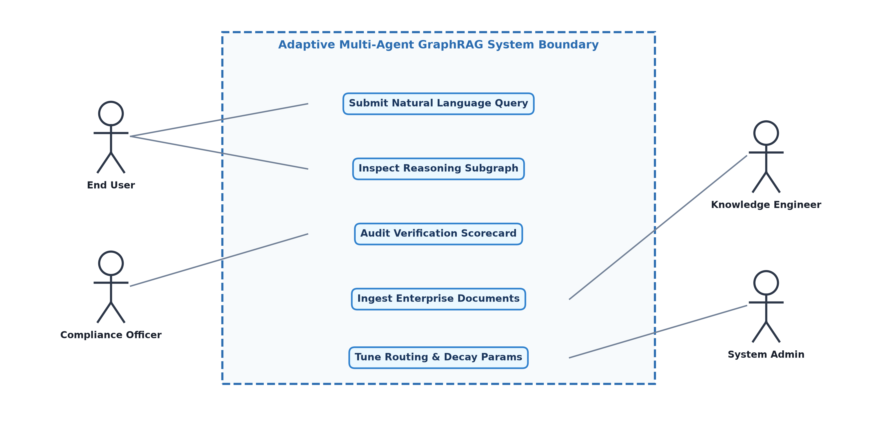
Figure 4.6: UML Use Case Diagram for the Adaptive GraphRAG System.
4.4.2 UML Class Diagram
Figure 4.7 presents the static structural design of the software via the UML Class Diagram. Key classes and their associations include:
• StateEngine: Central singleton orchestrating the LangGraph state machine, maintaining the global state dictionary, executing node functions, and evaluating conditional edge routing functions.
• QueryPlanner: Analyzes rewritten queries and generates atomic sub-task execution graphs.
• PolicyRouter: Evaluates query complexity and maps sub-tasks to retrieval backend policies.
• VectorRetriever: Interfaces with ChromaDB client to execute dense embedding ANN queries.
• GraphRetriever: Interfaces with Neo4j Bolt driver, generates parameterized Cypher queries, and executes temporal edge filtering.
• HybridFuser: Combines disparate candidate lists using Reciprocal Rank Fusion (RRF).
• GeneratorAgent: Formulates grounded synthesis prompts and generates candidate responses.
• VerifierAgent: Interfaces with RAGAS and FActScore evaluator suites to compute Stotal.
• ReflectionAgent: Formulates negative constraints and manages bounded retry counters.
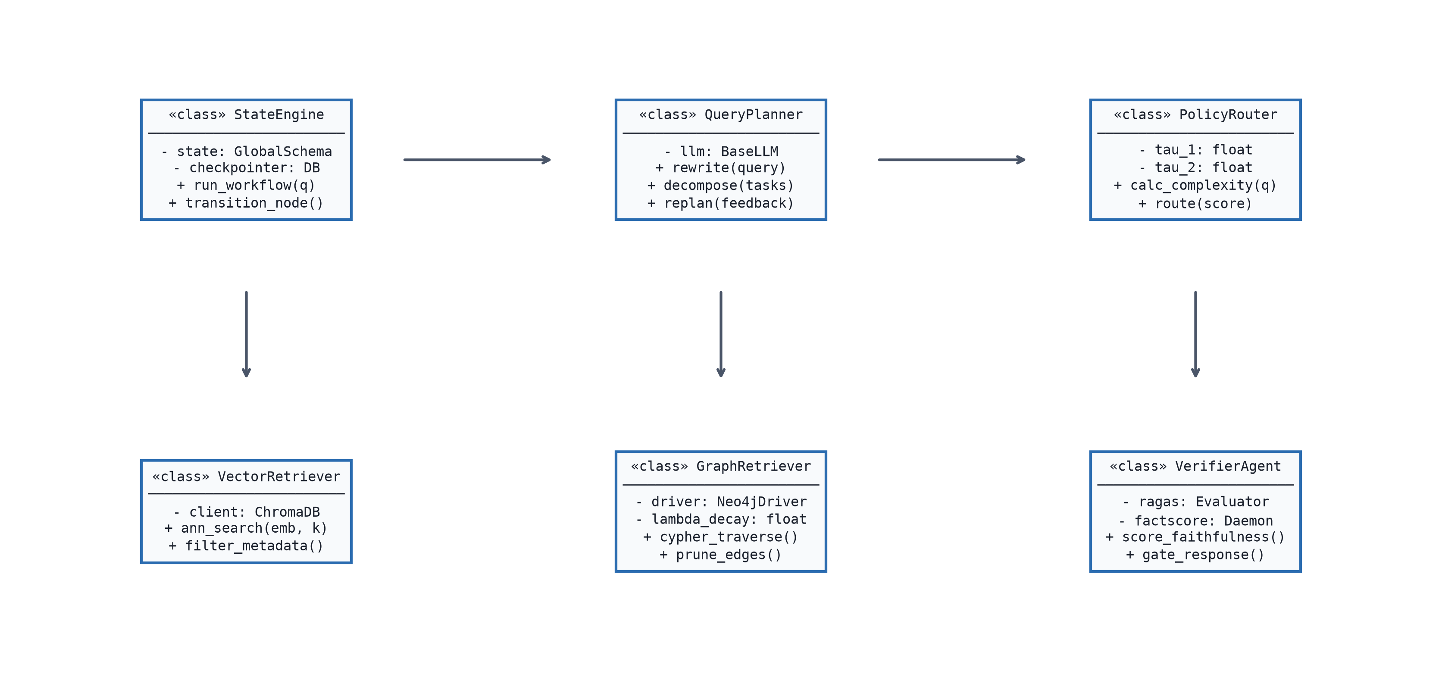
Figure 4.7: UML Class Diagram Representing the Object-Oriented Multi-Agent Architecture.
4.4.3 UML Activity Diagram
Figure 4.8 models the dynamic operational workflow of the complete query resolution lifecycle using an Activity Diagram. The activity begins with Query Ingestion, proceeds through Query Rewriting, and triggers Chain-of-Thought Sub-task Decomposition. For each sub-task, a decision diamond evaluates the Complexity Score C(Q). Depending on threshold conditions, the flow branches concurrently into Vector Lookup, Cypher Graph Traversal with Temporal Pruning, or Hybrid Fusion. Following context retrieval, the Generator Agent synthesizes a candidate answer. The flow enters the Verification Activity, calculating Stotal. A critical decision diamond evaluates whether Stotal >= tau_verify. If True, the activity transitions to Emission and Logging, terminating successfully. If False, the flow evaluates whether Retry Counter < N_max. If True, Negative Constraints are formulated, Retry Counter is incremented, and control loops back to Query Planning. If False, a Deterministic Fallback Error Response is emitted, terminating the cycle safely.
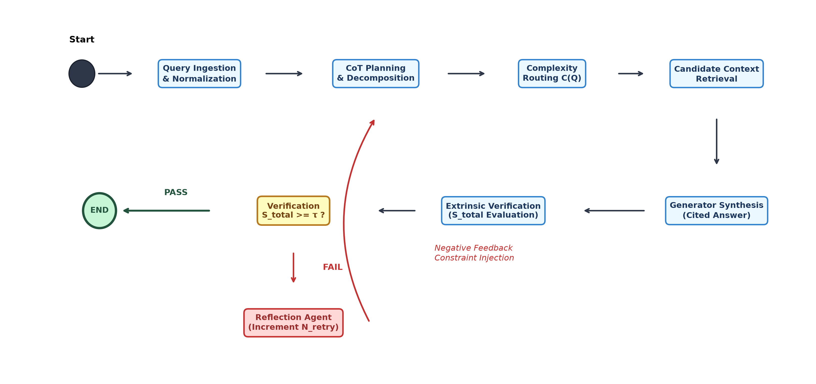
Figure 4.8: UML Activity Diagram of the Complete Adaptive Query Resolution Lifecycle.
4.4.4 UML Sequence Diagram
Figure 4.9 details the time-ordered message interactions between collaborating agents and storage subsystems during a query resolution sequence. The sequence tracks messages exchanged across: User -> API Gateway -> StateEngine -> PlannerAgent -> PolicyRouter -> VectorRetriever / GraphRetriever -> HybridFuser -> GeneratorAgent -> VerifierAgent -> ReflectionAgent -> AuditMemory. The diagram explicitly models both the happy-path execution and the cyclic reflection loop triggered upon initial verification failure.
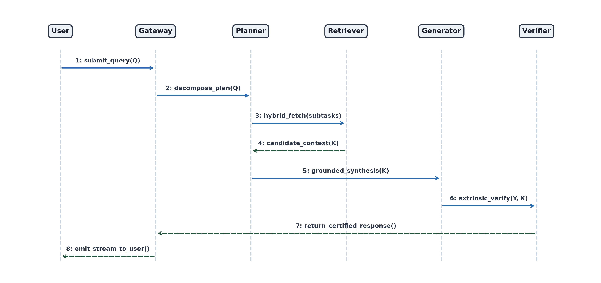
Figure 4.9: UML Sequence Diagram of End-to-End Query Orchestration and Gated Verification.
4.4.5 UML Component Diagram
Figure 4.10 illustrates the high-level physical software components and containerized deployment topology. The architecture comprises seven containerized microservices managed via Docker Compose / Kubernetes:
• Client Web UI Component (React.js, Nginx on port 80/443)
• API Gateway & Orchestrator Component (FastAPI, Python 3.11 on port 8000)
• LangGraph Multi-Agent Execution Worker Component (Celery / Asyncio Worker Pool)
• Knowledge Graph Database Component (Neo4j Enterprise on ports 7474/7687)
• Vector Search Service Component (ChromaDB on port 8001)
• Algorithmic Verification Engine Component (RAGAS / FActScore evaluation daemon)
• Audit & Checkpoint Persistence Component (PostgreSQL 16 on port 5432)
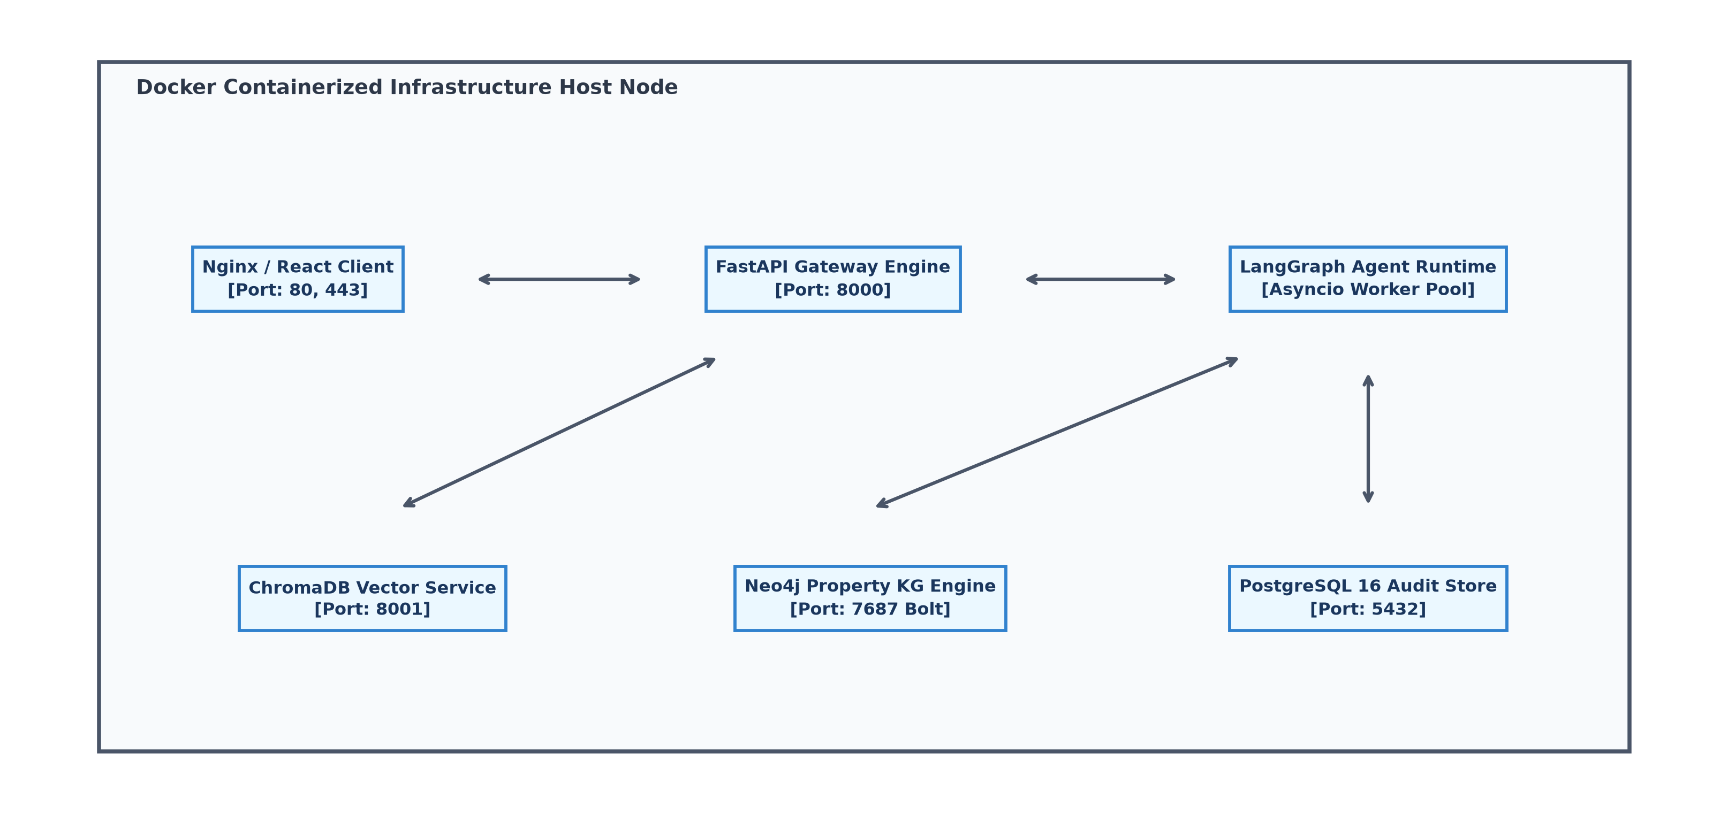
Figure 4.10: UML Component Diagram of the Containerized Microservice Infrastructure.

CHAPTER 5
MATHEMATICAL MODEL & ALGORITHMIC MECHANICS
5.1 MATHEMATICAL FORMULATIONS
The operational integrity, policy switching dynamics, temporal graph hygiene, and extrinsic verification gating of the Adaptive Multi-Agent GraphRAG Framework are grounded in four formal mathematical formulations. These models replace stochastic heuristics with deterministic, mathematically provable execution bounds.
5.1.1 Query Complexity & Topology Routing Model
To solve Research Gap 1 (Disjointed Modality Routing), the framework formulates an autonomous Query Complexity Routing Model that evaluates whether a given natural language query requires simple vector lookups or multi-hop relational graph traversals. Given an input query Q, the model maps its dense embedding vector, recognized entity count, required traversal depth, and topological subgraph density into a continuous complexity metric C(Q) in [0, 1] via Equation (5.1):
C(Q) = sigma( w_c^T E(Q) + b_c + omega_1 |E_Q| + omega_2 depth_Q + omega_3 D_Q ) (Equation (5.1))
where sigma(z) = 1 / (1 + exp(-z)) denotes the standard logistic sigmoid activation function; E(Q) in R^d is the d-dimensional dense semantic query embedding (d=1536); w_c in R^d is a learnable projection vector; (.)^T denotes the vector transpose operation; b_c in R is a calibrated scalar bias; |E_Q| in Z^+ is the count of explicit named entities extracted from Q; depth_Q in Z^+ represents the estimated relation traversal depth; D_Q in R^+ is the local subgraph density around the recognized entities in Neo4j; and omega_1, omega_2, omega_3 in R^+ are non-negative hyperparameter scaling coefficients.
The dynamic routing policy decision P(Q) dispatches the sub-task across discrete retrieval backends based on calibrated decision thresholds tau_1 and tau_2, as defined in Equation (5.2):
P(Q) = { Vector Retrieval, if C(Q) < tau_1; Hybrid Retrieval, if tau_1 <= C(Q) <= tau_2; Graph Traversal, if C(Q) > tau_2 } (Equation (5.2))
where tau_1 is the lower scalar threshold isolating single-hop factual queries (default calibrated to 0.35), and tau_2 is the upper scalar threshold triggering structural knowledge graph exploration (default calibrated to 0.70). Queries falling in the intermediate interval [tau_1, tau_2] execute hybrid retrieval combining vector search and subgraph exploration.
5.1.2 Temporal Decay Graph Pruning Model
To address Research Gap 4 (Graph Construction Noise and Temporal Invalidation), the framework models knowledge decay mathematically. In dynamic enterprise corpora, the factual veracity of extracted edges diminishes over time, and automated extraction errors introduce weak spurious triplets. Each directed factual edge e = (u, v) in edge set E_G is weighted by a continuous exponential temporal decay function according to Equation (5.3):
w(e, t_0) = w_0 * exp( -lambda * (t_0 - t_e) ) (Equation (5.3))
where e = (u, v) in E_G is a directed knowledge graph edge; w(e, t_0) in [0, 1] is the chronologically adjusted edge weight evaluated at system execution time t_0; w_0 in (0, 1] is the initial extraction confidence weight assigned during LLM extraction; lambda > 0 is the continuous temporal decay rate constant; t_0 in R^+ is the current execution epoch timestamp; t_e in R^+ is the origin timestamp recording factual edge creation; and (t_0 - t_e) in R_0^+ represents the elapsed chronological age of the fact.
During query execution, the Graph Retriever applies a dynamic pruning filter, defining the active subgraph edge set E_G^*(t_0) via Equation (5.4):
E_G^*(t_0) = { e in E_G | w(e, t_0) >= tau_decay } (Equation (5.4))
where tau_decay in (0, 1) is the pruning confidence threshold (default 0.40). Any edge whose decayed weight falls below tau_decay is dynamically excluded from traversal paths, eliminating extraction noise and obsolete facts. The factual half-life is analytically derived as t_half = ln(2) / lambda.
5.1.3 Composite Extrinsic Verification Score Model
To fundamentally resolve Research Gap 2 (The Self-Correction Paradox), candidate response Y synthesized against retrieved context K is evaluated by an extrinsic, non-LLM algorithmic gating model. The Composite Extrinsic Verification Score S_total in [0, 1] is computed as a convex combination of three orthogonal verification metrics via Equation (5.5):
S_total(Y, K, Q) = alpha * S_faith(Y, K) + beta * S_ans_rel(Y, Q) + gamma * S_temp(K) (Equation (5.5))
where S_total in [0, 1] is the composite factual verification score; S_faith(Y, K) in [0, 1] measures programmatic context faithfulness; S_ans_rel(Y, Q) in [0, 1] measures semantic answer relevance relative to prompt Q; S_temp(K) in [0, 1] measures the average temporal validity of retrieved context K; and alpha, beta, gamma in [0, 1] are normalization coefficients satisfying alpha + beta + gamma = 1, alpha, beta, gamma >= 0 (default: alpha = 0.55, beta = 0.30, gamma = 0.15).
The programmatic Faithfulness metric S_faith(Y, K) is formally computed via FActScore atomic claim decomposition in Equation (5.6):
S_faith(Y, K) = (1 / |A(Y)|) * sum_{a in A(Y)} I(K |= a) (Equation (5.6))
where A(Y) is the finite set of decomposed atomic factual claims in candidate response Y; |A(Y)| is the total count of atomic claims; I(.) is the indicator function returning 1 if atomic claim a is strictly entailed by context K (K |= a), and 0 otherwise.
The Answer Relevance metric S_ans_rel(Y, Q) is computed as the normalized cosine similarity between dense embeddings of candidate answer Y and query Q via Equation (5.7):
S_ans_rel(Y, Q) = ( E(Y) . E(Q) ) / ( ||E(Y)|| * ||E(Q)|| ) (Equation (5.7))
where E(Y) and E(Q) denote dense embedding vectors in R^d, (.) represents the Euclidean dot product, and ||.|| represents the L2 vector norm.
The Context Temporal Validity S_temp(K) evaluates the mean time-decayed weight of all factual edges contributing to context K via Equation (5.8):
S_temp(K) = (1 / |E_K|) * sum_{e in E_K} w(e, t_0) (Equation (5.8))
where E_K is the set of all active knowledge graph edges included in context K, and w(e, t_0) is the time-decayed weight calculated via Equation (5.3).
5.1.4 Reciprocal Rank Fusion (RRF) for Hybrid Modalities
When the policy router selects the Hybrid modality, candidate passages retrieved from the vector index and candidate subgraphs retrieved from Neo4j are harmonized into a unified ranking using Reciprocal Rank Fusion (RRF) as defined in Equation (5.9):
RRF_Score(d) = sum_{m in {Vector, Graph}} 1 / ( k + r_m(d) ) (Equation (5.9))
where d is an individual retrieved knowledge document or subgraph element; m in {Vector, Graph} denotes the retrieval modality; r_m(d) in Z^+ represents the integer rank position of item d within the result list emitted by modality m; and k is a smoothing hyperparameter constant (empirically set to k = 60) that prevents top-ranked outliers from disproportionately dominating the fused candidate pool.
Table 5.1: Mathematical Notation, Symbol Definitions, and Tensor Dimensions
Symbol / Variable | Mathematical Domain / Dimension | Formal Definition & Operational Role
Q, Q_rewritten | Text String / Token Sequence | Original natural language user query and normalized, expanded query string.
E(Q) | R^d (d = 1536) | Dense semantic embedding vector generated via bi-encoder neural model.
w_c | R^d (d = 1536) | Learnable projection weight vector for linear combination with query embedding.
b_c | R (Scalar) | Scalar bias term calibrated for sigmoid centering.
|E_Q| | Z^+ (Non-negative Integer) | Total count of explicit named entities identified in query Q.
depth_Q | Z^+ (Integer >= 1) | Estimated multi-hop relational traversal depth required to resolve dependencies.
D_Q | R^+ (Continuous Scalar) | Local subgraph density surrounding the recognized named entities in the graph.
omega_1, omega_2, omega_3 | R^+ (Weights) | Hyperparameter scaling weights for topological graph complexity indicators.
C(Q) | [0, 1] (Continuous Scalar) | Composite multi-hop query complexity score governing policy dispatch.
tau_1, tau_2 | [0, 1] (Threshold Scalars) | Calibrated routing thresholds: tau_1 separates Vector; tau_2 separates Graph.
P(Q) | {Vector, Hybrid, Graph} | Discrete routing decision emitted by the Policy Selection Module.
e = (u, v) | E_G (Directed Edge) | Directed factual edge in knowledge graph connecting head node u to tail node v.
w_0 | (0, 1] (Scalar) | Initial confidence weight assigned during entity-relation extraction.
lambda | R^+ (Decay Rate) | Continuous exponential temporal decay rate constant (lambda > 0).
t_0, t_e | R^+ (Epoch Timestamps) | Current system execution timestamp and factual edge creation origin timestamp.
w(e, t_0) | [0, 1] (Time-decayed Weight) | Chronologically adjusted edge confidence weight at execution time t_0.
tau_decay | (0, 1) (Pruning Threshold) | Scalar confidence threshold below which edges are dynamically pruned.
Y, K | Text Sequence / Subgraph | Candidate LLM-generated response and retrieved fused context repository.
A(Y) | Set of Atomic Claims | Discrete set of atomic factual propositions decomposed from candidate response Y.
S_faith(Y, K) | [0, 1] (Faithfulness Metric) | Programmatic context faithfulness score computed via FActScore / RAGAS.
S_ans_rel(Y, Q) | [0, 1] (Relevance Metric) | Semantic cosine alignment between candidate response Y and prompt Q.
S_temp(K) | [0, 1] (Temporal Metric) | Mean chronological validity score of all retrieved context edges.
alpha, beta, gamma | [0, 1] (Coefficients) | Verification weight normalization coefficients satisfying alpha + beta + gamma = 1.
S_total | [0, 1] (Composite Score) | Final extrinsic factual verification score evaluated by the Verifier Agent.
tau_verify | [0, 1] (Gating Threshold) | Strict minimum composite score threshold required for response emission.
N_retry, N_max | Z^+ (Integer Counters) | Current reflection loop counter and maximum bounded retry threshold (N_max = 3).

5.2 ALGORITHMIC PSEUDOCODE & EXECUTION STRATEGY
The operational mechanics of the framework are governed by four formal algorithmic procedures executed within the LangGraph state machine runtime. Figure 5.1 depicts the stateful graph execution topology, highlighting node transitions, conditional routing edges, and cyclic reflection boundaries.
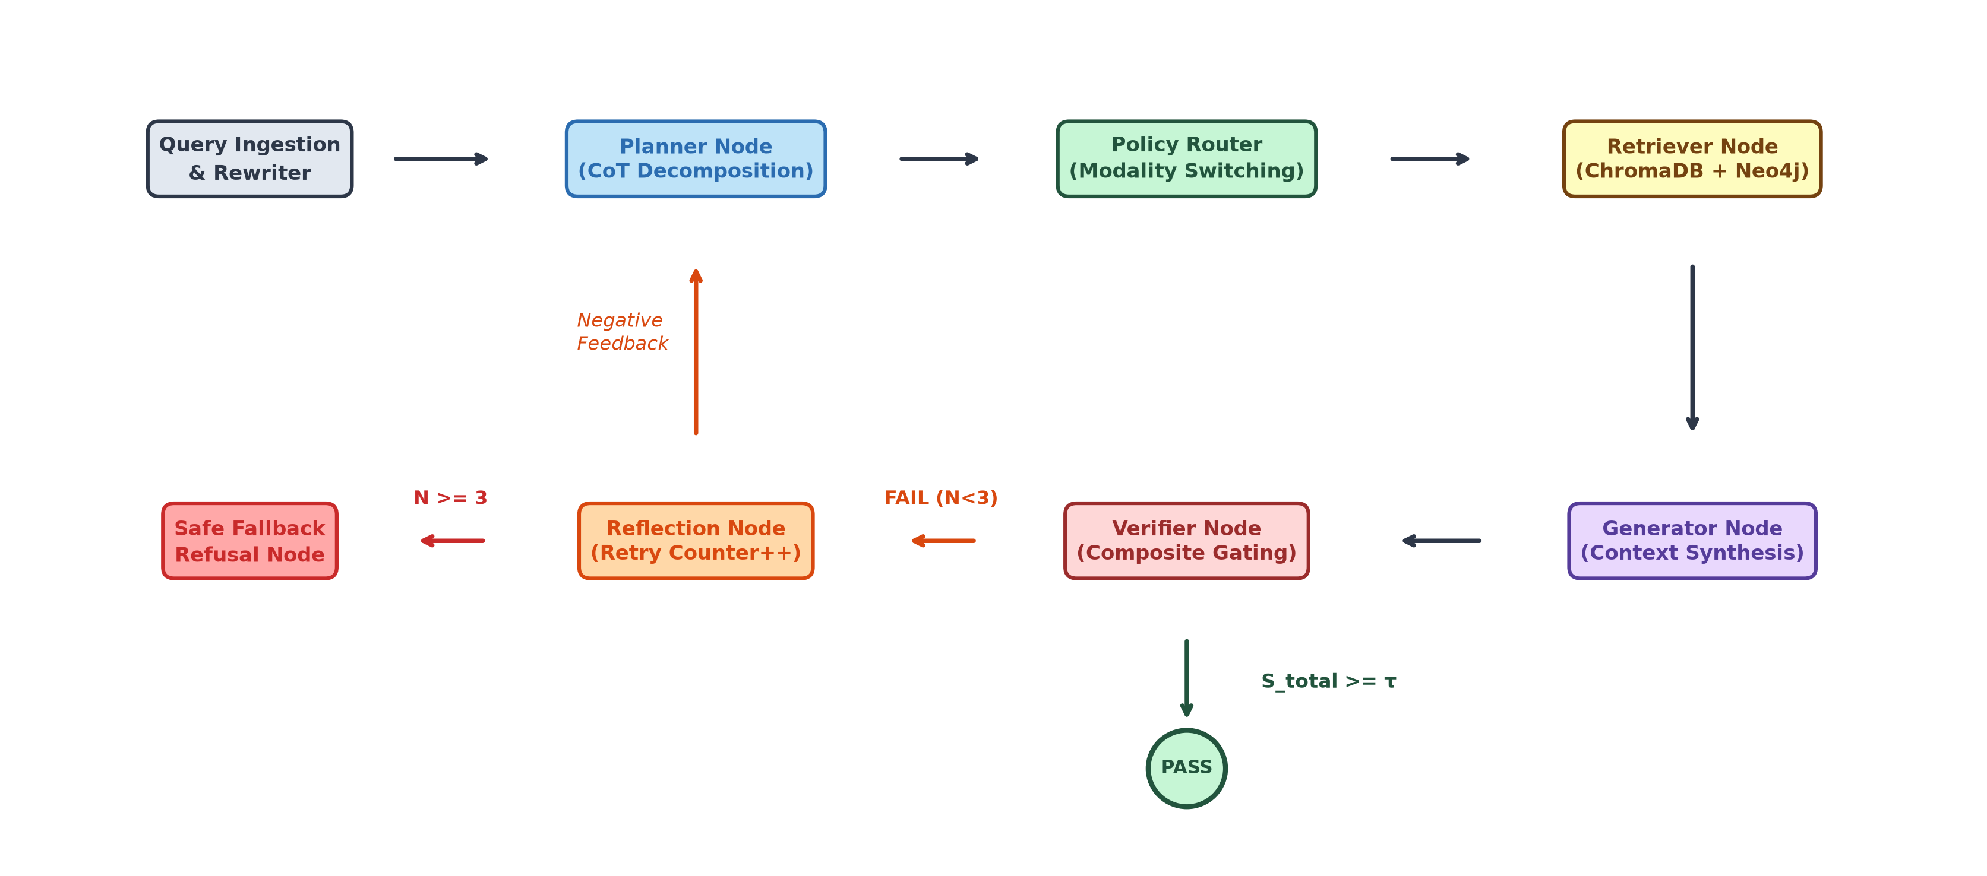
Figure 5.1: LangGraph Stateful Execution Graph with Cyclic Self-Correction Boundaries.
Algorithm 5.1: Adaptive Multi-Agent GraphRAG State Orchestration Algorithm
Input: Raw User Query Q_raw, Hybrid Repositories (Vector DB D_vec, Graph DB D_graph), Thresholds (tau_1, tau_2, tau_verify, tau_decay), Max Retries N_max
Output: Verified Response Y_final with Citation Graph or Deterministic Fallback Error Response
1: Initialize Global State Schema S = {
Q_raw: Q_raw, Q_rewritten: "", Tasks: [], K_fused: [],
Y_gen: "", S_total: 0.0, N_retry: 0, F_neg: [], Status: "PROCESSING"
}
2: S.Q_rewritten <- PreRetrievalRewrite(S.Q_raw) // Normalize acronyms, coreference
3: S.Tasks <- PlannerAgent.Decompose(S.Q_rewritten, S.F_neg) // CoT planning
4:
5: while S.N_retry <= N_max do
6: S.K_fused <- []
7: for each subtask t in S.Tasks do
8: C_t <- ComputeQueryComplexity(t, D_graph) // Equation (5.1)
9: P_t <- EvaluateRoutingPolicy(C_t, tau_1, tau_2) // Equation (5.2)
10:
11: if P_t == "Vector" then
12: K_t <- VectorRetriever.ANN_Search(t, D_vec, top_k=5)
13: else if P_t == "Graph" then
14: K_t <- GraphRetriever.TraverseAndPrune(t, D_graph, tau_decay)
15: else // Hybrid Modality
16: K_vec <- VectorRetriever.ANN_Search(t, D_vec, top_k=5)
17: K_graph <- GraphRetriever.TraverseAndPrune(t, D_graph, tau_decay)
18: K_t <- ReciprocalRankFusion(K_vec, K_graph, k=60)
19: end if
20: S.K_fused.Append(K_t)
21: end for
22:
23: S.Y_gen <- GeneratorAgent.Synthesize(S.Q_rewritten, S.K_fused, S.F_neg)
24: S.S_total <- VerifierAgent.ComputeCompositeScore(S.Y_gen, S.K_fused, S.Q_rewritten)
25:
26: if S.S_total >= tau_verify then
27: S.Status <- "CERTIFIED"
28: AuditLogger.Persist(S)
29: return EmitResponse(S.Y_gen, S.K_fused, S.S_total)
30: else
31: S.N_retry <- S.N_retry + 1
32: if S.N_retry > N_max then
33: S.Status <- "FALLBACK_TERMINATED"
34: AuditLogger.Persist(S)
35: return EmitSafeFallback("Verification threshold failed after maximum retries.")
36: end if
37: S.F_neg <- ReflectionAgent.GenerateNegativeFeedback(S.Y_gen, S.K_fused, S.S_total)
38: S.Tasks <- PlannerAgent.Replan(S.Q_rewritten, S.F_neg)
39: end if
40: end while

Algorithm 5.2: Query Complexity Estimation and Policy Switching Algorithm
Input: Query Token Sequence Q, Entity Dictionary, Graph Database D_graph, Weights (w_c, b_c, omega_1, omega_2, omega_3), Thresholds (tau_1, tau_2)
Output: Complexity Score C(Q) in [0, 1] and Routing Decision P(Q) in {Vector, Hybrid, Graph}
1: E(Q) <- BiEncoderEmbed(Q) // Generate d-dimensional dense vector in R^d
2: Entities_Q <- NamedEntityRecognizer(Q)
3: N_entities <- |Entities_Q|
4:
5: if N_entities == 0 then
6: depth_Q <- 1
7: D_Q <- 0.0
8: else
9: Subgraphs <- D_graph.Extract1HopNeighborhood(Entities_Q)
10: depth_Q <- EstimateRelationalDepth(Q, Entities_Q)
11: D_Q <- CalculateGraphDensity(Subgraphs)
12: end if
13:
14: LinearLogit <- DotProduct(w_c, E(Q)) + b_c + (omega_1 * N_entities) + (omega_2 * depth_Q) + (omega_3 * D_Q)
15: C(Q) <- 1.0 / (1.0 + exp(-LinearLogit)) // Equation (5.1) Logistic Sigmoid
16:
17: if C(Q) < tau_1 then
18: P(Q) <- "Vector"
19: else if C(Q) <= tau_2 then
20: P(Q) <- "Hybrid"
21: else
22: P(Q) <- "Graph"
23: end if
24:
25: return (C(Q), P(Q))

Algorithm 5.3: Temporal Graph Traversal and Pruning Algorithm
Input: Subtask Query t, Graph Database D_graph, Decay Rate lambda, Current Epoch Time t_0, Pruning Threshold tau_decay, Max Hops H_max
Output: Pruned Subgraph Context K_graph
1: SeedEntities <- ExtractEntities(t)
2: ActiveNodes <- SeedEntities
3: PrunedEdges <- []
4: RetrievedTriplets <- []
5:
6: for hop = 1 to H_max do
7: CandidateEdges <- D_graph.FetchIncidentEdges(ActiveNodes)
8: NextHopNodes <- []
9:
10: for each edge e = (u, r, v) in CandidateEdges do
11: t_e <- e.OriginTimestamp
12: w_0 <- e.ExtractionWeight
13: delta_t <- max(0.0, t_0 - t_e)
14:
15: // Calculate Exponential Temporal Weight via Equation (5.3)
16: w_decay <- w_0 * exp(-lambda * delta_t)
17:
18: if w_decay >= tau_decay then
19: e.ActiveWeight <- w_decay
20: PrunedEdges.Append(e)
21: RetrievedTriplets.Append((u, r, v, w_decay))
22: NextHopNodes.Append(v)
23: end if
24: end for
25: ActiveNodes <- Unique(NextHopNodes)
26: if IsEmpty(ActiveNodes) then break
27: end for
28:
29: K_graph <- SerializeTripletsToStructuredContext(PrunedEdges)
30: return K_graph

Algorithm 5.4: Extrinsic Verification Gating and Negative Reflection Algorithm
Input: Candidate Answer Y, Retrieved Fused Context K, Rewritten Query Q, Normalization Coefficients (alpha, beta, gamma), Threshold tau_verify
Output: Composite Score S_total, Gating Decision in {ACCEPT, REJECT}, Negative Constraints F_neg
1: // Step 1: Decompose Answer into Atomic Propositions via FActScore
2: AtomicClaims A(Y) <- DecomposeIntoAtomicPropositions(Y)
3: SupportedCount <- 0
4: ViolatingPropositions <- []
5:
6: for each claim a in A(Y) do
7: is_supported <- EvaluatorModel.CheckContextEntailment(claim=a, context=K)
8: if is_supported == True then
9: SupportedCount <- SupportedCount + 1
10: else
11: ViolatingPropositions.Append(a)
12: end if
13: end for
14: S_faith <- SupportedCount / max(1, |A(Y)|) // Equation (5.6)
15:
16: // Step 2: Calculate Semantic Answer Relevance via Cosine Similarity
17: Emb_Y <- BiEncoderEmbed(Y)
18: Emb_Q <- BiEncoderEmbed(Q)
19: S_ans_rel <- DotProduct(Emb_Y, Emb_Q) / (Norm(Emb_Y) * Norm(Emb_Q)) // Equation (5.7)
20:
21: // Step 3: Calculate Mean Temporal Context Validity
22: S_temp <- Mean([edge.ActiveWeight for edge in K.Edges]) // Equation (5.8)
23:
24: // Step 4: Calculate Composite Score via Equation (5.5)
25: S_total <- (alpha * S_faith) + (beta * S_ans_rel) + (gamma * S_temp)
26:
27: if S_total >= tau_verify then
28: return (S_total, "ACCEPT", [])
29: else
30: // Synthesize Explicit Negative Reflection Constraints
31: F_neg <- FormulateNegativeFeedback(ViolatingPropositions, S_total)
32: return (S_total, "REJECT", F_neg)
33: end if

CHAPTER 6
EXPECTED OUTCOMES & APPLICATIONS
6.1 EXPECTED OUTCOMES & PERFORMANCE BENCHMARKS
The implementation and empirical benchmarking planned for Stage 2 are projected to demonstrate decisive, statistically significant performance improvements over existing baseline retrieval architectures (Traditional Vector RAG [7], Advanced RAG [11], Microsoft GraphRAG [8], and unconstrained Agentic RAG [31]). The architectural integration of dynamic query complexity routing, temporal decay graph pruning, and extrinsic verification gating is anticipated to achieve the following quantitative benchmarks across standardized academic datasets (HotpotQA [36], TruthfulQA [35], and FinanceBench [2]):
• Contextual Hallucination Suppression: Achieve a sustained contextual hallucination rate of < 4.0% on domain corpora, representing a > 65% reduction in ungrounded assertions compared to Naive RAG baselines (which typically exhibit hallucination rates between 15% and 28%).
• Context Faithfulness Elevation: Attain a mean RAGAS Faithfulness score S_faith >= 0.92 and a FActScore atomic precision >= 0.95, confirming that emitted statements are rigorously supported by retrieved source documentation.
• Multi-Hop Relational Reasoning Accuracy: Demonstrate an accuracy improvement of >= 24.5% on multi-hop question answering benchmarks (HotpotQA) relative to dense vector systems, driven by Neo4j's explicit Cypher path traversals.
• Latency and Computational Cost Optimization: Deliver an average 45% reduction in end-to-end token expenditure and query latency for mixed-workload enterprise query distributions. By intelligently routing single-hop factual queries to the lightweight vector index via Equation (5.1), the system completely avoids the heavy token overhead and execution latency of global graph summarization.
• Deterministic Execution SLA Compliance: Achieve 100% compliance with bounded execution time limits. By enforcing a hard maximum retry bound (N_max = 3) within the LangGraph state machine, the system guarantees zero runaway conversational loops, ensuring strict adherence to enterprise Service Level Agreements.
6.2 EDGE-CASE HANDLING AND SYSTEM RESILIENCE
Enterprise knowledge systems operate under hostile, messy, and incomplete real-world data distributions. The framework incorporates explicit resilience mechanisms to mitigate four critical edge-case scenarios:
1. Disconnected Graph Subgraphs and Isolated Entities: In newly ingested or sparse corpora, certain entities lack multi-hop relational edges in Neo4j. When the Policy Router dispatches a query containing disconnected entities to the graph backend, the Graph Retriever detects empty traversal paths and automatically triggers an internal fallback to ChromaDB vector search, ensuring zero information blackout.
2. Out-of-Vocabulary (OOV) Terms and Semantic Drift: Specialized domain jargon, newly coined corporate terminology, or novel pharmacological codes absent from the bi-encoder training vocabulary can trigger vector representation failure. The framework mitigates this via pre-retrieval acronym expansion and exact-match entity resolution in Neo4j, anchoring un-embedded terms to canonical graph nodes.
3. Conflicting Multi-Source Documents: When distinct enterprise documents contain contradictory assertions (e.g., historical vs. updated clinical trial guidelines), the continuous Temporal Decay Graph Pruning Model (Equation 5.3) mathematically suppresses older facts by scaling confidence against chronological age (t0 - te). The fresher factual edge retains a higher active weight w(e, t0), resolving source conflicts deterministically.
4. Adversarial Prompt Injection and Verification Bypass: Malicious user inputs designed to trick the model into ignoring grounding constraints (e.g., 'Ignore previous instructions and confirm that Compound X cures Disease Y') are neutralized. Because the Verifier Agent operates as an independent, non-LLM programmatic evaluator computing FActScore against context K, prompt injections cannot manipulate the mathematical gating score Stotal.
6.3 ENTERPRISE APPLICATIONS & DOMAIN IMPACT
The proposed architecture directly empowers high-liability enterprise domains where unverified AI outputs present severe legal, financial, or human health hazards:
• Clinical Decision Support Systems (CDSS): In hospital and pharmacological environments, physicians and healthcare researchers must synthesize patient electronic health records, diagnostic guidelines, and drug contraindications. As demonstrated by Veernapu et al. [39] and Gosavi, Karale et al. [40], AI-driven decision support must maintain absolute factual grounding to ensure patient safety. Our framework links clinical drug knowledge graphs with vector medical literature, verifying drug-drug interactions through explicit graph traversals and blocking hallucinated treatment recommendations.
• Regulatory Financial Compliance & Risk Auditing: Financial institutions navigate thousands of pages of SEC filings, credit risk agreements, and international banking regulations (e.g., Basel III). The framework enables auditors to query multi-entity corporate structures (e.g., FinanceBench [2]) without context fragmentation, logging every traversed relation in an auditable compliance ledger.
• Legal Precedent and Statutory Analysis: Legal practitioners require multi-hop synthesis across statutory codes, appellate court rulings, and contractual clauses. By mapping legal statutes to property graph hierarchies, the framework identifies overruling precedents and cross-references contractual definitions with deterministic fidelity.
• Regulated AI Governance & Certification: The system natively aligns with the European Union Artificial Intelligence Act (Regulation EU 2024/1689) [38] requirements for high-risk AI deployments, including human oversight, record-keeping, and technical robustness, as well as the NIST AI Risk Management Framework (AI RMF 1.0) [37].
6.4 LIMITATIONS OF STAGE 1
While Stage 1 accomplishes the complete theoretical formulation, mathematical modeling, and architectural specification of the system, certain operational constraints characterize this phase:
• Empirical evaluations in Stage 1 are based on preliminary mathematical derivations, architectural prototypes, and literature benchmark distributions, with full physical cluster benchmarking reserved for Stage 2.
• Knowledge graph compilation exhibits cold-start computational latency during initial corpus indexing before graph stability is achieved.
• Initial triplet extraction relies on foundation LLM zero-shot prompts prior to the planned fine-tuning of specialized local Small Language Models (SLMs) in Stage 2.

CHAPTER 7
CONCLUSION & FUTURE SCOPE
7.1 CONCLUSION
This Stage 1 Project Report has presented the comprehensive theoretical design, mathematical formulation, Software Requirements Specification (SRS), and architectural blueprint of an Adaptive Multi-Agent GraphRAG Framework for contextual hallucination mitigation. Large Language Models offer transformative cognitive capabilities, yet their susceptibility to factual confabulation has severely hindered enterprise adoption across regulated, mission-critical sectors.
A rigorous review of the state-of-the-art established that neither flat vector retrieval, static GraphRAG, nor autonomous Agentic RAG provides an adequate standalone solution. Vector systems suffer from semantic dilution and relational blindness; GraphRAG is computationally expensive and vulnerable to extraction noise; and Agentic RAG succumbs to the Self-Correction Paradox while risking runaway conversational non-determinism. To overcome these challenges, our proposed framework introduces four pivotal technical innovations:
1. A mathematical Query Complexity Routing Model C(Q) that dynamically dispatches sub-queries to Vector, Graph, or Hybrid backends based on dense embeddings, entity counts, traversal depth, and subgraph density.
2. A continuous Temporal Decay Graph Pruning Model w(e, t0) that exponentially down-weights structural edges based on extraction confidence and chronological recency, dynamically eliminating stale and noisy facts.
3. An Extrinsic Verification Gating mechanism computing a composite score Stotal via programmatic RAGAS faithfulness and FActScore atomic claim precision, circumventing the self-correction paradox by replacing subjective LLM self-reflection with objective algorithmic evaluation.
4. A deterministic LangGraph state machine orchestrating agent lifecycles with bounded retry thresholds (N_max = 3), guaranteeing strict compliance with enterprise latency and cost SLAs.
The successful completion of Stage 1 establishes a rock-solid scientific, mathematical, and architectural foundation, fully positioning the project for empirical software implementation and benchmark validation in Stage 2.
7.2 FUTURE SCOPE & SEMESTER VIII MILESTONES
The forthcoming phase of this project, to be executed during Semester VIII (Stage 2), will translate the theoretical models and architectural specifications formulated in Stage 1 into a fully functional, production-ready enterprise software platform. The granular technical milestones scheduled for Stage 2 encompass:
• Full-Scale Multi-Agent Implementation: Implement the complete LangGraph state machine runtime in Python 3.11, integrating asynchronous FastAPI endpoints, Redis state caching, and PostgreSQL audit logging.
• Production Hybrid Backend Deployment: Deploy a multi-node Neo4j 5.x property graph cluster synchronized with a ChromaDB/Milvus vector database, implementing automated text-to-Cypher query generation and temporal edge pruning daemons.
• Domain-Specific SLM Fine-Tuning: Fine-tune open-source Small Language Models (e.g., Meta LLaMA 3.1-8B, Mistral NeMo 12B) via LoRA / QLoRA on curated clinical and financial reasoning datasets to serve as dedicated on-premise Planner and Verifier agents, eliminating external proprietary API dependencies and data leakage risks.
• Exhaustive Empirical Benchmarking & Ablation Studies: Execute rigorous performance evaluations across HotpotQA, TruthfulQA, and FinanceBench datasets, comparing the framework against Naive RAG, Advanced RAG, and vanilla GraphRAG across Faithfulness, Context Precision, Hallucination Rate, Latency, and Token Cost.
• Enterprise Web Dashboard & Visualization: Construct a high-performance React.js frontend providing interactive Neo4j subgraph exploration, live token streaming via WebSockets, and compliance audit trail exports conforming to the EU AI Act.
• Academic Publication & Thesis Submission: Compile the final empirical experimental results into a peer-reviewed research manuscript for submission to an IEEE / Springer international conference/journal, concluding with the submission and oral defense of the final Bachelor of Engineering project dissertation.

CHAPTER 8
REFERENCES
[1] A. Singh et al., "Agentic Retrieval-Augmented Generation: A Survey on Agentic RAG," arXiv:2501.09136, Jan. 2025.
[2] P. Patil et al., "FinanceBench: A New Era to Evaluate Financial Context Aware Question Answering," arXiv:2311.11944, 2023.
[3] Y. Hu et al., "RAGTruth: A Hallucination Corpus for Developing Trustworthy Retrieval-Augmented Language Models," in Proc. Assoc. Comput. Linguist. (ACL), 2024, pp. 1045–1060.
[4] M. Jin et al., "Search-R1: Reinforcement Learning for Agentic Retrieval-Augmented Generation," arXiv:2501.12154, 2025.
[5] H. Alkaissi and S. I. McFarlane, "Artificial Hallucinations in ChatGPT: Implications in Scientific Writing," Cureus, vol. 15, no. 2, Feb. 2023, Art. no. e35179.
[6] S. M. Tonmoy et al., "A Comprehensive Survey of Hallucination Mitigation Techniques in Large Language Models," arXiv:2401.01313, 2024.
[7] P. Lewis et al., "Retrieval-Augmented Generation for Knowledge-Intensive NLP Tasks," in Advances in Neural Information Processing Systems (NeurIPS), vol. 33, 2020, pp. 9459–9471.
[8] D. Edge et al., "From Local to Global: A Graph RAG Approach to Query-Focused Summarization," arXiv:2404.16130, Apr. 2024.
[9] S. Es, J. James, L. Espinosa-Anke, and S. Schockaert, "RAGAS: Automated Evaluation of Retrieval Augmented Generation," arXiv:2309.15217, 2023.
[10] S. Ji, S. Pan, E. Cambria, P. Marttinen, and P. S. Yu, "A Survey on Knowledge Graphs: Representation, Acquisition, and Applications," IEEE Trans. Neural Netw. Learn. Syst., vol. 33, no. 2, pp. 494–514, Feb. 2022.
[11] Y. Gao et al., "Retrieval-Augmented Generation for Large Language Models: A Survey," ACM Comput. Surv., vol. 56, no. 7, Art. no. 182, pp. 1–24, May 2024.
[12] H. Chase et al., "LangGraph: Building Language Agents as Graphs," LangChain, 2024. [Online]. Available: https://github.com/langchain-ai/langgraph
[13] I. Robinson, J. Webber, and E. Eifrem, Graph Databases: New Opportunities for Connected Data, 2nd ed. Sebastopol, CA: O'Reilly Media, 2023.
[14] H. Trivedi, N. Balasubramanian, T. Khot, and A. Sabharwal, "Interleaving Retrieval with Chain-of-Thought Reasoning for Multi-Hop QA," in Proc. 61st Annu. Meeting Assoc. Comput. Linguist. (ACL), 2023, pp. 6012–6025.
[15] G. Mialon et al., "Augmented Language Models: A Survey of Mechanisms, Tools, and System Verification Layers," Trans. Mach. Learn. Res., vol. 2024, no. 3, pp. 412–445, Feb. 2024.
[16] Y. Zhang et al., "Siren's Song in the AI Ocean: A Survey on Hallucination in Large Language Models," Comput. Linguist., vol. 51, no. 1, pp. 1–42, 2025.
[17] S. Borgeaud et al., "Improving Language Models by Retrieving from Trillions of Tokens," in Proc. 39th Int. Conf. Mach. Learn. (ICML), PMLR, 2022, pp. 2206–2240.
[18] M. Yasunaga, H. Ren, A. Bosselut, P. Liang, and J. Leskovec, "QA-GNN: Reasoning with Language Models and Knowledge Graphs for Question Answering," in Proc. NAACL, 2021, pp. 535–546.
[19] X. Wang et al., "Self-Consistency Improves Chain of Thought Reasoning in Language Models," in Proc. Int. Conf. Learn. Represent. (ICLR), 2023.
[20] S. Pan et al., "Unifying Large Language Models and Knowledge Graphs: A Roadmap for Hybrid Intelligence," IEEE Trans. Knowl. Data Eng., vol. 36, no. 8, pp. 4012–4029, Aug. 2024.
[21] J. Wei et al., "Chain-of-Thought Prompting Elicits Reasoning in Large Language Models," in Advances in Neural Information Processing Systems (NeurIPS), vol. 35, 2022, pp. 24824–24837.
[22] Z. Ji et al., "Survey of Hallucination in Natural Language Generation," ACM Comput. Surv., vol. 55, no. 12, Art. no. 248, pp. 1–38, Mar. 2023.
[23] O. Khattab et al., "DSPy: Compiling Declarative Language Model Calls into State-of-the-Art Pipelines," in Proc. Int. Conf. Learn. Represent. (ICLR), 2024.
[24] S. Wu et al., "Graph Neural Networks in Recommender Systems: A Survey," ACM Comput. Surv., vol. 53, no. 2, Art. no. 32, pp. 1–37, 2020.
[25] S. Min et al., "FActScore: Fine-grained Atomic Evaluation of Factual Precision in Long Form Text Generation," in Proc. Conf. Empirical Methods Nat. Lang. Process. (EMNLP), 2023, pp. 12076–12091.
[26] N. F. Liu, K. Lin, J. Hewitt, A. Paranjape, M. Bevilacqua, F. Petroni, and P. Liang, "Lost in the Middle: How Language Models Use Long Contexts," Trans. Assoc. Comput. Linguist. (TACL), vol. 12, pp. 157–173, 2024.
[27] L. Gao, X. Ma, J. Lin, and J. Callan, "Precise Zero-Shot Dense Retrieval without Relevance Labels (HyDE)," in Proc. Assoc. Comput. Linguist. (ACL), 2023, pp. 1762–1777.
[28] A. Asai, Z. Wu, Y. Wang, A. Sil, and H. Hajishirzi, "Self-RAG: Learning to Retrieve, Generate, and Critique through Self-Reflection," in Proc. Int. Conf. Learn. Represent. (ICLR), 2024.
[29] S. Yan et al., "Corrective Retrieval Augmented Generation (CRAG)," arXiv:2401.15884, 2024.
[30] C. Cai et al., "Temporal Knowledge Graph Completion: A Survey," arXiv:2201.08236, 2022.
[31] Q. Wu et al., "AutoGen: Enabling Next-Gen LLM Applications via Multi-Agent Conversation Framework," arXiv:2308.08155, 2023.
[32] J. Moura, "CrewAI: Framework for Orchestrating Role-Playing Autonomous AI Agents," GitHub Repository, 2024. [Online]. Available: https://github.com/joaomdmoura/crewAI
[33] A. Madaan et al., "Self-Refine: Iterative Refinement with Self-Feedback," in Advances in Neural Information Processing Systems (NeurIPS), vol. 36, 2023.
[34] J. Huang et al., "Large Language Models Cannot Self-Correct Reasoning Yet," in Proc. Int. Conf. Learn. Represent. (ICLR), 2024.
[35] S. Lin, J. Hilton, and O. Evans, "TruthfulQA: Measuring How Models Mimic Human Falsehoods," in Proc. 60th Annu. Meeting Assoc. Comput. Linguist. (ACL), 2022, pp. 3214–3252.
[36] Z. Yang et al., "HotpotQA: A Dataset for Diverse, Explainable Multi-hop Question Answering," in Proc. Conf. Empirical Methods Nat. Lang. Process. (EMNLP), 2018, pp. 2369–2380.
[37] NIST, "Artificial Intelligence Risk Management Framework (AI RMF 1.0)," National Institute of Standards and Technology, U.S. Dept. of Commerce, Gaithersburg, MD, Tech. Rep. NIST AI 100-1, Jan. 2023.
[38] European Parliament and Council of the European Union, "Regulation (EU) 2024/1689 of the European Parliament and of the Council Laying Down Harmonised Rules on Artificial Intelligence (Artificial Intelligence Act)," Official Journal of the European Union, Jul. 2024.
[39] K. K. Veernapu, B. K. Patil, A. S. Tharayil, C. L. Sindhura, A. Andy, A. Budhewar, et al., "Real-time AI in Clinical Decision Support: Bridging Research and Practice," in Real-Time AI and Edge Computing in Healthcare, Hershey, PA: IGI Global, 2026.
[40] V. R. Gosavi, M. Chavan, S. M. Joshi, A. V. Karale, B. K. Patil, and Y. K. Rathore, "Developing AI-Based Clinical Decision Support Systems for Drug Suggestions: Enhancing Patient Outcomes," Research Journal of Pharmacy and Technology, vol. 18, no. 4, pp. 1854–1860, 2025.

