# Assignment 4

**Student Name:** Himanshu Gupta **UID:** 23BCS10889

**Branch:** BE CSE **Section/Group:** Web Program.

**Semester:** 5th

1. **Aim:-**  **Friend Request System**

# CODE:

<?php

include 'header.php'; include 'config.php';

$userid = $_SESSION['userid'];

?>

<div style='max-width:700px;margin:30px auto;background:#fff;padding:30px;border- radius:10px;box-shadow:0 2px 8px rgba(0,0,0,0.1);'>

<h2 style='color:#15387a;'>Find Friends</h2>

<input type='text' id='searchUser' placeholder='Search by username or email...' style='width:100%;padding:8px;border:1px solid #ccc;border-radius:5px;margin- bottom:10px;'>

<div id='searchResults'></div>

<h3 style='color:#2660c5;margin-top:30px;'>Friend Requests</h3>

<div id='friendRequests'></div>

<h3 style='color:#2660c5;margin-top:30px;'>My Friends</h3>

<div id='myFriends'></div>

</div>

<script src='https://ajax.googleapis.com/ajax/libs/jquery/3.7.1/jquery.min.js'></script>

<script>

function loadRequests() {

$.post('friends_ajax.php', { action: 'requests' }, function(data) {

$('#friendRequests').html(data);

});

}

function loadFriends() {

$.post('friends_ajax.php', { action: 'friends' }, function(data) {

$('#myFriends').html(data);

});

}

$('#searchUser').on('input', function() { var query = $(this).val();

if(query.length < 2) { $('#searchResults').html(''); return; }

$.post('friends_ajax.php', { action: 'search', query: query }, function(data) {

$('#searchResults').html(data);

});

});

$(document).on('click', '.add-friend-btn', function() { var toid = $(this).data('toid');

var btn = $(this);

btn.prop('disabled', true).text('Request Sent');

$.post('friends_ajax.php', { action: 'add', toid: toid }, function(res) {});

});

$(document).on('click', '.accept-btn, .reject-btn', function() { var reqid = $(this).data('reqid');

var action = $(this).hasClass('accept-btn') ? 'accept' : 'reject';

$.post('friends_ajax.php', { action: action, reqid: reqid }, function(res) { loadRequests();

loadFriends();

});

});

loadRequests(); loadFriends();

</script>

**Friends_ajax.php**

<?php

include 'config.php'; session_start();

if (!isset($_SESSION['userid'])) { die("Please login first.");

}

$userid = $_SESSION['userid'];

$action = isset($_POST['action']) ? $_POST['action'] : ''; if ($action == 'search') {

$query = $_POST['query'];

$query = mysqli_real_escape_string($con, $query);

$result = mysqli_query($con, "SELECT * FROM txt92849x99x_userinfo WHERE id != '$userid' AND (username LIKE '%$query%' OR email LIKE '%$query%')");

while ($row = mysqli_fetch_assoc($result)) {

$check = mysqli_query($con, "SELECT * FROM friendreq WHERE (fromreq='$userid' AND toreq='{$row['id']}') OR (fromreq='{$row['id']}' AND toreq='$userid') AND status IN (0, 1)");

if (mysqli_num_rows($check) > 0) {

echo $row['username'] . " - Request Sent or Already Friends<br>";

} else {

echo $row['username'] . " <button class='add-btn' data-id='{$row['id']}'>Add Friend</button><br>";

}

}

exit;

}

if ($action == 'add') {

$toid = $_POST['toid'];

mysqli_query($con, "INSERT INTO friendreq (fromreq, toreq, status) VALUES ('$userid', '$toid', 0)");

echo "Request sent."; exit;

}

if ($action == 'requests') {

$result = mysqli_query($con, "SELECT * FROM friendreq WHERE toreq='$userid' AND status=0");

while ($row = mysqli_fetch_assoc($result)) {

$fromid = $row['fromreq'];

$user = mysqli_fetch_assoc(mysqli_query($con, "SELECT username FROM txt92849x99x_userinfo WHERE id='$fromid'"));

echo $user['username'] . " <button class='accept-btn' data- id='{$row['id']}'>Accept</button> <button class='reject-btn' data- id='{$row['id']}'>Reject</button><br>";

}

exit;

}

if ($action == 'accept') {

$reqid = $_POST['reqid'];

mysqli_query($con, "UPDATE friendreq SET status=1 WHERE id='$reqid' AND toreq='$userid'");

echo "Request accepted."; exit;

}

if ($action == 'reject') {

$reqid = $_POST['reqid'];

mysqli_query($con, "UPDATE friendreq SET status=2 WHERE id='$reqid' AND toreq='$userid'");

echo "Request rejected."; exit;

}

if ($action == 'friends') {

$result = mysqli_query($con, "SELECT * FROM friendreq WHERE (fromreq='$userid' OR toreq='$userid') AND status=1");

while ($row = mysqli_fetch_assoc($result)) {

$friendid = ($row['fromreq'] == $userid) ? $row['toreq'] : $row['fromreq'];

$user = mysqli_fetch_assoc(mysqli_query($con, "SELECT username FROM txt92849x99x_userinfo WHERE id='$friendid'"));

echo $user['username'] . "<br>";

}

exit;

}

?>

# OUTPUT:-

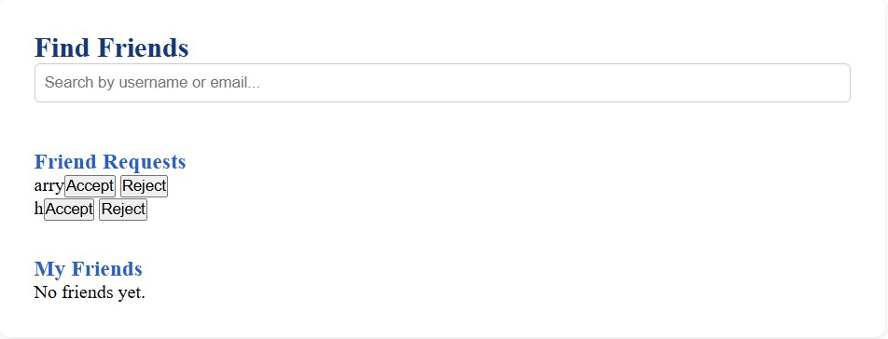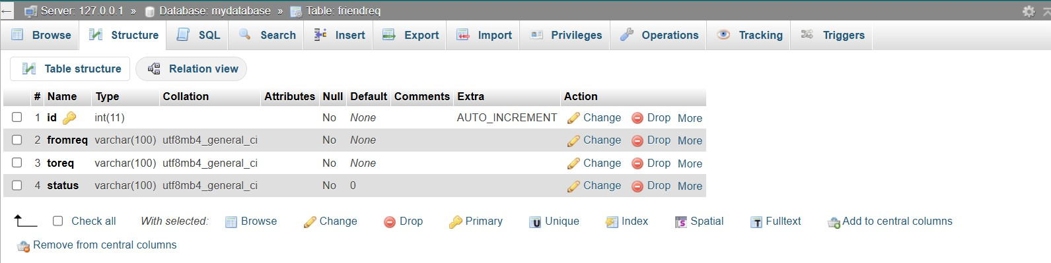

1. **LEARNING OUTCOMES:-**

* **Understanding AJAX Fundamentals**
* **Asynchronous Communication with PHP**
* **Frontend Interaction Using JavaScript**
* **Database Design for User Relationships**
* **Dynamic UI Updates Without Reload**
* **Request Handling Logic in PHP**
* **Status Management (Sent, Accepted, Rejected)**
* **Using JSON for Data Exchange**
* **Security and Validation Checks**