# Assignment 5

**Student Name:** Himanshu Gupta **UID:** 23BCS10889

**Branch:** BE CSE **Section/Group:** Web Program.

**Semester:** 5th

1. **Aim:-**  **Chat and Posting**
2. **CODE:**

**posts.php**

<?php

include 'header.php'; include 'config.php';

?>

<style>

.container { max-width: 700px; margin: auto; }

.post-box { background: #fff; padding: 20px; border-radius: 10px; box-shadow: 0 2px 8px rgba(0,0,0,0.1); margin-bottom: 20px; }

.post-box textarea { width: 100%; padding: 10px; border: 1px solid #ccc; border-radius: 6px; min-height: 80px; margin-bottom: 10px; }

.post-box button { float: right; padding: 8px 20px; background: #2660c5; color: #fff; border: none; border-radius: 6px; cursor: pointer; }

.post-feed { margin-top: 20px; }

.post-item { background: #fff; padding: 20px; border-radius: 10px; box-shadow: 0 2px 8px rgba(0,0,0,0.1); margin-bottom: 15px; }

.post-header { display: flex; align-items: center; margin-bottom: 15px; }

.post-header img { width: 45px; height: 45px; border-radius: 50%; object-fit: cover; margin- right: 15px; }

.post-header-info span { font-weight: bold; }

.post-header-info small { color: #888; }

.pagination { text-align: center; margin-top: 20px; }

.pagination a, .pagination span { margin: 0 5px; padding: 8px 12px; text-decoration: none; color: #2660c5; background: #f4f4f4; border-radius: 5px; }

.pagination span { background: #2660c5; color: #fff; }

</style>

<div class="container">

<div class="post-box">

<h3>Create a Post</h3>

<textarea id="postContent" placeholder="What's on your mind?"></textarea>

<button id="createPostBtn">Post</button>

</div>

<div class="post-feed" id="postFeed">

<!-- Posts will be loaded here -->

</div>

<div class="pagination" id="pagination">

<!-- Pagination links will be loaded here -->

</div>

</div>

<script src="https://ajax.googleapis.com/ajax/libs/jquery/3.7.1/jquery.min.js"></script>

<script>

function loadPosts(page = 1) {

$.post('posts_ajax.php', { action: 'get_posts', page: page }, function(data) { const res = JSON.parse(data);

$('#postFeed').html(res.posts);

$('#pagination').html(res.pagination);

});

}

$('#createPostBtn').on('click', function() {

const content = $('#postContent').val(); if (content.trim() === '') return;

$.post('posts_ajax.php', { action: 'create_post', content: content }, function() {

$('#postContent').val(''); loadPosts(); // Refresh feed

});

});

$(document).on('click', '.pagination a', function(e) { e.preventDefault();

const page = $(this).data('page'); loadPosts(page);

});

loadPosts();

</script>

**Posts_ajax.php**

<?php

include 'config.php'; session_start();

$userid = $_SESSION['userid'];

$action = isset($_POST['action']) ? $_POST['action'] : ''; if ($action == 'create_post') {

$content = mysqli_real_escape_string($con, $_POST['content']);

mysqli_query($con, "INSERT INTO userpost (content, userid) VALUES ('$content', '$userid')");

exit;

}

if ($action == 'get_posts') {

$limit = 5; // Posts per page

$page = isset($_POST['page']) ? intval($_POST['page']) : 1;

$start = ($page - 1) * $limit;

$total_res = mysqli_query($con, "SELECT COUNT(*) as total FROM userpost");

$total_row = mysqli_fetch_assoc($total_res);

$total_posts = $total_row['total'];

$total_pages = ceil($total_posts / $limit);

$posts_html = '';

$res = mysqli_query($con, "SELECT p.*, u.username, u.userpic FROM userpost p JOIN txt92849x99x_userinfo u ON p.userid=u.id ORDER BY p.id DESC LIMIT $start, $limit");

while ($row = mysqli_fetch_assoc($res)) {

$posts_html .= '<div class="post-item">

<div class="post-header">

<img src="pic/' . htmlspecialchars($row['userpic']) . '">

<div class="post-header-info">

<span>' . htmlspecialchars($row['username']) . '</span><br>

<small>' . date('F j, Y, g:i a', strtotime($row['curtime'])) . '</small>

</div>

</div>

<p>' . nl2br(htmlspecialchars($row['content'])) . '</p>

</div>';

}

$pagination_html = '';

for ($i = 1; $i <= $total_pages; $i++) { if ($i == $page) {

$pagination_html .= '<span>' . $i . '</span>';

} else {

$pagination_html .= '<a href="#" data-page="' . $i . '">' . $i . '</a>';

}

}

echo json_encode(['posts' => $posts_html, 'pagination' => $pagination_html]); exit;

}

**Chat.php**

<?php

include 'header.php'; include 'config.php';

?>

<style>

.chat-container { display: flex; max-width: 900px; margin: auto; background: #fff; border- radius: 10px; box-shadow: 0 2px 8px rgba(0,0,0,0.1); height: calc(100vh - 120px); }

.friends-list { width: 30%; border-right: 1px solid #eee; padding: 20px; overflow-y: auto; }

.friends-list h3 { color: #15387a; margin-top: 0; }

.friend-item { display: flex; align-items: center; padding: 10px; cursor: pointer; border-radius: 8px; }

.friend-item:hover, .friend-item.active { background: #f4f4f4; }

.friend-item img { width: 40px; height: 40px; border-radius: 50%; object-fit: cover; margin- right: 10px; }

.chat-window { width: 70%; display: flex; flex-direction: column; }

.chat-header { padding: 20px; border-bottom: 1px solid #eee; }

.messages { flex-grow: 1; padding: 20px; overflow-y: auto; display: flex; flex-direction: column-reverse; }

.message-input { padding: 20px; border-top: 1px solid #eee; }

.message-input input { width: calc(100% - 80px); padding: 10px; border: 1px solid #ccc; border-radius: 6px; }

.message-input button { width: 70px; padding: 10px; background: #2660c5; color: #fff; border: none; border-radius: 6px; cursor: pointer; }

.message { margin-bottom: 15px; max-width: 70%; }

.message.sent { align-self: flex-end; background: #2660c5; color: #fff; padding: 10px; border-radius: 10px 10px 0 10px; }

.message.received { align-self: flex-start; background: #e9e9eb; color: #000; padding: 10px; border-radius: 10px 10px 10px 0; }

</style>

<div class="chat-container">

<div class="friends-list" id="friendsList">

<h3>Friends</h3>

<!-- Friends will be loaded here by AJAX -->

</div>

<div class="chat-window">

<div class="chat-header" id="chatHeader">Select a friend to start chatting</div>

<div class="messages" id="messages"></div>

<div class="message-input" id="messageInput" style="display:none;">

<input type="text" id="messageText" placeholder="Type a message...">

<button id="sendBtn">Send</button>

</div>

</div>

</div>

<script src="https://ajax.googleapis.com/ajax/libs/jquery/3.7.1/jquery.min.js"></script>

<script>

let activeChatUser = null; function loadFriends() {

$('#friendsList').html('<h3>Friends</h3>' + data);

});

}

function loadMessages() {

if (!activeChatUser) return;

$.post('chat_ajax.php', { action: 'get_messages', touser: activeChatUser }, function(data) {

$('#messages').html(data);

});

}

$(document).on('click', '.friend-item', function() { activeChatUser = $(this).data('userid');

$('.friend-item').removeClass('active');

$(this).addClass('active');

$('#chatHeader').text('Chat with ' + $(this).find('span').text());

$('#messageInput').show(); loadMessages();

});

$('#sendBtn').on('click', function() { const msg = $('#messageText').val();

if (msg.trim() === '' || !activeChatUser) return;

$.post('chat_ajax.php', { action: 'send_message', touser: activeChatUser, msg: msg }, function() {

$('#messageText').val(''); loadMessages();

});

});

setInterval(loadMessages, 3000); // Poll for new messages every 3 seconds loadFriends();

</script

**Chat_ajax.php**

<?php

include 'config.php'; session_start();

$userid = $_SESSION['userid'];

$action = isset($_POST['action']) ? $_POST['action'] : '';

if ($action == 'get_friends') {

$friends = mysqli_query($con, "SELECT u.id, u.username, u.userpic FROM txt92849x99x_userinfo u JOIN friendreq f ON ((f.fromreq=u.id AND f.toreq='$userid') OR (f.toreq=u.id AND f.fromreq='$userid')) WHERE f.status=1 AND u.id!='$userid'");

if(mysqli_num_rows($friends)==0) {

echo '<div>No friends to chat with.</div>';

} else {

while($f = mysqli_fetch_assoc($friends)) {

echo '<div class="friend-item" data-userid="' . $f['id'] . '">

<img src="pic/' . htmlspecialchars($f['userpic']) . '">

<span>' . htmlspecialchars($f['username']) . '</span>

</div>';

}

}

exit;

}

if ($action == 'get_messages') {

$touser = intval($_POST['touser']);

$res = mysqli_query($con, "SELECT * FROM messege WHERE (fromuser='$userid' AND touser='$touser') OR (fromuser='$touser' AND touser='$userid') ORDER BY timestamp DESC");

while ($row = mysqli_fetch_assoc($res)) {

$class = $row['fromuser'] == $userid ? 'sent' : 'received';

echo '<div class="message ' . $class . '">' . htmlspecialchars($row['msg']) . '</div>';

}

exit;

}

if ($action == 'send_message') {

$touser = intval($_POST['touser']);

$msg = mysqli_real_escape_string($con, $_POST['msg']);

mysqli_query($con, "INSERT INTO messege (fromuser, touser, msg) VALUES ('$userid', '$touser', '$msg')");

exit;

}

1. **OUTPUT**

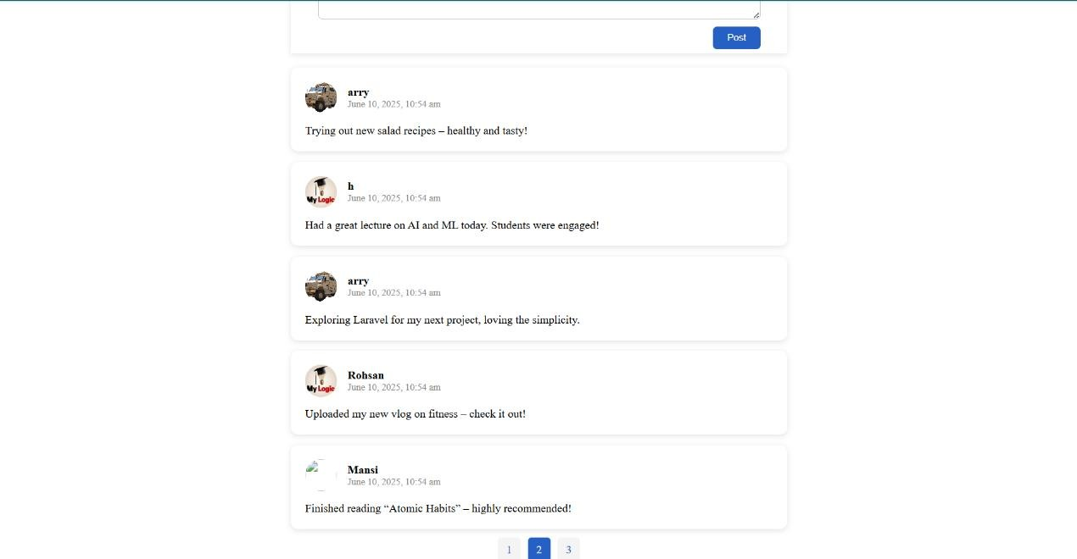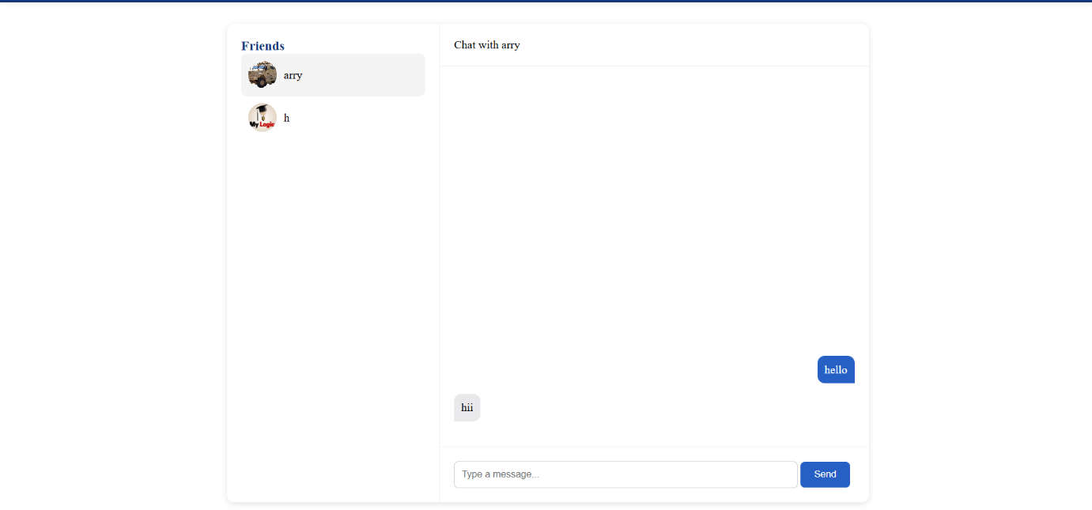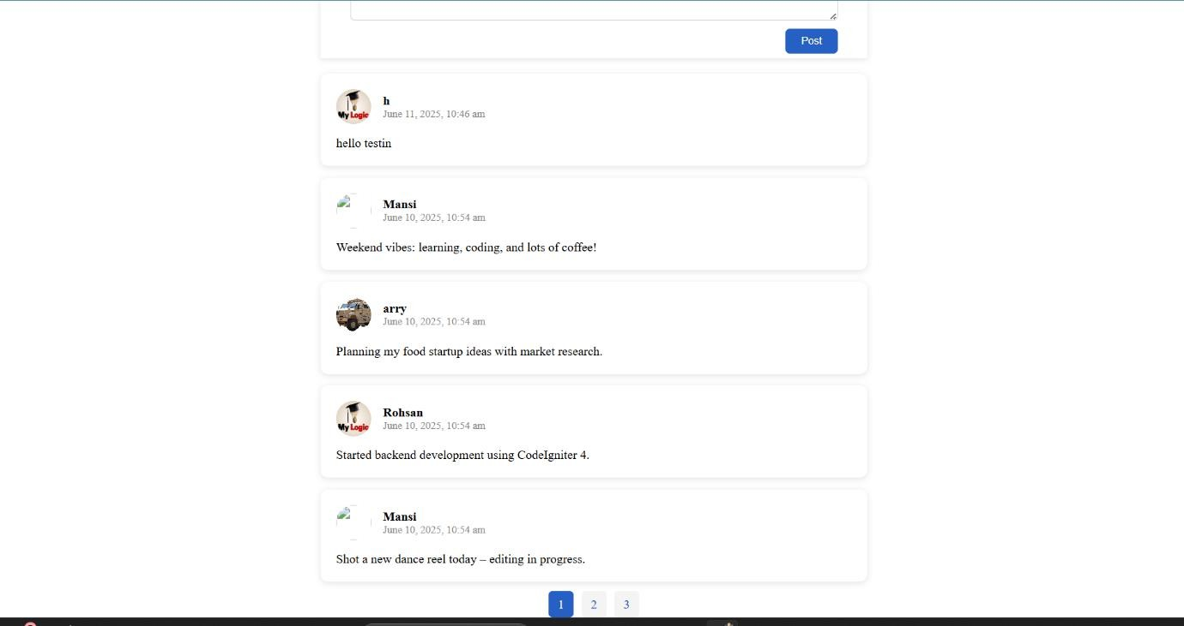

1. **LEARNING OUTCOMES:-**

* **Real-Time Communication Concepts**
* **Frontend Message Interface Design**
* **Asynchronous Data Handling with AJAX**
* **Message Storage and Retrieval using PHP & MySQL**
* **Database Structure for Conversations**
* **User Authentication and Session Handling**
* **Dynamic Message Rendering with JavaScript**
* **Polling vs WebSocket (Basic Comparison)**
* **Input Sanitization and Security**
* **Improving UX with Instant Feedback and Auto-Scroll**