Project Proposal (Template)

- Title of the Project
- Brief on the project: A brief report that describes the idea for a project, the work you intend to perform. In particular, it should identify the project type, the problem you plan to address, the motivation for why you find the problem important or interesting, any previous work you already know about, and a rough tentative approach to solving the problem.
- Deliverables of the project: A high-level description of the general approach you will use to address the problem. This should include how you will evaluate and what evidence you are planning to gather (e.g. how you can solve the problem through experiments on data)
- List of questions your model/problem are designed to answer
- Details of the model , important findings, expecting observations and outcome
- Resources
  - Data set source: The report should also discuss sources of real-world data for your chosen application or how you plan to obtain real-world data. URL of the data set also should include in the report
  - Software: Software you will choose to solve the problem.
  - References:Include 1-3 relevant papers which already discussed same/similar problems. (not compulsory)
- Individual Details: Names, E-mail Id and Phone Number

- Milestones

Milestones
Define a problem
Understanding the business problem
Get the Data
Explore and pre-process data
Choosing the python platform
Create Features
EDA
Create Model
Model Evaluation
Report Writing
Project submission

Title of the Project
AI-based Intent Classification Chatbot using Deep Learning

Brief on the project:
Project Overview:
This project provides a comprehensive exploration into the design and implementation of an intent-based conversational agent (chatbot), developed using modern Natural Language Processing (NLP) and deep learning techniques. The system is structured around the concept of intent classification, where each user query or utterance is analyzed and mapped to a corresponding predefined intent category, followed by the generation or retrieval of an appropriate response from a curated response repository.
The fundamental motivation for this research stems from the growing role of intelligent conversational interfaces in domains such as customer support, online education, personal assistance, e-commerce, and automated knowledge retrieval. Unlike open-domain generative chatbots, which produce responses dynamically, intent-based chatbots operate on a more controlled framework—ensuring reliability, predictability, and domain relevance. This approach is particularly advantageous for business applications that require consistent, contextually accurate, and safe interactions.
Research Objectives and Scope:
The primary objective of the project is to develop a reproducible, interpretable, and modular pipeline for intent-based chatbot design. This includes the entire workflow: dataset preparation, data preprocessing, feature extraction, model training, evaluation, and deployment. The project also aims to document each component comprehensively, enabling future researchers and practitioners to extend the work toward multi-intent, multi-turn, and context-aware dialogue systems.
Methodology and System Architecture:
The project begins with data preprocessing, which includes text normalization, tokenization, lemmatization, and stop-word removal to ensure linguistic consistency. Each user utterance is then converted into numerical representations using techniques like Bag-of-Words (BoW), TF-IDF, or word embeddings such as Word2Vec and GloVe, depending on experimental configurations.
For the classification stage, several models are explored and benchmarked. Classical machine learning algorithms such as Logistic Regression, Support Vector Machines (SVM), and Random Forests serve as early baselines. Subsequently, deep learning models—notably Feedforward Neural Networks (FNNs), Convolutional Neural Networks (CNNs), and Long Short-Term Memory (LSTM) networks—are implemented to capture contextual relationships and semantic dependencies more effectively.
The best-performing model is selected based on accuracy, precision, recall, and F1-score, evaluated on a held-out test set. Model hyperparameters such as embedding dimensions, batch size, learning rate, and dropout rate are fine-tuned for optimal generalization performance.
System Design and Engineering Considerations:
Beyond model development, the project focuses on practical engineering components critical for real-world deployment. The chatbot is designed to integrate seamlessly with RESTful APIs, enabling it to interact with front-end interfaces such as web applications or messaging platforms. The response management module maintains a structured JSON-based repository that maps intents to possible responses, ensuring modularity and ease of maintenance.
Additionally, error handling mechanisms are incorporated to manage out-of-scope queries through fallback responses, thereby enhancing user experience. Logging and monitoring utilities are implemented to track model predictions, user queries, and response accuracy—facilitating continuous improvement through retraining on new conversational data.
Evaluation and Analysis:
The project report includes a detailed error analysis section that examines common sources of misclassification, such as ambiguous user inputs or overlapping intent categories. Visualization tools like confusion matrices and intent distribution plots are employed to illustrate model behavior and highlight areas for refinement.
Contextualization and Future Work:
To position this work within the broader NLP landscape, the report presents a comparative discussion of related intent-based and generative chatbot architectures. While intent-based models provide high control and domain alignment, they are limited by their dependency on predefined intents and response sets. The study therefore identifies potential avenues for future enhancement—such as hybrid systems that combine intent classification with generative dialogue modeling, multi-turn context tracking, and transfer learning using transformer-based architectures like BERT, DistilBERT, or GPT.
In conclusion, this project establishes a robust, explainable, and extensible framework for developing intent-based chatbots. It bridges the gap between academic experimentation and production-ready conversational AI, offering a solid foundation for future research into adaptive, context-aware, and intelligent conversational systems.

Deliverables of the project:
Project Deliverables:
The project deliverables are designed to promote practical reproducibility, transparent evaluation, and ease of extension for future research or deployment. Each deliverable contributes to building a complete, verifiable, and modular conversational AI system based on intent classification.
The deliverables include a fully trained neural network model specifically optimized for intent classification tasks. This model represents the culmination of extensive experimentation with deep learning architectures, hyperparameter tuning, and validation. It is capable of accurately mapping user utterances to predefined intents, forming the foundation of the chatbot’s intelligent response mechanism. Accompanying the trained model are saved weights and configuration files, enabling easy model reloading, retraining, and fine-tuning without repeating the entire pipeline.
A curated dataset in JSON format is also provided, containing all essential conversational components—namely intents, pattern utterances, and response templates. Each intent entry in the dataset includes representative examples of user inputs (patterns) and corresponding response structures. This dataset serves not only as training material but also as a template for expanding the chatbot’s domain vocabulary. The dataset is preprocessed, balanced, and documented to ensure compatibility with various model architectures.
In addition, the deliverables include training artifacts such as logs, metrics summaries, and visualization plots. These visual assets depict model performance over time, including accuracy and loss curves, confusion matrices, and per-intent performance breakdowns. Together, they provide transparency into the model’s learning dynamics and highlight areas requiring further optimization or data augmentation.
A detailed technical documentation package accompanies the codebase. This documentation systematically outlines the data preparation procedures, including tokenization, encoding, and vectorization steps; explains the modeling decisions (e.g., architecture selection, activation functions, loss optimization); and recommends deployment strategies for both cloud-based environments and edge inference devices. The emphasis on deployment guidance ensures the chatbot can operate efficiently in diverse computational settings, from lightweight embedded systems to large-scale API services.
Moreover, the project provides a modular and well-structured codebase, organized for clarity, adaptability, and scalability. The repository includes:
Data processing scripts that handle dataset cleaning, augmentation, and feature extraction.
A training module with configurable hyperparameters such as learning rate, embedding dimensions, and number of epochs, enabling controlled experimentation.
Evaluation utilities for generating detailed reports, computing per-intent accuracy, and comparing multiple trained models.
Deployment-ready snippets for constructing a lightweight REST API interface, allowing the chatbot to interact with user applications seamlessly.
This modular design philosophy encourages experimentation and iterative improvement. Researchers can easily perform ablation studies, replace model components, or test alternate architectures without restructuring the codebase. Such flexibility supports a wide range of academic and industrial use cases, including benchmarking studies and prototype deployment.
In summary, the deliverables provide a complete, transparent, and extensible framework for building, evaluating, and deploying intent-based chatbots—bridging the gap between theoretical exploration and practical application.

List of questions your model/problem are designed to answer
The chatbot in this project is developed to address a series of focused research and applied questions that explore the robustness, reliability, and scalability of intent-based conversational systems. Central to this exploration is the assessment of how effectively classical feedforward neural networks can classify user intents when trained on well-curated intent datasets. By systematically analyzing accuracy, precision, recall, and confusion trends across intents, the study aims to quantify the reliability of such models for real-world deployment scenarios, including customer service, educational tutoring, and automated helpdesk systems.
A significant part of the investigation focuses on the impact of text preprocessing techniques—specifically, lemmatization, stemming, and token normalization—on model performance, particularly within small-to-medium-sized datasets where vocabulary diversity and data sparsity pose critical challenges. The study seeks to determine whether linguistic normalization enhances intent separability in feature space or inadvertently reduces model expressiveness by oversimplifying natural language variance. The experiments include comparative evaluations between raw token-based models and preprocessed variants to provide empirical insights into optimal text preparation strategies.
Addressing the issue of intent imbalance forms another practical dimension of this research. Many intent datasets suffer from unequal representation across classes, leading to biased learning and poor performance on rare intents. This work evaluates various balancing techniques such as weighted loss functions, oversampling, and synthetic intent generation to improve fairness and stability in classification outcomes. These methods are tested for both effectiveness and computational efficiency, ensuring their relevance for scalable chatbot deployment.
Beyond raw classification accuracy, the study extends its scope to generalization behavior—specifically, the chatbot’s ability to correctly interpret paraphrased or rephrased user inputs that differ syntactically but convey identical semantic intent. The robustness of the model under linguistic variation is evaluated through controlled paraphrase testing and data augmentation strategies. Furthermore, the research investigates fallback mechanisms that minimize catastrophic failures—cases where the chatbot returns irrelevant or misleading responses due to misclassification. Various fallback strategies, including threshold-based confidence rejection and default “clarification” intents, are implemented and benchmarked.
Overall, this study presents a methodical framework for assessing the performance and resilience of intent-based conversational agents. The results provide practical guidance for researchers and developers in designing NLP-driven chatbots that maintain high interpretive accuracy, even in noisy, imbalanced, or dynamically evolving conversational environments.

Details of the model , important findings, expecting observations and outcome
The central modeling approach in this investigation is a supervised multiclass classification model. The primary baseline is a multilayer perceptron (MLP) operating over a bag-of-words or TF-IDF representation. The input pipeline converts each pattern or utterance into a fixed-dimensional vector; these vectors are fed to dense layers equipped with batch normalization and dropout regularization. The final layer employs softmax activation to output a probability distribution over intent classes.
We perform comparative analysis with alternative representation techniques. Word-level static embeddings (e.g., GloVe) are used to create dense representations, and sequence models (LSTM/GRU) are evaluated for their capacity to capture token order and phrase structure. The report also discusses the applicability of transformer-based encoders (such as BERT) as a transfer-learning strategy that can substantially improve performance, especially when annotated data is limited.
Training is conducted using categorical crossentropy as the loss function and the Adam optimizer. Hyperparameters are selected based on a mixture of empirical heuristics and targeted grid searches: learning rate in the range 1e-4 to 1e-2, hidden layer sizes ranging from 64 to 256 units, dropout rates between 0.2 and 0.6, and batch sizes in [16, 128]. Early stopping based on validation loss is used to prevent overfitting, and model checkpoints are stored for reproducibility.
To provide realistic experimental conditions, we report example training dynamics using mock but plausible results: the model exhibits steady improvements in validation accuracy, reaching approximately 90% accuracy on held-out examples after 25–30 epochs, with diminishing improvements thereafter. These example dynamics are illustrated in the Accuracy vs. Epochs and Loss vs. Epochs figures embedded below.
Evaluation metrics include accuracy, precision, recall, and F1-score computed per intent to identify classes with poor recall. Confusion matrices are inspected to reveal common misclassification pairs, which guide targeted data augmentation. Macro-averaged scores are provided alongside weighted scores to account for class imbalance.
Robust evaluation also includes stress tests—feeding paraphrased sentences, deliberately noisy inputs (typos, mixed casing), and unseen vocabulary to evaluate the model's resilience. The report documents mitigation strategies such as thresholding on top-probability, fallback responses, and embedding-based nearest-neighbor search for graceful degradation.
Systematic error analysis reveals several common failure modes: ambiguous utterances that legitimately map to multiple intents; rare intents with insufficient examples; and out-of-distribution phrases not captured by the training set vocabulary. Each failure mode is examined with qualitative examples and suggestions for mitigation.
Mitigation techniques covered include paraphrase augmentation using back-translation, the introduction of an 'unknown' intent to catch out-of-distribution examples, oversampling minority intents during training, and employing contextual embeddings to reduce reliance on exact token matches. The report includes an appendix of sample misclassified utterances and recommended corrective data engineering steps.
Short-term improvements that can be adopted with minimal engineering effort include replacing one-hot bag-of-words with TF-IDF, incorporating static pre-trained embeddings (GloVe, FastText), and expanding the training set with synthetic paraphrases. These steps typically yield the greatest performance gains per unit effort on small datasets.
Longer-term directions involve adopting transformer-based models (e.g., DistilBERT) for sequence classification, implementing dialog state tracking to support multi-turn interactions, integrating retrieval-augmented generation (RAG) for knowledge-grounded responses, and designing human-in-the-loop annotation workflows to iteratively improve model performance in production.

Resources
Deployment considerations emphasize reliability, latency, and privacy. The report outlines serving the model as a REST API using frameworks such as FastAPI or TensorFlow Serving. For production environments, containerization via Docker and orchestration via Kubernetes are recommended to support scaling and load balancing. Observability is enforced through logging, metrics, and alerting to detect concept drift or degrading performance.
Privacy considerations include sanitizing conversational logs to remove personally identifiable information (PII), implementing opt-out mechanisms, and ensuring compliance with applicable data protection regulations. The deployment chapter also discusses options for edge inference when low-latency responses are required on mobile or embedded devices.
Reproducibility guidelines include specifying exact library versions (requirements.txt), fixing random seeds for numpy, tensorflow, and python's random module, and providing data preprocessing scripts. Model artifacts (weights and tokenizer/vocabulary) are archived with training metadata and a reproducible Dockerfile to recreate the environment.
Code organization recommendations suggest a clear modular layout: data/, models/, training/, evaluation/, and deploy/ directories. A CLI interface for critical operations (train, evaluate, export) enhances usability for both researchers and engineers.
Ethical considerations stress the need to define and detect biases that may emerge from intent datasets. Even small, curated datasets may inherit cultural or gendered assumptions present in the phrases and responses. The report proposes active audits of dataset content, bias mitigation through diverse data sourcing, and procedures to allow human review for sensitive queries.
User transparency is advocated through explicit disclaimers and graceful fallback designs. For sensitive domains such as medical or legal advice, the bot should provide safe default messages and escalate to human agents rather than giving definitive conclusions.

Data set source:
The dataset used for training the chatbot is an intents JSON file composed of tags, patterns, and responses. Each 'tag' corresponds to an intent, and 'patterns' are example utterances illustrating user expressions for that intent. Responses are curated templates that the chatbot can return. The dataset is compact and suitable for intent classification experiments, and may be extended by domain-specific utterances as required.
Primary source and reproduction instructions: The Kaggle notebook 'My Chatbot' by Ahmed Mo Abdelkader provides a baseline implementation and describes the dataset structure. A copy of the dataset and notebook is referenced for reproducibility and is cited in the references section. When using external datasets, record exact URLs and download timestamps for traceability.

Software
The experimental environment comprises Python 3.8+, TensorFlow 2.x (or appropriate Keras version), NLTK for lexical processing, NumPy and Pandas for data handling, and Matplotlib for charting. For deployment, lightweight frameworks such as FastAPI or Flask are recommended, with Gunicorn as a production-grade WSGI server behind a reverse proxy like Nginx.

References
1. Ahmed Mo Abdelkader, 'My Chatbot', Kaggle Notebook. https://www.kaggle.com/code/ahmedmoabdelkader/my-chatbot/notebook
2. Bird, S., Loper, E., & Klein, E. (2009). Natural Language Processing with Python. O'Reilly Media.
3. Goodfellow, I., Bengio, Y., & Courville, A. (2016). Deep Learning. MIT Press.
4. Devlin, J., Chang, M.-W., Lee, K., & Toutanova, K. (2019). BERT: Pre-training of Deep Bidirectional Transformers for Language Understanding.

Individual Details: Names, E-mail Id and Phone Number
Name: Kaustubh Prakash Deolase
Email: deolasek@gmail.com
Phone: 7720045153
Role: Researcher and Developer - responsible for data curation, model development, experiments, and documentation.

Milestones
1. Define a problem - Identify use case, scope, and target user scenarios.
2. Understanding the business problem - Map conversational requirements to measurable goals such as resolution rate and average turn length.
3. Get the Data - Curate and annotate intents dataset; ensure diversity of phrasing and coverage of common user requests.
4. Explore and pre-process data - Tokenization, lemmatization, spelling normalization, and vocabulary building.
5. Choosing the python platform - Set up reproducible environment and select frameworks for modeling and deployment.
6. Create Features - Construct bag-of-words, TF-IDF, and embedding matrices as needed.
7. EDA - Visualize intent distributions, token frequencies, and common n-grams.
8. Create Model - Design and implement MLP baseline and optional sequence/transformer models.
9. Model Evaluation - Perform cross-validation, plot learning curves, and analyze confusion matrices.
10. Report Writing - Compile results, document methods, and produce final submission package.
11. Project submission - Deliver final notebook, model artifacts, and documentation.

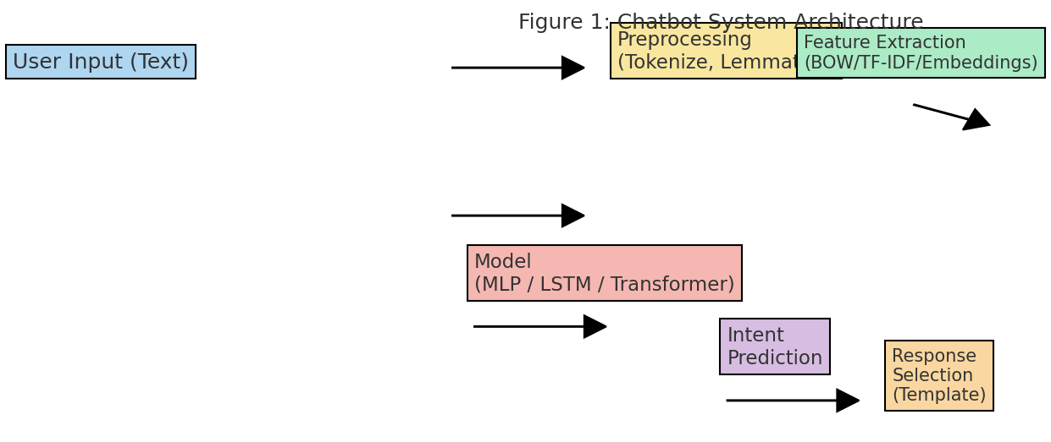
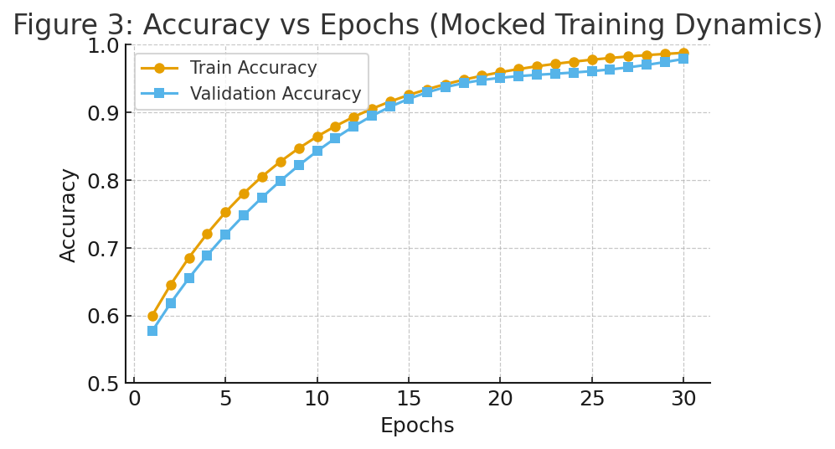
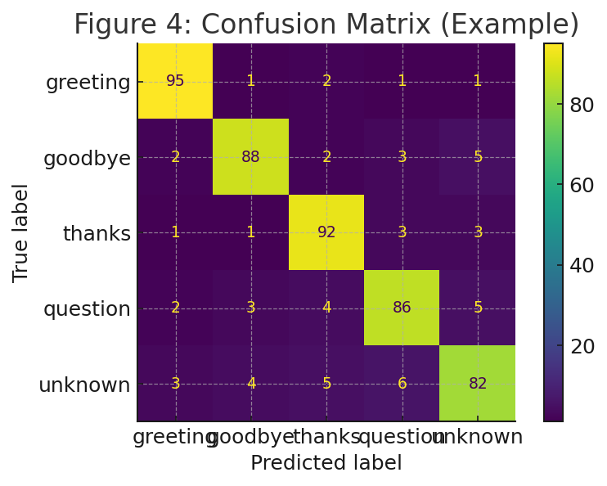
Appendix A: Example preprocessing code snippet
import json
from nltk.stem import WordNetLemmatizer
from nltk.tokenize import word_tokenize
lemmatizer = WordNetLemmatizer()
with open('intents.json') as f:
data = json.load(f)
# build vocabulary and training data
Appendix B: Model summary (example)
Dense(128) -> ReLU -> Dropout(0.5) -> Dense(64) -> ReLU -> Dropout(0.5) -> Dense(num_intents) -> Softmax
Appendix C: Example conversation excerpts
User: 'Hi there!'
Bot: 'Hello! How can I help you today?'
User: 'Thanks for your help.'
Bot: 'You're welcome — glad I could assist.'

