FEST REALM
Project Design &
Implementation Handoff
A concise briefing for the team: current progress, visual direction, implementation approach, and the next delivery steps.
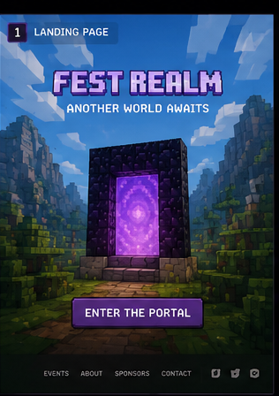
Provided visual reference — landing screen / portal entry
PROJECT STATE  Phases 0–5 built | CORE IDEA  Voxel-styled fest portal | NEXT MILESTONE  Supabase + organizer tools
Prepared from the current codebase and supplied design screens · 26 July 2026

1. Where the project is today
The product is an interactive prototype, not just a visual concept.
Team takeaway: the end-to-end participant experience, the 3D/2D event world, and a repository-based data model are in place. The work now moves from a self-contained demo to production-ready content, backend security, and organizer operations.
Built and reviewable
- Portal-led visitor journey: landing → entering animation → sign-in/sign-up → character creation → travelling transition → world.
- Public festival pages: events, event detail, schedule, sponsors, and leaderboard; protected participant areas include dashboard, inventory, team, achievements, notifications, profile, and settings.
- A walkable voxel village plus equal Map and List views. Desktop-capable browsers can use 3D; phones and assistive paths retain practical alternatives.
- Local data system for profiles, events, registrations, teams, XP, achievements, and attendance. Its repository interface is deliberately ready to swap to Supabase.
- Motion and accessibility foundations: GSAP for cinematic timelines, Framer Motion for UI elements, a reduced-motion path, responsive layouts, labelled controls, and a mobile tab bar.
Current implementation status
Area | What exists now | Production follow-up
Experience | Portal, auth, character, world, dashboard and public routes implemented. | Run a full team QA pass with real event copy.
World | 3D village, 2D interactive map and list access all describe the same locations. | Finish art pass and test on target devices.
Data | localStorage repository with idempotent XP, registration/waitlist and achievement rules. | Replace with Supabase before trusted attendance or roles.
Art | Manifest-based placeholders maintain the intended image dimensions and avoid layout shifts. | Deliver original production art into public/art/**.
Important scope note: localStorage is appropriate for the prototype but is not a security boundary. Do not use it for trusted QR attendance, prizes, or live organizer permissions.

2. Intended participant experience
The supplied screen set maps to an implementation already represented in the route structure.
The design tells a clear story: enter a special realm, create an identity, then discover the festival as a world. The portal is a navigation device, not a decorative splash screen; it gives the product a memorable opening and hides route/data preparation behind a purposeful transition.
  1. Landing — establish the Fest Realm premise. | 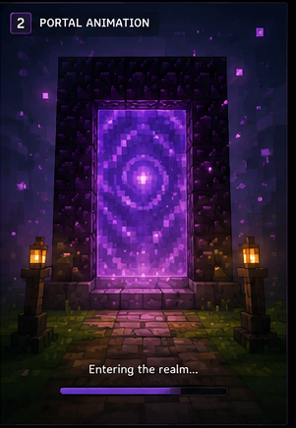  2. Entering — portal animation provides a loading bridge. | 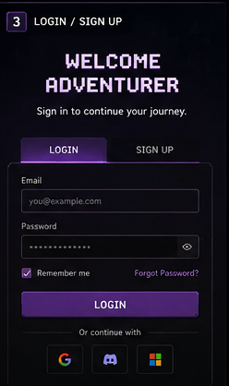  3. Login / signup — a focused, game-like form.
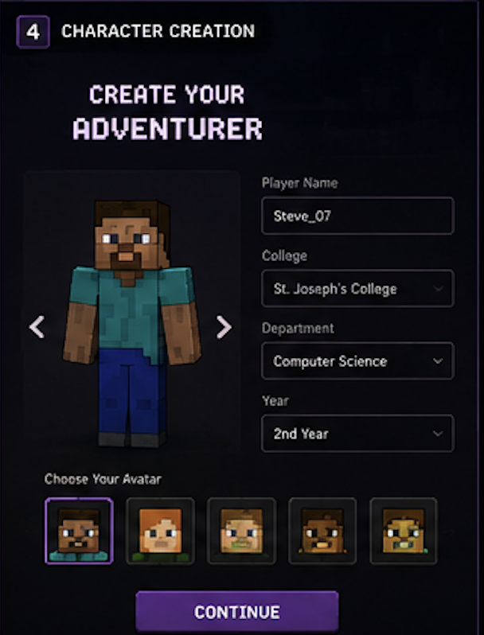  4. Create character — player name, college and avatar. | 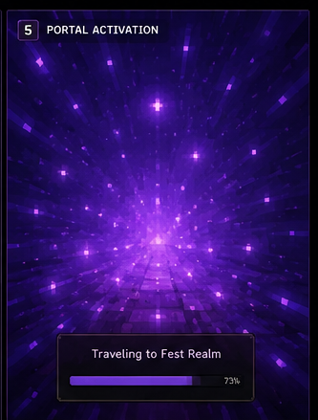  5. Travelling — transition to the festival space. | 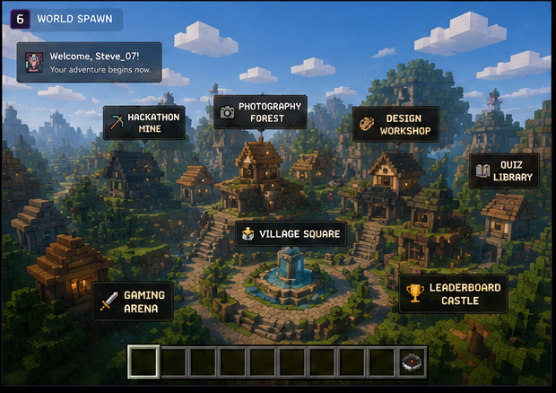  6. World spawn — event categories become places to explore.
What makes this feel coherent
- One stable motif: deep-violet portal energy carries the visitor from landing through authentication and into the world.
- The world is informational as well as atmospheric: each landmark maps to an event category, so a visitor can enter through their interest rather than a generic navigation menu.
- Progression is visible through avatar, XP, registrations, achievement slots and the inventory metaphor, giving repeat attendance a rewarding loop.

3. Visual language and responsive UI
Use the blocky aesthetic as a consistent interaction system, while keeping every asset and character original.
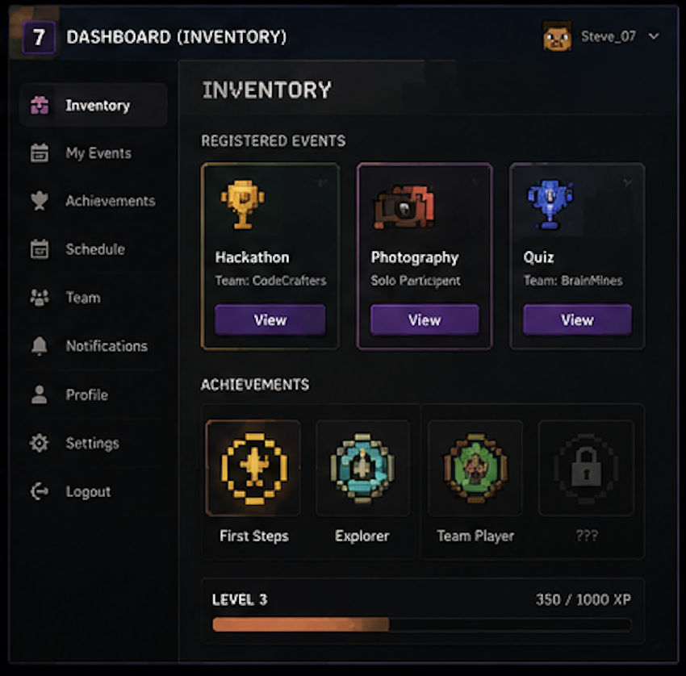  Desktop inventory/dashboard reference | 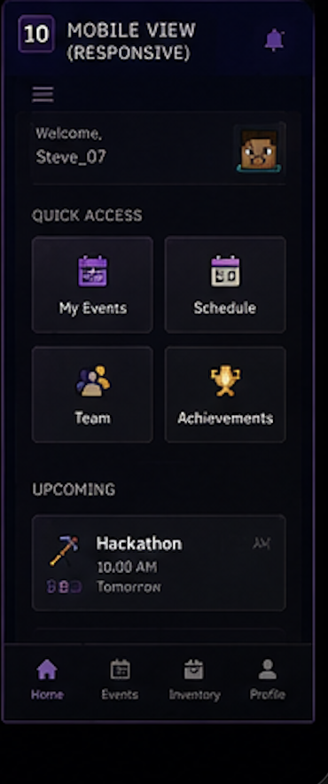  Mobile quick-access reference
Design decisions to carry into every screen
Surfaces | Near-black panels, inset slots, hard borders and bevel highlights make controls feel tactile without needing copied game UI art.
Accent system | Portal violet is the primary action/transition colour; emerald, gold, cyan and red communicate states, rarity and event categories.
Type | Pixel display type is reserved for headings and micro-labels; readable body copy supports forms, schedules and longer event information.
Responsive pattern | Desktop uses side navigation and multi-column cards. Mobile prioritises a tab bar, quick actions and a single-column task-focused flow.
Asset policy | Original voxel-inspired art only. Avoid game logos, fonts, characters, skins, textures and trademark terms from other games.
Implementation reference: the Tailwind v4 tokens are centralised in src/app/globals.css, while reusable components such as BlockButton, BlockPanel, BlockInput, Hotbar, PixelAvatar and Signpost prevent style drift.

4. How the website is implemented
The architecture is intentionally modular so visual work, interaction work and backend work can advance without a rewrite.
Layer | Current implementation | Why it matters
Routes & screens | Next.js 16 App Router separates portal, auth, public and signed-in route groups. | The visitor journey stays understandable and routes can be protected later without redesigning screens.
UI system | React 19 + TypeScript, Tailwind v4 design tokens, Radix dialog primitives and reusable voxel-style components. | A single component vocabulary gives every team member a safe, repeatable way to build new pages.
Motion | GSAP owns portal/cinematic timelines; Framer Motion handles component-level transitions. Reduced motion is supported in code and settings. | Motion adds atmosphere while remaining optional and accessible.
World | React Three Fiber/three.js renders a generated walkable village; Map and List expose the same event locations. | 3D is a differentiator, but no visitor is blocked by device capability or motion preference.
Data seam | All screens use an async Repository interface; LocalRepository currently stores data in localStorage. | Supabase can replace the implementation without rewriting every screen call.
Art delivery | A central asset manifest declares dimensions and serves generated placeholders until files arrive. | Artists can deliver incrementally without layout shift or hard-coded paths.
Practical development approach
- Build each new feature as a route-level screen composed from the shared voxel components; avoid one-off CSS that bypasses the theme tokens.
- Add or refine an event category in the data model, then map it to a world location and a biome scene so public listings, map labels and world markers stay aligned.
- Supply art to the documented public/art/** paths at the declared pixel dimensions. The placeholder system ensures screens do not jump when each asset is replaced.
- Before trusted live operations, connect Supabase Auth/Postgres, move route protection server-side, and enforce roles through database RLS—not through client-side UI checks.

5. Recommended next steps
Sequence the delivery so the team can demo confidently now and harden for a real event later.
Priority | Work to schedule | Definition of done
Now | Content and experience QA: enter real event details, verify the journey on desktop/mobile, and decide the first public event categories. | A shareable internal demo with approved copy and tested flows.
Next | Original art production: portal scenes, five character archetypes, biome layers, sprites, badges and world-map image to the supplied manifest sizes. | Placeholders are replaced incrementally with no visual re-layout.
Before live | Supabase migration: auth, Postgres tables, RLS roles, server route protection and environment configuration. | Cross-device accounts and secure data mutations.
Then | Operational tools: full event CRUD, teams, organizer/admin dashboards, realtime announcements and QR check-in with server-held signing. | A festival operations workflow that can be trusted on event day.
Launch hardening | Accessibility, performance, device testing, load testing, monitoring and a final design consistency review. | A reliable public launch, not just a polished demo.
Team reference links and source material
The following repository documents are the source of truth for implementation decisions.
Project overview | Routes, tech stack, shipped phases, verification notes and roadmap.
3D world | World controls, device fallbacks, performance constraints and extension points.
Art contract | Original-art rules, exact output dimensions, file paths and scene briefs.
Backend plan | Auth, database schema, roles/RLS and the pre-live migration plan.
Motion rules | Ownership of timelines, reduced-motion behaviour and known animation pitfalls.
Visual references used in this handoff are the supplied Fest Realm screen images in assets/Login, assets/Homapage and the two supplied dashboard/mobile UI references. They are direction references; the product must continue using original assets and naming.

