***ENVIRONMENTAL MONITORING USING***

***INTERNET OF THINGS(IoT)***

**TEAM MEMBER**

**712221121006- GEERTHANA.P**

**Phase 5 :Document Submission**

**Project Title:** Environmental Monitoring

**Phase 4:** Project Documentation & Submission

**Topic:** Complete Project submission of Environmental Monitoring using IoT

**Abstract:**

* Environmental monitoring using the Internet of Things (IoT) is a cutting-edge approach that leverages advanced technology to collect, analyze, and manage data related to the natural world. It involves the deployment of sensors, communication networks, and data analytics to continuously assess and understand environmental conditions. This comprehensive and real-time data collection and analysis have a wide range of applications, from tracking air and water quality to monitoring wildlife habitats and climate change. Here is an overall introduction to environmental monitoring using IoT:

1. **IoT and Environmental Monitoring**:

* IoT refers to the network of interconnected devices, sensors, and systems that collect and exchange data over the internet. In the context of environmental monitoring, IoT extends this connectivity to gather data about the natural environment.

1. **Sensor Technology**:

* The foundation of IoT-based environmental monitoring is sensor technology. Sensors are used to detect various environmental parameters, such as temperature, humidity, air quality, water quality, soil conditions, and more. These sensors can be deployed in remote and challenging environments, allowing for comprehensive data collection.

1. **Data Collection**:

* Sensors collect data continuously or at predefined intervals. This data can include measurements like temperature, humidity, pollution levels, water flow, and more. The data is transmitted to a central hub for processing and analysis.

1. **Communication Networks**:

* IoT devices communicate this data through various communication technologies, including Wi-Fi, cellular networks, satellite communication, LoRa (Long Range), and more. The choice of communication method depends on the specific application and its geographic location.

1. **Data Management and Storage**:

* Collected data is stored in cloud-based platforms or local servers for further analysis. Cloud platforms offer scalability, accessibility, and data security. Data is typically structured and organized to make it easier for analysts to derive meaningful insights.

1. **Real-time Monitoring**:

* One of the key advantages of IoT-based environmental monitoring is real-time data collection and monitoring. This allows for immediate responses to changing environmental conditions, which can be crucial for addressing issues like pollution incidents, natural disasters, or wildlife conservation.

1. **Data Analysis**:

* Environmental data is analyzed to identify trends, anomalies, and potential issues. Machine learning and data analytics tools are often used to process large datasets and extract valuable information, such as identifying patterns, predicting future trends, or triggering alerts.

1. **Applications**:
   * **Air Quality Monitoring**: IoT sensors measure pollutants in the air, helping governments and individuals make informed decisions about health and the environment.
   * **Water Quality Monitoring**: Sensors in bodies of water assess factors like pH, dissolved oxygen, and contaminants, supporting clean water management.
   * **Agriculture**: IoT-based systems optimize crop management by monitoring soil conditions, weather, and irrigation needs.
   * **Wildlife Conservation**: Tracking wildlife behavior and habitat conditions using IoT can aid conservation efforts.
   * **Weather Forecasting**: Real-time data from environmental sensors contribute to more accurate weather predictions.
   * **Urban Planning**: IoT-enabled monitoring assists in designing and managing smart cities, improving sustainability and livability.
2. **Challenges and Considerations**:

* Despite its benefits, environmental monitoring using IoT presents challenges such as data security, privacy, power management for remote sensors, data accuracy, and the need for standardized protocols and interoperability.

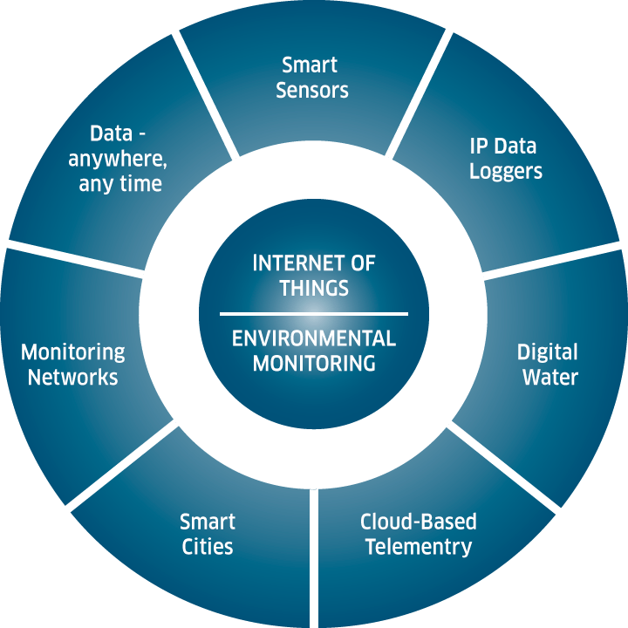

**Content**:

1. **Project Overview**:
   * Briefly introduce the project's goals and objectives.
2. **IoT Sensors and Data Collection**:
   * Discuss the types of environmental sensors used.
   * Explain the data collection process and its frequency.
   * Present the data transmission methods (e.g., Wi-Fi, LoRa, or cellular networks).
3. **Data Preprocessing**:
   * Describe data cleaning and preprocessing techniques.
   * Explain any missing data handling procedures.
4. **Environmental Parameters**:
   * List the environmental parameters under consideration (e.g., temperature, humidity, air quality, etc.).
5. **Data Source**:
   * Describe the source of environmental data (e.g., weather stations, IoT sensors, public APIs).
   * Mention the geographic coverage and update frequency.
6. **Price Prediction Model**:
   * Discuss the machine learning model used for price prediction.
   * Explain the features and variables used in the model.
   * Detail the training and validation process.
7. **Environmental Impact on Prices**:
   * Explore the relationship between environmental parameters and commodity prices.
   * Discuss the potential impact of environmental changes on pricing.
8. **Visualization and Reporting**:
   * Present visualizations of environmental data.
   * Discuss the reporting mechanism for price predictions and environmental insights.
9. **Challenges and Limitations**:
   * Address challenges faced during data collection and modeling.
   * Describe any limitations in the predictive capabilities.

**Data Source**:

The project relies on a combination of data sources, including:

* IoT sensors deployed in strategic locations.
* Publicly available weather data from local and global sources.
* Historical price data from relevant commodities markets.
* Real-time market data for price tracking.

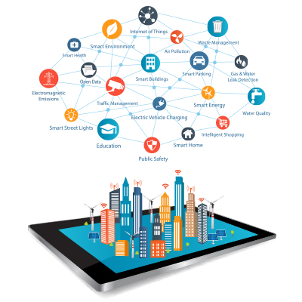

**Predicting Prices**:

Price prediction is a crucial aspect of this project, aiming to forecast the cost of essential commodities based on environmental conditions. This is achieved through a machine learning model that takes into account historical pricing data and real-time environmental parameters to make predictions.

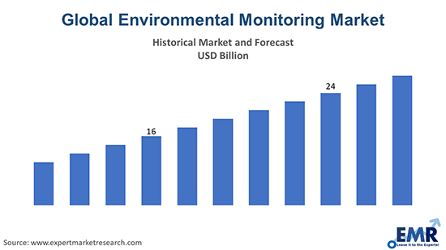

**Loading and Preprocessing Dataset**

1. **Data Collection**:

* Environmental monitoring data can be collected from various sources, such as sensors, weather stations, remote sensing devices, or databases. Ensure you have access to the raw data in a suitable format, which could be CSV, Excel, JSON, or other common formats.

1. **Data Inspection**:

* Before loading the data, it's crucial to inspect it to understand its structure and content. Look for missing values, outliers, and inconsistencies. This step will help you make decisions about data preprocessing.

1. **Data Loading**:

* Use a programming language such as Python or a data analysis tool like R to load the data into your working environment. For example, in Python, you can use libraries like Pandas to read data from CSV files or other formats.

1. **Data Cleaning**:
   * **Handling Missing Values**: Environmental datasets often have missing data. Decide how to handle these missing values, either by imputing them or removing the affected rows or columns.
   * **Outlier Detection and Treatment**: Identify and handle outliers, which can significantly affect the analysis. You may decide to remove them, transform the data, or use robust statistical methods.
2. **Data Transformation**:
   * **Feature Engineering**: Create new features from the existing data if it helps in analysis. For example, derive daily averages from hourly data.
   * **Normalization/Scaling**: Normalize or scale the data if you plan to use machine learning algorithms that are sensitive to feature scales.
   * **Data Aggregation**: If your data is collected at high frequency, you might want to aggregate it to a lower frequency (e.g., daily or monthly averages) for analysis.

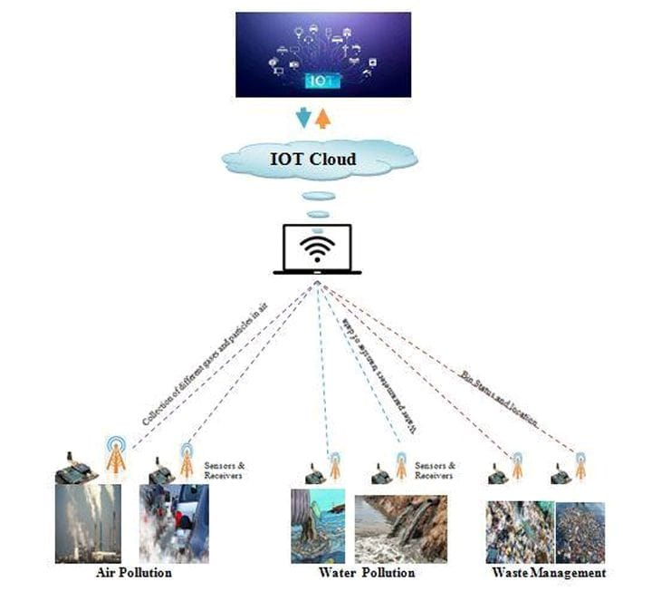

1. **Data Visualization**:

* Create visualizations of the data to gain insights and better understand patterns and trends. Matplotlib and Seaborn in Python are common libraries for this purpose.

1. **Exploratory Data Analysis (EDA)**:

* Conduct EDA to identify relationships, correlations, and patterns in the data. This step often involves statistical analysis and hypothesis testing.

1. **Data Splitting**:

* If you plan to build models, split the dataset into training, validation, and test sets. Cross-validation is also a useful technique for model evaluation.

1. **Data Preprocessing for Machine Learning**:
   * **Encoding Categorical Variables**: If your dataset contains categorical variables, encode them into numerical format, e.g., one-hot encoding.
   * **Feature Scaling**: Standardize or normalize features, especially if you plan to use machine learning algorithms.
   * **Dimensionality Reduction**: Consider techniques like PCA to reduce the dimensionality of the data if it's too high.
2. **Saving Processed Data**:

* Save the preprocessed dataset for further analysis and modeling to avoid redoing these steps every time you

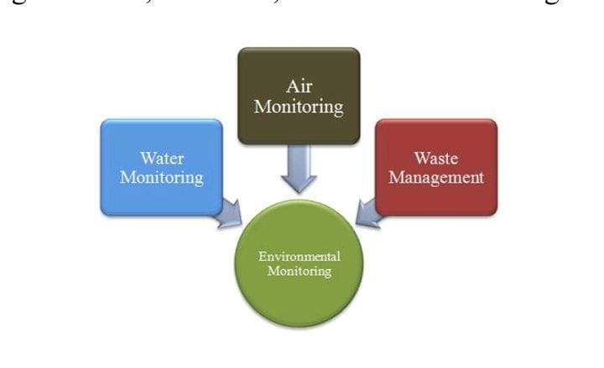

Smartly Environmental Monitoring

on the project.

Environmental monitoring using IoT (Internet of Things) involves the collection of data from various sensors and devices to monitor and manage environmental conditions. The data collected can be used for various purposes, such as assessing air quality, monitoring water pollution, tracking climate change, and more. Feature engineering, model training, and evaluation are essential steps in building effective environmental monitoring systems using IoT. Here's a step-by-step guide:

Data Collection and Preprocessing

- Deploy IoT sensors and devices to collect data. These sensors can include temperature sensors, humidity sensors, air quality sensors, water quality sensors, and more.

- Ensure the data collected is accurate and reliable. Quality assurance and calibration of sensors may be necessary.

- Data preprocessing involves cleaning, handling missing values, and dealing with outliers. This step is crucial to ensure the data's quality.

2. Feature Engineering:-

- Feature engineering is the process of creating relevant and informative features from the raw sensor data. It helps improve the model's performance.

- Domain knowledge is critical in this step. Consider expert advice or research to determine which features are relevant to your environmental monitoring goals.

- Feature extraction and selection techniques can be applied to transform and choose the most meaningful features.

3. Data Splitting:-

- Divide the data into training, validation, and test sets. Common splits are 70% for training, 15% for validation, and 15% for testing.

- Ensure that the data is split temporally to prevent data leakage.

4. Model Selection:-

- Choose a machine learning or deep learning model appropriate for the environmental monitoring task. Common models include decision trees, random forests, support vector machines, neural networks, and more.

- Consider the model's ability to handle time-series data if your data is sequential.

5. Model Training:-

- Train the selected model on the training data. During training, the model learns the underlying patterns in the data.

- Optimize hyperparameters to improve model performance through techniques like cross-validation.

6. Model Evaluation:-

- Evaluate the model's performance on the validation set using appropriate metrics for your task. Common metrics for environmental monitoring include Mean Absolute Error (MAE), Mean Squared Error (MSE), or domain-specific metrics.

- Plot relevant graphs or visualizations to better understand the model's predictions and performance.

7. Model Fine-Tuning:-

- Adjust the model as needed based on the evaluation results. This may involve changing hyperparameters, adjusting the model architecture, or trying different algorithms.

8. Testing and Deployment:-

- Once satisfied with the model's performance, test it on the held-out test set to assess its generalization capabilities.

- Deploy the model in your IoT system for real-time monitoring and decision-making.

9. Continuous Monitoring and Maintenance:-

- Monitor the model's performance over time, as environmental conditions can change.

- Retrain the model periodically with new data to adapt to changing conditions.

10. Ethical Considerations:-

- Be mindful of privacy and security concerns when collecting and using environmental data.

- Consider the ethical implications of your monitoring system, especially when dealing with sensitive environmental data.

Remember that environmental monitoring with IoT is an ongoing process that requires continuous improvement and adaptation to changing conditions and data sources.

**Evaluation of Environmental Monitoring Systems**

* The main purpose of this research paper is to advance research towards a framework for evaluating IoT environmental monitoring systems. Such systems are typically based on some form of the IT Service-Oriented Architecture (SOA) model, with common versions (at different levels of abstraction) being wireless sensor networks (WSN) and the (five-layer version of) IoT-Architecture (IoT-A) [6]. For IoT systems to be successful, they need to be viable, versatile, and modifiable, and for this reason IoT designs need to meet scalability, interoperability, distributed network, resource minimization and security requirements [8]. At the conceptual stage of the system development life cycle, an evaluation of alternative design models is performed so as to satisfy any stakeholder concerns about the quality and future potential of their system. This is recommended by BS ISO/IEC 42030 (ISO 42030) [33], which is specifically published to help with IT architecture evaluations [34]. Such evaluations aim to answer the questions of “what the system does'' and “how well it does it”, answers which involve value assessments as well as fact finding [34]. ISO 42030 requires that an architecture evaluation framework consists of a two-pass process [11] in order to facilitate better control for qualities which are irrelevant or redundant. Thus, the analysts performing the assessment will need to firstly eliminate proposals that do not satisfy mandatory non-functional requirements (NFRs identified from ISO 25010), and secondly, critically compare the proposed systems [11]. To do this, business value drivers (e.g., costs, resource consumption, time use, risk factors) will need to be sourced from relevant analytical, statistical and system audit records [34].

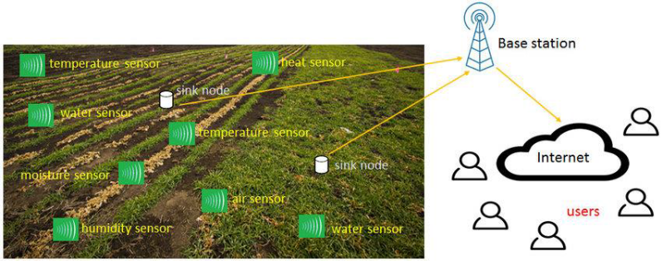

**Elimination of Redundant -Ilities (Step 1)**

The aim of Steps 1 is to ensure that only the required -ilities are included during the evaluation at Step 2. Fig. 1: Step 1 of the Environmental Monitoring Evaluation. The conclusion of the first pass evaluation (Step 1), is followed by the evaluation of the factors that correspond with the specific evaluation objectives. This is the second pass of the evaluation process in ISO 42030 [33] and is referred to in this paper as Step 2. This entire process is represented diagrammatically.

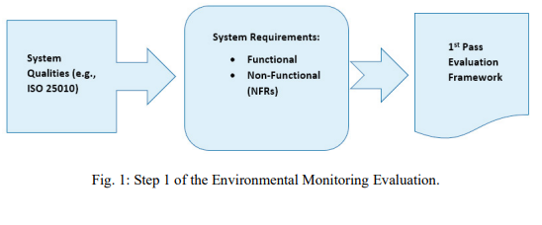

**Evaluation Approaches, Methods, and Analysis (Step 2)**

The process of architecture evaluation at Step 2 involves the selection of evaluation objectives for the Architecture Evaluation Approach (AEA) which will help to form the evaluation strategy [33]. The AEA is used to conceptualize a desired IT architecture. This is done in terms of mapping its key characteristics, properties, knowledge as well as the capabilities of current permutations of the system [34]. Evaluation approaches can include models, simulations, prototype demonstration, technical analysis, expert panel, and independent audit [34]. Smart environmental monitoring approaches could include air quality data analytics [35], AI waterbody models [36] and WSN prototypes [37].

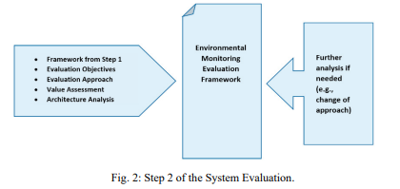

This analysis will show the preferable options for stakeholders. Where this is not the case or more information is needed, additional analysis using other evaluation approaches from ISO 42030 may have to be performed [34]. The choice of the evaluation approach should be driven by selected evaluation objectives. These may be fundamental objectives which aim at answering the question of “what the system does” or means objectives which serve to benchmark “how well the system fulfills its mission”. Attention to the type and substance of evaluation objectives plays an important part in producing valuable assessments.

**A Model Environmental Monitoring Framework**

In the context of the envisaged environmental monitoring framework, therefore, the evaluation objectives are the key NFR which were identified for these variants of IT architectures. In this framework these objectives are Reliability, Functional Suitability, Maintainability, Security, and Usability. The Architecture Evaluation Approach (AEA) uses these objectives to investigate a proposed architecture’s suitability as an IoT environmental monitoring solution.

Thus, for example, to perform the evaluation for these qualities the following objectives could be used:

• IoT environmental sensor systems should possess a constant rate of resource utilization.

• ‘Smart’ sensors should gather environmental data accurately.

• Such-and-such a system needs to support different communication modules.

• Expected rates of breach of access and confidentiality in our network need to be low.

• The user interface should be attractive to users (sensor data should be easy to find and navigate).

These objectives can be used to evaluate the monitoring system by balancing the socio-political factors relevant to aspects of the architecture which impact on the community and society. Noran & Bernus [11] suggest the PESTEL Model (political, economic, social, technological, environmental, and legal dimensions) for this external factor analysis. Additionally, systems need to meet relevant regulatory requirements (e.g., communication protocols, sensor certification, etc.) to satisfy respective stakeholders. The process and results of this evaluation need to be documented for use in future decision-making and analysis.

**Here's a list of tools and software commonly used in the process:**

Environmental monitoring involves the collection and analysis of data related to the environment to assess its health, track changes, and make informed decisions. Various tools and software are used for this purpose. Here is a list of tools and software commonly used in environmental monitoring:

1. **Weather Stations**: Weather monitoring tools and software include anemometers, barometers, rain gauges, and software to record and analyze weather data.
2. **Air Quality Monitors**: Devices like particulate matter (PM) sensors, gas analyzers, and software to measure and monitor air quality.
3. **Water Quality Sensors**: These sensors measure parameters like pH, dissolved oxygen, turbidity, and temperature to assess the quality of water bodies.
4. **Remote Sensing Tools**: Tools like satellites, drones, and aerial photography are used to monitor large-scale environmental changes.
5. **Geographic Information Systems (GIS)**: GIS software is used to map, analyze, and visualize spatial data related to the environment.
6. **Environmental Data Loggers**: These devices are used to collect and store data from various sensors for later analysis.
7. **Wildlife Tracking Devices**: GPS collars, radio transmitters, and other tracking devices are used to monitor the movement and behavior of animals.
8. **Soil Testing Equipment**: Tools for measuring soil properties, such as soil moisture, nutrient levels, and soil texture.
9. **Noise Monitoring Equipment**: Sound level meters and noise monitoring software are used to measure and analyze noise pollution.
10. **Radiation Detectors**: These devices measure various forms of radiation and are used in nuclear and radiological monitoring.
11. **Aerial Lidar Scanners**: Lidar technology is used to create detailed 3D maps of the environment, which is valuable for various environmental applications.
12. **Automated Weather Prediction Models**: Numerical weather prediction models, such as WRF and GFS, are used to forecast weather and climate conditions.
13. **Water Flow Meters**: These devices measure the flow rate of water in rivers, streams, and other water bodies.
14. **Environmental Management Software**: Software solutions that help manage and analyze environmental data, compliance, and reporting.
15. **Environmental Monitoring and Reporting Systems**: Comprehensive systems designed to collect, store, analyze, and report on environmental data.
16. **Data Visualization and Analysis Tools**: Software like R, Python, and specialized environmental data analysis tools to process and analyze collected data.
17. **Citizen Science Apps**: Mobile apps that allow citizens to participate in environmental monitoring by collecting and reporting data.
18. **Oceanographic Instruments**: Instruments like buoys, ROVs, and AUVs are used for monitoring oceans and marine environments.
19. **Environmental Sensors and Probes**: A wide range of sensors and probes are used for specific measurements, such as water temperature, turbidity, and more.
20. **Environmental Reporting and Compliance Software**: Software systems for complying with environmental regulations and reporting to regulatory agencies.
21. **Environmental Modeling Software**: Tools for creating models to simulate and predict environmental changes, such as climate modeling software.
22. **Environmental Monitoring Databases**: Databases to store and manage large volumes of environmental data.

These tools and software are essential for monitoring various aspects of the environment, including air quality, water quality, climate conditions, and ecosystems.

**Conclusion and future scope**

* In this paper, the author extensively reviews research studies on various environmental monitoring systems used for different purposes. The analysis and discussion of the review suggest vital recommendations for improving these systems. Research on deep learning, handling big data, and using consistent classification approaches has led to a realization of the need for extensive research in these areas. We have focused on water, air quality monitoring and intelligent waste management systems that can deal with environmental challenges.
* The significant challenges in implementing smart sensors, artificial intelligence (AI), and wireless sensor networks (WSNs) need to be addressed for sustainable growth through Smart Environmental Monitoring (SEM). Participation by environmental organizations, regulatory bodies, and general awareness would strengthen SEM efforts. Pre-processing techniques can be used to improve the quality of sensory data. These techniques include filtering and signal processing, which makes the data more suitable for tasks associated with SEM.
* The future scope of the work aims to study other environmental factors such as flexible sensing, energy harvesting sensing, marine pollution, sound pollution, etc.