## Initial ERD:

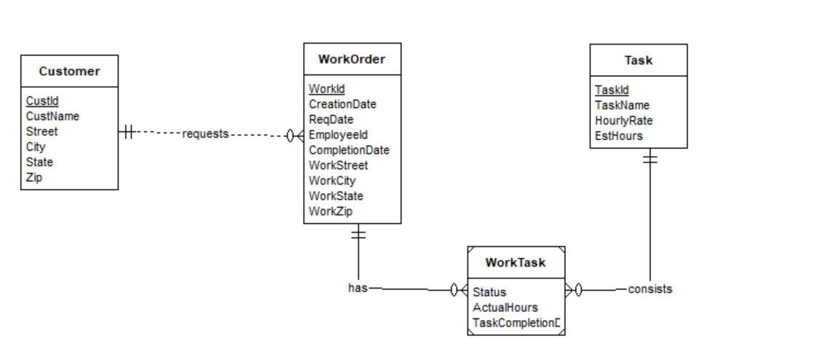

The Customer, WorkOrder, Task entity types follow directly from the question. It defines the attributes and a primary key for each of the entity types.

In the relationship, ‘requests’ between Customer and WorkOrder, the customer can have 0 or many work order, making it optional and Many WorkOrders. Whereas, for a particular WorkOrder, Customer is mandatory and only one. (1-M relationship)

There is a relationship ‘has’ between WorkOrder and WorkTask, and ‘consists’ between WorkTask and Task. The primary key of the associating table ‘WorkTask’ can be the combination of WorkId and TaskId, along with some or none of the attributes of its own. A WorkOrder can be linked to many tasks, and a task can have many work orders as per the narrative.

As the actual hours and completion date varies based on the work and task, it is appropriate to put these attributes as attributes of the weak entity table.

## **Second Iteration:**

## 

On new entity is added – ‘Materials’. Each WorkOrder requires a collection of materials, hence it is mandatory. The ‘WorkMaterial’ entity is a weak entity, as one WorkOrder may require many Materials and each material can be associated with many work orders. The Estimated quantity and actual quantity are attributes of this weak entity.

The last part of the narrative is covered by moving the EstHours to the weak entity, as estimated hours depends on both the work and task.