GOLANG DEVELOPER ASSESSMENT
TOY BLOCKCHAIN AND LEDGER SIMULATOR
Name: Janindu Geesara Abenayaka
Email: janindu.a@botcalm.com
Repo Link: https://github.com/Geesara-BC/toy-blockchain-ledger

Introduction
Before this assessment, my knowledge of blockchain was limited. I knew the word "blockchain" but I did not know how it actually works inside.
I had already started learning Go, so I first completed Sangam Mukherjee's "Golang Full Course 2026" on YouTube (https://www.youtube.com/watch?v=DR4QhvIlFfQ). This helped me get comfortable with Go basics such as structs, slices, pointers, and error handling. So the hard part of this project was not Go syntax. The hard part was understanding how a blockchain really works, step by step, so I could build one myself.
To learn the concepts, I watched a few videos:
- "Blockchain In 7 Minutes" by Simplilearn (https://www.youtube.com/watch?v=yubzJw0uiE4) - a short, simple explanation of what a blockchain is.
- "Blockchain Explained in Sinhala" (https://www.youtube.com/watch?v=lKi8OtMb7yY) - explained the idea in my own language.
- "What is Blockchain Technology (Sinhala)" (https://www.youtube.com/watch?v=lTifnWEfGjE) - more detail, also in Sinhala.
These videos gave me the basic picture: blocks linked by hashes, proof-of-work, and why changing old data is hard. After that, I designed and coded everything in this project myself in Go, using only the standard library.
This report explains what I built, the tests I ran on my own program, and what I learned from the results.

Investigation 1: Tamper Evidence
To check that my blockchain can detect tampering, I picked a real transaction inside Block #3 and changed it by hand, without using my program's normal "add transaction" flow. I did this to prove that the chain protects itself even if someone edits the saved data directly.
First, here is Block #3 before I touched anything. It has 2 transactions, and the second one sends 100 coins:
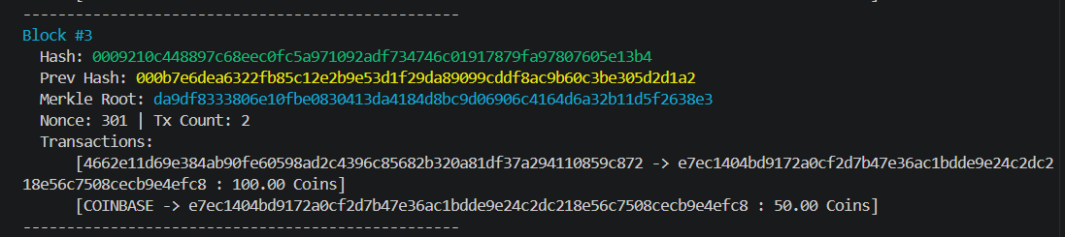
Figure 1: Block #3 before tampering. Merkle Root ends in ...2638e3, Hash starts with 0009...
Here is that same transaction shown as raw JSON data, with amount: 100:
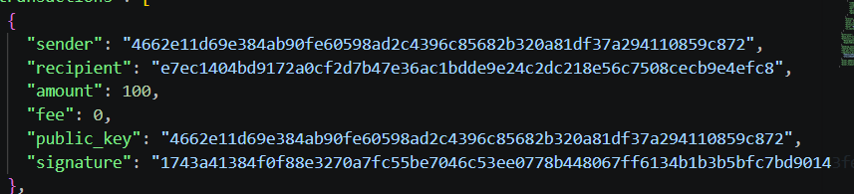
Figure 2: The transaction record before tampering. Amount = 100.
I then opened the saved chain file and manually changed the amount field from 100 to 150, without re-signing the transaction and without re-mining the block:
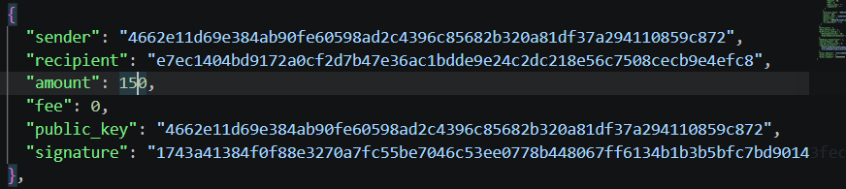
Figure 3: The same transaction after I manually changed amount to 150.
After I saved this change, I asked my program to print Block #3 again. Notice that the Merkle Root is now completely different (it now ends in ...c39c5 instead of ...2638e3), but the Hash field still shows the old value, because I only edited the file and did not re-mine the block:
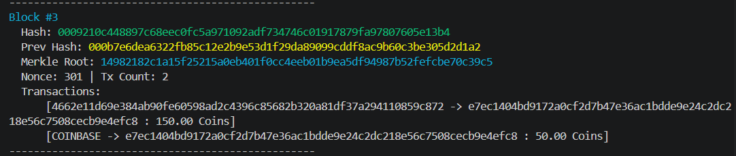
Figure 4: Block #3 after tampering. The Merkle Root changed, but the stored Hash did not.
This mismatch is exactly what my validation check looks for. Before I made any change, running validation gave this result:
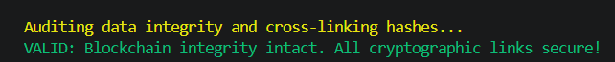
Figure 5: Validation output on the honest, untouched chain.
After the tamper, running the same validation command gave this result instead:
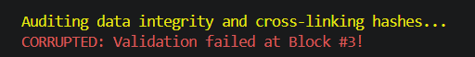
Figure 6: Validation output after the transaction amount was changed. It correctly points to Block #3.
Why this happens: my block hash is not built from the raw transaction list. It is built from a Merkle Root, which is a short summary value calculated from all the transactions in the block. When I changed the amount inside one transaction, the Merkle Root for Block #3 changed too. But the Hash field that was saved earlier still belongs to the old Merkle Root. So when validation recalculates the hash using the current (tampered) data and compares it to the stored hash, they do not match. My validation function checks every block in order and reports the first block where this mismatch happens, which is why it correctly says "Block #3".

Investigation 2: Difficulty versus Effort
Next, I wanted to see how much extra work is needed as mining difficulty goes up. My program has a built-in benchmark mode for this. I ran it with mining spread across 32 worker goroutines, testing difficulty levels 1 to 8, and it recorded the time taken and the number of hashes tried at each level:
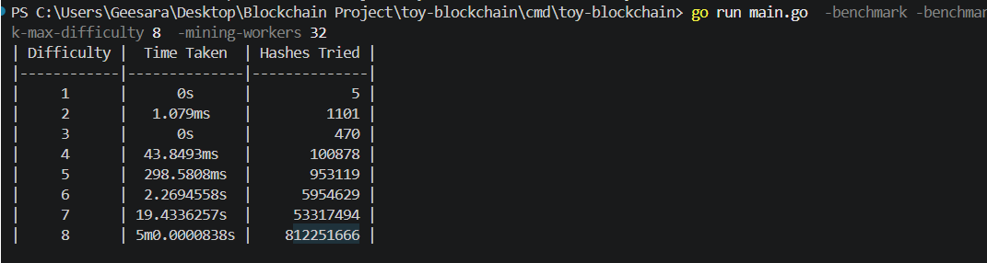
Figure 7: Time taken and hashes tried at difficulty levels 1 to 8.
The result is clearly not a straight line. At difficulty 1 to 3, a valid hash was found almost instantly, in under 500 hash attempts. But the numbers grow very fast after that:
- Difficulty 4 needed about 100,000 hashes and took 44 milliseconds.
- Difficulty 5 needed about 953,000 hashes and took about 0.3 seconds.
- Difficulty 6 needed almost 6 million hashes and took about 2.3 seconds.
- Difficulty 7 needed over 53 million hashes and took about 19.4 seconds.
- Difficulty 8 needed over 812 million hashes and took close to 5 minutes. This run was near my program's mining timeout, so at difficulty 8 the true number of hashes needed for a guaranteed match may be even higher than what is shown here.
Each extra difficulty level means the hash must start with one more zero. Since SHA-256 produces hash values that look random, adding one more required zero divides the chance of any single guess being valid by 16 (since hex digits have 16 possible values). This is why the effort roughly multiplies by around 10 to 16 times for every extra difficulty level, instead of just adding a fixed amount of extra work. That is why the growth is exponential rather than linear.

Investigation 3: Design Write-up
My block hash is calculated using Go's crypto/sha256 package, over the following fields, in this exact order:
- Index - the block's position in the chain.
- Timestamp - the Unix time the block was created.
- Merkle Root - a single summary value built from every transaction in the block.
- Previous Hash - the hash of the block right before this one.
- Nonce - the number miners change repeatedly while searching for a valid hash.
- Difficulty - the difficulty level this block was mined at.
These fields are placed into a small internal struct and turned into a fixed byte sequence with Go's encoding/json package, and that byte sequence is hashed once with SHA-256. The block's own Hash field is deliberately left out of this calculation, since a field cannot be used to calculate itself.
I chose to use a Merkle Root instead of hashing the raw list of transactions directly. Each transaction (sender, recipient, amount, and fee) is turned into a short text value and hashed on its own. These transaction hashes are then paired up and hashed again, layer by layer, until only one hash is left: the Merkle Root. This has two benefits. First, the block header stays a small, fixed size no matter how many transactions are inside. Second, changing even one transaction, even a small change like the amount, changes that transaction's hash, which changes the Merkle Root, which changes the block hash. So the Merkle Root is what actually links the transaction data to the block's identity.
On top of hashing, every transaction is also digitally signed. My wallet feature generates a public/private key pair (using Go's crypto/ed25519 package) for each account. When a transaction is created, it is signed with the sender's private key. During validation, my program checks that the signature matches the sender's public key. This means a transaction cannot be faked or claimed by someone else, even before it is added to a block, which is a separate and additional protection on top of the Merkle Root and block hashing.
Putting it together, my chain validation walks every block from the genesis block onward and checks, for each block: that recalculating the hash from the current data gives the same value as the stored hash, that the Previous Hash field correctly points to the actual hash of the block before it, that the hash meets the required difficulty target, and that block heights and timestamps increase in the correct order. If any single check fails, validation stops and reports the exact block number where the problem was found. Together with signatures on each transaction, this means both the transaction author and the block contents are protected: nobody can insert a transaction that was not really signed by its sender, and nobody can silently edit data that was already added to a block.

Discussion Questions

1. Why is tampering with an old block impractical in a real chain, even though it is easy in my toy?
In my toy project, tampering is easy because I am the only person with a copy of the chain. Nobody else checks it against me, so I can quietly re-mine every block after the one I changed, and nobody would notice.
In a real blockchain, thousands of computers (called nodes) each keep their own copy of the chain. If I change an old block, its hash changes, which breaks the link to the next block, which breaks the link to the block after that, and so on to the end of the chain. To fix this, I would have to redo the proof-of-work for that block and every block after it, faster than the rest of the honest network can keep adding new blocks. Since the honest network usually has far more combined computing power than one attacker, my fake version of the chain falls behind and gets rejected, because nodes always trust the longest valid chain.
The only real way around this is called a 51% attack, where an attacker controls more than half of the network's total mining power. This is possible in theory, but on a large real network it would need enormous amounts of hardware and electricity, so in practice it is too expensive to be worth it.

2. Name one alternative to proof-of-work, with one advantage and one drawback.
One alternative is proof-of-stake. Instead of miners competing by doing huge amounts of computing work, the network picks the next block creator based on how many coins they have locked up (staked) in the system. The more coins someone stakes, the higher their chance of being picked.
Advantage: proof-of-stake uses far less electricity, since there is no need for thousands of computers constantly guessing hashes.
Drawback: it can favor people who are already wealthy in the system, since having more coins staked gives a higher chance of being chosen and earning more rewards. This can make it harder for smaller participants to catch up over time. Proof-of-work, in comparison, only needs computing power, so anyone with a computer can try to take part.

3. Three ways my toy differs from a production blockchain (and how I would fix one).
- No network of peers. My program runs on a single computer as one process. There is no group of independent nodes checking each other's copy of the chain, so there is no real trust model, just one copy that I fully control. A real blockchain needs many independent nodes agreeing on the same data.
- No true finality. In a real network, a block is considered final once enough other blocks are safely built on top of it by independent miners. Since my toy has no other miners or nodes, this kind of finality does not really exist here, even though my code already has logic to pick the longest valid chain if there were two competing chains.
- Private keys are stored in plain text. My wallet feature does create real key pairs and real signatures, but the private keys are saved directly in a JSON file on disk with no password or extra protection. A real wallet would encrypt private keys, or keep them in separate secure hardware.
If I had more time, I would fix the first point: no network of peers. I would add a simple HTTP layer so that each running copy of my program could talk to others: broadcasting new blocks it has mined, and asking peers for their chain when it starts up. My project already has a longest-valid-chain check for resolving competing local chains, so the main new work would be sending and receiving that data over the network, and re-using this existing check to decide which peer's chain to accept.

Known Limitations
- This is a single-process program. There is no real network of peers, only local simulation of what a longer chain would look like.
- Wallet private keys are stored as plain text on disk, with no encryption.
- The benchmark at difficulty 8 was close to my program's mining timeout, so the hash count at that level may not represent a fully completed, successful mine.
Overall, this project covers block structure, deterministic hashing, proof-of-work mining, a ledger with balance checks, full chain validation with tamper detection, persistence, and command-line access, along with digital signatures, Merkle roots, concurrent mining, difficulty retargeting, and fork resolution as extra stretch goals.

