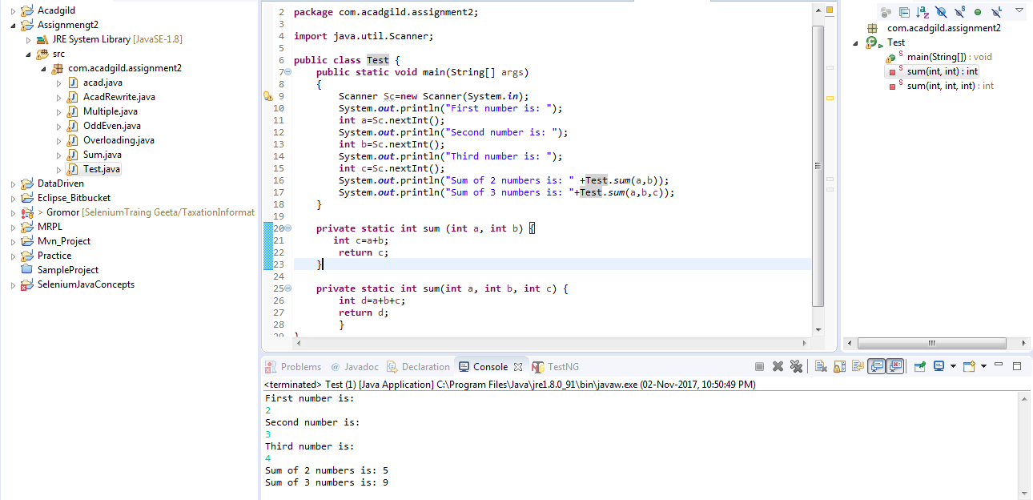

Method overloading – In method overloading 2 or more methods having same method name but

1.different number of arguments and

2.different data types of arguments are overloaded

In the above example ‘sum’ is method name having same return type int

- First ‘sum’ method is having 2 arguments whereas second ‘sum’ method is having 3 arguments

- First method is having ‘int’ as return type and we can replace with it any other data type(float, double..)without changing no of arguments.