
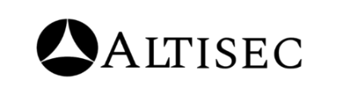

BAJAJ LIFE
SOC REPORT SEPTEMBER
WEEK 01(01ST TO 07TH SEP) 2026
DATE: 10TH SEP 2026



FOREWORD
This Weekly Executive summary report has been produced by ALTISEC TECHNOLOGIES PVT. LTD. Security Operations (SOC) team covering BAJAJ LIFE critical infrastructure and information processing assets under the purview of 24*7- daily real time SOC operations.

BAJAJ LIFE
SOC SERVICES:

Objectives & Goals:
Our consultants are P2ly focused towards eliminating the noise (unwanted traffic, Incidents/Cases) by identifying and prioritizing real actionable threats and help BAJAJ LIFE to take necessary preventive actions for the reported tickets that may put the business at risk.

Security Operations:
- Our Security Operations Center (SOC) activities and reports are tracked, reviewed, and communicated on a periodic basis to capture SOC performance and enhancements over time.
- Top 10 Security Risks, Daily Incidents & cases Tickets are all logged, tracked.

Incidents & cases Reporting:
- Our incidents & cases reporting strategies with root cause analysis helps BAJAJ LIFE management to document significant security risks to information processing assets.
- The incidents & cases reports clearly communicate incidents & cases type, incident risk & cases risk and severity, and specific event details covering a detailed technical analysis of the incidents & cases analyzed by our consultants.


RISK CALCULATION
The risk rating section describes the potential impact if the identified security Incidents/Cases is exploited by a threat source, or the severity of the security Incidents/Case/event is generated. The risk rating is calculated by considering the “Ease of exploitation” and the “Potential Impact” on application, servers, endpoints, and Critical Network Devices.

Rating | Description
P1 | The security risk/Incidents/Case/event is Critical as either it is considerably easy to exploit the observed incidents & cases, or the gain/impact is Critical. This Incidents/Case should be fixed on an urgent basis. Any security Incidents/Case generated with this severity needs to be treated immediately. Any suspicious but potential attack will also be considered as Critical severity.
P2 | The security risk/Incidents/Case/event is P2 as the ease of exploitation of the observed incidents & cases is Moderate, or the attack severity and the overall resulting impact is considerably Moderate.
P3 | The security risk/Incidents/Case/event is P3 as the ease of exploitation of observed incidents & cases and its exposure is P3. Furthermore, events generated under P3 severity are not having any immediate impact on the organization and its data.
P4 | The security risk/Incidents/Case/event is P4 as the ease of exploitation of observed incidents & cases and its exposure is P4. Furthermore, events generated under P4 severity are not having any immediate impact on the organization and its data.

To graphically showcase the health of an asset, the folP4ing health icons

will be used as the case arises.

- Indicates that the assets have exceeded the acceptable operational threshold in that performance category and needs to be addressed immediately. Each of the critical health areas are backed up by a recommendation in the recommendations section.

- Indicates that the assets, though not yet in the critical area, but it is likely to exceed the threshold if left unattended.

- Indicates that the assets performance is acceptable in that performance category.

- Indicates that the assets performance is acceptable in that performance category, and it shows the informational or P4 severity.
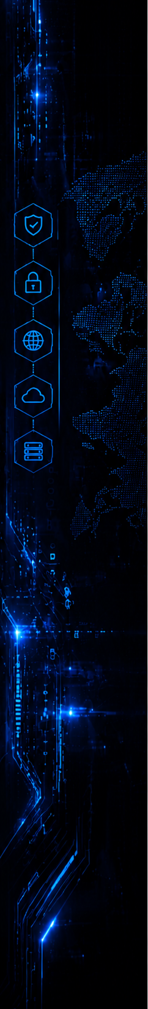

TABLE OF CONTENTS

FOREWORD 2
RISK CALCULATION 3
TABLE OF CONTENTS 4
DOCUMENT PROPERTY 5
SOC ENGAGEMENT TEAM 5
CONFIDENTIALITY CLAUSE 6
OVERVIEW OF INCIDENTS & CASES 7
GOVERNANCE TEAM MATRIX 18

DOCUMENT PROPERTY

Content | BAJAJ LIFE | SECURITY OPERATIONS SERVICES WEEKLY REPORT [September 2026 (WEEK – 01)]
Classification | CONFIDENTIAL
Client | BAJAJ LIFE
Contact | Name - Prakash Jadhav  Mail - Prakash.Jadhav@bajajlife.com
Report Status | Final

SOC ENGAGEMENT TEAM

Analysts’ Names | Roles | Email IDs
Snehankeet Shinde | SPOC | snehankeet.s@alticyber.com
Shaktiprasad Anami | SOC Manager | shaktiprasad.a@alticyber.com



CONFIDENTIALITY CLAUSE

- No part of this publication may be reproduced or translated into any language in any form by any means without the written permission of ALTISEC TECHNOLOGIES PVT. LTD.

- The security tickets/events denoted in this report can be shared or used by BAJAJ LIFE authorized personnel for their internal usage or to meet any compliance requirement.

- While every precaution has been taken in the preparation of this document, of ALTISEC TECHNOLOGIES PVT. LTD. assumes no responsibility for errors, omissions, or for damages resulting from the use of the information herein.

- This document provides detailed information about security operations services offered to BAJAJ LIFE and related Information Technology environment and is therefore considered CONFIDENTIAL. It also contains detailed information about some of ALTISEC TECHNOLOGIES PVT. LTD methodologies. It contains customer information, resource’s details, and relevant corporate information. Appropriate discretion is advised when sharing this information with third parties.

- Products or corporate names used in the report are trademarks or registered trademarks of respective companies and are used only for a better explanation and to the owner’s benefit, without intent to infringe.

OVERVIEW OF INCIDENTS & CASES
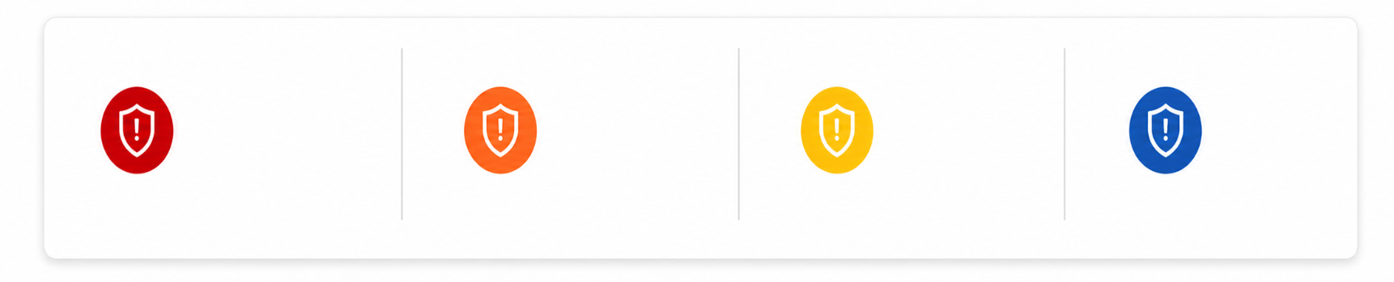
FolP4ing is the overview of total incidents & cases based on severity for the reporting period 01st to 07th September 2026.
P4
MEDIUM

P3
MEDIUM

P2
P1
14

05

01

00

1. INCIDENTS/CASES BY STATUS
TOTAL INCIDENTS/CASES
20
- OPEN
05
- CLOSED
15
It shows the information about
the status of all the Incidents/Cases
Tickets generated in last 7 days.
Which shows the Incidents/Cases
which shows the Incidents/Cases
which are Open and Closed after
the customer’s acknowledgement
by the soc team.

Severity | Cases | New | In Progress | Resolved
P1 | 00 | 00 | 00 | 00
P2 | 01 | 00 | 00 | 01
P3 | 14 | 00 | 02 | 02
P4 | 05 | 00 | 03 | 12
Total | 20 | 00 | 05 | 15

2. INCIDENTS/CASES CREATED TREND


FolP4ing section depicts the daily Incidents/Case ticket trend for the last 7 days (01st to 07th September 2026)This includes multiple Incidents/Cases which are stitched and scanning related Incidents/Cases.
INCIDENTS/CASE TREND

HIGHLIGHT – 04th Sep 2026 had the highest Incidents/Cases.
3. OPEN INCIDENTS/CASES
CASE NAME | Severity | Teams | Case time
First successful SSO access from ASN in the organization | P4 | Sagar Kulat/Pune HO/Technology/Life | Sep 2nd 2026 15:39:32
First successful SSO access from ASN in the organization | P4 | Sagar Kulat/Pune HO/Technology/Life | Sep 3rd 2026 15:45:25
Rare unsigned process execution with high integrity level by scheduled task | P3 | Windows. admin | Sep 4th 2026 12:10:28
First successful SSO access from ASN in the organization | P4 | Sagar Kulat/Pune HO/Technology/Life | Sep 5th 2026 12:11:00
New Administrative Behavior | P3 | Vinayak | Sep 7th 2026 11:45:47

4. INCIDENTS/CASES SENT BASED ON ALERT NAMES.

This section depicts information about TOP 10 Incidents/Cases triggered of various Incidents/Case names.
INCIDENTS/CASES SENT BASED ON INCIDENTS/CASE NAME

5. MITRE ATT&CK TACTICS

This section depicts MITRE ATT&CK tactics in correspondence with TOP Incidents/Case tickets sent by the SOC team.
INCIDENTS/CASE COUNT BASED ON MITRE TACTICS

6. MITRE ATT&CK TECHNIQUES

This section depicts MITRE ATT&CK techniques in correspondence with TOP Incidents/Case tickets sent by the SOC team.
INCIDENTS/CASE COUNT BASED ON MITRE TECHNIQUES

G
7. INCIDENTS/CASE CATEGORY


This section provides information about the TOP 10 category of all Incidents/Case tickets generated in the last 7 days.
INCIDENTS/CASE COUNT BASED ON CATEGORY

HIGHLIGHT – Vulnerability tactic accounts for highest number of total Incidents/Cases.
9. INCIDENTS/CASES TRIGGERED FROM USERNAMES


The graph beP4 depicts the statistics about TOP user due to whom most Incidents/Cases are triggered from 01st to 07th September 2026.
INCIDENTS/CASE TRIGGERED FROM USERNAME

10. INCIDENTS/CASES TRIGGERED FROM HOSTNAME

The graph beP4 depicts the statistics about TOP host due to whom most true positive Incidents/Cases are triggered from 01st to 07th September 2026.
INCIDENTS/CASE COUNT BASED ON HOSTNAMES

11. SLA COMPLIANCE
The SLA adherence for this week's four severity levels—critical, P2, P3, and P4 is displayed in this section.
SLA COMPLIANCE

12. MTTR RESPONSE

The SOC Team maintained SLA-aligned MTTR response by prioritizing Incidents/Cases based on severity for the true positive Incidents/Cases from 01st to 07th September 2026.
RESPONSE

13. MTTR RESOLVE

The SOC Team maintained SLA-aligned MTTD by prioritizing Incidents/Cases based on severity for the true positive Incidents/Cases from 01st to 07th September 2026.
RESOLVE

GOVERNANCE TEAM MATRIX
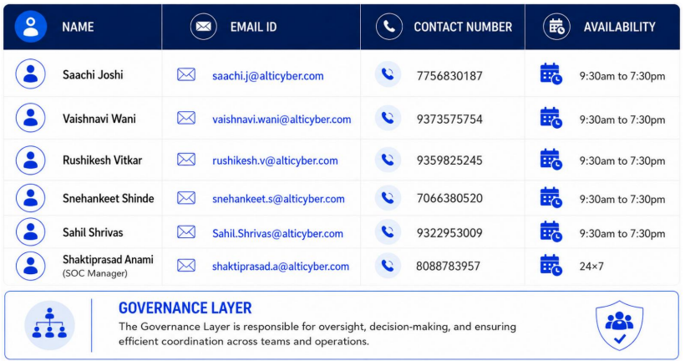
As a part of team re-structuring, we have formed a governance layer that will oversee operations. In-case of any queries, please contact the team members (Governance Layer) from the table beP4.

