


TATA TECHNOLOGIES
SOC REPORT OCTOBER
WEEK 03 (09TH TO 15TH OCT) 2026
DATE: 16TH OCTOBER 2026

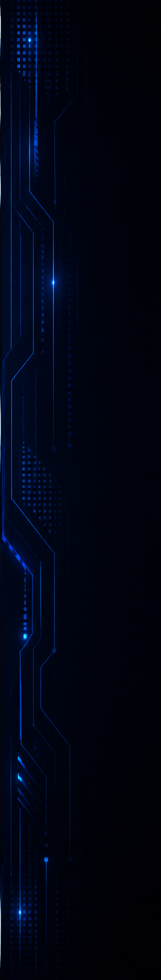

FOREWORD
This Weekly Executive summary report has been produced by ALTISEC TECHNOLOGIES PVT. LTD. Security Operations (SOC) team covering TATA TECHNOLOGIES. critical infrastructure and information processing assets under the purview of 24*7- daily real time SOC operations.

TATA TECHNOLOGIES
SOC SERVICES:

Objectives & Goals:
Our consultants are highly focused towards eliminating the noise (unwanted traffic, Incidents/Cases) by identifying and prioritizing real actionable threats and help TATA TECHNOLOGIES to take necessary preventive actions for the reported tickets that may put the business at risk.

Security Operations:
- Our Security Operations Center (SOC) activities and reports are tracked, reviewed, and communicated on a periodic basis to capture SOC performance and enhancements over time.
- Top 10 Security Risks, Daily Incidents & cases Tickets are all logged, tracked.

Incidents & cases Reporting:
- Our incidents & cases reporting strategies with root cause analysis helps TATA TECHNOLOGIES management to document significant security risks to information processing assets.
- The incidents & cases reports clearly communicate incidents & cases type, incident risk & cases risk and severity, and specific event details covering a detailed technical analysis of the incidents & cases analyzed by our consultants.


RISK CALCULATION
The risk rating section describes the potential impact if the identified security Incidents/Cases is exploited by a threat source, or the severity of the security Incidents/Case/event is generated. The risk rating is calculated by considering the “Ease of exploitation” and the “Potential Impact” on application, servers, endpoints, and Critical Network Devices.

Rating | Description
P1 | The security risk/Incidents/Case/event is Critical as either it is considerably easy to exploit the observed incidents & cases, or the gain/impact is Critical. This Incidents/Case should be fixed on an urgent basis. Any security Incidents/Case generated with this severity needs to be treated immediately. Any suspicious but potential attack will also be considered as Critical severity.
P2 | The security risk/Incidents/Case/event is High as the ease of exploitation of the observed incidents & cases is Moderate, or the attack severity and the overall resulting impact is considerably Moderate.
P3 | The security risk/Incidents/Case/event is Medium as the ease of exploitation of observed incidents & cases and its exposure is Medium. Furthermore, events generated under medium severity are not having any immediate impact on the organization and its data.
P4 | The security risk/Incidents/Case/event is Low as the ease of exploitation of observed incidents & cases and its exposure is Low. Furthermore, events generated under Low severity are not having any immediate impact on the organization and its data.

To graphically showcase the health of an asset, the following health icons

will be used as the case arises.

- Indicates that the assets have exceeded the acceptable operational threshold in that performance category and needs to be addressed immediately. Each of the critical health areas are backed up by a recommendation in the recommendations section.

- Indicates that the assets, though not yet in the critical area, but it is likely to exceed the threshold if left unattended.

- Indicates that the assets performance is acceptable in that performance category.

- Indicates that the assets performance is acceptable in that performance category, and it shows the informational or low severity.
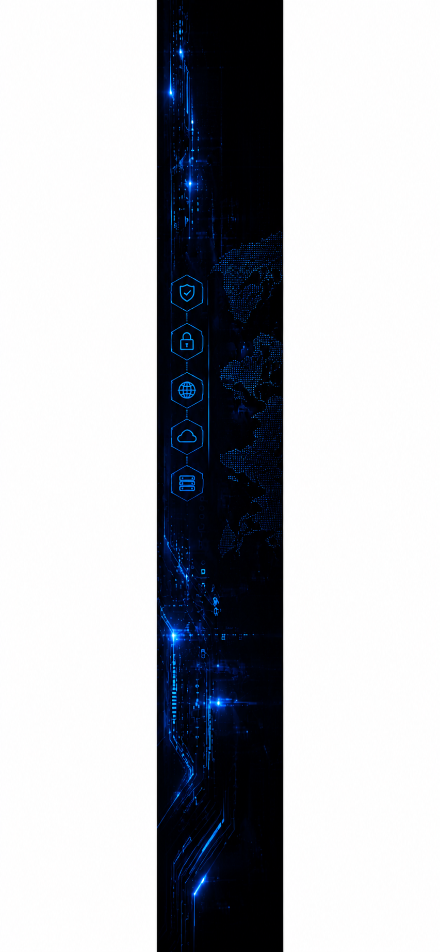

TABLE OF CONTENTS

FOREWORD 2
RISK CALCULATION 3
TABLE OF CONTENTS 4
DOCUMENT PROPERTY 5
SOC ENGAGEMENT TEAM 5
CONFIDENTIALITY CLAUSE 6
OVERVIEW OF INCIDENTS & CASES 7
GOVERNANCE TEAM MATRIX 21

DOCUMENT PROPERTY

Content | TATA TECHNOLOGIES | SECURITY OPERATIONS SERVICES WEEKLY REPORT [OCTOBER 2026 (WEEK – 03)]
Classification | CONFIDENTIAL
Client | TATA TECHNOLOGIES
Contact | Name - Anil Taddi  Mail - anil.taddi@tatatechnologies.com
Report Status | Final

SOC ENGAGEMENT TEAM

Analysts’ Names | Roles | Email IDs
Vaishnavi Wani | Governance | vaishnavi.wani@alticyber.com
Shaktiprasad Anami | SOC Manager | shaktiprasad.a@alticyber.com



CONFIDENTIALITY CLAUSE

- No part of this publication may be reproduced or translated into any language in any form by any means without the written permission of ALTISEC TECHNOLOGIES PVT. LTD.

- The security tickets/events denoted in this report can be shared or used by TATA TECHNOLOGIES authorized personnel for their internal usage or to meet any compliance requirement.

- While every precaution has been taken in the preparation of this document, of ALTISEC TECHNOLOGIES PVT. LTD. assumes no responsibility for errors, omissions, or for damages resulting from the use of the information herein.

- This document provides detailed information about security operations services offered to TATA TECHNOLOGIES and related Information Technology environment and is therefore considered CONFIDENTIAL. It also contains detailed information about some of ALTISEC TECHNOLOGIES PVT. LTD methodologies. It contains customer information, resource’s details, and relevant corporate information. Appropriate discretion is advised when sharing this information with third parties.

- Products or corporate names used in the report are trademarks or registered trademarks of respective companies and are used only for a better explanation and to the owner’s benefit, without intent to infringe.

OVERVIEW OF INCIDENTS & CASES
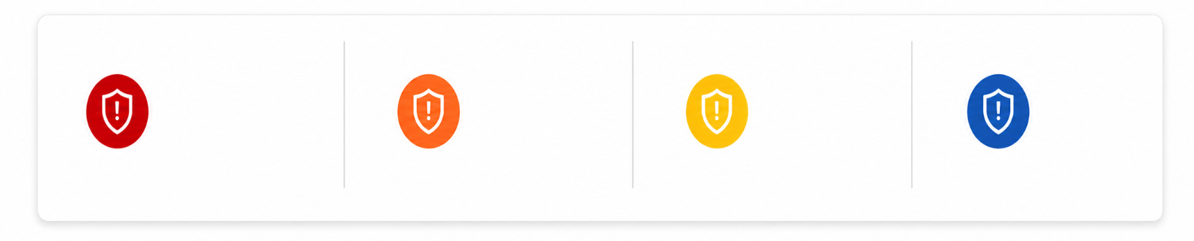
Following is the overview of total incidents & cases based on severity for the reporting period 09th to 15th Oct 2026.
P4
MEDIUM

P3
MEDIUM

P2
P1
27

00

28

02

01. INCIDENTS/CASES BY STATUS
TOTAL INCIDENTS/CASES
57
- OPEN
28
- CLOSED
29
It shows the information about
the status of all the Incidents/Cases
Tickets generated in last 7 days.
Which shows the Incidents/Cases
which shows the Incidents/Cases
which are Open and Closed after
the customer’s acknowledgement
by the soc team.

Severity | Cases | New | In Progress | Resolved
P1 | 02 | 00 | 01 | 01
P2 | 28 | 00 | 09 | 19
P3 | 27 | 00 | 18 | 09
P4 | 00 | 00 | 00 | 00
Total | 57 | 00 | 28 | 29

02. INCIDENTS/CASES CREATED TREND


Following section depicts the daily Incidents/Case ticket trend for the last 7 days (09th to 15th Oct 2026) This includes multiple Incidents/Cases which are stitched and scanning related Incidents/Cases.
INCIDENTS/CASE TREND

HIGHLIGHT – 14th Oct had the highest Incidents/Cases.
03. OPEN INCIDENTS/CASES
CASE NAME | SEVERITY | TEAM
TTL-78494 - 'Horizontal Port Scanning Detected from Endpoint' | P1 | TTL Team
TTL-79353 - 'ELT - Login Outside Normal Working Hours / Behavioral Deviation Detected' | P1 | TTL Team
TTL-78559 - P1 RT PaloAlto - Phishing Malware Grayware Detection | P1 | TTL Team
TTL-77340 - P1 RT PaloAlto - Phishing Malware Grayware Detection | P1 | TTL Team
TTL-76208 - P1 RT PaloAlto - Phishing Malware Grayware Detection | P1 | TTL Team
TTL-76167 - P1 RT PaloAlto - Phishing Malware Grayware Detection | P1 | TTL Team
TTL-75896 - cve 2021-44228-detection for Domain | P1 | TTL Team
TTL-75309 - P1 RT PaloAlto - Phishing Malware Grayware Detection | P1 | TTL Team
TTL-75125 - P1 RT PaloAlto - Phishing Malware Grayware Detection | P1 | TTL Team
TTL-74740 - P1 RT PaloAlto - Phishing Malware Grayware Detection | P1 | TTL Team

04. INCIDENTS/CASES SENT BASED ON ALERT NAMES.

This section depicts information about TOP 10 Incidents/Cases triggered of various Incidents/Case names.
INCIDENTS/CASES SENT BASED ON INCIDENTS/CASE NAME

05. MITRE ATT&CK TACTICS

This section depicts MITRE ATT&CK tactics in correspondence with TOP 10 Incidents/Case tickets sent by the SOC team.
INCIDENTS/CASE COUNT BASED ON MITRE TACTICS

06. MITRE ATT&CK TECHNIQUES

This section depicts MITRE ATT&CK techniques in correspondence with TOP 10 Incidents/Case tickets sent by the SOC team.
INCIDENTS/CASE COUNT BASED ON MITRE TECHNIQUES

07. INCIDENTS/CASE CATEGORY


This section provides information about the all category of all Incidents/Case tickets generated in the last 7 days.
INCIDENTS/CASE COUNT BASED ON CATEGORY

HIGHLIGHT – Other tactic accounts for highest number of total Incidents/Cases.
08. INCIDENTS/CASES TRIGGERED FROM USERNAMES


The graph below depicts the statistics about TOP 10 user due to whom most Incidents/Cases are triggered from 09th to 15th Oct 2026.
INCIDENTS/CASE TRIGGERED FROM USERNAME

09. INCIDENTS/CASES TRIGGERED FROM HOSTNAME

The graph below depicts the statistics about TOP 10 host due to whom most true positive Incidents/Cases are triggered from 09th to 15th Oct 2026
INCIDENTS/CASE COUNT BASED ON HOSTNAMES

PREVENTED BLOCKED CASES COUNT
424

10. UNIT 42 SOC
ASSIGNED TO | STATUS | COUNT
SOC ANALYST | Resolved - Security Testing | 00
SOC ANALYST | Resolved - Duplicate Cases | 124
SOC ANALYST | Resolved – Known issue | 102
SOC ANALYST | Resolved – Others | 00
SOC ANALYST | Resolved – False Positive | 193
SOC ANALYST | Resolved – True Positive | 72
UNIT 42 | Resolved – Others | 2622
GRAND TOTAL |  | 491

11. SLA COMPLIANCE
The SLA adherence for this week's four severity levels—critical, high, medium, and low is displayed in this section.
SLA COMPLIANCE

🔵complaint
🔴non-complaint

12. MTTR RESPONSE

The SOC Team maintained SLA-aligned MTTR response by prioritizing Incidents/Cases based on severity for the true positive Incidents/Cases from 09th to 15th Oct 2026.
RESPONSE

13. MTTR RESOLUTION

The SOC Team maintained SLA-aligned MTTD by prioritizing Incidents/Cases based on severity for the true positive Incidents/Cases from 09th to 15th Oct 2026.
RESOLUTION
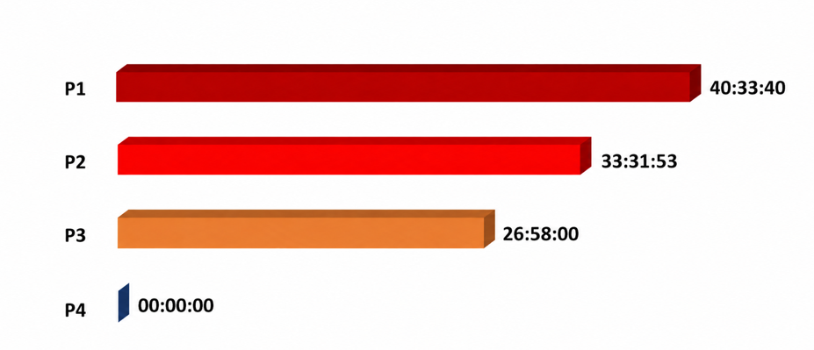

14. MTTD

The SOC Team maintained SLA-aligned MTTD by prioritizing Incidents/Cases based on severity for the true positive Incidents/Cases from 09th to 15th Oct 2026.
MTTD

14. CASES SUMMARY
Case Name | Total Triggered | Closed / Resolved | Open / In Progress | Mitre Tactic
Silent data source Firewall | 98 | 98 | 0 | Not applicable - Health
Horizontal Port Scanning Detected from Endpoint | 72 | 72 | 0 | Discovery (TA0007)
Firewall Outbound Communication To Well Known Ports | 63 | 63 | 0 | Command and Control (TA0011)
Paloalto Critical Severity Signature Observed | 46 | 46 | 0 | Initial Access (TA0001)
Large Outbound Data Transfer Detected | 44 | 44 | 0 | Exfiltration (TA0010)
P1 RT PaloAlto - Phishing Malware Grayware Detection | 39 | 39 | 0 | Initial Access (TA0001)
P2 - Suspicious Categories Allowed on ZScaler | 36 | 36 | 0 | Command and Control (TA0011)
Zscaler Malicious Web Traffic Blocked | 16 | 16 | 0 | Command and Control (TA0011)
ELT - Login Outside Normal Working Hours / Behavioral Deviation Detected | 7 | 7 | 0 | Credential Access (TA0006)
Potential Data Exfiltration Detected | 7 | 7 | 0 | Exfiltration (TA0010)
Silent Data Source F5 WAF | 7 | 7 | 0 | Not applicable - Health
AD Brute force | 6 | 6 | 0 | Credential Access (TA0006)
Azure AD - Unauthorized MFA Security Information Removal Detected | 6 | 6 | 0 | Initial Access (TA0001); Persistence (TA0003); Privilege Escalation (TA0004); Defense Evasion (TA0005); Credential Access (TA0006)
Inbound Traffic Blocked in Forcepoint by Hosted Anti Virus Scanning | 6 | 6 | 0 | Initial Access (TA0001)
Multiple Authentication Attempts to Disabled Account Detected | 5 | 5 | 0 | Credential Access (TA0006)
TTL_Success VPN Login from Different Geo Region in 24 Hours | 5 | 5 | 0 | Initial Access (TA0001); Persistence (TA0003)
Proofpoint TAP - Malicious URL Phishing Email Detected | 4 | 4 | 0 | Initial Access (TA0001)
SQL Injection Attempt | 3 | 3 | 0 | Initial Access (TA0001)
UBA : Malware Activity - Registry Modified In Bulk | 2 | 2 | 0 | Execution (TA0002); Persistence (TA0003); Defense Evasion (TA0005); Lateral Movement (TA0008)
Critical Linux System File Modification Attempt Detected | 1 | 1 | 0 | Privilege Escalation (TA0004); Discovery (TA0007)
Excessive Security Group Membership Changes by Privileged User | 1 | 1 | 0 | Initial Access (TA0001); Persistence (TA0003); Privilege Escalation (TA0004); Defense Evasion (TA0005)
Multiple Blocked Requests | 1 | 1 | 0 | Initial Access (TA0001)
Multiple Large Emails Sent with Same Subject | 1 | 1 | 0 | Exfiltration (TA0010)
O365_Multiple_Exchange_Online_Mailbox_Permission_Changes_By_Same_User | 1 | 1 | 0 | Persistence (TA0003); Privilege Escalation (TA0004)
Case Name | Total Triggered | Closed / Resolved | Open / In Progress | Mitre Tactic
P1 - AWS IAM Privilege Escalation Detected | 1 | 1 | 0 | Initial Access (TA0001); Persistence (TA0003); Privilege Escalation (TA0004); Defense Evasion (TA0005)
P2_WAF_Threat Campaign Detected | 1 | 1 | 0 | Initial Access (TA0001)
Palo Alto Firewall Configuration Changes Detected | 1 | 1 | 0 | Defense Evasion (TA0005)
Potential Log4Shell Exploitation Attempt Detected | 1 | 1 | 0 | Initial Access (TA0001)
Potential Pass The Ticket Attack | 1 | 1 | 0 | Lateral Movement (TA0008)
RT WINRS Remote Execution | 1 | 1 | 0 | Lateral Movement (TA0008)
Silent Data Source AD | 1 | 1 | 0 | Not applicable - Health
Successful Firewall Communication with Malicious Threat Intelligence IP | 1 | 1 | 0 | Command and Control (TA0011)
UBA : Detected Activity from a Locked Machine | 1 | 1 | 0 | Initial Access (TA0001); Persistence (TA0003); Privilege Escalation (TA0004); Defense Evasion (TA0005)
WAF Policy Violation Detected | 1 | 1 | 0 | Initial Access (TA0001)

GOVERNANCE TEAM MATRIX
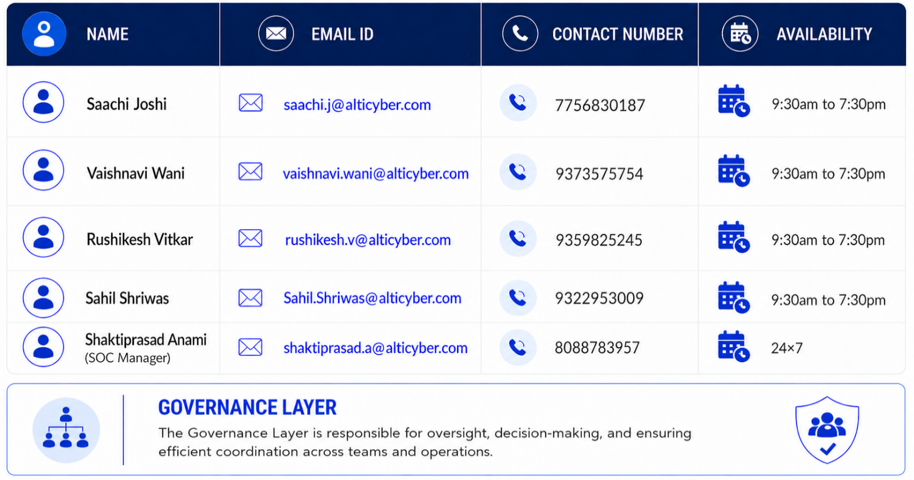
As a part of team re-structuring, we have formed a governance layer that will oversee operations. In-case of any queries, please contact the team members (Governance Layer) from the table below.

