# Data Importing And Cleaning

HousePrice <- read.csv("G:/Ryerson-BigData/capstone/kc_house_data.csv")  
head(HousePrice)

## id date price bedrooms bathrooms sqft_living  
## 1 7129300520 20141013T000000 221900 3 1.00 1180  
## 2 6414100192 20141209T000000 538000 3 2.25 2570  
## 3 5631500400 20150225T000000 180000 2 1.00 770  
## 4 2487200875 20141209T000000 604000 4 3.00 1960  
## 5 1954400510 20150218T000000 510000 3 2.00 1680  
## 6 7237550310 20140512T000000 1225000 4 4.50 5420  
## sqft_lot floors waterfront view condition grade sqft_above sqft_basement  
## 1 5650 1 0 0 3 7 1180 0  
## 2 7242 2 0 0 3 7 2170 400  
## 3 10000 1 0 0 3 6 770 0  
## 4 5000 1 0 0 5 7 1050 910  
## 5 8080 1 0 0 3 8 1680 0  
## 6 101930 1 0 0 3 11 3890 1530  
## yr_built yr_renovated zipcode lat long sqft_living15 sqft_lot15  
## 1 1955 0 98178 47.5112 -122.257 1340 5650  
## 2 1951 1991 98125 47.7210 -122.319 1690 7639  
## 3 1933 0 98028 47.7379 -122.233 2720 8062  
## 4 1965 0 98136 47.5208 -122.393 1360 5000  
## 5 1987 0 98074 47.6168 -122.045 1800 7503  
## 6 2001 0 98053 47.6561 -122.005 4760 101930

colnames(HousePrice)

## [1] "id" "date" "price" "bedrooms"   
## [5] "bathrooms" "sqft_living" "sqft_lot" "floors"   
## [9] "waterfront" "view" "condition" "grade"   
## [13] "sqft_above" "sqft_basement" "yr_built" "yr_renovated"   
## [17] "zipcode" "lat" "long" "sqft_living15"  
## [21] "sqft_lot15"

any(is.na(HousePrice$id))

## [1] FALSE

any(is.na(HousePrice$date))

## [1] FALSE

any(is.na(HousePrice$price))

## [1] FALSE

any(is.na(HousePrice$bedrooms))

## [1] FALSE

any(is.na(HousePrice$bathrooms))

## [1] FALSE

any(is.na(HousePrice$sqft_living))

## [1] FALSE

any(is.na(HousePrice$sqft_lot))

## [1] FALSE

any(is.na(HousePrice$floors))

## [1] FALSE

any(is.na(HousePrice$waterfront))

## [1] FALSE

any(is.na(HousePrice$view))

## [1] FALSE

any(is.na(HousePrice$condition))

## [1] FALSE

any(is.na(HousePrice$grade))

## [1] FALSE

any(is.na(HousePrice$sqft_above))

## [1] FALSE

any(is.na(HousePrice$sqft_basement))

## [1] FALSE

any(is.na(HousePrice$yr_built))

## [1] FALSE

any(is.na(HousePrice$yr_renovated))

## [1] FALSE

any(is.na(HousePrice$zipcode))

## [1] FALSE

any(is.na(HousePrice$lat))

## [1] FALSE

any(is.na(HousePrice$long))

## [1] FALSE

any(is.na(HousePrice$sqft_living15))

## [1] FALSE

any(is.na(HousePrice$sqft_lot15))

## [1] FALSE

# BEDROOM ANALYSIS

hist(HousePrice$bedrooms,main = 'HousePrice',xlab = 'Bedrooms',ylab = 'No of Houses',col.main='Blue',col.axis='Blue',col.lab = 'Blue',col = 'Blue')

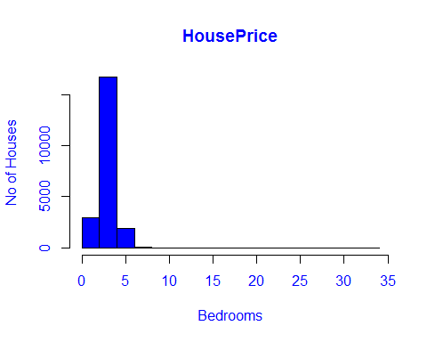

boxplot(HousePrice$bedrooms,main = 'HousePrice',col.main='Blue',col.axis='Blue',col.lab = 'Blue',col = 'Blue')

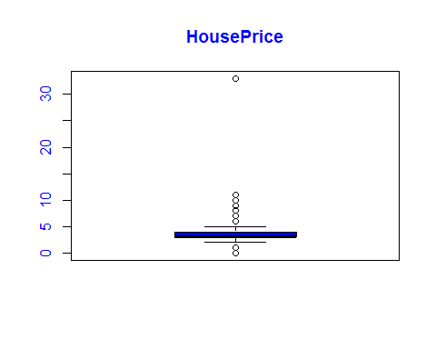

#*******Initial correlation =   
cor(HousePrice$bedrooms,HousePrice$price)

## [1] 0.3083496

#*******Removing the outliers  
#Since more than 7 bedrooms are very rare.Also it's the outlier for my model.  
#I have removed the outlier data.  
HousePrice<-subset(HousePrice,bedrooms>=1 & bedrooms<=7)  
  
#*******Once we removed the outliers  
#******Final Correlation =  
cor(HousePrice$bedrooms,HousePrice$price)

## [1] 0.3156734

hist(HousePrice$bedrooms,main = 'HousePrice',xlab = 'Bedrooms',ylab = 'No of Houses',col.main='Blue',col.axis='Blue',col.lab = 'Blue',col = 'Blue')

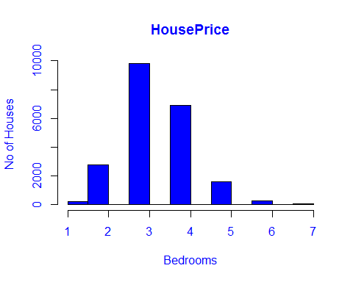

boxplot(HousePrice$bedrooms,main = 'HousePrice',xlab = 'Bedrooms',  
 col.main='Blue',col.axis='Blue',col.lab = 'Blue',col = 'Blue')

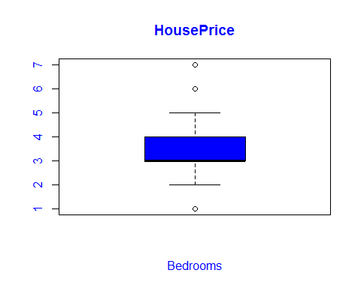

# BATHROOM ANALYSIS

plot(HousePrice$price~HousePrice$bathrooms,main = 'HousePrice',xlab = 'Bathrooms',ylab = 'No of Houses',col.main='Blue',col.axis='Blue',col.lab = 'Blue',col = 'Blue')

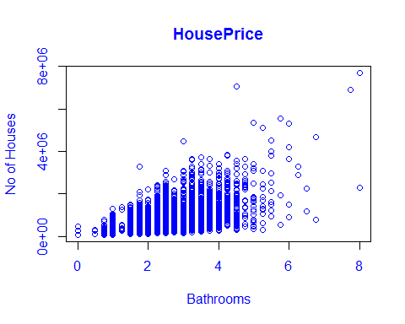

hist(HousePrice$bathrooms,main = 'HousePrice',xlab = 'Bathrooms',ylab = 'No of Houses',col.main='Blue',col.axis='Blue',col.lab = 'Blue',col = 'Blue')

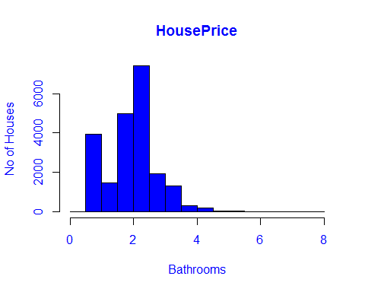

boxplot(HousePrice$bathrooms,main = 'HousePrice',xlab = 'Bathroom',col.main='Blue',col.axis='Blue',col.lab = 'Blue',col = 'Blue')

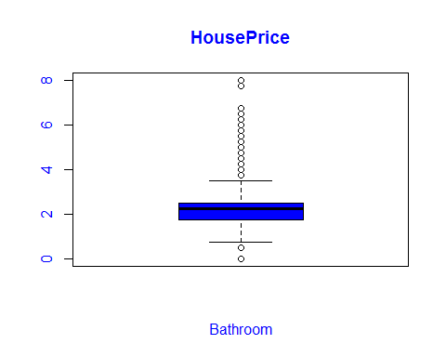

#*******Initial correlation =   
cor(HousePrice$bathrooms,HousePrice$price)

## [1] 0.5259342

#*******Removing the outliers  
#More than 4 bathrooms are very rare in this data.So I am removing it.  
HousePrice<-subset(HousePrice,bathrooms>=1 & bathrooms<=4)  
  
#*******Once we removed the outliers  
plot(HousePrice$price~HousePrice$bathrooms,main = 'HousePrice',xlab = 'Bathrooms',ylab = 'No of Houses',col.main='Blue',col.axis='Blue',col.lab = 'Blue',col = 'Blue')

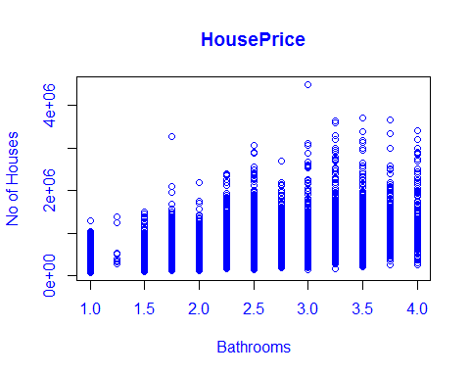

hist(HousePrice$bathrooms,main = 'HousePrice',xlab = 'Bathrooms',ylab = 'No of Houses',col.main='Blue',col.axis='Blue',col.lab = 'Blue',col = 'Blue')

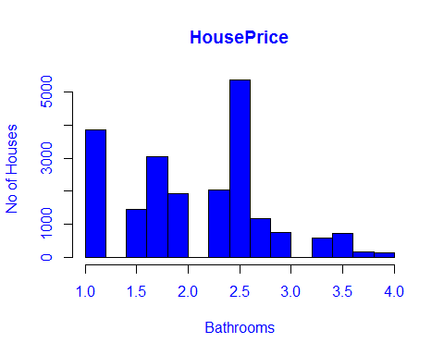

boxplot(HousePrice$bathrooms,main = 'HousePrice',xlab = 'bathrooms',col.main='Blue',col.axis='Blue',col.lab = 'Blue',col = 'Blue')

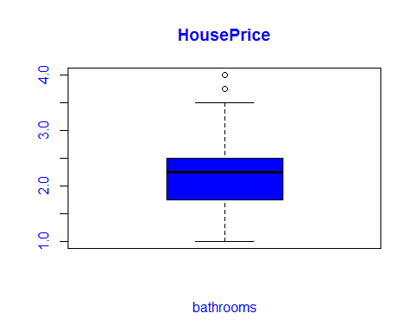

#******Final Correlation =  
cor(HousePrice$bathrooms,HousePrice$price)

## [1] 0.475159

# SQFT LIVING ANALYSIS

hist(HousePrice$sqft_living,main = 'HousePrice',xlab = 'Sqft_living',ylab = 'No of Houses',col.main='Blue',col.axis='Blue',col.lab = 'Blue',col = 'Blue')

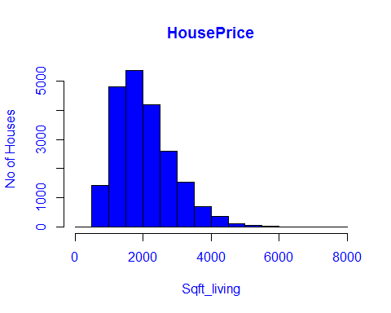

boxplot(HousePrice$sqft_living, xlab = 'Sqft_living',col.main='Blue',col.axis='Blue',col.lab = 'Blue',col = 'Blue',main = 'HousePrice')

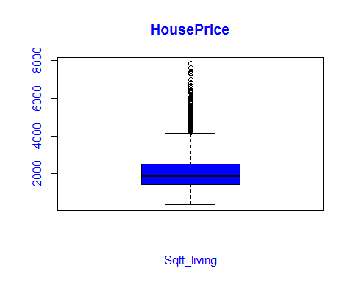

#*******Initial correlation =   
cor(HousePrice$sqft_living,HousePrice$price)

## [1] 0.6701029

#  
  
#*******Removing the outliers  
HousePrice<-subset(HousePrice,sqft_living >1000 & sqft_living<=4000)  
  
#*******Once we removed the outliers  
hist(HousePrice$sqft_living,main = 'HousePrice',xlab = 'Sqft_living',ylab = 'No of Houses',col.main='Blue',col.axis='Blue',col.lab = 'Blue',col = 'Blue')

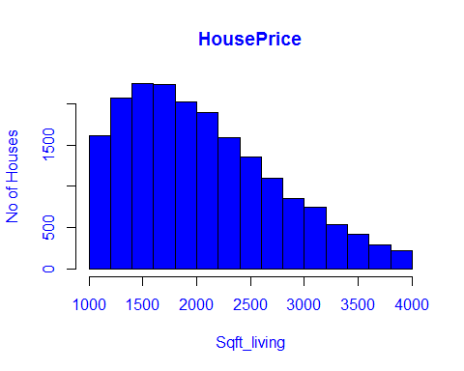

boxplot(HousePrice$sqft_living, xlab = 'Sqft_living',col.main='Blue',col.axis='Blue',col.lab = 'Blue',col = 'Blue',main = 'HousePrice')

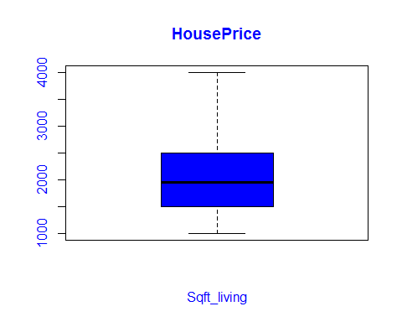

#******Final Correlation =  
cor(HousePrice$sqft_living,HousePrice$price)

## [1] 0.5938015

## GRADE ANALYSIS

boxplot(HousePrice$grade,main = 'HousePrice',xlab = 'Grade',col.main='Blue',col.axis='Blue',col.lab = 'Blue',col = 'Blue')

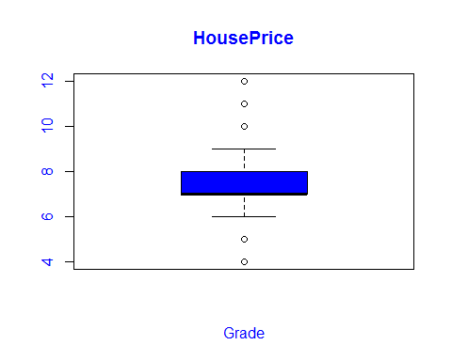

hist(HousePrice$grade,main = 'HousePrice',xlab = 'grade',ylab = 'No of Houses',col.main='Blue',col.axis='Blue',col.lab = 'Blue',col = 'Blue')

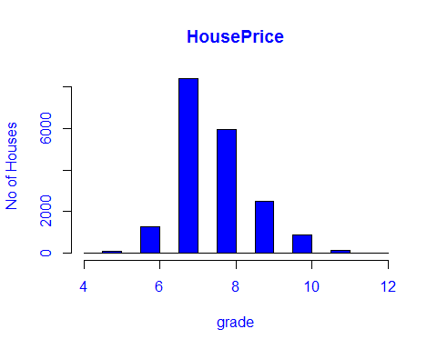

#*******Initial correlation =   
cor(HousePrice$price,HousePrice$grade)

## [1] 0.6106929

#*******Removing the outliers  
  
#Most of the houses grades are between 6-10   
HousePrice<-subset(HousePrice,grade >= 6 & grade<=10)  
  
#*******Once we removed the outliers  
  
boxplot(HousePrice$grade,main = 'HousePrice',xlab = 'Grade',col.main='Blue',col.axis='Blue',col.lab = 'Blue',col = 'Blue')

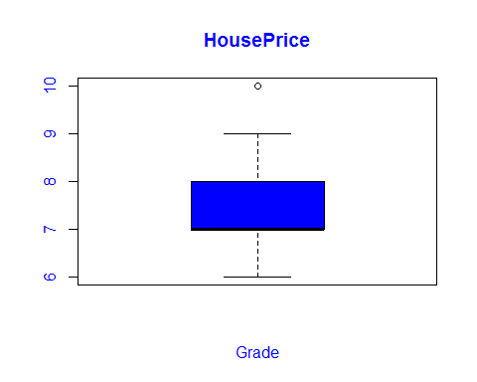

hist(HousePrice$grade,main = 'HousePrice',xlab = 'grade',ylab = 'No of Houses'  
,col.main='Blue',col.axis='Blue',col.lab = 'Blue',col = 'Blue')

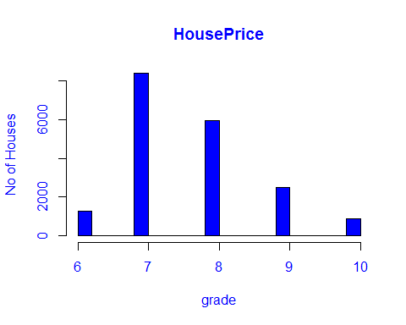

#******Final Correlation =   
cor(HousePrice$price,HousePrice$grade)

## [1] 0.592697

# SQFT_ABOVE ANALYSIS

boxplot(HousePrice$sqft_above,main = 'HousePrice',xlab = 'sqft_above',col.main='Blue',col.axis='Blue',col.lab = 'Blue',col = 'Blue')

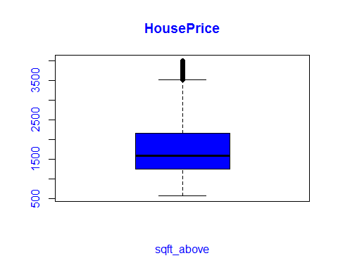

hist(HousePrice$sqft_above,main = 'HousePrice',xlab = 'sqft_above',ylab = 'No of Houses',col.main='Blue',col.axis='Blue',col.lab = 'Blue',col = 'Blue')

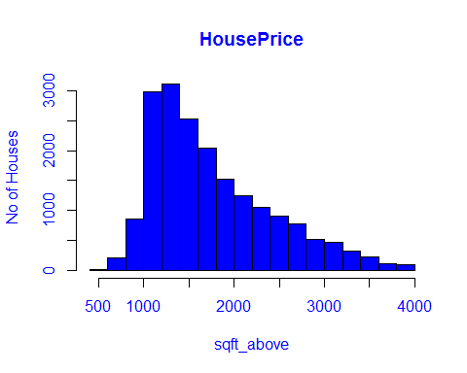

#*******Initial correlation =  
cor(HousePrice$price,HousePrice$sqft_above)

## [1] 0.4553313

#*******Removing the outliers  
HousePrice<-subset(HousePrice,sqft_above >=500 & sqft_above<=3500)  
  
#*******Once we removed the outliers  
  
boxplot(HousePrice$sqft_above,main = 'HousePrice',xlab = 'sqft_above',col.main='Blue',col.axis='Blue',col.lab = 'Blue',col = 'Blue')

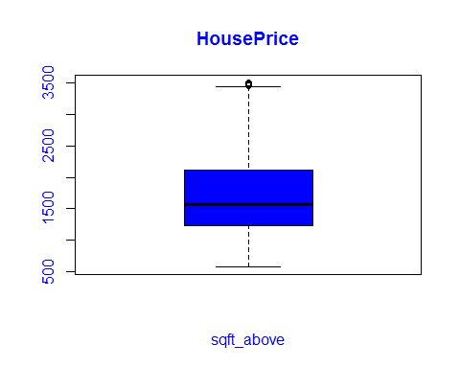

hist(HousePrice$sqft_above,main = 'HousePrice',xlab = 'sqft_above',ylab = 'No of Houses',col.main='Blue',col.axis='Blue',col.lab = 'Blue',col = 'Blue')

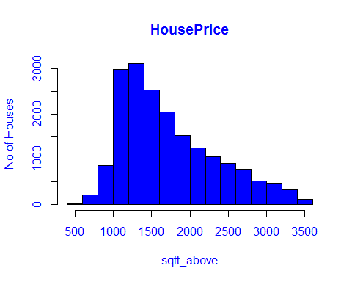

#******Final Correlation =   
cor(HousePrice$price,HousePrice$sqft_above)

## [1] 0.4254812

# YR_BUILT ANALYSIS

##YR_BUILT ANALYSIS  
hist(HousePrice$yr_built,main = 'HousePrice',xlab = 'yr_built',ylab = 'No of Houses',col.main='Blue',col.axis='Blue',col.lab = 'Blue',col = 'Blue')

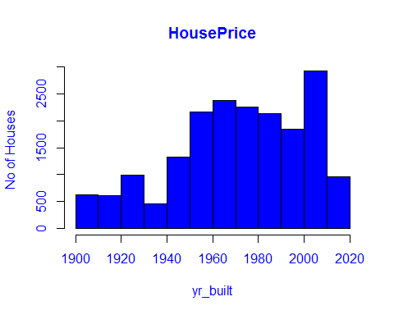

boxplot(HousePrice$yr_built,main = 'HousePrice',xlab = 'yr_built',col.main='Blue',col.axis='Blue',col.lab = 'Blue',col = 'Blue')

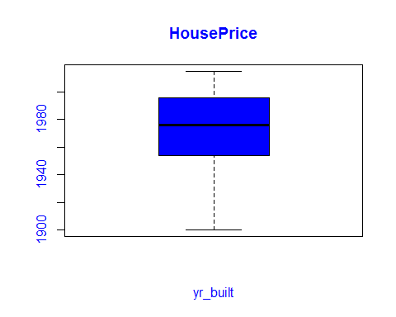

#*******Initial correlation =  
cor(HousePrice$price,HousePrice$yr_built)

## [1] -0.07805272

#*******Removing the outliers  
#In our data some records are too old..I just removed that data from my model.  
#Because It doesn't make any sense to keep more than 100 years house in our model  
HousePrice<-subset(HousePrice,yr_built>=1950& yr_built<=2015)  
  
#*******Once we removed the outliers  
  
hist(HousePrice$yr_built,main = 'HousePrice',xlab = 'yr_built',ylab = 'No of Houses',col.main='Blue',col.axis='Blue',col.lab = 'Blue',col = 'Blue')

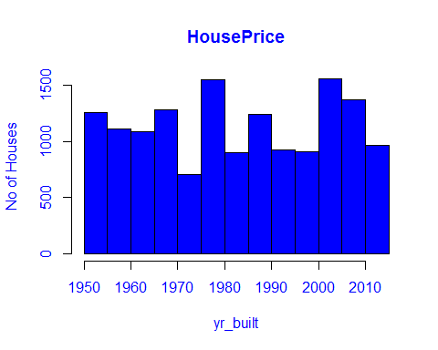

boxplot(HousePrice$yr_built,main = 'HousePrice',xlab = 'yr_built',col.main='Blue',col.axis='Blue',col.lab = 'Blue',col = 'Blue')

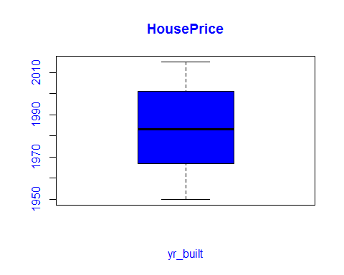

#******Final Correlation =   
cor(HousePrice$price,HousePrice$yr_built)

## [1] 0.08555947

# ZIPCODE ANALYSIS

plot(HousePrice$price~HousePrice$zipcode,main = 'HousePrice',xlab = 'zipcode',ylab = 'price',col.main='Blue',col.axis='Blue',col.lab = 'Blue',col = 'Blue')

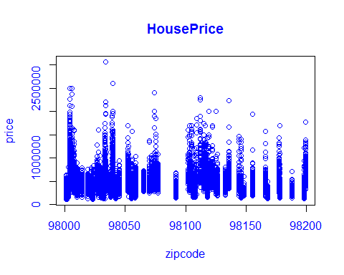

#correlation =   
cor(HousePrice$price,HousePrice$zipcode)

## [1] -0.02647096

## CONDITION aNALYSIS

hist(HousePrice$condition,main = 'HousePrice',xlab = 'condition',ylab = 'No of Houses',col.main='Blue',col.axis='Blue',col.lab = 'Blue',col = 'Blue')

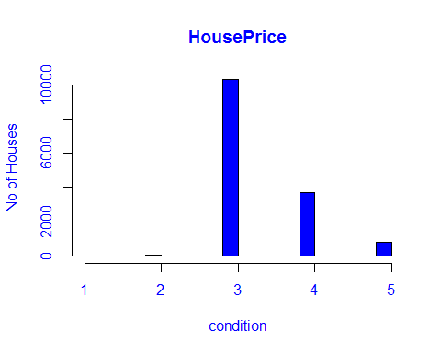

#*******Removing the outliers  
HousePrice<-subset(HousePrice,condition>=3& condition<=5)  
  
#*******Once we removed the outliers  
# Most of the houses are of condition 3-5  
  
hist(HousePrice$condition,main = 'HousePrice',xlab = 'condition',ylab = 'No of Houses',col.main='Blue',col.axis='Blue',col.lab = 'Blue',col = 'Blue')

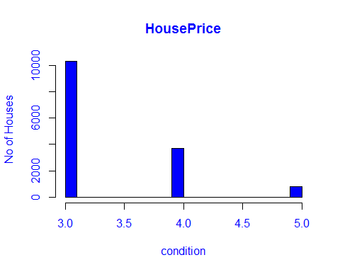

#*********correlation =   
cor(HousePrice$price,HousePrice$condition)

## [1] 0.02442002

plot(HousePrice$price~HousePrice$condition)

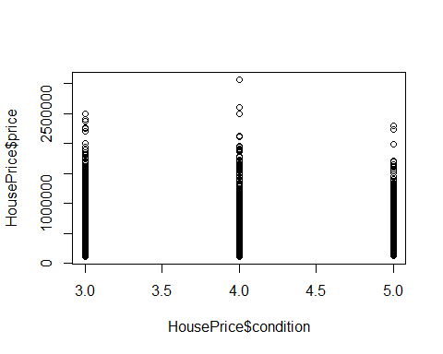

## SQFT_BASEMENT ANALYSIS

#*******Initial correlation =   
cor(HousePrice$price,HousePrice$sqft_basement)

## [1] 0.2254519

hist(HousePrice$sqft_basement,main = 'HousePrice',xlab = 'sqft_basment',ylab = 'No of Houses',col.main='Blue',col.axis='Blue',col.lab = 'Blue',col = 'Blue')

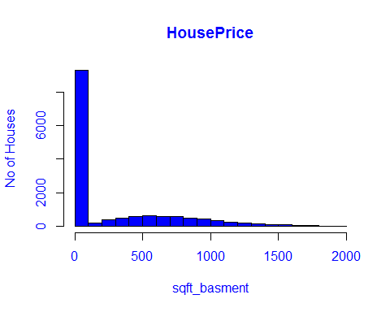

#*******Removing the outliers  
HousePrice<-subset(HousePrice,sqft_basement >=0 & sqft_basement<=1500)  
  
#*******Once we removed the outliers  
#*************Final correlation =   
cor(HousePrice$price,HousePrice$sqft_basement)

## [1] 0.1879221

hist(HousePrice$sqft_basement,main = 'HousePrice',xlab = 'sqft_basment',ylab = 'No of Houses',col.main='Blue',col.axis='Blue',col.lab = 'Blue',col = 'Blue')

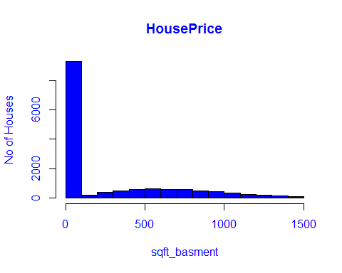

boxplot(HousePrice$sqft_basement,main = 'HousePrice',xlab = 'sqft_basment',col.main='Blue',col.axis='Blue',col.lab = 'Blue',col = 'Blue')

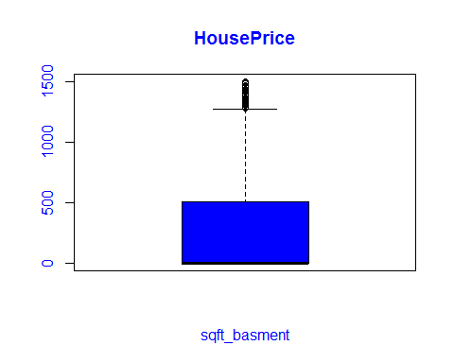

## LAT ANALYSIS

hist(HousePrice$lat, main = 'HousePrice',xlab = 'lat',col.main='Blue',col.axis='Blue',col.lab = 'Blue',col = 'Blue')

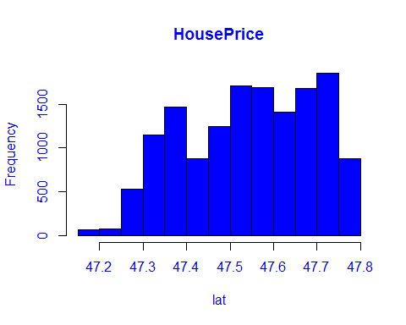

boxplot(HousePrice$lat,main = 'HousePrice',xlab = 'lat',col.main='Blue',col.axis='Blue',col.lab = 'Blue',col = 'Blue')

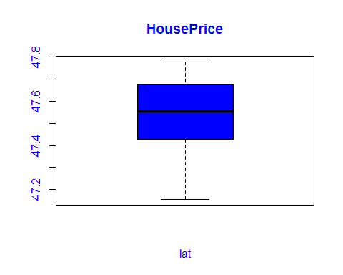

#*********Initial Correlation =  
cor(HousePrice$price,HousePrice$lat)

## [1] 0.4161934

#*******Removing the outliers  
HousePrice<-subset(HousePrice,lat>=47.3)  
  
#*******Once we removed the outliers  
#************Final Correlation =   
cor(HousePrice$price,HousePrice$lat)

## [1] 0.3848454

hist(HousePrice$lat, main = 'HousePrice',xlab = 'lat',ylab = 'No of Houses',col.main='Blue',col.axis='Blue',col.lab = 'Blue',col = 'Blue')

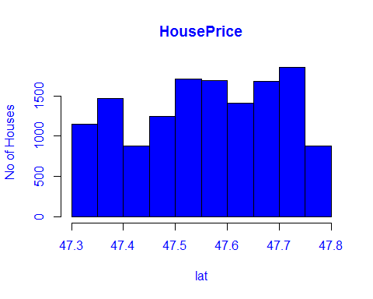

boxplot(HousePrice$lat,main = 'HousePrice',xlab = 'lat',col.main='Blue',col.axis='Blue',col.lab = 'Blue',col = 'Blue')

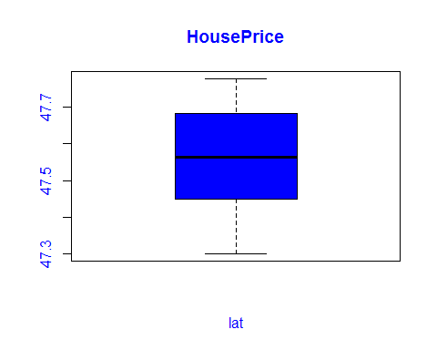

## LONG ANALYSIS

hist(HousePrice$long,main = 'HousePrice',xlab = 'long',ylab = 'No of Houses',col.main='Blue',col.axis='Blue',col.lab = 'Blue',col = 'Blue')

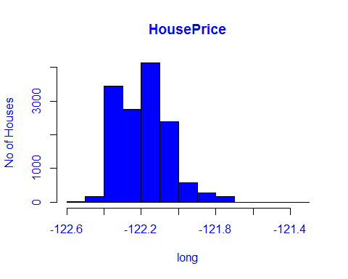

#*********Initial Correlation =  
cor(HousePrice$price,HousePrice$long)

## [1] 0.03740839

#*******Removing the outliers  
HousePrice<-subset(HousePrice,long>=-122.4 & long < -121.8)  
  
#*******Once we removed the outliers  
#************Final Correlation =   
cor(HousePrice$price,HousePrice$long)

## [1] 0.0746599

hist(HousePrice$long,main = 'HousePrice',xlab = 'long',ylab = 'No of Houses',col.main='Blue',col.axis='Blue',col.lab = 'Blue',col = 'Blue')

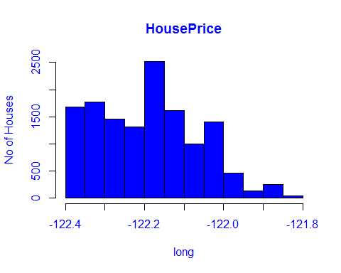

## SQFT_LOT ANALYSIS

hist(HousePrice$sqft_lot,main = 'HousePrice',xlab = 'sqft_lot',ylab = 'No of Houses',col.main='Blue',col.axis='Blue',col.lab = 'Blue',col = 'Blue')

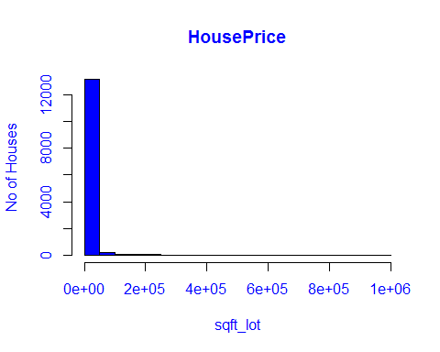

boxplot(HousePrice$sqft_lot,main = 'HousePrice',xlab = 'sqft_lot', col.main='Blue',col.axis='Blue',col.lab = 'Blue',col = 'Blue')

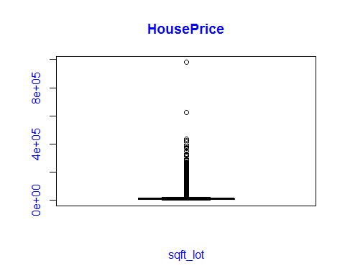

#*********Initial Correlation =  
cor(HousePrice$price,HousePrice$sqft_lot)

## [1] 0.09390182

#*******Removing the outliers  
HousePrice<-subset(HousePrice,sqft_lot>=0 & sqft_lot<=25000)  
  
#*******Once we removed the outliers  
#************Final Correlation =   
cor(HousePrice$price,HousePrice$sqft_lot)

## [1] 0.1228599

hist(HousePrice$sqft_lot,main = 'HousePrice',xlab = 'sqft_lot',ylab = 'No of Houses',col.main='Blue',col.axis='Blue',col.lab = 'Blue',col = 'Blue')

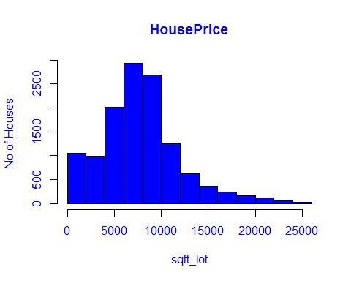

boxplot(HousePrice$sqft_lot,main = 'HousePrice',xlab = 'sqft_lot', col.main='Blue',col.axis='Blue',col.lab = 'Blue',col = 'Blue')

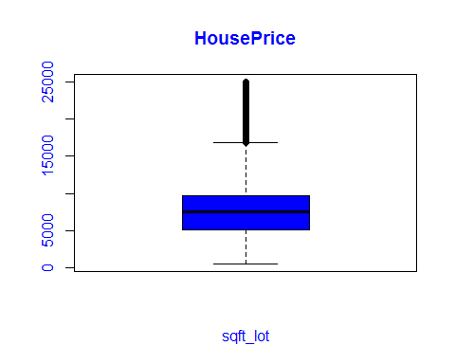

## FLOOR ANALYSIS

hist(HousePrice$floors,main = 'HousePrice',xlab = 'floors',ylab = 'No of Houses',col.main='Blue',col.axis='Blue',col.lab = 'Blue',col = 'Blue')

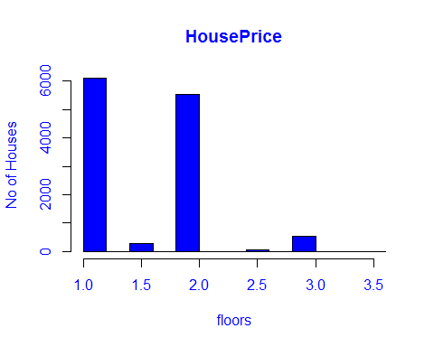

boxplot(HousePrice$floors,main = 'HousePrice',xlab = 'floors' ,col.main='Blue',col.axis='Blue',col.lab = 'Blue',col = 'Blue')

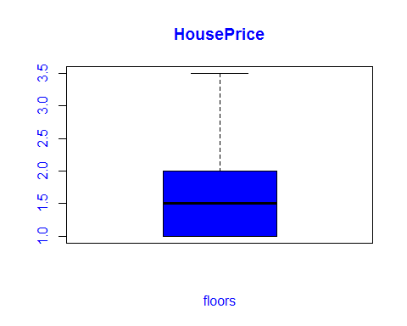

#*********Initial Correlation =  
cor(HousePrice$price,HousePrice$floors)

## [1] 0.189869

## SQFT_LIVING15 ANALYSIS

hist(HousePrice$sqft_living15, main = 'HousePrice',xlab = 'sqft_living15', ylab = 'No of Houses',col.main='Blue',col.axis='Blue',col.lab = 'Blue', col = 'Blue')

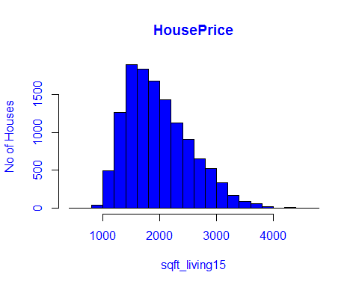

boxplot(HousePrice$sqft_living15,main = 'HousePrice',xlab = 'sqft_living15', col.main='Blue',col.axis='Blue',col.lab = 'Blue',col = 'Blue')

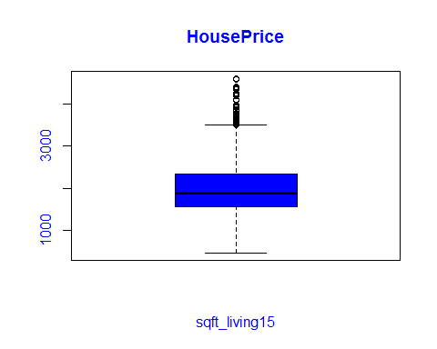

#************Final Correlation =   
cor(HousePrice$sqft_living15,HousePrice$price )

## [1] 0.5377631

## SQFT_LOT15 ANALYSIS

hist(HousePrice$sqft_lot15, main = 'HousePrice',xlab = 'sqft_lot15', ylab = 'No of Houses',col.main='Blue',col.axis='Blue',col.lab = 'Blue', col = 'Blue')

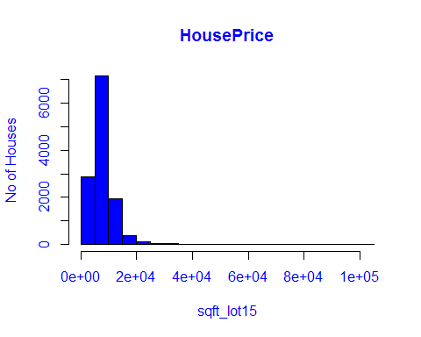

boxplot(HousePrice$sqft_lot15,main = 'HousePrice',xlab = 'sqft_lot15',col.main='Blue',col.axis='Blue',col.lab = 'Blue',col = 'Blue')

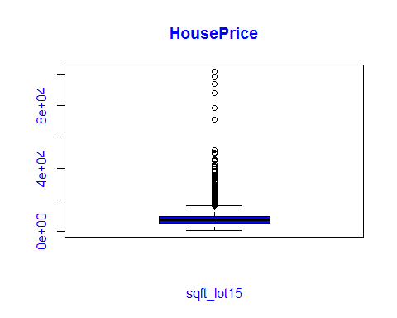

#************initial Correlation =   
cor(HousePrice$sqft_lot15,HousePrice$price)

## [1] 0.1155467

#*******Removing the outliers  
HousePrice<-subset(HousePrice,sqft_lot15>=0 & sqft_lot<=20000)  
  
#*******Once we removed the outliers  
hist(HousePrice$sqft_lot15, main = 'HousePrice',xlab = 'sqft_lot15', ylab = 'No of Houses',col.main='Blue',col.axis='Blue',col.lab = 'Blue', col = 'Blue')

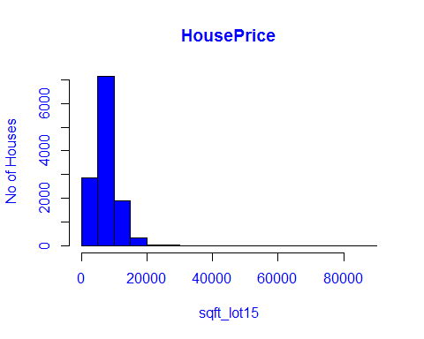

boxplot(HousePrice$sqft_lot15,main = 'HousePrice',xlab = 'sqft_lot15',col.main='Blue',col.axis='Blue',col.lab = 'Blue',col = 'Blue')

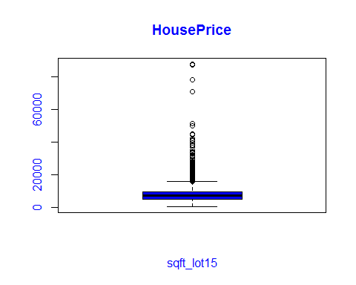

#************Final Correlation =   
cor(HousePrice$sqft_lot15,HousePrice$price)

## [1] 0.1046768

## Correlation among all the variables

#*******Only sqft_living & sqft_above,sqft_living & grade,sqft_living & bathrooms have good correlation between them  
HousePrice$date <- NULL  
cor(HousePrice)

## id price bedrooms bathrooms sqft_living  
## id 1.00000000 0.03088511 -0.00248828 0.05248387 0.05591911  
## price 0.03088511 1.00000000 0.21316110 0.40694539 0.58753189  
## bedrooms -0.00248828 0.21316110 1.00000000 0.35967366 0.54595425  
## bathrooms 0.05248387 0.40694539 0.35967366 1.00000000 0.61084492  
## sqft_living 0.05591911 0.58753189 0.54595425 0.61084492 1.00000000  
## sqft_lot -0.04881811 0.09879146 0.21379756 -0.15003858 0.21349737  
## floors 0.03142587 0.19599487 -0.01231716 0.48824267 0.21834143  
## waterfront -0.00601867 0.18723046 -0.02388155 0.02402709 0.04512995  
## view 0.04845104 0.32126248 0.04370921 0.10743868 0.20290469  
## condition -0.05442527 0.01080196 0.05075847 -0.20275433 -0.08704616  
## grade 0.06542157 0.62532384 0.17613009 0.51361808 0.62530895  
## sqft_above 0.06310017 0.47583099 0.37950422 0.52925673 0.80769249  
## sqft_basement -0.01105019 0.18482790 0.27249273 0.13661508 0.31810283  
## yr_built 0.07163873 0.11886923 -0.02014115 0.56553240 0.25215473  
## yr_renovated -0.01141468 0.10260750 0.01761968 0.01698352 0.02780418  
## zipcode -0.03344919 -0.06661544 -0.10383298 -0.08873701 -0.13655332  
## lat -0.01028660 0.39782088 -0.04362736 0.03452169 0.02941721  
## long 0.09490813 0.06021992 0.09157411 0.15541240 0.21179591  
## sqft_living15 0.07487106 0.53192136 0.34578440 0.44219575 0.73234542  
## sqft_lot15 -0.05544805 0.10467684 0.16855680 -0.13671006 0.17733937  
## sqft_lot floors waterfront view condition  
## id -0.04881811 0.03142587 -0.006018670 0.04845104 -0.05442527  
## price 0.09879146 0.19599487 0.187230461 0.32126248 0.01080196  
## bedrooms 0.21379756 -0.01231716 -0.023881549 0.04370921 0.05075847  
## bathrooms -0.15003858 0.48824267 0.024027088 0.10743868 -0.20275433  
## sqft_living 0.21349737 0.21834143 0.045129953 0.20290469 -0.08704616  
## sqft_lot 1.00000000 -0.46764775 0.061281460 0.10171693 0.27240654  
## floors -0.46764775 1.00000000 0.020419644 -0.01755120 -0.36800514  
## waterfront 0.06128146 0.02041964 1.000000000 0.34042155 0.01009095  
## view 0.10171693 -0.01755120 0.340421549 1.00000000 0.03451890  
## condition 0.27240654 -0.36800514 0.010090951 0.03451890 1.00000000  
## grade 0.01799467 0.40495046 0.058898054 0.18464079 -0.19021868  
## sqft_above 0.10812840 0.46766878 0.019014619 0.06247316 -0.19571109  
## sqft_basement 0.17132458 -0.39896785 0.042393068 0.22760950 0.17395516  
## yr_built -0.47268086 0.72279773 -0.025271092 -0.08730803 -0.45609638  
## yr_renovated 0.04836387 -0.03403060 0.050423835 0.06473431 -0.04580786  
## zipcode -0.20648742 0.02202050 0.049153202 0.11697692 -0.09996766  
## lat -0.05925894 0.05026221 -0.007680641 0.01912452 -0.04700562  
## long 0.15246300 0.07677540 -0.010330764 -0.10532559 -0.04109049  
## sqft_living15 0.26717897 0.16001569 0.063053624 0.22038305 -0.07723497  
## sqft_lot15 0.80071360 -0.40438723 0.101403098 0.10986952 0.24966404  
## grade sqft_above sqft_basement yr_built  
## id 0.0654215660 0.063100165 -0.0110501872 0.07163873  
## price 0.6253238358 0.475830987 0.1848279021 0.11886923  
## bedrooms 0.1761300924 0.379504224 0.2724927258 -0.02014115  
## bathrooms 0.5136180759 0.529256730 0.1366150794 0.56553240  
## sqft_living 0.6253089478 0.807692487 0.3181028274 0.25215473  
## sqft_lot 0.0179946663 0.108128401 0.1713245799 -0.47268086  
## floors 0.4049504567 0.467668775 -0.3989678500 0.72279773  
## waterfront 0.0588980541 0.019014619 0.0423930680 -0.02527109  
## view 0.1846407902 0.062473162 0.2276095048 -0.08730803  
## condition -0.1902186768 -0.195711088 0.1739551648 -0.45609638  
## grade 1.0000000000 0.629292059 -0.0008512015 0.41391909  
## sqft_above 0.6292920588 1.000000000 -0.3020484503 0.43178138  
## sqft_basement -0.0008512015 -0.302048450 1.0000000000 -0.28659200  
## yr_built 0.4139190905 0.431781375 -0.2865920034 1.00000000  
## yr_renovated 0.0137545251 0.005527641 0.0360665829 -0.14488568  
## zipcode -0.0963141760 -0.207857824 0.1134416369 -0.10071641  
## lat 0.1244168337 -0.030479955 0.0965731536 -0.05718985  
## long 0.1212933902 0.346947946 -0.2154373008 0.25864663  
## sqft_living15 0.6095840261 0.677956453 0.0939590371 0.21331396  
## sqft_lot15 0.0242929122 0.088065155 0.1451238319 -0.41247570  
## yr_renovated zipcode lat long  
## id -0.011414678 -0.03344919 -0.010286601 0.09490813  
## price 0.102607501 -0.06661544 0.397820880 0.06021992  
## bedrooms 0.017619683 -0.10383298 -0.043627362 0.09157411  
## bathrooms 0.016983524 -0.08873701 0.034521688 0.15541240  
## sqft_living 0.027804177 -0.13655332 0.029417207 0.21179591  
## sqft_lot 0.048363871 -0.20648742 -0.059258942 0.15246300  
## floors -0.034030600 0.02202050 0.050262205 0.07677540  
## waterfront 0.050423835 0.04915320 -0.007680641 -0.01033076  
## view 0.064734312 0.11697692 0.019124515 -0.10532559  
## condition -0.045807864 -0.09996766 -0.047005621 -0.04109049  
## grade 0.013754525 -0.09631418 0.124416834 0.12129339  
## sqft_above 0.005527641 -0.20785782 -0.030479955 0.34694795  
## sqft_basement 0.036066583 0.11344164 0.096573154 -0.21543730  
## yr_built -0.144885684 -0.10071641 -0.057189850 0.25864663  
## yr_renovated 1.000000000 0.04008558 0.021904703 -0.03691168  
## zipcode 0.040085583 1.00000000 0.185270334 -0.54354459  
## lat 0.021904703 0.18527033 1.000000000 -0.08224426  
## long -0.036911680 -0.54354459 -0.082244257 1.00000000  
## sqft_living15 0.002850830 -0.25878003 0.012087716 0.33806073  
## sqft_lot15 0.060629185 -0.16726839 -0.043272796 0.13205797  
## sqft_living15 sqft_lot15  
## id 0.07487106 -0.05544805  
## price 0.53192136 0.10467684  
## bedrooms 0.34578440 0.16855680  
## bathrooms 0.44219575 -0.13671006  
## sqft_living 0.73234542 0.17733937  
## sqft_lot 0.26717897 0.80071360  
## floors 0.16001569 -0.40438723  
## waterfront 0.06305362 0.10140310  
## view 0.22038305 0.10986952  
## condition -0.07723497 0.24966404  
## grade 0.60958403 0.02429291  
## sqft_above 0.67795645 0.08806515  
## sqft_basement 0.09395904 0.14512383  
## yr_built 0.21331396 -0.41247570  
## yr_renovated 0.00285083 0.06062919  
## zipcode -0.25878003 -0.16726839  
## lat 0.01208772 -0.04327280  
## long 0.33806073 0.13205797  
## sqft_living15 1.00000000 0.25196255  
## sqft_lot15 0.25196255 1.00000000

# HousePrice regression Models

# Based on above analysis I am going to make models.

# I wii start with one variable and keep on adding others according to requirement and depending on the RMSE value.

# Linear Model using price~grade

set.seed(1)  
rn_train <- sample(nrow(HousePrice),floor(nrow(HousePrice)*0.7))  
train <- HousePrice[rn_train,colnames(HousePrice)]  
test <- HousePrice[-rn_train,colnames(HousePrice)]  
lm.price<-lm(price~grade,data = train)  
prediction <- predict(lm.price,newdata = test)  
training_data_prediction = fitted(lm.price)  
training_rmse = sqrt(sum((training_data_prediction-train$price)^2)/nrow(train))  
training_rmse

## [1] 183129.9

testing_rmse = sqrt(sum((prediction - test$price)^2)/nrow(test))  
testing_rmse

## [1] 183143.4

# Linear Model using price~grade+sqft_living

set.seed(1)  
rn_train <- sample(nrow(HousePrice),floor(nrow(HousePrice)*0.7))  
train <- HousePrice[rn_train,colnames(HousePrice)]  
test <- HousePrice[-rn_train,colnames(HousePrice)]  
lm.price<-lm(price~grade+sqft_living,data = train)  
prediction <- predict(lm.price,newdata = test)  
training_data_prediction = fitted(lm.price)  
training_rmse = sqrt(sum((training_data_prediction-train$price)^2)/nrow(train))  
training_rmse

## [1] 172884.3

testing_rmse = sqrt(sum((prediction - test$price)^2)/nrow(test))  
testing_rmse

## [1] 174402

# Linear Model using price~grade+sqft_living+lat

set.seed(1)  
rn_train <- sample(nrow(HousePrice),floor(nrow(HousePrice)*0.7))  
train <- HousePrice[rn_train,colnames(HousePrice)]  
test <- HousePrice[-rn_train,colnames(HousePrice)]  
lm.price<-lm(price~grade+sqft_living+lat,data = train)  
prediction <- predict(lm.price,newdata = test)  
training_data_prediction = fitted(lm.price)  
training_rmse = sqrt(sum((training_data_prediction-train$price)^2)/nrow(train))  
training_rmse

## [1] 153387.7

testing_rmse = sqrt(sum((prediction - test$price)^2)/nrow(test))  
testing_rmse

## [1] 155486.7

# Linear Model using price~grade+sqft_living+lat+long

set.seed(1)  
rn_train <- sample(nrow(HousePrice),floor(nrow(HousePrice)*0.7))  
train <- HousePrice[rn_train,colnames(HousePrice)]  
test <- HousePrice[-rn_train,colnames(HousePrice)]  
lm.price<-lm(price~grade+sqft_living+lat+long,data = train)  
prediction <- predict(lm.price,newdata = test)  
training_data_prediction = fitted(lm.price)  
training_rmse = sqrt(sum((training_data_prediction-train$price)^2)/nrow(train))  
training_rmse

## [1] 153253.7

testing_rmse = sqrt(sum((prediction - test$price)^2)/nrow(test))  
testing_rmse

## [1] 155244.8

# Linear Model using price~grade+sqft_living+lat+long+condition

set.seed(1)  
rn_train <- sample(nrow(HousePrice),floor(nrow(HousePrice)*0.7))  
train <- HousePrice[rn_train,colnames(HousePrice)]  
test <- HousePrice[-rn_train,colnames(HousePrice)]  
lm.price<-lm(price~grade+sqft_living+lat+long+condition,data = train)  
prediction <- predict(lm.price,newdata = test)  
training_data_prediction = fitted(lm.price)  
training_rmse = sqrt(sum((training_data_prediction-train$price)^2)/nrow(train))  
training_rmse

## [1] 150741.3

testing_rmse = sqrt(sum((prediction - test$price)^2)/nrow(test))  
testing_rmse

## [1] 151250.2

# Linear Model using price~grade+sqft_living+lat+long+condition+yr_built

set.seed(1)  
rn_train <- sample(nrow(HousePrice),floor(nrow(HousePrice)*0.7))  
train <- HousePrice[rn_train,colnames(HousePrice)]  
test <- HousePrice[-rn_train,colnames(HousePrice)]  
lm.price<-lm(price~grade+sqft_living+lat+long+condition+yr_built,data = train)  
prediction <- predict(lm.price,newdata = test)  
training_data_prediction = fitted(lm.price)  
training_rmse = sqrt(sum((training_data_prediction-train$price)^2)/nrow(train))  
training_rmse

## [1] 150108.5

testing_rmse = sqrt(sum((prediction - test$price)^2)/nrow(test))  
testing_rmse

## [1] 150743.8

# Linear Model using price~grade+sqft_living+lat+long+condition+yr_built+bedrooms

set.seed(1)  
rn_train <- sample(nrow(HousePrice),floor(nrow(HousePrice)*0.7))  
train <- HousePrice[rn_train,colnames(HousePrice)]  
test <- HousePrice[-rn_train,colnames(HousePrice)]  
lm.price<-lm(price~grade+sqft_living+lat+long+condition+yr_built+bedrooms,data = train)  
prediction <- predict(lm.price,newdata = test)  
training_data_prediction = fitted(lm.price)  
training_rmse = sqrt(sum((training_data_prediction-train$price)^2)/nrow(train))  
training_rmse

## [1] 149767

testing_rmse = sqrt(sum((prediction - test$price)^2)/nrow(test))  
testing_rmse

## [1] 150022.3

# Linear Model using price~grade+sqft_living+lat+long+condition+yr_built+bedrooms+bathrooms

set.seed(1)  
rn_train <- sample(nrow(HousePrice),floor(nrow(HousePrice)*0.7))  
train <- HousePrice[rn_train,colnames(HousePrice)]  
test <- HousePrice[-rn_train,colnames(HousePrice)]  
lm.price<-lm(price~grade+sqft_living+lat+long+condition+yr_built+bedrooms+bathrooms,data = train)  
prediction <- predict(lm.price,newdata = test)  
training_data_prediction = fitted(lm.price)  
training_rmse = sqrt(sum((training_data_prediction-train$price)^2)/nrow(train))  
training_rmse

## [1] 149009.2

testing_rmse = sqrt(sum((prediction - test$price)^2)/nrow(test))  
testing_rmse

## [1] 149582.1