library_Management_System

CREATE & USE DATABASE-
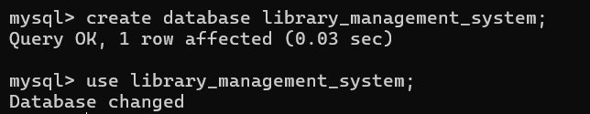
create database library_management_system;
use library_management_system;

CREATE TABLE BRANCHES-
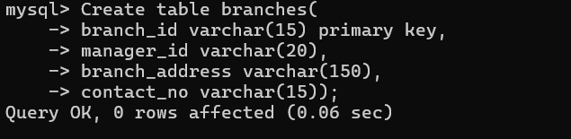
> Create table branches(
-> branch_id varchar(15) primary key,
-> manager_id varchar(20),
-> branch_address varchar(150),
-> contact_no varchar(15));

CREATE TABLE EMPLOYEES-
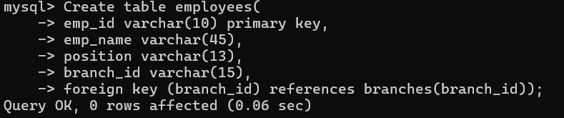
Create table employees(
-> emp_id varchar(10) primary key,
-> emp_name varchar(45),
-> position varchar(13),
-> branch_id varchar(15),
-> foreign key (branch_id) references branches(branch_id));

CREATE TABLE MEMBERS-
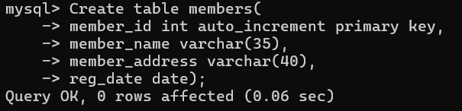
Create table members(
-> member_id int auto_increment primary key,
-> member_name varchar(35),
-> member_address varchar(40),
-> reg_date date);

CREATE TABLE BOOKS-
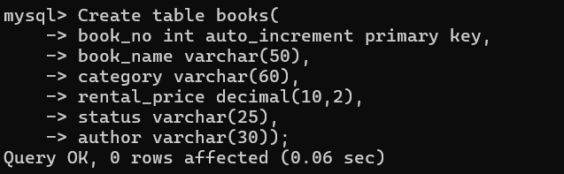
Create table books(
-> book_no int auto_increment primary key,
-> book_name varchar(50),
-> category varchar(60),
-> rental_price decimal(10,2),
-> status varchar(25),
-> author varchar(30));

CREATE TABLE ISSUED STATUS-
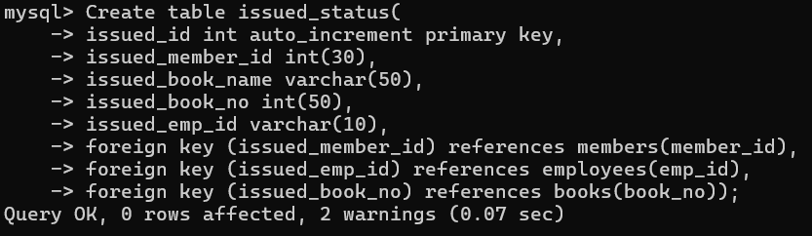
Create table issued_status(
-> issued_id int auto_increment primary key,
-> issued_member_id int(30),
-> issued_book_name varchar(50),
-> issued_book_no int(50),
-> issued_emp_id varchar(10),
-> foreign key (issued_member_id) references members(member_id),
-> foreign key (issued_emp_id) references employees(emp_id),
-> foreign key (issued_book_no) references books(book_no));

CREATE TABLE RETURN STATUS-
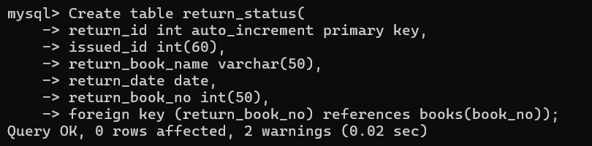
Create table return_status(
-> return_id int auto_increment primary key,
-> issued_id int(60),
-> return_book_name varchar(50),
-> return_date date,
-> return_book_no int(50),
-> foreign key (return_book_no) references books(book_no));

INSERT TABLE BRANCHES-

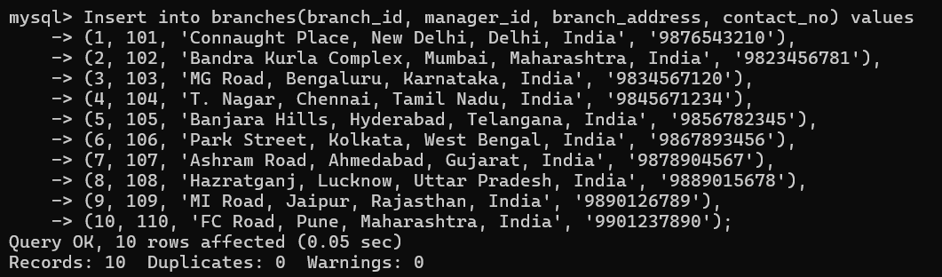
Insert into branches(branch_id, manager_id, branch_address, contact_no) values
-> (1, 101, 'Connaught Place, New Delhi, Delhi, India', '9876543210'),
-> (2, 102, 'Bandra Kurla Complex, Mumbai, Maharashtra, India', '9823456781'),
-> (3, 103, 'MG Road, Bengaluru, Karnataka, India', '9834567120'),
-> (4, 104, 'T. Nagar, Chennai, Tamil Nadu, India', '9845671234'),
-> (5, 105, 'Banjara Hills, Hyderabad, Telangana, India', '9856782345'),
-> (6, 106, 'Park Street, Kolkata, West Bengal, India', '9867893456'),
-> (7, 107, 'Ashram Road, Ahmedabad, Gujarat, India', '9878904567'),
-> (8, 108, 'Hazratganj, Lucknow, Uttar Pradesh, India', '9889015678'),
-> (9, 109, 'MI Road, Jaipur, Rajasthan, India', '9890126789'),
-> (10, 110, 'FC Road, Pune, Maharashtra, India', '9901237890');

INSERT TABLE EMPLOYEES-
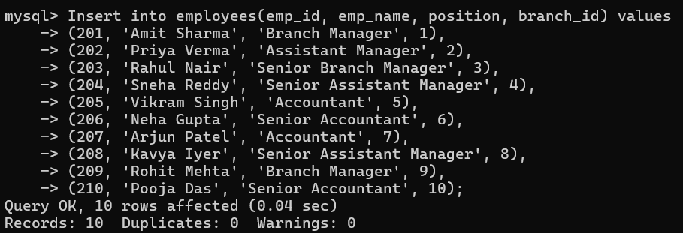
Insert into employees(emp_id, emp_name, position, branch_id) values
-> (201, 'Amit Sharma', 'Branch Manager', 1),
-> (202, 'Priya Verma', 'Assistant Manager', 2),
-> (203, 'Rahul Nair', 'Senior Branch Manager', 3),
-> (204, 'Sneha Reddy', 'Senior Assistant Manager', 4),
-> (205, 'Vikram Singh', 'Accountant', 5),
-> (206, 'Neha Gupta', 'Senior Accountant', 6),
-> (207, 'Arjun Patel', 'Accountant', 7),
-> (208, 'Kavya Iyer', 'Senior Assistant Manager', 8),
-> (209, 'Rohit Mehta', 'Branch Manager', 9),
-> (210, 'Pooja Das', 'Senior Accountant', 10);
ALTER TABLE EMPLOYEES-
alter table employees modify position varchar(70);

INSERT TABLE MEMBERS-
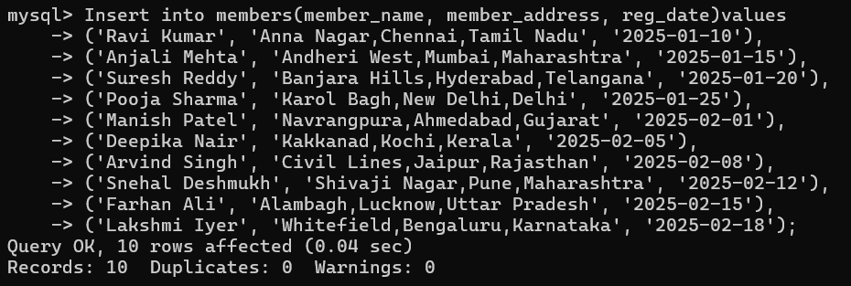
Insert into members(member_name, member_address, reg_date)values
-> ('Ravi Kumar', 'Anna Nagar,Chennai,Tamil Nadu', '2025-01-10'),
-> ('Anjali Mehta', 'Andheri West,Mumbai,Maharashtra', '2025-01-15'),
-> ('Suresh Reddy', 'Banjara Hills,Hyderabad,Telangana', '2025-01-20'),
-> ('Pooja Sharma', 'Karol Bagh,New Delhi,Delhi', '2025-01-25'),
-> ('Manish Patel', 'Navrangpura,Ahmedabad,Gujarat', '2025-02-01'),
-> ('Deepika Nair', 'Kakkanad,Kochi,Kerala', '2025-02-05'),
-> ('Arvind Singh', 'Civil Lines,Jaipur,Rajasthan', '2025-02-08'),
-> ('Snehal Deshmukh', 'Shivaji Nagar,Pune,Maharashtra', '2025-02-12'),
-> ('Farhan Ali', 'Alambagh,Lucknow,Uttar Pradesh', '2025-02-15'),
-> ('Lakshmi Iyer', 'Whitefield,Bengaluru,Karnataka', '2025-02-18');

INSERT TABLE BOOKS-
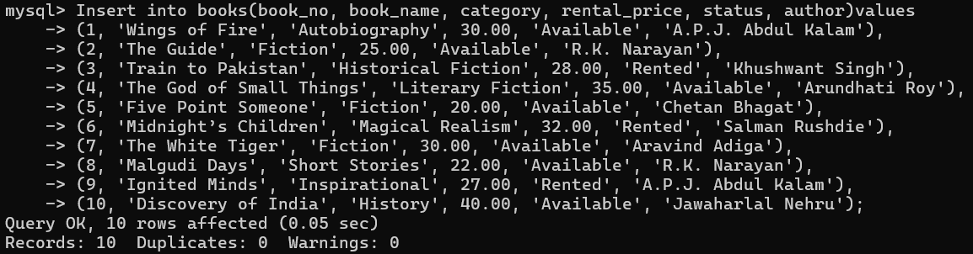
Insert into books(book_no, book_name, category, rental_price, status, author)values
-> (1, 'Wings of Fire', 'Autobiography', 30.00, 'Available', 'A.P.J. Abdul Kalam'),
-> (2, 'The Guide', 'Fiction', 25.00, 'Available', 'R.K. Narayan'),
-> (3, 'Train to Pakistan', 'Historical Fiction', 28.00, 'Rented', 'Khushwant Singh'),
-> (4, 'The God of Small Things', 'Literary Fiction', 35.00, 'Available', 'Arundhati Roy'),
-> (5, 'Five Point Someone', 'Fiction', 20.00, 'Available', 'Chetan Bhagat'),
-> (6, 'Midnight’s Children', 'Magical Realism', 32.00, 'Rented', 'Salman Rushdie'),
-> (7, 'The White Tiger', 'Fiction', 30.00, 'Available', 'Aravind Adiga'),
-> (8, 'Malgudi Days', 'Short Stories', 22.00, 'Available', 'R.K. Narayan'),
-> (9, 'Ignited Minds', 'Inspirational', 27.00, 'Rented', 'A.P.J. Abdul Kalam'),
-> (10, 'Discovery of India', 'History', 40.00, 'Available', 'Jawaharlal Nehru');

INSERT TABLE ISSUED STATUS-
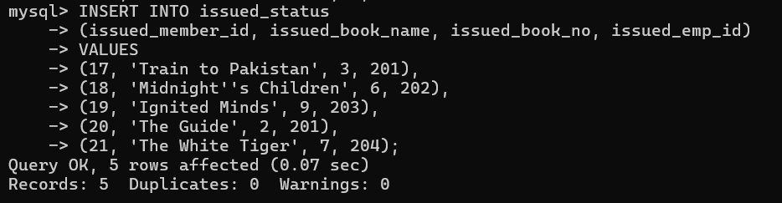
INSERT INTO issued_status
-> (issued_member_id, issued_book_name, issued_book_no, issued_emp_id)
-> VALUES
-> (17, 'Train to Pakistan', 3, 201),
-> (18, 'Midnight''s Children', 6, 202),
-> (19, 'Ignited Minds', 9, 203),
-> (20, 'The Guide', 2, 201),
-> (21, 'The White Tiger', 7, 204);

INSERT TABLE RETURN STATUS-
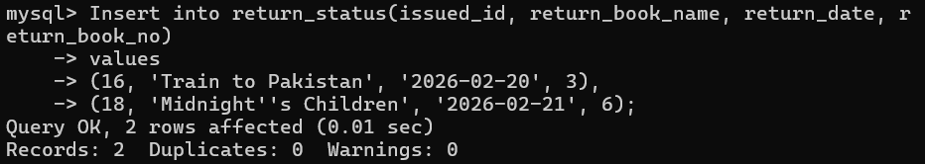
Insert into return_status(issued_id, return_book_name, return_date, return_book_no)
-> values
-> (16, 'Train to Pakistan', '2026-02-20', 3),
-> (18, 'Midnight''s Children', '2026-02-21', 6);

QUE.1. Display the list of all branches.
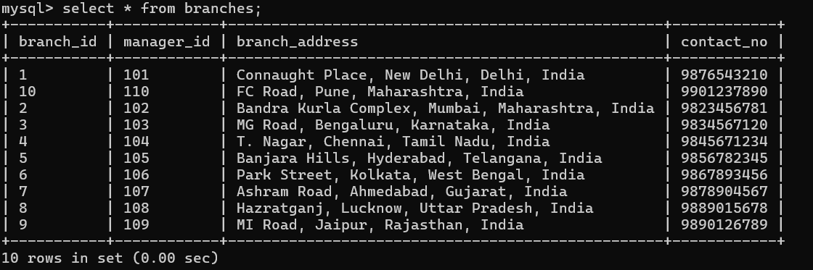
select * from branches;
+-----------+------------+--------------------------------------------------+------------+
| branch_id | manager_id | branch_address | contact_no |
+-----------+------------+--------------------------------------------------+------------+
| 1 | 101 | Connaught Place, New Delhi, Delhi, India | 9876543210 |
| 10 | 110 | FC Road, Pune, Maharashtra, India | 9901237890 |
| 2 | 102 | Bandra Kurla Complex, Mumbai, Maharashtra, India | 9823456781 |
| 3 | 103 | MG Road, Bengaluru, Karnataka, India | 9834567120 |
| 4 | 104 | T. Nagar, Chennai, Tamil Nadu, India | 9845671234 |
| 5 | 105 | Banjara Hills, Hyderabad, Telangana, India | 9856782345 |
| 6 | 106 | Park Street, Kolkata, West Bengal, India | 9867893456 |
| 7 | 107 | Ashram Road, Ahmedabad, Gujarat, India | 9878904567 |
| 8 | 108 | Hazratganj, Lucknow, Uttar Pradesh, India | 9889015678 |
| 9 | 109 | MI Road, Jaipur, Rajasthan, India | 9890126789 |
+-----------+------------+--------------------------------------------------+------------+

QUE.2. Display the list of all members.
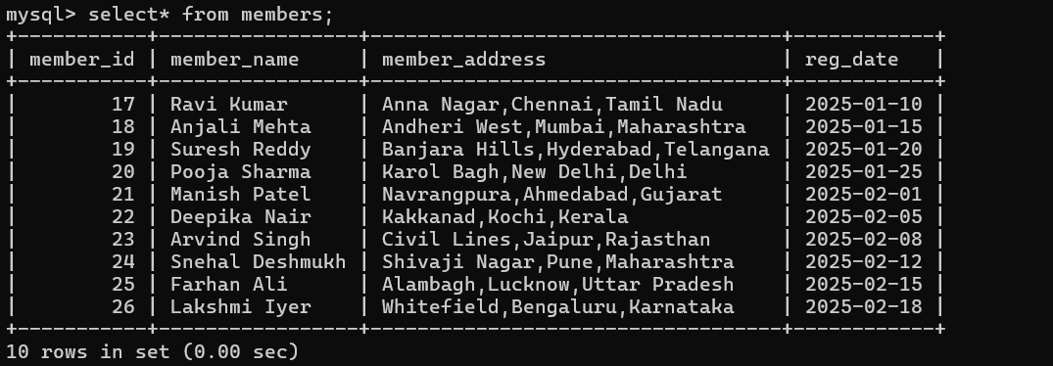
select* from members;
+-----------+-----------------+-----------------------------------+------------+
| member_id | member_name | member_address | reg_date |
+-----------+-----------------+-----------------------------------+------------+
| 17 | Ravi Kumar | Anna Nagar,Chennai,Tamil Nadu | 2025-01-10 |
| 18 | Anjali Mehta | Andheri West,Mumbai,Maharashtra | 2025-01-15 |
| 19 | Suresh Reddy | Banjara Hills,Hyderabad,Telangana | 2025-01-20 |
| 20 | Pooja Sharma | Karol Bagh,New Delhi,Delhi | 2025-01-25 |
| 21 | Manish Patel | Navrangpura,Ahmedabad,Gujarat | 2025-02-01 |
| 22 | Deepika Nair | Kakkanad,Kochi,Kerala | 2025-02-05 |
| 23 | Arvind Singh | Civil Lines,Jaipur,Rajasthan | 2025-02-08 |
| 24 | Snehal Deshmukh | Shivaji Nagar,Pune,Maharashtra | 2025-02-12 |
| 25 | Farhan Ali | Alambagh,Lucknow,Uttar Pradesh | 2025-02-15 |
| 26 | Lakshmi Iyer | Whitefield,Bengaluru,Karnataka | 2025-02-18 |
+-----------+-----------------+-----------------------------------+------------+

QUE.3. Display the list of all employee.
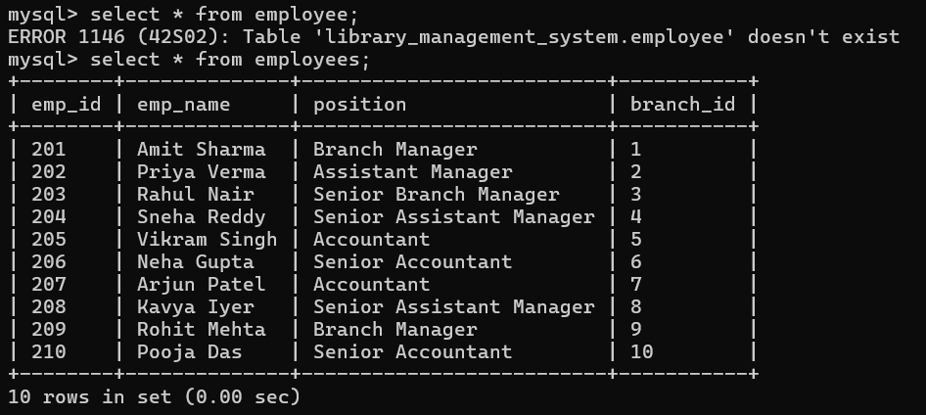
select * from employees;
+--------+--------------+--------------------------+-----------+
| emp_id | emp_name | position | branch_id |
+--------+--------------+--------------------------+-----------+
| 201 | Amit Sharma | Branch Manager | 1 |
| 202 | Priya Verma | Assistant Manager | 2 |
| 203 | Rahul Nair | Senior Branch Manager | 3 |
| 204 | Sneha Reddy | Senior Assistant Manager | 4 |
| 205 | Vikram Singh | Accountant | 5 |
| 206 | Neha Gupta | Senior Accountant | 6 |
| 207 | Arjun Patel | Accountant | 7 |
| 208 | Kavya Iyer | Senior Assistant Manager | 8 |
| 209 | Rohit Mehta | Branch Manager | 9 |
| 210 | Pooja Das | Senior Accountant | 10 |
+--------+--------------+--------------------------+-----------+

QUE.4. Display the list of all books.
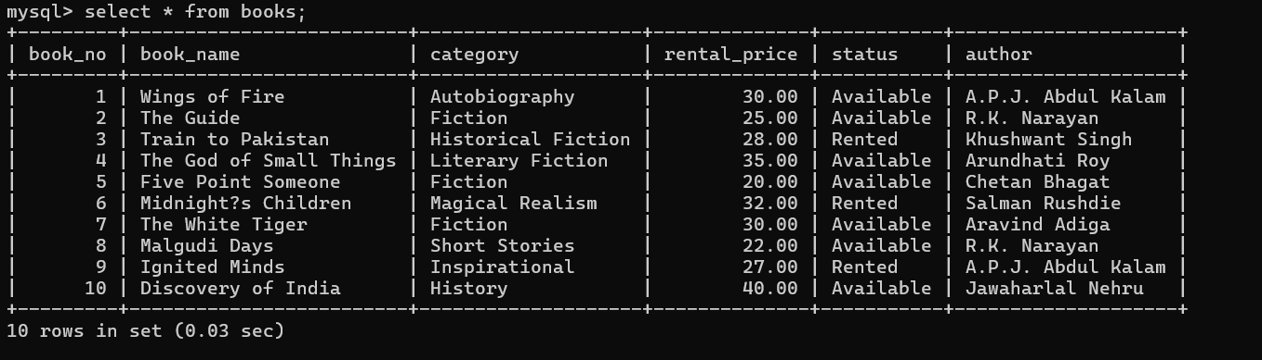
select * from books;
+---------+-------------------------+--------------------+--------------+-----------+--------------------+
| book_no | book_name | category | rental_price | status | author |
+---------+-------------------------+--------------------+--------------+-----------+--------------------+
| 1 | Wings of Fire | Autobiography | 30.00 | Available | A.P.J. Abdul Kalam |
| 2 | The Guide | Fiction | 25.00 | Available | R.K. Narayan |
| 3 | Train to Pakistan | Historical Fiction | 28.00 | Rented | Khushwant Singh |
| 4 | The God of Small Things | Literary Fiction | 35.00 | Available | Arundhati Roy |
| 5 | Five Point Someone | Fiction | 20.00 | Available | Chetan Bhagat |
| 6 | Midnight?s Children | Magical Realism | 32.00 | Rented | Salman Rushdie |
| 7 | The White Tiger | Fiction | 30.00 | Available | Aravind Adiga |
| 8 | Malgudi Days | Short Stories | 22.00 | Available | R.K. Narayan |
| 9 | Ignited Minds | Inspirational | 27.00 | Rented | A.P.J. Abdul Kalam |
| 10 | Discovery of India | History | 40.00 | Available | Jawaharlal Nehru |
+---------+-------------------------+--------------------+--------------+-----------+--------------------+

QUE.4. Display the issued_status.
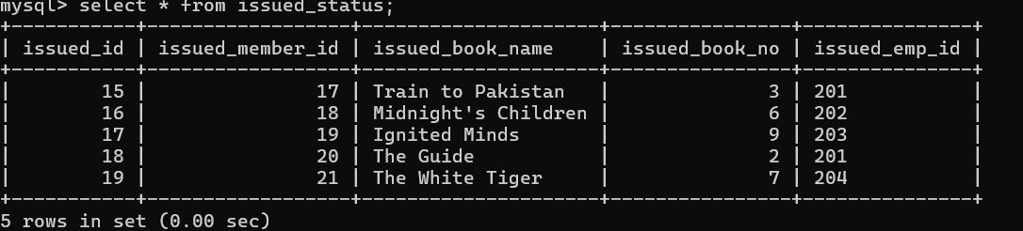
select * from issued_status;
+-----------+------------------+---------------------+----------------+---------------+
| issued_id | issued_member_id | issued_book_name | issued_book_no | issued_emp_id |
+-----------+------------------+---------------------+----------------+---------------+
| 15 | 17 | Train to Pakistan | 3 | 201 |
| 16 | 18 | Midnight's Children | 6 | 202 |
| 17 | 19 | Ignited Minds | 9 | 203 |
| 18 | 20 | The Guide | 2 | 201 |
| 19 | 21 | The White Tiger | 7 | 204 |
+-----------+------------------+---------------------+----------------+---------------+

QUE.5. Retrieve All Books in a Specific Category.
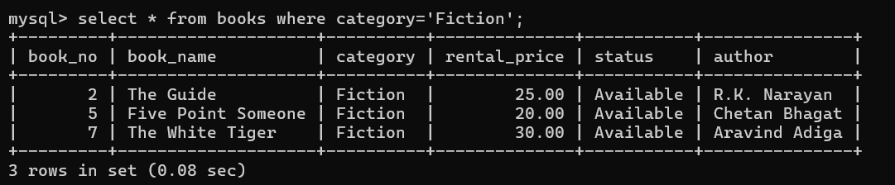
select * from books where category='Fiction';
+---------+--------------------+----------+--------------+-----------+---------------+
| book_no | book_name | category | rental_price | status | author |
+---------+--------------------+----------+--------------+-----------+---------------+
| 2 | The Guide | Fiction | 25.00 | Available | R.K. Narayan |
| 5 | Five Point Someone | Fiction | 20.00 | Available | Chetan Bhagat |
| 7 | The White Tiger | Fiction | 30.00 | Available | Aravind Adiga |
+---------+--------------------+----------+--------------+-----------+---------------+

QUE.6. Update an Existing Member's Address.
update members set member_address='swami stays 403' where member_id=17;

QUE.7. Retrieve All Books Issued by a Specific Employee.
select * from issued_status where issued_emp_id=19;

QUE.8. Retrieve All Books Issued by a Specific Member.
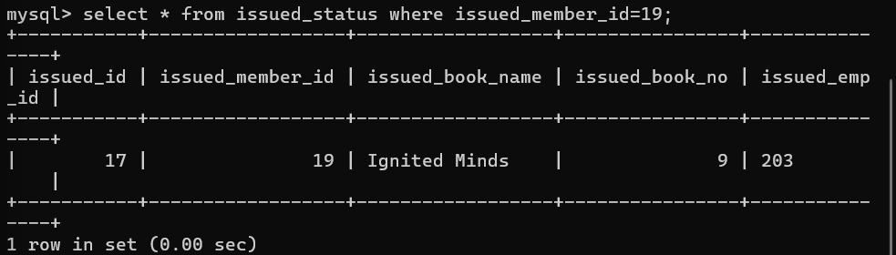
select * from issued_status where issued_member_id=19;
+-----------+------------------+------------------+----------------+---------------+
| issued_id | issued_member_id | issued_book_name | issued_book_no | issued_emp_id |
+-----------+------------------+------------------+----------------+---------------+
| 17 | 19 | Ignited Minds | 9 | 203 |
+-----------+------------------+------------------+----------------+---------------+

QUE.9. List Members Who Have Issued More Than One Book.
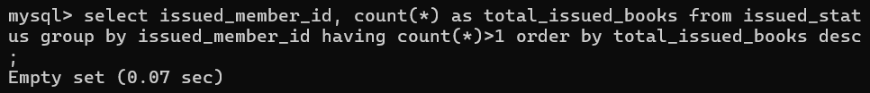
select issued_member_id, count(*) as total_issued_books from issued_status group by issued_member_id having count(*)>1 order by total_issued_books desc;

QUE.10. List Employees with Their Branch Manager's Name and their branch details.
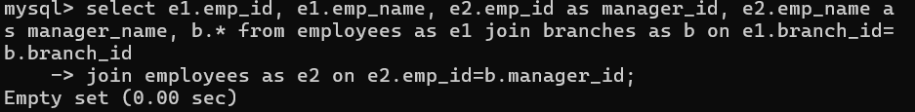
select e1.emp_id, e1.emp_name, e2.emp_id as manager_id, e2.emp_name as manager_name, b.* from employees as e1 join branches as b on e1.branch_id=b.branch_id
-> join employees as e2 on e2.emp_id=b.manager_id;

