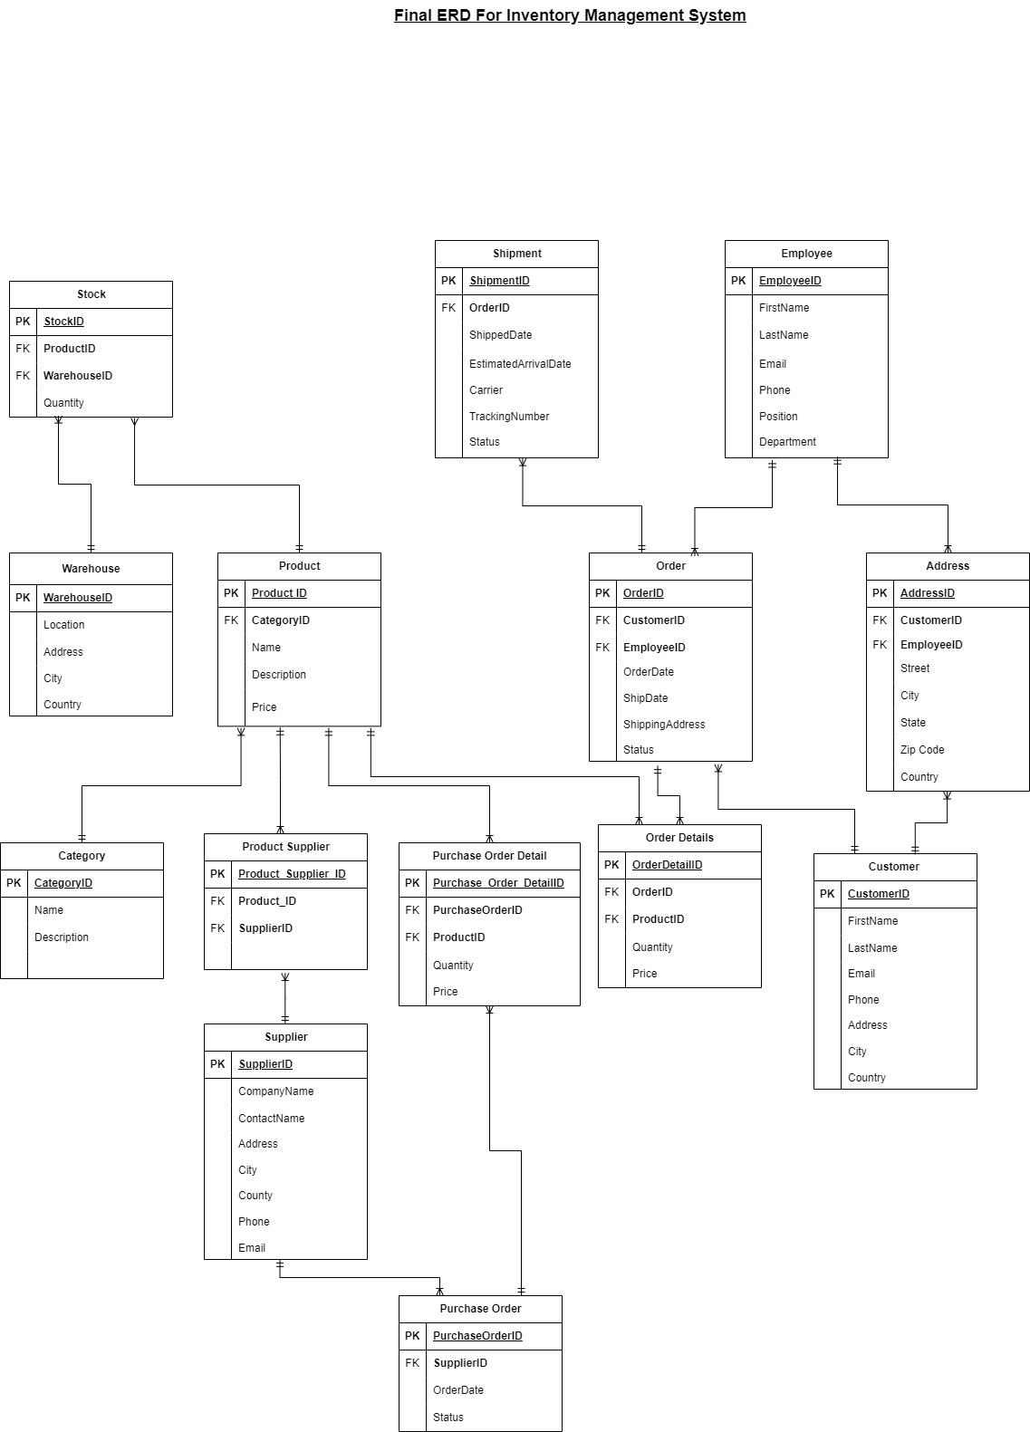

To document the changes made from the initial to the final ERD for the Inventory Management System, here's a comparison:

1. Introduction of the Address Table:

- Initial ERD: There was no separate Address table. Address details were likely duplicated within Employee and Customer tables.

- Final ERD: An Address table has been added to eliminate redundancy and allow for better normalization. This table includes AddressID as the primary key and address-related fields such as Street, City, State, Zip Code, and Country.

2. Changes in Foreign Keys:

- Initial ERD: It seems that Employee and Customer tables had direct address fields within them.

- Final ERD: CustomerID and EmployeeID has been added as foreign keys to both Employee and Customer tables to reference the Address table.

3. Changes in Cardinality:

- Initial ERD: The exact cardinalities were not mentioned, but typically, Employee and Customer tables may have been directly linked to orders or other entities without a clear address relationship.

- Final ERD: The Address table likely changed the cardinality to one-to-many (1:N) for both Employee and Customer tables, assuming that each address can be related to multiple employees and customers.

4. Associative Entity (Junction Table) Addition:

- Initial ERD: If there were many-to-many relationships directly between entities like Product and Supplier, they were not properly resolved.

- Final ERD: An associative entity (junction table) named Product_Supplier has been introduced to resolve the many-to-many relationship between Product and Supplier. The Product_Supplier table includes Product_Supplier_ID as the primary key, and ProductID and SupplierID as foreign keys.

5. Updates to Foreign Keys Placement and Cardinalities:

- Stock and Product: ProductID remains as a foreign key in the Stock table, maintaining the one-to-many relationship where a product can be in stock in multiple warehouses.

- Stock and Warehouse: WarehouseID is correctly placed as a foreign key in the Stock table, reflecting that one warehouse can contain many stock records.

- Employee and Order: The EmployeeID foreign key in the Order table suggests that one employee can be associated with many orders.

- Customer and Order: The CustomerID foreign key in the Order table maintains that one customer can place many orders.

- Order Details: The OrderID and ProductID as foreign keys in the Order Details table confirm that an order can include multiple products, and each product can be part of many orders.

- Purchase Order and Supplier: The SupplierID foreign key in the Purchase Order table supports that one supplier can have many purchase orders.

- Shipment and Order: The OrderID as a foreign key in the Shipment table indicates a one-to-many relationship where an order can have multiple shipments.

6. Renaming and Clarification of Entities:

- The ERD's naming conventions appear consistent, and the new entities and relationships are clearly labeled, which was necessary for understanding the relationships and maintaining clarity in the database schema.