**Assignment 1 Task 1**

1.To check the vision of git:

Command: git --version

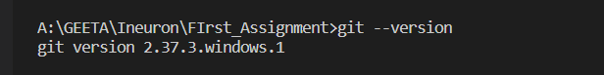

2.To initialise the new repository:

Command: git init



3.To get the status:

Command: git status



4.To get the status:

Command: git status

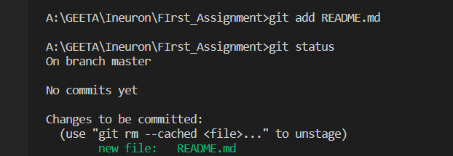

5. To add the files to a Staging Environment where **Staged** files are files that are ready to be **committed** to the repository we are working on

Command: git add .

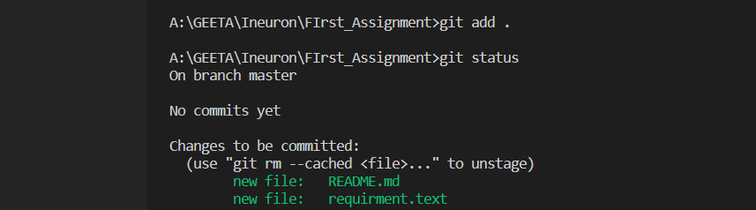

To add files and whatever changes we do to be committed

6. Commit with passed commit message

Command: git commit -m “message”

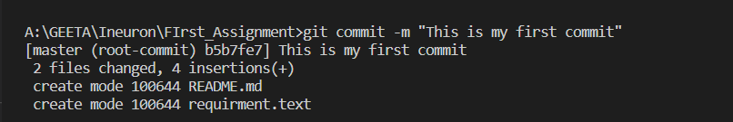

7. Rename your local master branch into main

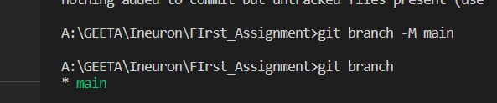

8. Adding place to add commits



9. Checking a remote branch

Command: git remote -v

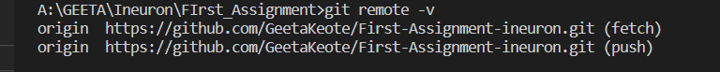

10 To move stagging to commit, adding commits keep track of our progress and changes as we work, The push command is used to upload local repository content to a remote repository.

Command: git push -u origin main

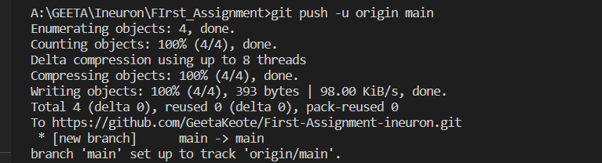

11. To view the history of commits for a repository, we can use the log command

Command: git log

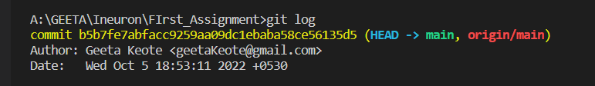

12. See all possible commands

Command: git help -- all

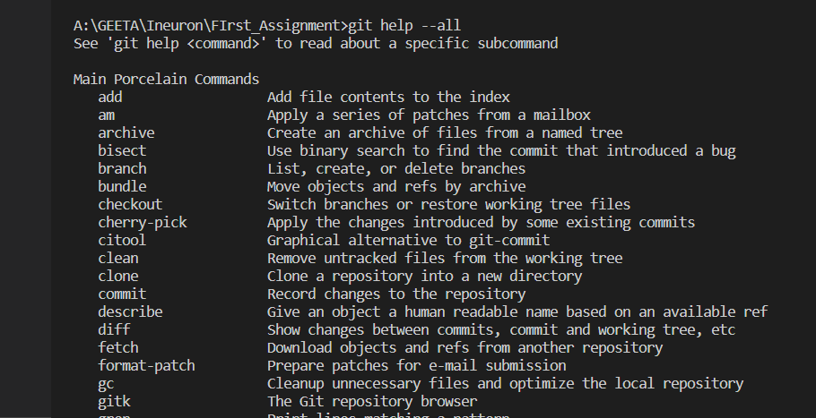

13.To create branch

Command: git branch

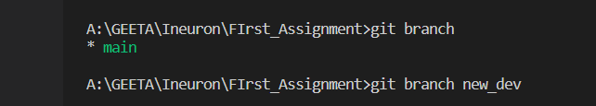

14. Switching between branches

Command: git checkout branch name

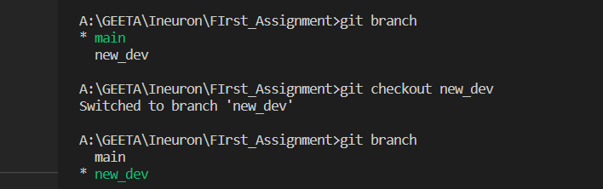

15.To merge branch in to main git merge command

Command: git merge branch name

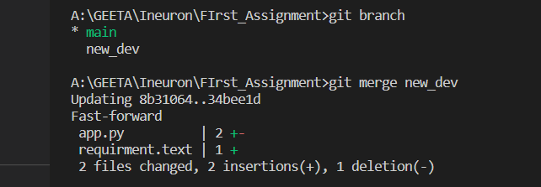

16.To delete a branch

Command: git branch -d branch name

