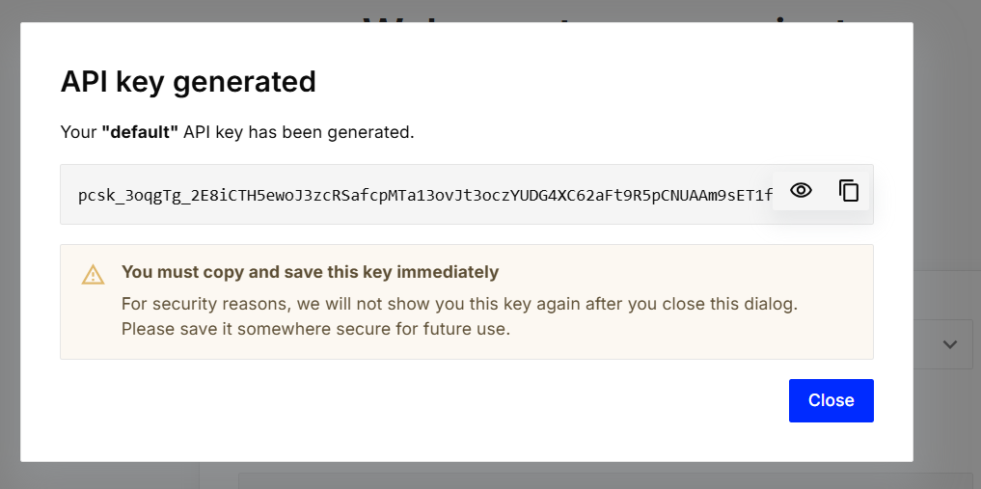

pcsk_3oqgTg_2E8iCTH5ewoJ3zcRSafcpMTa13ovJt3oczYUDG4XC62aFt9R5pCNUAAm9sET1fx **pine cone api** **key**