**EXP1: Design an LED Flasher**

**Circuit Diagram:**

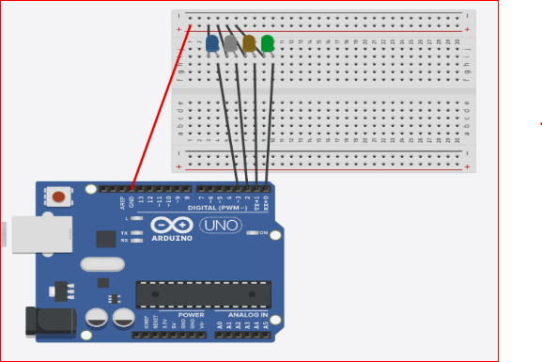

**Theory:**

**Concept Used:**

This experiment involves the flashing of four LEDs one by one using ARDUINO UNO.

For this experiment, the circuit needs to be connected as shown in the circuit diagram.

**Learning and Observation :**

Following observations were recorder during the experiment:

* There are certain time delays in between consequent LED flashes.
* The program uploaded into the ARDUINO UNO starts executing as soon as the power is supplied and goes on executing in a loop till the power is supplied.
* The ARDUINO UNO circuit can be programmed as per the requirement by just defining few functions.
* To find the least resistance that needs to be attached to the LED in a circuit to protect the LED from overload can be calculated by given formula.

**Problems and Troubleshooting:**

The problem faced while performing the experiment was the error in uploading which was the programmer not responding error.

The error was troubleshooted by disconnecting the 0 and 1 pins while uploading the program.

**Precautions:**

The following precautions need to be considered while performing this experiment.

* The USB ports of the PC and the ARDUINO UNO should be in a working condition.
* The correct serial port should be selected that is the one through which the ARDUINO UNO has been connected.
* The connections of the USB in both the PC and the ARDUINO UNO board should be snug.
* The sketch should be logically and syntactically correct to the experiment that needs to be performed.
* Do not open more than one instance of the ARDUINO IDE at a time.

**LEARNING OUTCOMES:**

The various learning as the outcome of performing the above-mentioned experiment are :

* Ability to distinguish between the various parts of the ARDUINO UNO and learn the basics of how the circuit works.
* Ability to distinguish between the setup(), loop(), digitalWrite(), pinMode(), and delay() functions and the loop and their respective working.
* Ability to write the basic code required for reading or writing digital values to a pin.
* Ability to use the ARDUINO IDE that is required for the debugging and writing the code for a particular experiment.