**Following are the projects created:**

* Egen-emulator – Sensor emulator that sends the weight to the API
* Egen-metrics – Spring boot microservice for Metrics
  + Creates the metrics in MangoDB using Morphia API
  + Calls the Egen-Alerts spring boot microservice for firing the rules for creating alerts
  + Provides API for reading all the metrics created
  + Provides API for reading the metrics by time range
* Egen-alerts
  + Runs the rules and creates alerts in MangoDB
  + Provides API for reading all the alerts created
  + Provides API for reading all the alerts by timerange

**Egen-Metrics – Project structure and execution environment**

This is built as a Maven project with the below structure

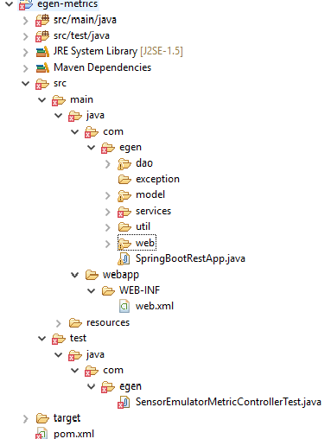

Project build: mvn clean package. This builds the project as a jar file in the target directory

Project is run using java -jar target/egen-metrics-0.0.1-SNAPSHOT.jar which starts the spring service

**Egen-Alerts – Project structure and execution environment**

The structure is same as egen-metrics structure and it is built and the service is started the same way like egen-metrics

**Once the above 2 services are started, the sensor-emulator is started:**

mvn exec:java -Dbase.value=150 -Dapi.url=http://localhost:8080/create -Dexec.mainClass="com.egen.sensor.Emulator"

This will start sending data to egen-metrics service which in turn calls the egen-alerts service

* MongoDB is started usig mongo.exe and mongod --port 27017 --dbpath c:\mongodb\data.
* C:\mongodb\data is the local path for mongodb

**Metrics can be viewed by calling the following service urls:**

<http://localhost:8080/read>

<http://localhost:8080/readByTimeRange?startTm=2017-12-02%2015:00:00&endTm=2017-12-02%2016:15:00>

**Alerts can be viewed by calling the following service urls:**

<http://localhost:8090/read>

http://localhost:8090/readByTimeRange?startTm=2017-12-02%2015:00:00&endTm=2017-12-02%2016:15:00