Development understanding

1. Application has 3 projects

* Web Application
* Web API
* Data Access Layer

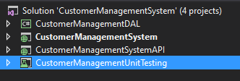

1. Application is using Entity Framework with Code First Approach
2. Web API has security in place used Web API Key, since this is the easiest way for now. We can use various ways for it.

**Web Application**

1. **Technologies -**  HTML5, CSS and JavaScript
2. Web Application uses the Web API i.e. CustomerInfoAPI for the getting the data
3. Web application has following folders

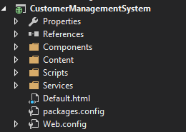

1. Components has all the HTML pages.
2. How handled security for the Web API in the headers based the security API Key as shown below

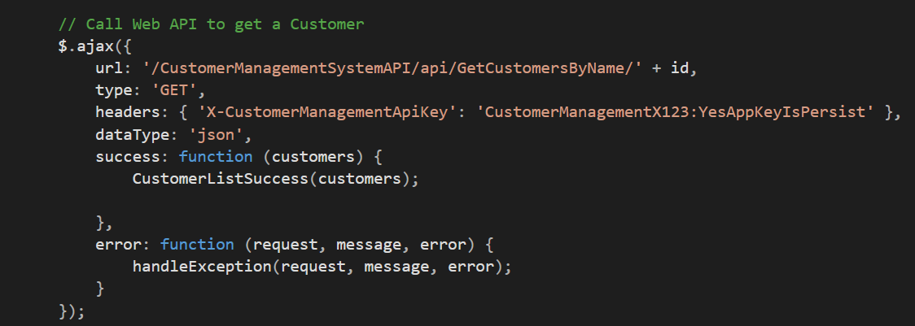

**Web API**

1. Technologies – C#, SQL Server
2. Web API

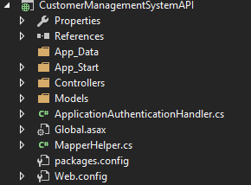

1. Web API uses the Data Access Layer for connecting the database
2. Dependency Injection used for injecting the Data Access Layer

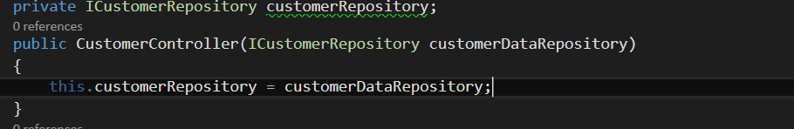

1. Use dependency resolver for the application

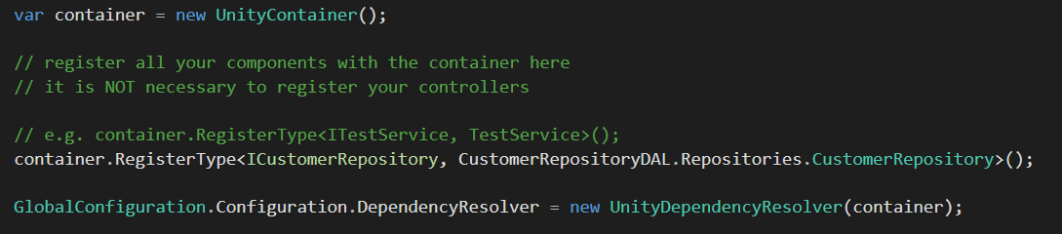

1. Added Attribute **Authorize to the methods for security purpose**

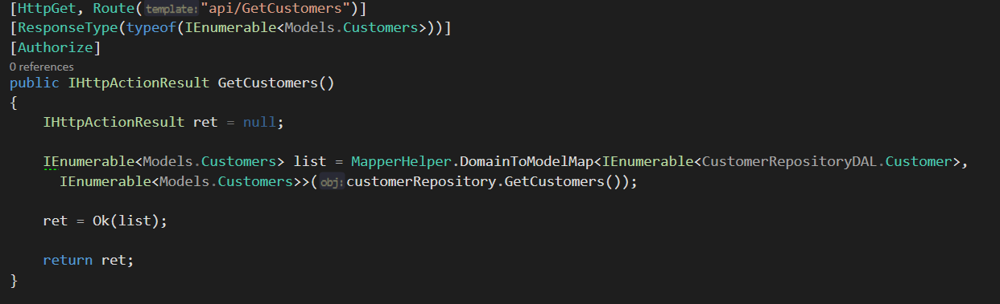

1. In the Global.asax

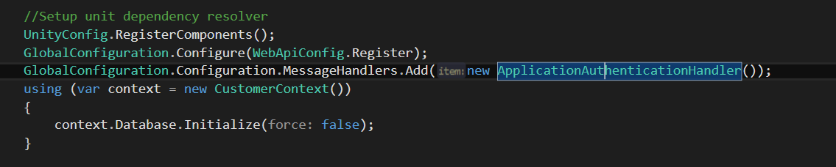

**Data Access Layer**

1. Technologies used C#, Entity Framework
2. Used code first approach where the database is created using the Entity Framework
3. Seeded data also from the application
4. 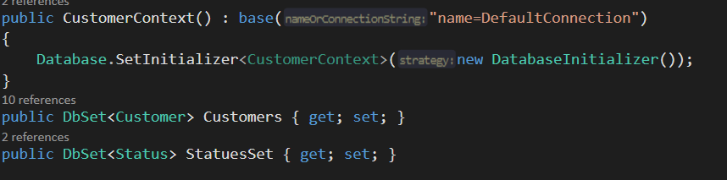
5. 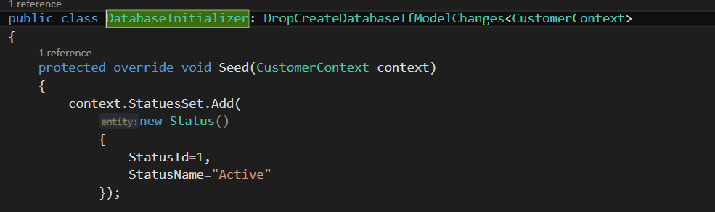
6. Used the interface for the knowing the methods to be used by the client

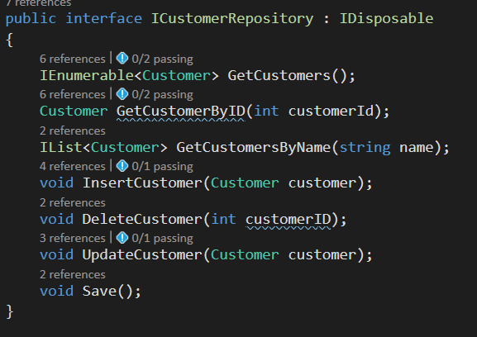

1. CustomerRepository implents the interface and uses the DataBase Context

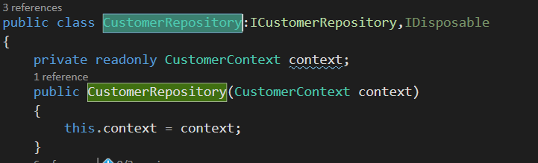

Uses Constructor Injection for the injection of the database Context class

1. Customer is the Entity which creates the table Customer in the database

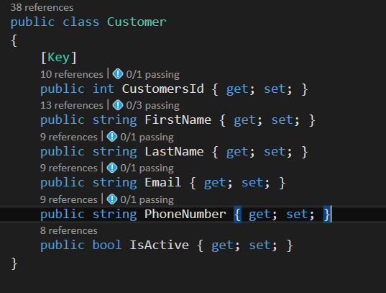

**Test Project**

1. Technologies – C#, Moq framework
2. Wrote unit test for the Data Access Layer