**Department of Computer Science & Engineering**

**Practical file submitted in partial fulfillment for the evaluation of**

**Computer Networks Lab**

**(CIC-355)**





**VIVEKANANDA INSTITUTE OF PROFESSIONAL STUDIES - TECHNICAL CAMPUS**

**Grade A++ Accredited Institution by NAAC**

NBA Accredited for MCA Programme; Recognized under Section 2(f) by UGC;

Affiliated to GGSIP University, Delhi; Recognized by Bar Council of India and AICTE

An ISO 9001:2015 Certified Institution

**SCHOOL OF ENGINEERING & TECHNOLOGY**

**INDEX**

|  |  |  |  |  |  |  |  |  |
| --- | --- | --- | --- | --- | --- | --- | --- | --- |
| S.No | EXP. | Date | Marks | | | Remark | Updated Marks | Faculty Signature |
| Laboratory Assessment (15 Marks) | Class Participation (5 Marks) | Viva (5 Marks) |  |  |  |
| 1 | Introduction to cisco packet tracer and implementation of topology | 6 Aug 2024 |  |  |  |  |  |  |
| 2 | Configuration of DHCP and DNS server | 13 Aug 2024 |  |  |  |  |  |  |
| 3 | Configuration of single router | 20 Aug 2024 |  |  |  |  |  |  |
| 4 | Configuration of WAN using two routers | 27 Aug 2024 |  |  |  |  |  |  |
| 5 | Static routing using 3 routers | 10 sept 2024 |  |  |  |  |  |  |
|  |  |  |  |  |  |  |  |  |
|  |  |  |  |  |  |  |  |  |
|  |  |  |  |  |  |  |  |  |
|  |  |  |  |  |  |  |  |  |

**EXPERIMENT 1**

**AIM-**

Introduction to cisco packet tracer and implementation of topology

**THEORY-**

**PROCEDURE-**

1. **Initial Setup:**

Open Cisco Packet Tracer and sign in with your account (only required for the first-time setup).

1. **Star Topology:**

a. Place a 2960 switch on the workspace.

b. Add multiple PCs and connect them to the switch using copper straight-through cables.

c. Double-click each PC, go to Desktop → IP Configuration, and assign an IP address. Ensure all PCs are on the same network.

d. Rename each PC according to its IP address for clarity.

e. On any PC, open Command Prompt and use the ping command to check connectivity with other PCs.

1. **Mesh Topology:**

a. Place five PCs on the screen, each with a 2960 switch.

b. Connect each PC to its respective switch using copper straight-through cables.

c. Use copper crossover cables to interconnect the switches, forming a mesh topology.

d. Assign IP addresses to each PC and test the connection by pinging other devices.

**OUTPUT-**

1. **STAR TOPOLOGY-**

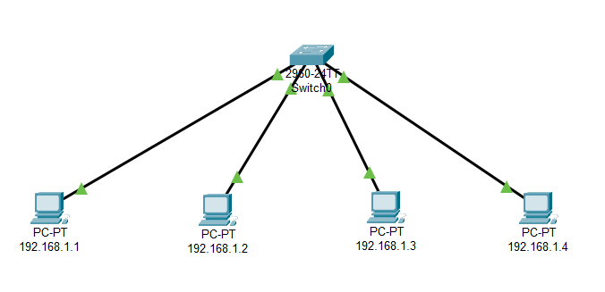

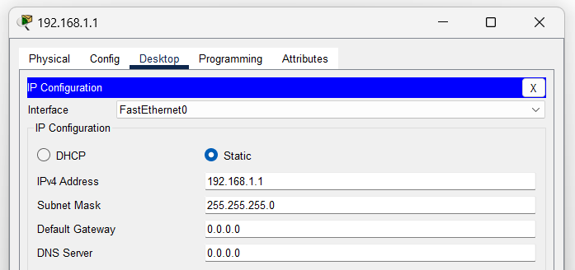

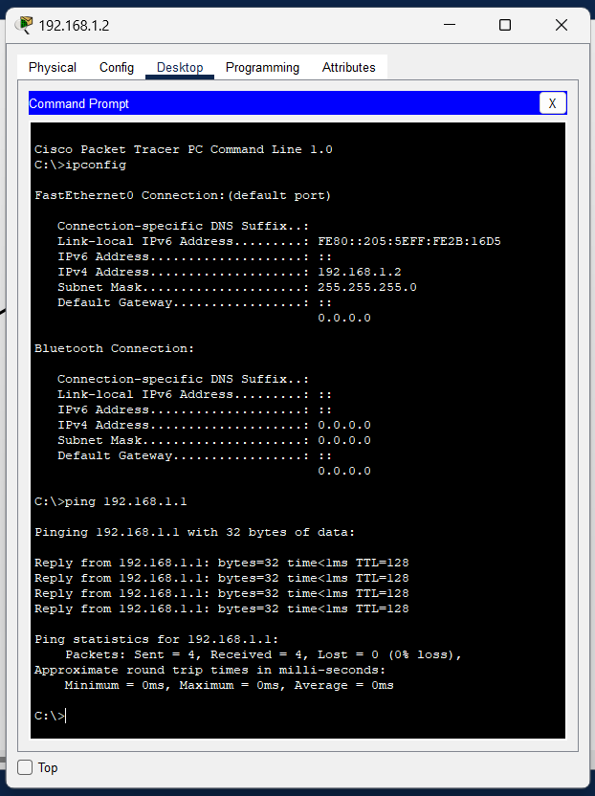

1. **MESH TOPOLOGY-**

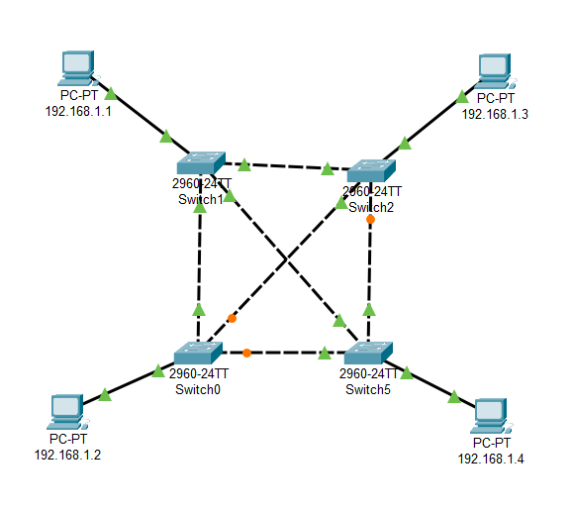

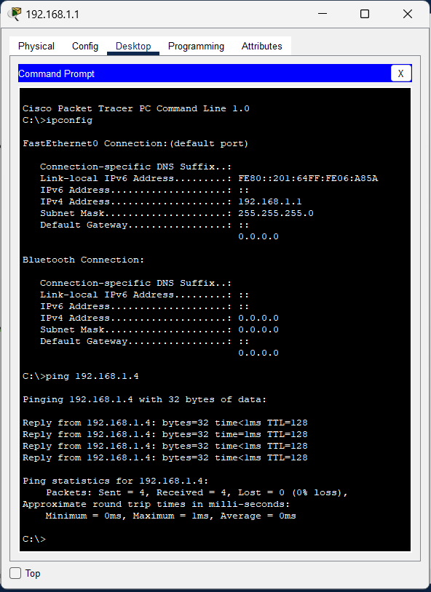

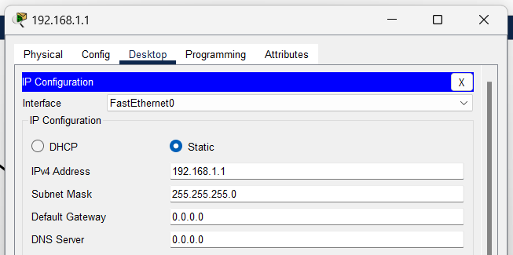

**LEARNING OUTCOMES-**

**EXPERIMENT 2**

**AIM-**

To implement DHCP in a network topology using Cisco Packet Tracer.

**THEORY-**

**PROCEDURE-**

1. **Star Topology:**

a. Build a star topology (refer to Experiment 1 for steps).

b. Add a server and connect it to the switch using a copper straight-through cable.

c. Assign a static IP to the server.

d. Double-click the server, go to Services → DHCP, and enable the DHCP service. The starting IP address and subnet mask will auto-fill.

e. On each PC, change the IP configuration to DHCP. The server should now assign IPs automatically.

f. Test connectivity by pinging any PC on the network.

1. **Mesh Topology:**

a. Build a mesh topology (refer to Experiment 1 for steps).  
b. Place a server and an additional switch, connecting the server to the switch using copper straight-through cables.  
c. Use copper crossover cables to connect the new switch to the existing network switches.  
d. Assign a static IP to the server.  
e. Double-click the server, enable the DHCP service in the Services tab.  
f. Set each PC to DHCP and verify that the server assigns IPs automatically.  
g. Test the connection by pinging across devices.

**OUTPUT-**

1. **STAR TOPOLOGY-**

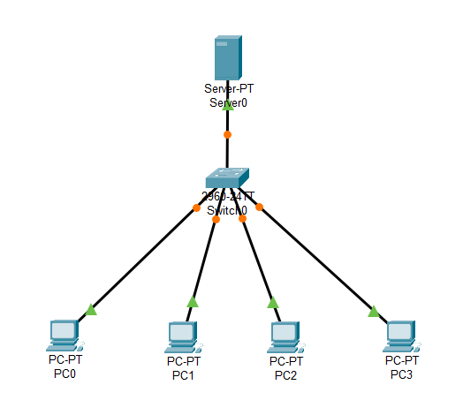

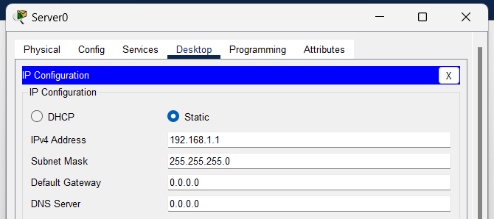

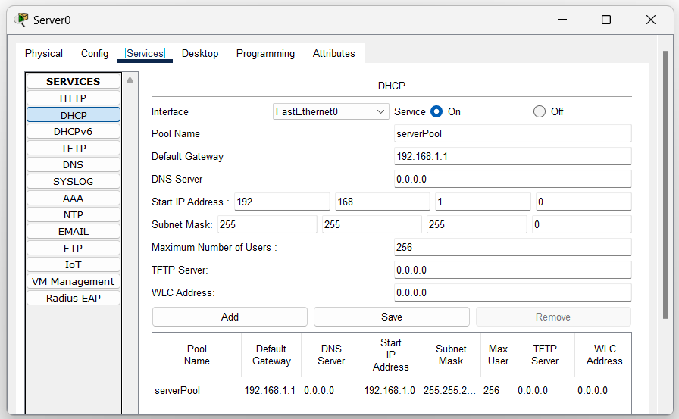

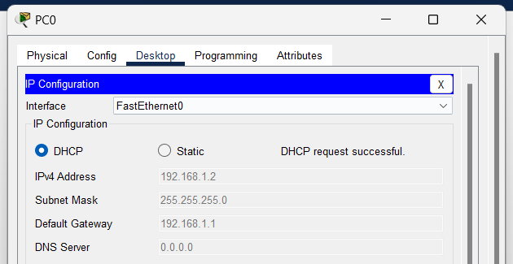

1. **MESH TOPOLOGY-**

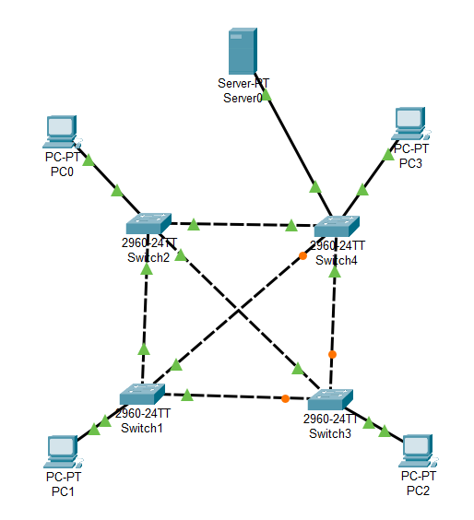

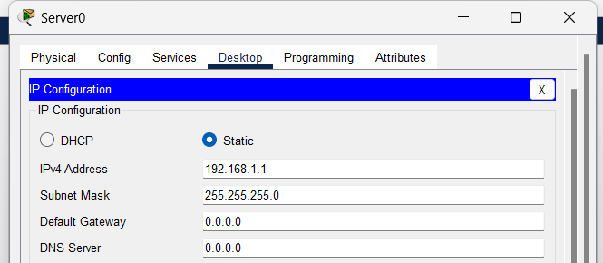

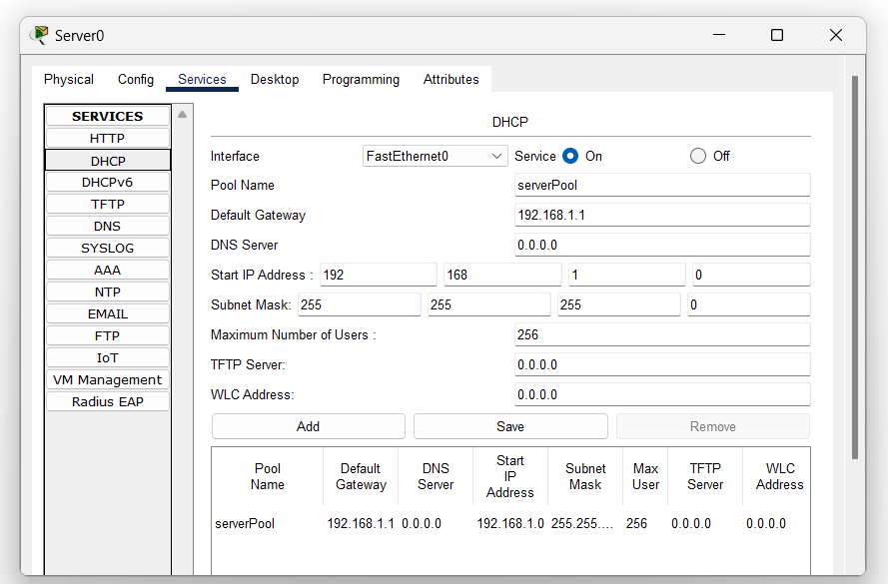

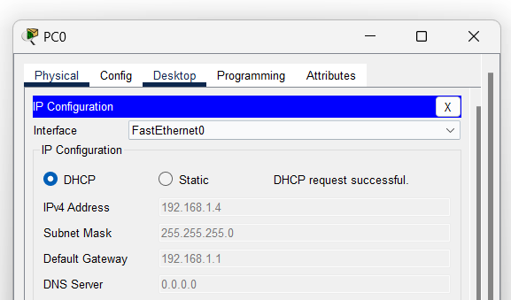

**LEARNING OUTCOMES-**

**EXPERIMENT 3**

**AIM-**

To configure a single router in a network.

**THEORY-**

**PROCEDURE-**

1. Place a Router-PT on the workspace and connect it to a switch using a copper straight-through cable.
2. Connect multiple PCs to the switch using copper straight-through cables.
3. Double-click the router, go to Config → Interface → FastEthernet0/1 (or FastEthernet0/0):

a. Enable the interface by checking "On".  
b. Assign an IP address and subnet mask.

1. Repeat the process for other interfaces if needed (e.g., FastEthernet0/2).
2. Assign static IPs to each PC by double-clicking them, going to Desktop → IP Configuration, and entering the IP and subnet mask.
3. Test connectivity by using the Command Prompt on a PC and pinging other PCs.

**OUTPUT-**

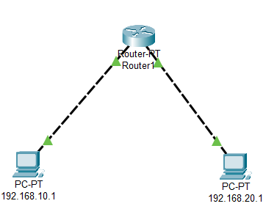

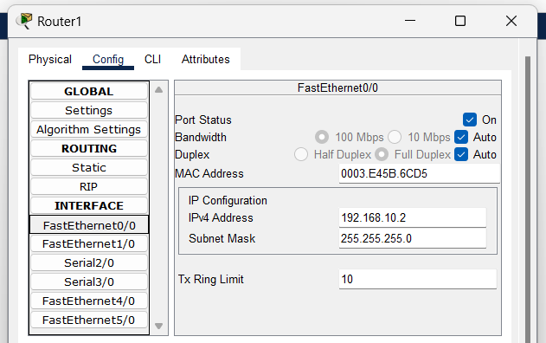

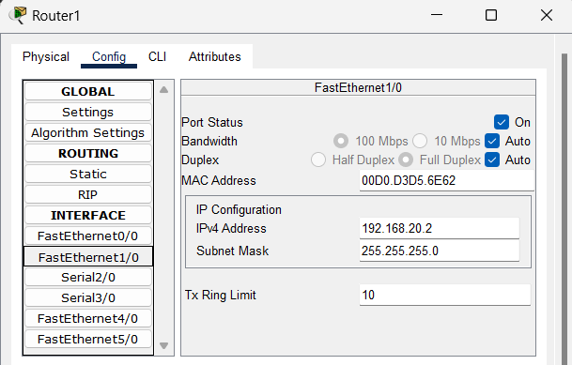

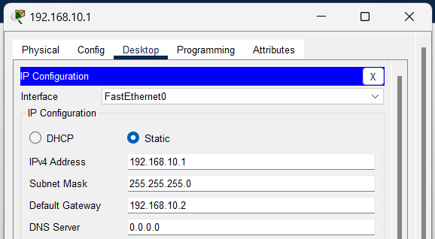

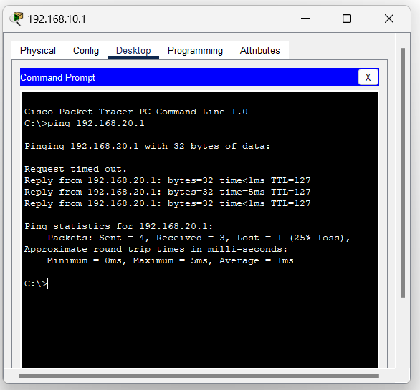

**LEARNING OUTCOMES-**

**EXPERIMENT 4**

**AIM-**

To configure WAN between two routers using Router-PT.

**THEORY-**

**PROCEDURE-**

1. Place two Router-PT devices and connect them using a serial DCE cable.
2. Connect each router to its respective switch using a copper straight-through cable, and then connect PCs to the switches.
3. Double-click each router, go to Config → Interface → Serial0/0/0 (or Serial0/0/1): a. Enable the interface by checking "On".  
   b. Assign an IP address and subnet mask. c. On one router, set the clock rate for the serial connection.
4. For LAN communication, configure the FastEthernet interfaces:  
   a. Go to Config → Interface → FastEthernet0/1 and assign an IP address. b. Ensure the interface is enabled by checking "On".
5. On each router, go to Config → Routing and set static routes to allow communication between networks by entering the destination network, subnet mask, and next hop.
6. Test the WAN connection by pinging between PCs connected to different routers.

**OUTPUT-**

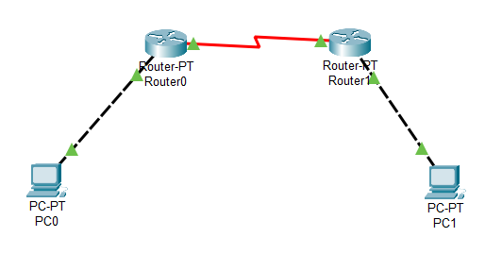

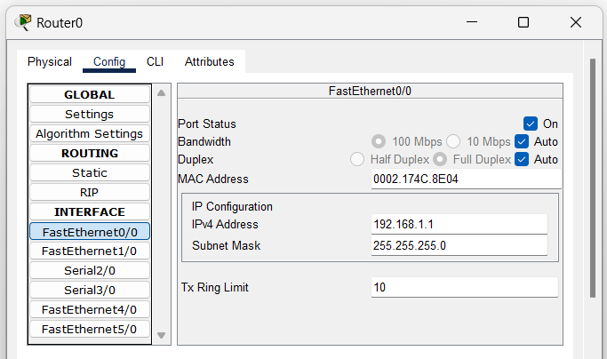

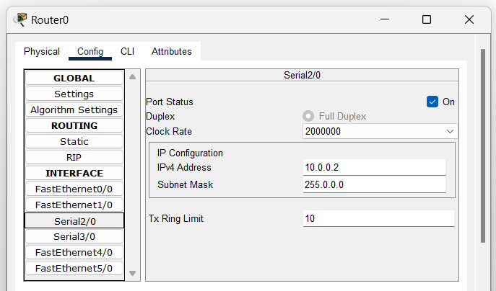

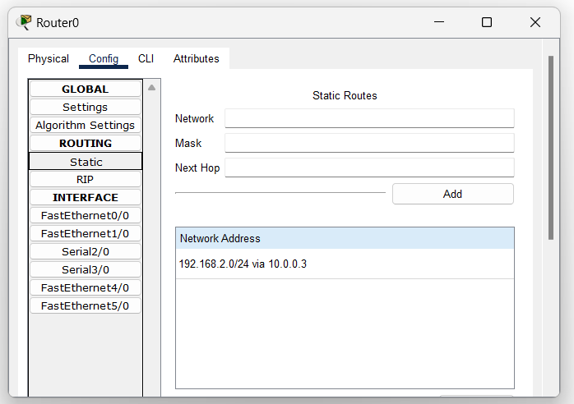

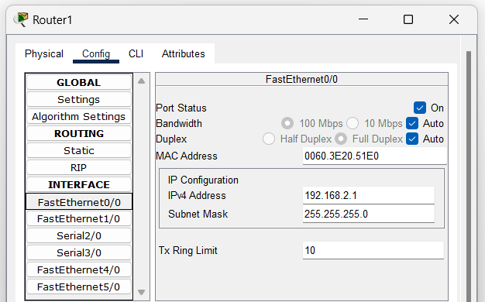

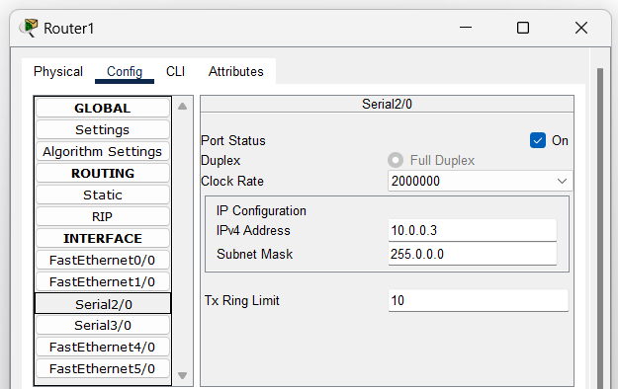

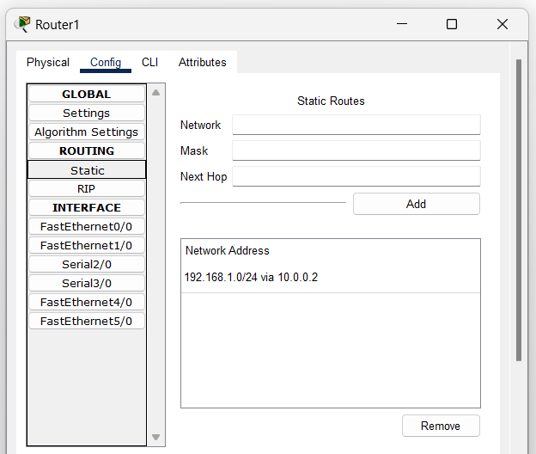

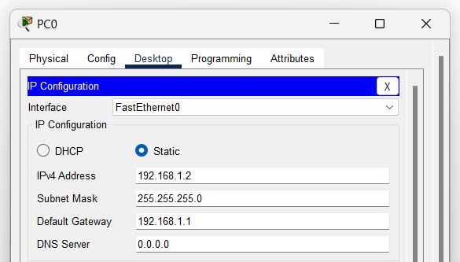

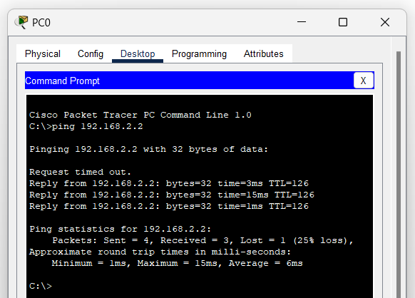

**LEARNING OUTCOMES-**

**EXPERIMENT 5**

**AIM-**

To configure static routing between three routers using Router-PT.

**THEORY-**

**PROCEDURE-**

1. Place three Router-PT devices on the workspace and connect them using serial DCE cables.
2. Connect each router to its respective switch using copper straight-through cables, and connect PCs to each switch.
3. For each router, go to Config → Interface → Serial0/0/0 (or relevant interface) and assign IP addresses, subnet masks, and set the clock rate for one of the routers in each serial connection.
4. Configure the FastEthernet interfaces for LAN communication:  
   a. Go to Config → Interface → FastEthernet0/1 on each router and assign an IP address.  
   b. Ensure the interface is enabled by checking "On".
5. Configure static routes on each router by going to Config → Routing → Static and adding routes to other networks with the destination network, subnet mask, and next hop.
6. Assign static IPs to each PC and test the network by pinging across the devices connected to different routers.

**OUTPUT-**

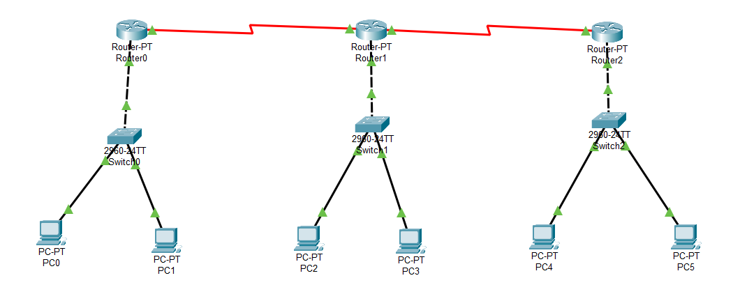

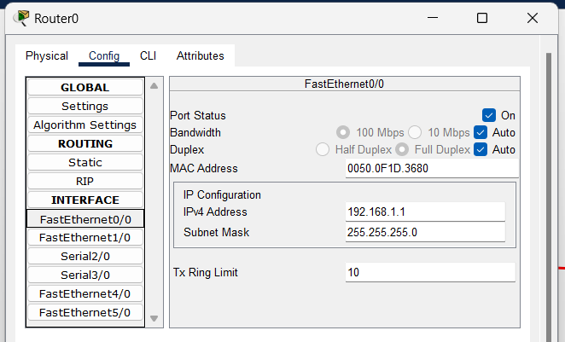

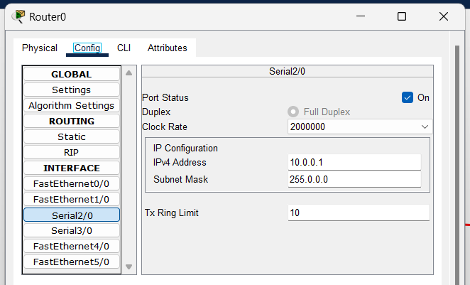

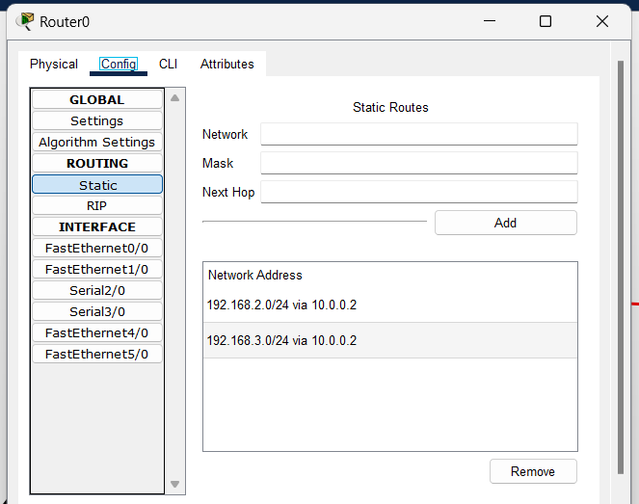

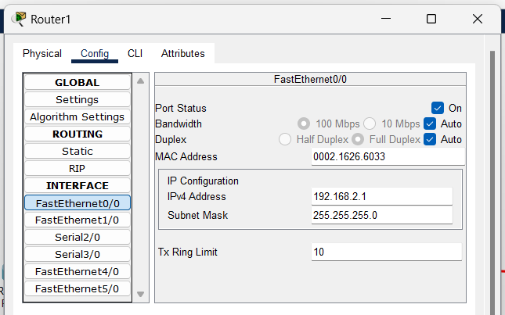

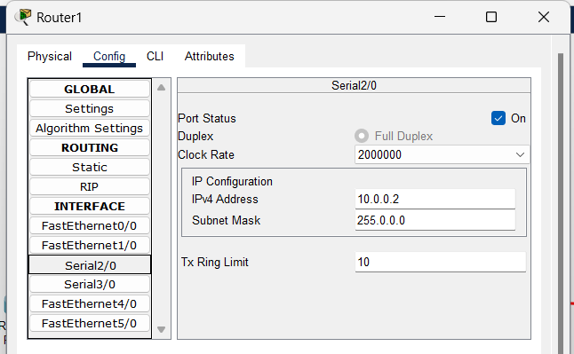

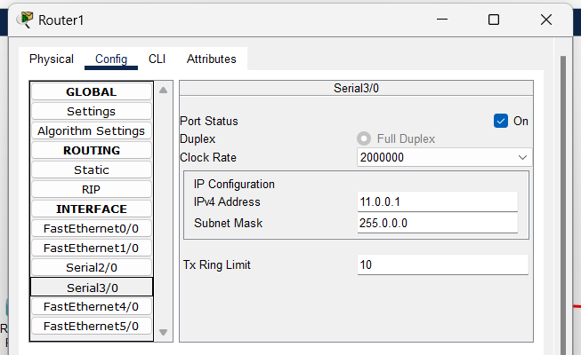

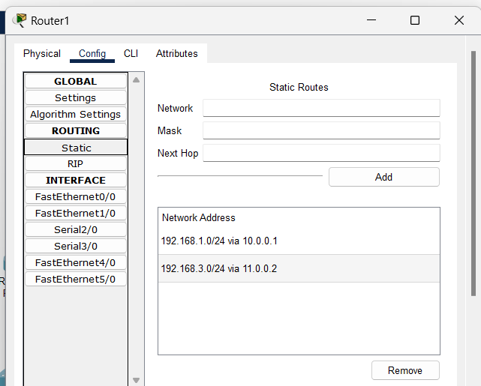

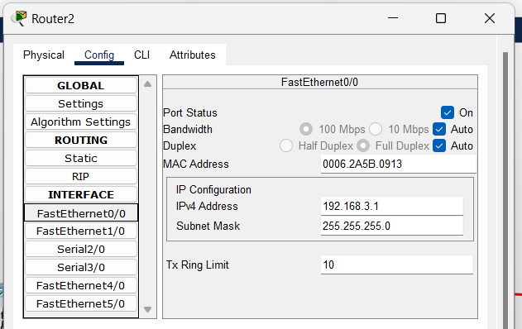

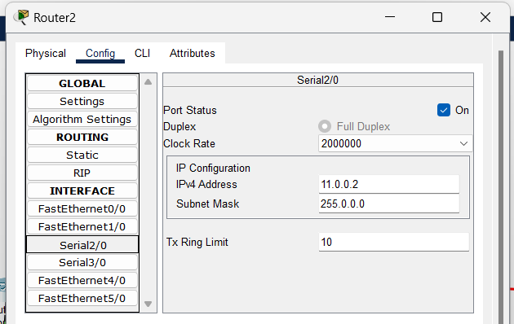

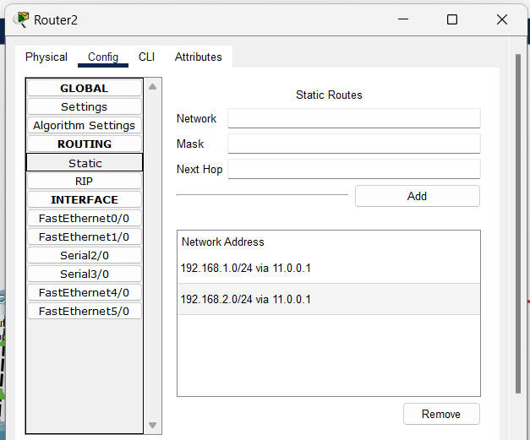

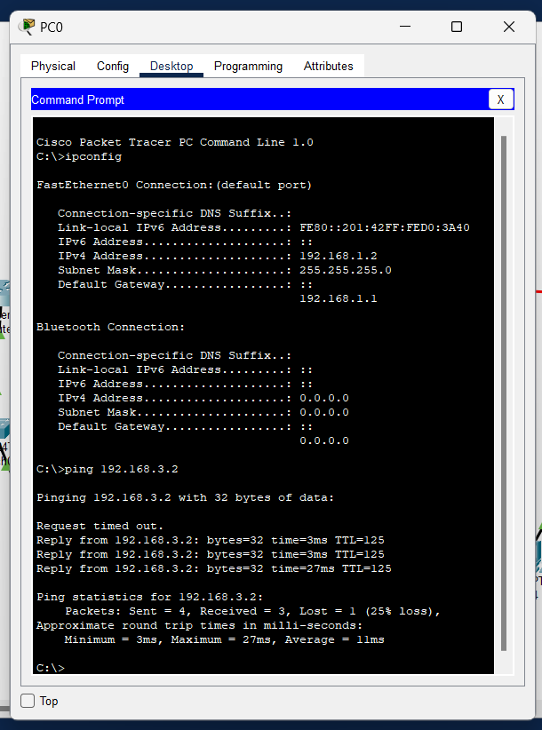

**LEARNING OUTCOMES-**

# EXPERIMENT 6

**AIM-**

To implement the Dynamic Routing Protocols: RIP, IGRP using Cisco Packet Tracker.

**Theory:**

**PROCEDURE-**

**For RIP Implementation:**

1. Open Cisco Packet Tracer and create a network topology with multiple routers.
2. Connect routers using appropriate cables (e.g., serial or Ethernet).
3. Click on each router and enter the CLI (Command-Line Interface).
4. Enter global configuration mode: enable then configure terminal.
5. Enable RIP on each router: router rip.
6. Define the version of RIP: version 2 (if using RIP v2).
7. Configure network statements for connected networks: network [network address].
8. Exit RIP configuration: exit.
9. Verify RIP routing table: show ip route.
10. Test the RIP configuration by pinging from one router to another.

**For IGRP Implementation:**

1. In Cisco Packet Tracer, add multiple routers and connect them.
2. Access the router’s CLI by clicking on the router.
3. Enter global configuration mode: enable then configure terminal.
4. Enable IGRP: router igrp [AS number] (e.g., router igrp 100).
5. Define networks for IGRP: network [network address].
6. Exit IGRP configuration: exit.
7. Verify IGRP routing table: show ip route igrp.
8. Test IGRP by pinging from one router to another.
9. Monitor routing updates: show ip protocols.

**OUTPUT-**

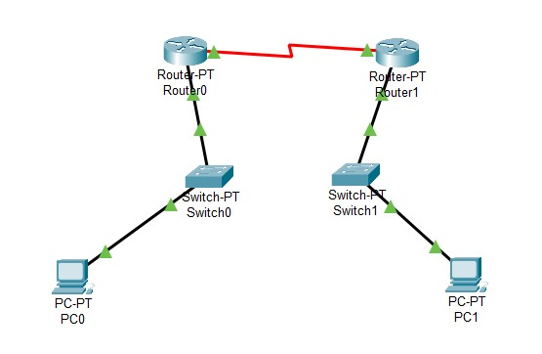 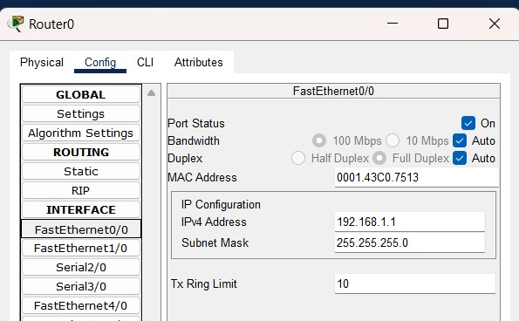

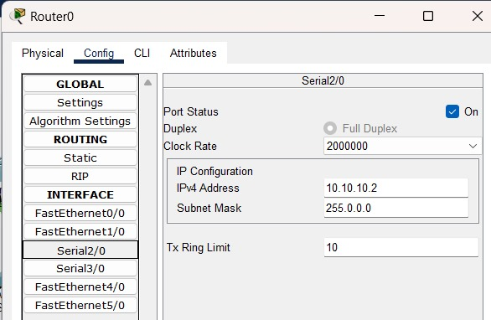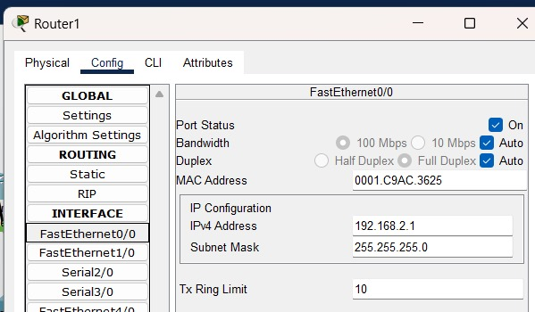

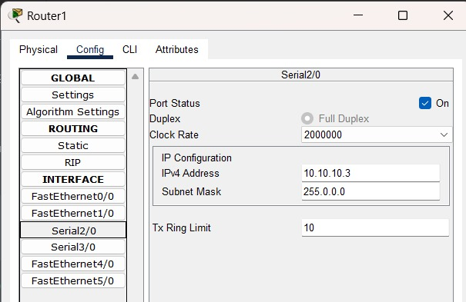 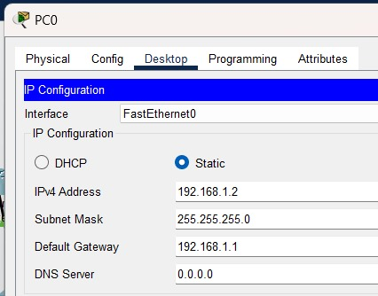

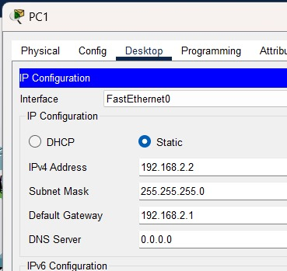

**LEARNING OUTCOMES-**

# EXPERIMENT 7

**AIM-**

To construct multiple router networks and implement the EIGRP Protocol.

**PROCEDURE-**

1. Place multiple routers (e.g., Router-PT1, Router-PT2) and connect them using serial or Ethernet cables.
2. On each router, configure interfaces with IP addresses and subnet masks (e.g., Router-PT1: 192.168.1.1/24, Router-PT2: 192.168.2.1/24).
3. On each router, enter global config mode: configure terminal.
4. Enable EIGRP on each router with the command: router eigrp <AS_number>.
5. Define the networks to participate in EIGRP by using network <network_address> <wildcard_mask>.
6. On each router, verify EIGRP configuration with show ip eigrp neighbors and show ip route.
7. Test inter-router connectivity by pinging between devices on different networks.
8. Optionally, configure EIGRP settings like passive interfaces, delay, or bandwidth for optimization.

**OUTPUT-**

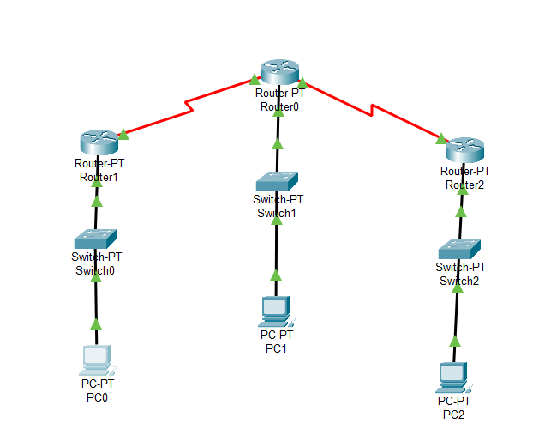 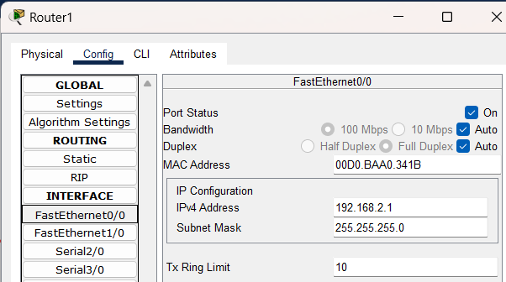

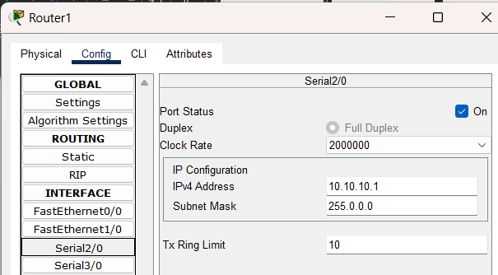 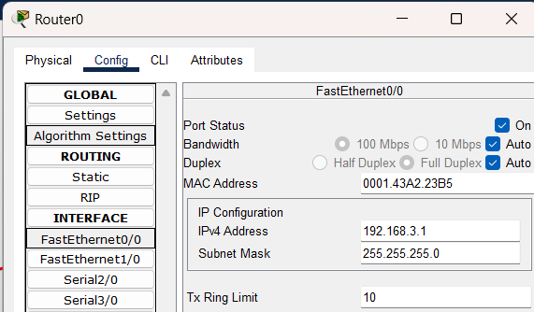

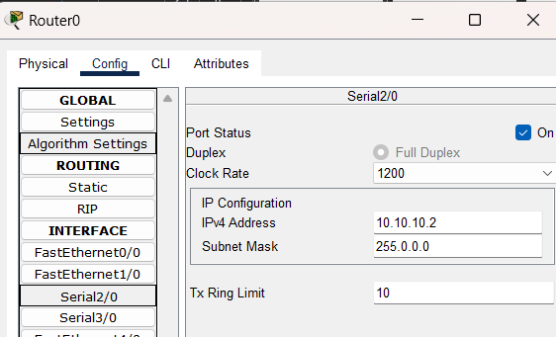 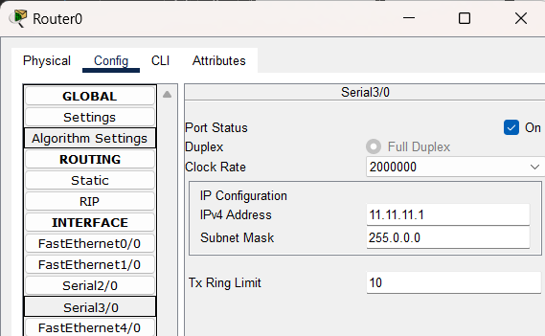

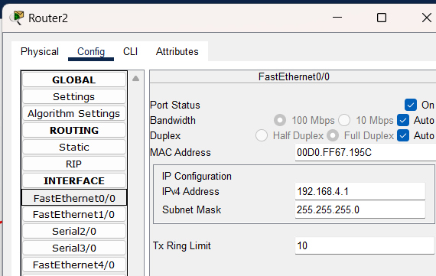 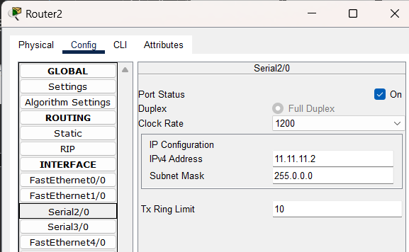

**LEARNING OUTCOMES-**

# EXPERIMENT 8

**AIM-**

To implement the Network Address Resolution (NAT) using Cisco Packet Tracker.

**Theory:**

**PROCEDURE-**

1. Place a router and switch, then connect PCs to the switch with copper straight-through cables.
2. On the router, configure **FastEthernet0/1** (inside) and **FastEthernet0/0** (outside) interfaces with IP addresses and subnet masks.
3. On the router CLI, enter global config mode: configure terminal and set interfaces with ip nat inside and ip nat outside.
4. Define a NAT pool with ip nat pool NAT_POOL 203.0.113.2 203.0.113.10 netmask 255.255.255.248.
5. Create an access list with access-list 1 permit 192.168.1.0 0.0.0.255 to match internal IPs.
6. Enable NAT with ip nat inside source list 1 pool NAT_POOL.
7. Assign static IPs to PCs (e.g., 192.168.1.x/255.255.255.0) and set the default gateway to 192.168.1.1.
8. Test connectivity by pinging between PCs and verify NAT with show ip nat translations on the router.

**OUTPUT-**

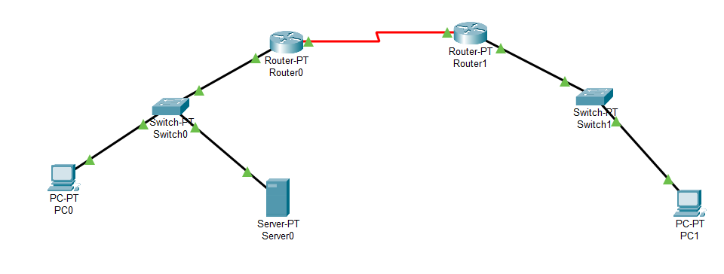 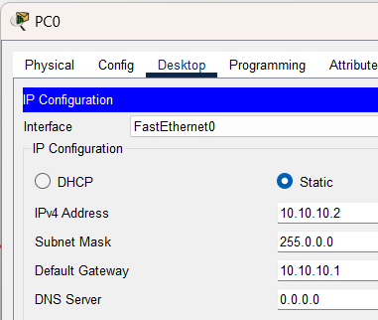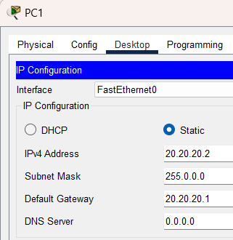

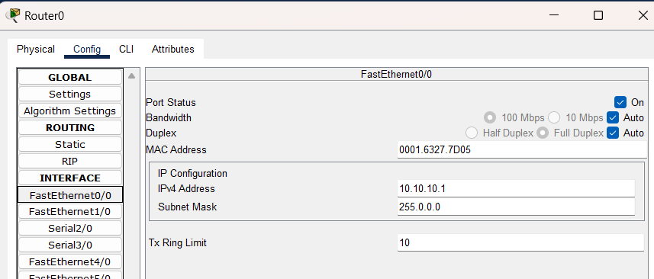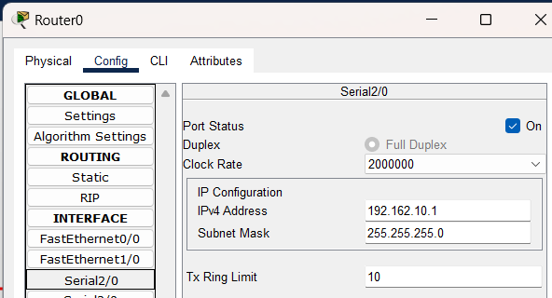

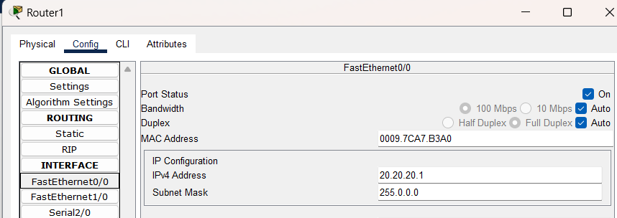

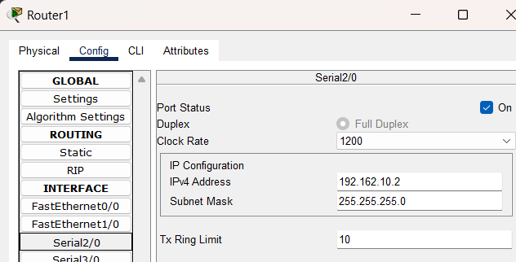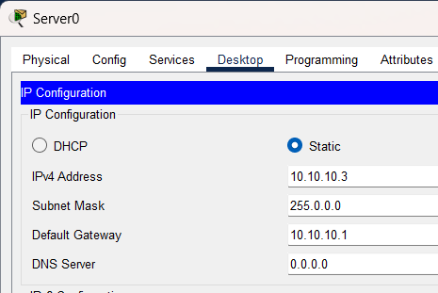

**LEARNING OUTCOMES-**