**Department of Computer Science & Engineering**



**Practical file submitted in partial fulfillment for the evaluation of**

**DESIGN AND ANALYSIS OF ALGORITHM**

**(CIC-359)**



**VIVEKANANDA INSTITUTE OF PROFESSIONAL STUDIES - TECHNICAL CAMPUS**

**Grade A++ Accredited Institution by NAAC**

NBA Accredited for MCA Programme; Recognized under Section 2(f) by UGC;

Affiliated to GGSIP University, Delhi; Recognized by Bar Council of India and AICTE

An ISO 9001:2015 Certified Institution

**SCHOOL OF ENGINEERING & TECHNOLOGY**

**INDEX**

|  |  |  |  |  |  |  |  |  |
| --- | --- | --- | --- | --- | --- | --- | --- | --- |
| S.No | EXP. | Date | Marks | | | Remark | Updated Marks | Faculty Signature |
| Laboratory Assessment (15 Marks) | Class Participation (5 Marks) | Viva (5 Marks) |  |  |  |
| 1 | To implement following algorithm using array as a data structure and analyse its time complexity.  a) Merge sort  b) Quick sort  c)  Bubble sort  d) Selection sort  e)  Heap sort |  |  |  |  |  |  |  |
| 2 | To implement Linear search and Binary search and analyse its time complexity. |  |  |  |  |  |  |  |
|  |  |  |  |  |  |  |  |  |
|  |  |  |  |  |  |  |  |  |
|  |  |  |  |  |  |  |  |  |
|  |  |  |  |  |  |  |  |  |
|  |  |  |  |  |  |  |  |  |
|  |  |  |  |  |  |  |  |  |
|  |  |  |  |  |  |  |  |  |

**PROGRAM 1**

**Aim: To implement following algorithm using array as a data structure and**

**analyse its time complexity.**

**a) Insertion Sort**

**Theory:**

Insertion Sort is a simple and intuitive sorting algorithm. It builds the final sorted array (or list) one item at a time. It is much less efficient on large lists than more advanced algorithms such as quicksort, heapsort, or merge sort. However, it has some advantages, such as simplicity, stability (it preserves the relative order of equal elements), and efficiency for small datasets or nearly sorted data.

**Algorithm Steps:**

1. Initialization: Start with the second element (index 1) in the array as the current key.

2. Comparison: Compare the current key with elements in the sorted portion of the array (i.e.,the elements to its left).

3. Shifting: If the key element is smaller than its predecessor, compare it with the elements before. Shift all larger elements one position to the right to make space for the swapped element.

4. Insertion: Insert the key element at the correct position in the sorted part of the array.

5. Repeat: Move to the next element and repeat the process until the entire array is sorted.

**Time Complexity Analysis:**

**•**

**Best Case:** O(n)

Occurs when the array is already sorted. The inner loop is never executed, so each element is compared once, resulting in linear time complexity.

**•**

**Average Case:** O(n2)

On average, half of the elements in the array will need to be shifted for each element being inserted. This results in a quadratic time complexity.

**•**

**Worst Case:** O(n2)

The worst-case scenario occurs when the array is sorted in reverse order. Every insertion requires shifting all the previously sorted elements, leading to a quadratic time complexity.

**Program:**

#include <iostream>

#include <chrono>

#include <cstdlib>

using namespace std;

using namespace std::chrono;

void insertionSort(int arr[], int n) {

for (int i = 1; i < n; ++i) {

int key = arr[i];

int j = i - 1;

//move one position right if greater than key

while (j >= 0 && arr[j] > key) {

arr[j + 1] = arr[j];

j = j - 1; }

arr[j + 1] = key;

}}

void generateRandomArray(int arr[], int size) {

for (int i = 0; i < size; ++i) {

arr[i] = rand();

}}

int main() {

srand(static_cast<unsigned int>(time(0)));

int sizes[] = {100, 500, 1000, 1500};

cout<<"For Insertion Sort:"<<endl;

for (int i = 0; i < 4; ++i) {

int size = sizes[i];

int* arr = new int[size];

generateRandomArray(arr, size);

auto start = high_resolution_clock::now();

insertionSort(arr, size);

auto end = high_resolution_clock::now();

auto time_spent = duration_cast<nanoseconds>(end -

start).count();

cout << "The elapsed time for " << size << " elements

is " << time_spent << " nanoseconds" << endl;

delete[] arr;

}

return 0;

}

**Output:**

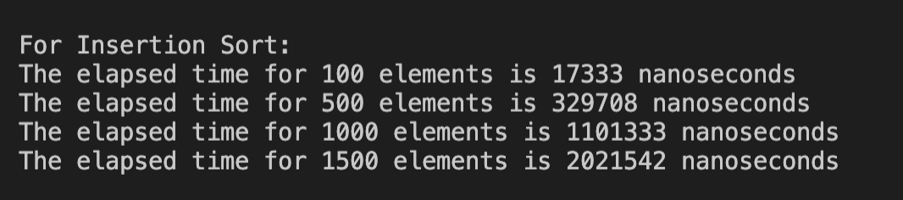

**Graph:**

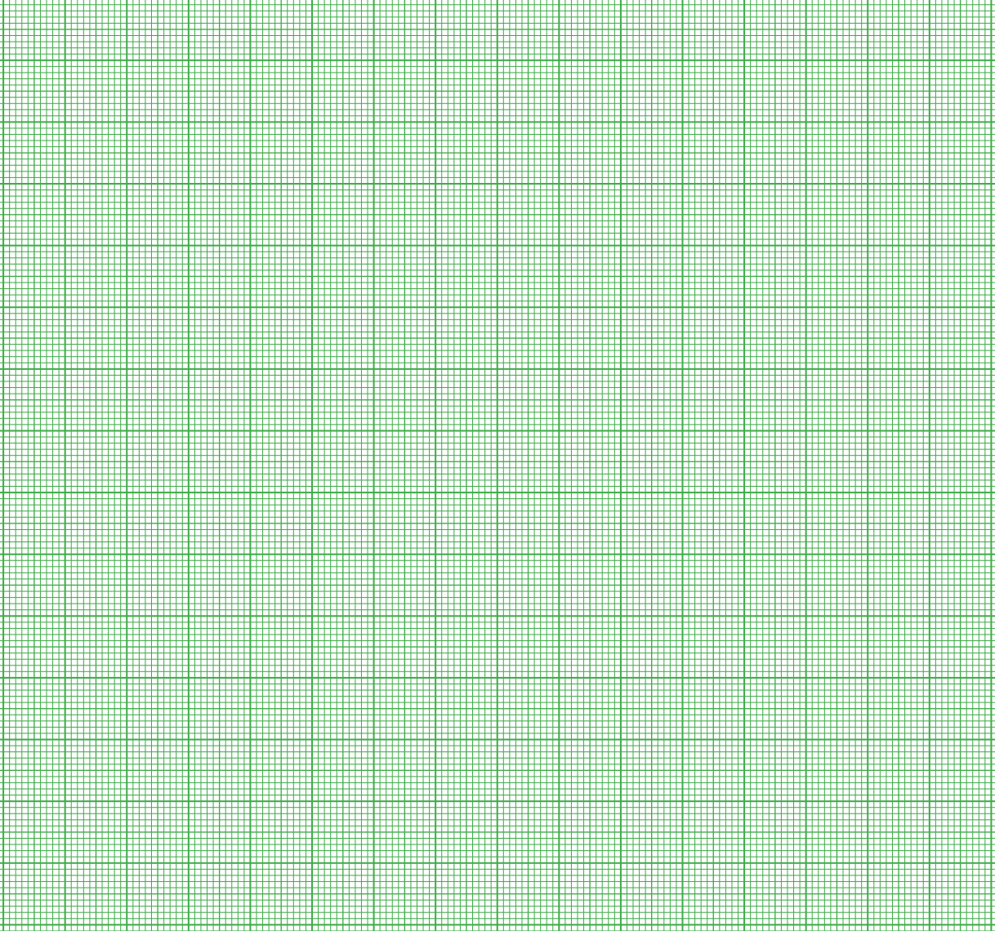

**Learning Outcomes:**

**b) Selection Sort**

**Theory:**

Selection Sort is a simple comparison-based sorting algorithm. It works by dividing the input array into a sorted and an unsorted region, repeatedly selecting the smallest (or largest,depending on the order) element from the unsorted region, and moving it to the end of the sorted region.

**Algorithm Steps:**

**1.** Initialization: Start with the entire array as the unsorted region.

**2.** Find the Minimum Element: Iterate through the unsorted region to find the minimum element.

**3.** Swap: Swap the minimum element found with the first element of the unsorted region.

**4.** Repeat: Move the boundary between the sorted and unsorted regions one element to the right and repeat the process until the entire array is sorted.

**Time Complexity Analysis:**

**•**

**Best Case:** O(n2)

Selection Sort always performs n(n−1)/2 comparisons, regardless of the initial arrangement of the array. Thus, the best-case time complexity is O(n2).

**•**

**Average Case:** O(n2)

On average, the number of comparisons is the same as in the worst case, leading to a quadratic time complexity.

**•**

**Worst Case:** O(n2)

The worst-case scenario also results in O(n2) time complexity, as the algorithm always performs the same number of comparisons and swaps regardless of the input array’s order.

**Program:**

#include <iostream>

#include <chrono>

#include <cstdlib>

using namespace std;

using namespace std::chrono;

void selectionSort(int arr[], int n)

{

for (int i = 0; i < n - 1; ++i) {

// Find the minimum element in the unsorted part of

the array

int minIndex = i;

for (int j = i + 1; j < n; ++j) {

if (arr[j] < arr[minIndex]) {

minIndex = j;}}

// Swap the found minimum element with the first

element of unsorted part

if (minIndex != i) {

swap(arr[i], arr[minIndex]);}}}

void generateRandomArray(int arr[], int size) {

for (int i = 0; i < size; ++i) {

arr[i] = rand();

}

}

int main()

{

srand(static_cast<unsigned int>(time(0)));

int sizes[] = {100, 500, 1000, 1500};

cout<<"\n\nFor Selection Sort:"<<endl;

for (int i = 0; i < 4; ++i) {

int size = sizes[i];

int* arr = new int[size];

generateRandomArray(arr, size);

auto start = high_resolution_clock::now();

selectionSort(arr, size);

auto end = high_resolution_clock::now();

auto time_spent = duration_cast<nanoseconds>(end -

start).count();

cout << "The elapsed time for " << size << " elements

is " << time_spent << " nanoseconds" << endl;

delete[] arr; // Deallocate the array

}

cout<<endl<<endl;

return 0;

}

**Output:**

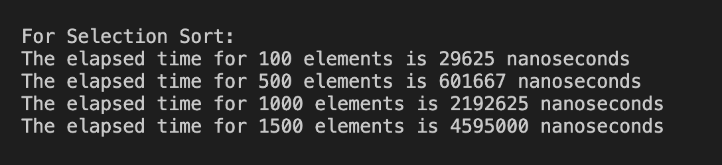

**Graph:**



**Learning Outcomes:**

**c) Bubble Sort**

**Theory:**

Bubble Sort is one of the simplest sorting algorithms that works by repeatedly stepping

through the list, comparing adjacent elements, and swapping them if they are in the wrong

order. This process is repeated until the list is sorted. The name "Bubble Sort" comes from the

way larger elements "bubble" to the top of the list.

**Algorithm Steps:**

1. Initialization: Start from the beginning of the array.

2. Pairwise Comparison: Compare each pair of adjacent elements in the array. If the current

element is greater than the next element, swap them.

3. Pass Through the Array: After each pass through the array, the largest unsorted element is

moved to its correct position at the end of the array.

4. Repeat: Repeat the process for the remaining unsorted portion of the array until no swaps

are needed, indicating the array is sorted.

**Time Complexity Analysis:**

**•**

**Best Case:** O(n)

The best case occurs when the array is already sorted. The algorithm only needs one pass

through the array to confirm that no swaps are needed, resulting in linear time

complexity.

**•**

**Average Case:** O(n2)

On average, the algorithm needs to perform n(n−1)/2 comparisons and a number of

swaps, leading to quadratic time complexity.

**•**

**Worst Case:** O(n2)

The worst case occurs when the array is sorted in reverse order. In this case, the algorithm

must make the maximum number of comparisons and swaps, resulting in quadratic time

complexity.

D

**Program:**

#include <iostream>

#include <chrono>

#include <cstdlib>

using namespace std;

using namespace std::chrono;

void bubbleSort(int arr[], int n) {

int flag=0;

for (int i = 0; i < n - 1; ++i) {

flag=0;

for (int j = 0; j < n - i - 1; ++j) {

if (arr[j] > arr[j + 1]) {

// Swap if the element found is greater than

the next element

swap(arr[j], arr[j + 1]);

flag=1;

}

}

// If no two elements were swapped by inner loop, then

the array is sorted

if (flag!=1) break;

}

}

void generateRandomArray(int arr[], int size) {

for (int i = 0; i < size; ++i) {

arr[i] = rand();

}

}

int main() {

srand(static_cast<unsigned int>(time(0)));

int sizes[] = {100, 500, 1000, 1500};

cout<<"\n\nFor Bubble Sort:"<<endl;

for (int i = 0; i < 4; ++i) {

int size = sizes[i];

int* arr = new int[size];

//sri

generateRandomArray(arr, size);

auto start = high_resolution_clock::now();

bubbleSort(arr, size);

auto end = high_resolution_clock::now();

auto time_spent = duration_cast<nanoseconds>(end -

start).count();

cout << "The elapsed time for " << size << " elements

is " << time_spent << " nanoseconds" << endl;

delete[] arr; // Deallocate the array

}

cout<<endl<<endl;

return 0;

}

**Output:**

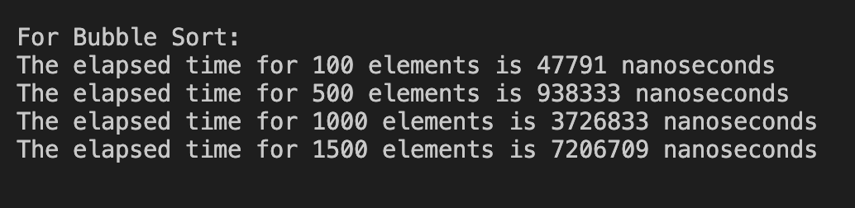

**Graph:**



**Learning Outcomes:**

**d) Quick Sort**

**Theory:**

Quick Sort is a highly efficient and widely used sorting algorithm. It employs the divide-and

conquer strategy to sort elements, making it significantly faster than simpler algorithms like

Bubble Sort or Selection Sort, especially for large datasets.

**Algorithm Steps:**

1. Choose a Pivot: Select an element from the array as the pivot. The choice of pivot can vary

(e.g., first element, last element, middle element, or a random element).

2. Partitioning: Rearrange the array such that all elements less than the pivot are placed

before it, and all elements greater than the pivot are placed after it. This step is known as

partitioning. After partitioning, the pivot is in its final sorted position.

3. Recursion: Recursively apply the above steps to the sub-arrays formed by dividing the

array at the pivot's position—one sub-array contains elements less than the pivot, and the

other contains elements greater than the pivot.

4. Base Case: The recursion ends when the sub-array has one or zero elements, which are

already sorted by definition.

**Time Complexity Analysis:**

**•**

**Best Case:** O(n logn)

The best-case scenario occurs when the pivot always divides the array into two equal

halves. This leads to nlogn levels of recursion, with n comparisons at each level, resulting

in O(nlogn) time complexity.

**•**

**Average Case:** O(n logn)

On average, Quick Sort performs O(nlogn) comparisons. The division of the array is

typically balanced, making it an efficient sorting algorithm for most cases.

**•**

**Worst Case:** O(n2)

The worst-case scenario occurs when the pivot chosen is always the smallest or largest

element, resulting in an extremely unbalanced partitioning. This can happen if the array is

already sorted or nearly sorted. The time complexity in this case is quadratic, O(n2).

**Program:**

#include <iostream>

#include <cstdlib>

#include <chrono>

using namespace std;

using namespace std::chrono;

int partition(int arr[], int low, int high) {

int pivot = arr[high];

int i = low - 1;

for (int j = low; j < high; ++j) {

if (arr[j] <= pivot) {

++i;

swap(arr[i], arr[j]);

}

}

swap(arr[i + 1], arr[high]);

return i + 1;

}

void quickSort(int arr[], int low, int high) {

if (low < high) {

int pi = partition(arr, low, high);

quickSort(arr, low, pi - 1);

quickSort(arr, pi + 1, high);

}

}

void generateRandomArray(int arr[], int size) {

for (int i = 0; i < size; ++i) {

arr[i] = rand();

}

}

int main() {

srand(static_cast<unsigned int>(time(0)));

int sizes[] = {100, 500, 1000, 1500};

cout<<"\n\nFor Quick Sort:"<<endl;

for (int i = 0; i < 4; ++i) {

int size = sizes[i];

int* arr = new int[size];

//sri

generateRandomArray(arr, size);

auto start = high_resolution_clock::now();

quickSort(arr, 0, size - 1);

auto end = high_resolution_clock::now();

auto time_spent = duration_cast<nanoseconds>(end -

start).count();

cout << "The elapsed time for " << size << " elements

is " << time_spent << " nanoseconds" << endl;

delete[] arr;

}

cout<<endl<<endl;

return 0;

}

**Output:**

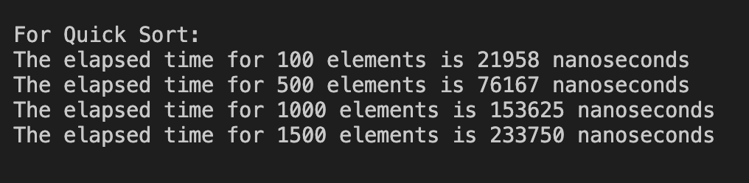

**Graph:**



**Learning Outcomes:**

**e) Merge Sort**

**Theory:**

Merge Sort is an efficient, stable, and comparison-based sorting algorithm that uses the

divide-and-conquer strategy. It works by recursively splitting the array into smaller sub

arrays until each sub-array has only one element, and then merging those sub-arrays in a

sorted manner to produce the final sorted array.

**Algorithm Steps:**

1. Divide: Split the array into two halves, typically at the midpoint.

2. Conquer (Recursion): Recursively apply Merge Sort to both halves of the array.

3. Merge: Merge the two sorted halves back together into a single sorted array. The merging

process involves comparing elements from each half and arranging them in order.

4. Base Case: The recursion terminates when the sub-array has only one element, which is

inherently sorted.

**Time Complexity Analysis:**

**•**

**Best Case:** O(nlogn)

Merge Sort consistently divides the array into two equal parts, performing a merge

process for each division, leading to a time complexity of O(nlogn) in the best case.

**•**

**Average Case:** O(nlogn)

Regardless of the initial arrangement of elements, Merge Sort always requires O(nlogn)

time, making it highly efficient even on average.

**•**

**Worst Case:** O(nlogn)

The worst-case time complexity is also O(nlogn) since the number of operations remains

the same across all cases.

**Program:**

#include <iostream>

#include <cstdlib>

#include <chrono>

using namespace std;

using namespace std::chrono;

void merge(int arr[], int left, int mid, int right) {

int n1 = mid - left + 1;

int n2 = right - mid;

int* L = new int[n1];

int* R = new int[n2];

for (int i = 0; i < n1; ++i)

L[i] = arr[left + i];

for (int j = 0; j < n2; ++j)

R[j] = arr[mid + 1 + j];

int i = 0;

int j = 0;

int k = left;

while (i < n1 && j < n2) {

if (L[i] <= R[j]) {

arr[k] = L[i];

++i; } else {

arr[k] = R[j];

++j; }

++k; }

while (i < n1) {

arr[k] = L[i];

++i;

++k; }

while (j < n2) {

arr[k] = R[j];

++j;

++k; }

delete[] L;

delete[] R; }

void mergeSort(int arr[], int left, int right) {

if (left < right) {

int mid = left + (right - left) / 2;

mergeSort(arr, left, mid);

mergeSort(arr, mid + 1, right);

merge(arr, left, mid, right);

}}

void generateRandomArray(int arr[], int size) {

for (int i = 0; i < size; ++i) {

arr[i] = rand();

}}

int main() {

srand(static_cast<unsigned int>(time(0)));

int sizes[] = {100, 500, 1000, 1500};

cout << "\n\nFor Merge Sort:" << endl;

for (int i = 0; i < 4; ++i) {

int size = sizes[i];

int* arr = new int[size];

//sri

generateRandomArray(arr, size);

auto start = high_resolution_clock::now();

mergeSort(arr, 0, size - 1);

auto end = high_resolution_clock::now();

auto time_spent = duration_cast<nanoseconds>(end -

start).count();

cout << "The elapsed time for " << size << " elements

is " << time_spent << " nanoseconds" << endl;

delete[] arr; }

cout<<endl<<endl;

return 0; }

**Output:**

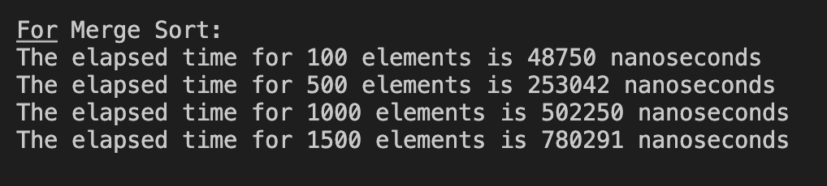

**Graph:**



**Learning Outcomes:**

**f) Heap Sort**

**Theory:**

Heap Sort is a comparison-based sorting algorithm that uses a binary heap data structure to

sort elements. It is an in-place algorithm, meaning it doesn't require additional memory, and it

is not a stable sort. Heap Sort is particularly useful for its efficiency in sorting large datasets

and its ability to guarantee a worst-case time complexity of O(nlogn).

**Algorithm Steps:**

1. Build a Max-Heap: Convert the array into a max-heap, a complete binary tree where the

value of each node is greater than or **e**qual to the values of its children. This ensures the

largest element is at the root of the heap.

2. Swap and Reduce:

• Swap the root (the largest element) with the last element in the array, effectively

moving the largest element to its final sorted position.

• Reduce the heap size by one (excluding the last element from the heap) and heapify

the root to maintain the max-heap property.

3. Repeat: Continue the process of swapping the root with the last element of the heap and

reducing the heap size until the heap is empty and the array is fully sorted.

**Time Complexity Analysis:**

**•**

**Best Case:** O(nlogn)

Even in the best case, Heap Sort requires O(nlogn)operations because each element must

be inserted into the heap and extracted, both of which are O(logn) operations.

**•**

**Average Case:** O(nlogn)

On average, Heap Sort performs consistently at O(nlogn) since the heapification process

ensures a balanced binary heap.

**•**

**Worst Case:** O(nlogn)

The worst-case time complexity is O(nlogn), as the operations required to maintain the

heap structure are the same regardless of the initial order of elements.

**Program:**

#include <iostream>

#include <cstdlib>

#include <chrono>

using namespace std;

using namespace std::chrono;

void heapify(int arr[], int n, int i) {

int largest = i;

int left = 2 * i + 1;

int right = 2 * i + 2;

if (left < n && arr[left] > arr[largest])

largest = left;

if (right < n && arr[right] > arr[largest])

largest = right;

if (largest != i) {

swap(arr[i], arr[largest]);

heapify(arr, n, largest);

}

}

void heapSort(int arr[], int n) {

for (int i = n / 2 - 1; i >= 0; --i)

heapify(arr, n, i);

for (int i = n - 1; i >= 0; --i) {

swap(arr[0], arr[i]);

heapify(arr, i, 0);

}

}

void generateRandomArray(int arr[], int size) {

for (int i = 0; i < size; ++i) {

arr[i] = rand();

}

}

int main() {

srand(static_cast<unsigned int>(time(0)));

int sizes[] = {100, 500, 1000, 1500};

cout << "\n\nFor Heap Sort:" << endl;

for (int i = 0; i < 4; ++i) {

int size = sizes[i];

int* arr = new int[size];

//sri

generateRandomArray(arr, size);

auto start = high_resolution_clock::now();

heapSort(arr, size);

auto end = high_resolution_clock::now();

auto time_spent = duration_cast<nanoseconds>(end -

start).count();

cout << "The elapsed time for " << size << " elements

is " << time_spent << " nanoseconds" << endl;

delete[] arr;

}

cout<<endl<<endl;

return 0;

}

**Output:**

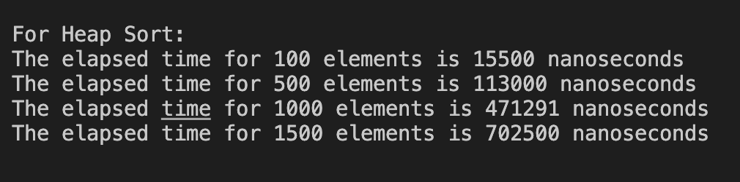

**Graph:**



**Learning Outcomes:**

**PROGRAM 2**

**Aim: To implement linear search and binary search and analyse its time**

**complexity.**

**Linear Search**

**Theory:**

Linear Search is the simplest search algorithm used to find a particular element in an array or

list. The algorithm works by sequentially checking each element of the array until it finds the

target element or reaches the end of the array.

**Algorithm Steps:**

1. Start from the Beginning: Begin at the first element of the array.

2. Compare Each Element: Compare the target element with the current element of the

array.

3. Check for Match: If the current element matches the target, return the index of the

element. If it doesn't match, move to the next element.

4. Continue Until Found or End: Repeat the comparison process until the element is

found or until the end of the array is reached.

5. Return Result: If the target element is found, return its index. If the target element is

not found after checking all elements, return an indication (like -1) that the element is

not present in the array.

**Time Complexity Analysis:**

**•**

**Best Case: O(1)**

The best-case scenario occurs when the target element is the first element in the array.

The algorithm only needs one comparison to find the target.

**•**

**Average Case: O(n)**

On average, the algorithm will have to search through half of the array before finding the

target, leading to a time complexity of O(n)O(n)O(n), where nnn is the number of

elements in the array.

**•**

**Worst Case: O(n)**

The worst-case scenario occurs when the target element is the last element in the array or

is not present at all. The algorithm must check every element, resulting in O(n)O(n)O(n)

time complexity.

**Program:**

#include <iostream>

#include <chrono>

#include <cstdlib>

using namespace std;

using namespace std::chrono;

int linearSearch(int arr[], int n, int key)

{

for (int i = 0; i < n; i++)

{

if (arr[i] == key)

{

return i;

}

}

return -1;

}

void generateRandomArray(int arr[], int size) {

for (int i = 0; i < size; ++i) {

arr[i] = rand();

}

}

int main() {

srand(static_cast<unsigned int>(time(0)));

int sizes[] = {100, 500, 1000, 1500};

cout << "\n\nFor Linear Search:" << endl;

for (int i = 0; i < 4; ++i) {

int size = sizes[i];

int* arr = new int[size];

generateRandomArray(arr, size);

//sri

auto start = high_resolution_clock::now();

linearSearch(arr, size, rand());

auto end = high_resolution_clock::now();

auto time_spent = duration_cast<nanoseconds>(end -

start).count();

cout << "The elapsed time for " << size << " elements

is " << time_spent << " nanoseconds" << endl;

delete[] arr;

}

cout<<endl<<endl;

return 0;

}

**Output:**

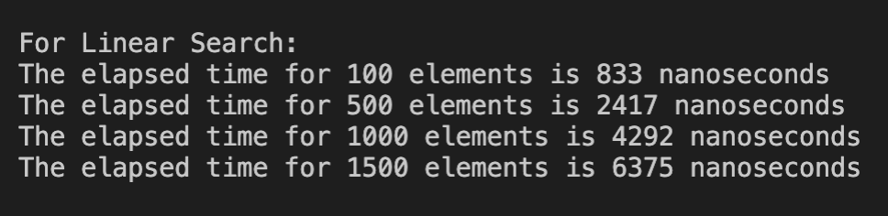

**Graph:**



**Learning Outcomes:**

**Binary Search**

**Theory:**

Binary Search is an efficient search algorithm that finds the position of a target value within a

sorted array or list. It works by repeatedly dividing the search interval in half, which allows it

to achieve a time complexity of O(logn), making it much faster than linear search for large

datasets.

**Algorithm Steps:**

1. Initialize Pointers: Set two pointers, **low** and high, representing the start and end of the

array segment being searched.

2. Calculate Midpoint: Compute the midpoint index as **mid = (low + high) // 2.**

3. Compare with Target: Compare the target value with the element at the midpoint index.

4. Adjust Search Range:

• If the target value equals the element at the midpoint, return the midpoint index

(target found).

• If the target value is less than the element at the midpoint, adjust the **high** pointer to

**mid - 1** (search the left half).

• If the target value is greater than the element at the midpoint, adjust the **low** pointer

to **mid + 1** (search the right half).

5. Repeat Until Found or Exhausted: Continue the process until the **low** pointer exceeds the

**high** pointer.

6. Return Result: If the target value is not found, return an indication (like -**1**) that the target

is not present in the array.

**Time Complexity Analysis:**

**•**

**Best Case:** O(1)

The best-case scenario occurs when the target element is at the midpoint index of the

array. The algorithm finds the target in one comparison.

**•**

**Average Case:** O(logn)

On average, Binary Search performs nlogn comparisons, where n is the number of

elements in the array. The array is divided in half at each step.

**•**

**Worst Case:** O(logn)

The worst-case time complexity occurs when the target is not present, and the search

interval needs to be halved repeatedly until it is exhausted.

**•**

**Space Complexity:** O(1)

Binary Search is an in-place algorithm that requires only a constant amount of extra

space, regardless of the input size.

**Program:**

#include <iostream>

#include <chrono>

#include <cstdlib>

using namespace std;

using namespace std::chrono;

int binarySearch(int arr[], int n, int key)

{

int low = 0;

int high = n - 1;

while (low <= high)

{

int mid = (low + high) / 2;

if (arr[mid] == key)

{

return mid;

}

else if (arr[mid] < key)

{

low = mid + 1;

}

else

{

high = mid - 1;

}

}

return -1;

}

void generateRandomArray(int arr[], int size) {

for (int i = 0; i < size; ++i) {

arr[i] = rand();

}

}

int main() {

srand(static_cast<unsigned int>(time(0)));

int sizes[] = {100, 500, 1000, 1500};

cout << "\n\nFor Binary Search:" << endl;

for (int i = 0; i < 4; ++i) {

int size = sizes[i];

int* arr = new int[size];

//sri

generateRandomArray(arr, size);

auto start = high_resolution_clock::now();

binarySearch(arr, size, rand());

auto end = high_resolution_clock::now();

auto time_spent = duration_cast<nanoseconds>(end -

start).count();

cout << "The elapsed time for " << size << " elements

is " << time_spent << " nanoseconds" << endl;

delete[] arr; }

cout<<endl<<endl;

return 0; }

**Output:**

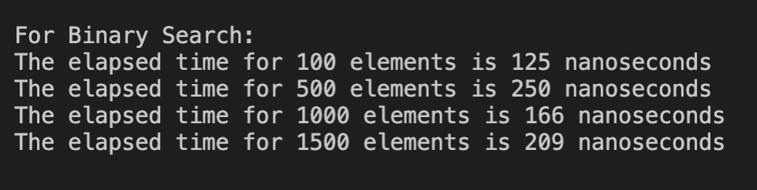

**Graph:**



**Learning Outcomes:**

**PROGRAM 3**

**AIM :- To implement Huffman Coding and analyze its time complexity**

**THEORY:**

### Huffman coding is a lossless compression algorithm that assigns variable-length codes to characters based on their frequencies. More frequent characters get shorter codes, while less frequent ones get longer codes. The steps are:

1. **Frequency Analysis:** Count character frequencies in the input.
2. **Priority Queue:** Build a min-heap where each node represents a character and its frequency.
3. **Huffman Tree:**
   * Repeatedly extract the two nodes with the lowest frequencies.
   * Combine them into a new node and insert it back into the heap.
   * Continue until one node remains, which becomes the root of the Huffman Tree.
4. **Generate Codes:** Traverse the tree to assign binary codes to characters.

### Time Complexity Analysis

1. **Frequency Analysis: O(n),** where n is the input length.
2. **Building the Priority Queue and Huffman Tree: O(m log m),** where m is the number of unique characters.
3. **Generating Codes: O(m).**

**Overall, the time complexity is dominated by the frequency analysis, making it:**

O(n)

This makes Huffman coding efficient for compressing data with skewed frequency distributions.

**CODE:-**

#include <iostream>

#include <queue>

#include <vector>

#include <unordered_map>

#include <chrono>

using namespace std;

using namespace std::chrono;

// A Huffman tree node

struct MinHeapNode {

char data;

int freq;

MinHeapNode *left, *right;

MinHeapNode(char data, int freq) {

left = right = nullptr;

this->data = data;

this->freq = freq;

}

};

// For comparison of two heap nodes (needed for min heap)

struct compare {

bool operator()(MinHeapNode* l, MinHeapNode* r) {

return (l->freq > r->freq);

}

};

// Print the codes of each character from the root of Huffman tree

void printCodes(struct MinHeapNode* root, string str, unordered_map<char, string>& huffmanCode) {

if (!root)

return;

// If this is a leaf node

if (!root->left && !root->right)

huffmanCode[root->data] = str;

printCodes(root->left, str + "0", huffmanCode);

printCodes(root->right, str + "1", huffmanCode);

}

// Build the Huffman tree and print codes

void HuffmanCodes(unordered_map<char, int>& freqMap) {

struct MinHeapNode *left, *right, *top;

// Create a min heap & inserts all characters of data[]

priority_queue<MinHeapNode*, vector<MinHeapNode*>, compare> minHeap;

for (auto pair: freqMap)

minHeap.push(new MinHeapNode(pair.first, pair.second));

// Iterate until size of heap doesn't become 1

while (minHeap.size() != 1) {

// Extract the two minimum freq items from heap

left = minHeap.top();

minHeap.pop();

right = minHeap.top();

minHeap.pop();

// Create a new internal node with frequency equal to the sum of the two nodes' frequencies.

top = new MinHeapNode('$', left->freq + right->freq);

top->left = left;

top->right = right;

minHeap.push(top);

}

// Store Huffman codes

unordered_map<char, string> huffmanCode;

printCodes(minHeap.top(), "", huffmanCode);

// Print the Huffman codes

cout << "\nCharacter\tHuffman Code\n";

for (auto pair: huffmanCode)

cout << pair.first << "\t\t" << pair.second << '\n';

}

int main() {

string input;

cout << "Enter a string: ";

getline(cin, input);

// Step 1: Calculate frequency of each character

unordered_map<char, int> freqMap;

for (char ch : input) {

freqMap[ch]++;

}

// Measure time for Huffman coding

auto start = high_resolution_clock::now();

// Step 2: Generate Huffman Codes

HuffmanCodes(freqMap);

auto end = high_resolution_clock::now();

auto time_spent = duration_cast<nanoseconds>(end - start).count();

cout << "\nTime taken for Huffman Coding: " << time_spent << " nanoseconds\n";

return 0;

}

**OUTPUT:-**

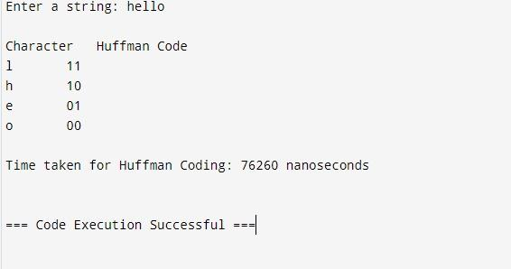

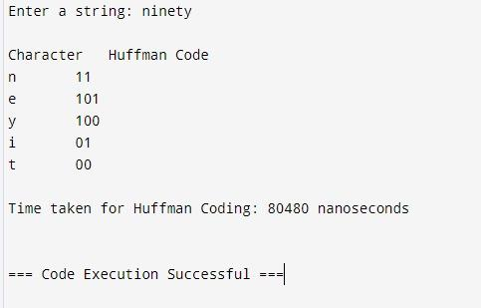

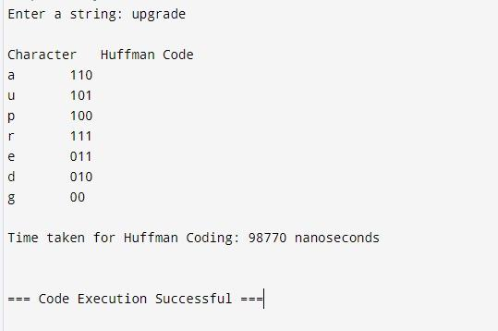

**Graph:**



**Learning Outcomes:**

**PROGRAM 4**

**AIM :** To implement Kruskal's Algorithm and analyse its time complexity.

**THEORY:**

### Code:

#include <stdio.h>

#include <stdlib.h>

#include <time.h> // Include for clock() function

// Comparator function to use in sorting

int comparator(const void *p1, const void *p2)

{

const int(*x)[3] = p1;

const int(*y)[3] = p2;

return (*x)[2] - (*y)[2];

}

// Initialization of parent[] and rank[] arrays

void makeSet(int parent[], int rank[], int n)

{

for (int i = 0; i < n; i++)

{

parent[i] = i;

rank[i] = 0;

}

}

// Function to find the parent of a node

int findParent(int parent[], int component)

{

if (parent[component] == component)

return component;

return parent[component] = findParent(parent, parent[component]);

}

// Function to unite two sets

void unionSet(int u, int v, int parent[], int rank[], int n)

{

// Finding the parents

u = findParent(parent, u);

v = findParent(parent, v);

if (rank[u] < rank[v])

{

parent[u] = v;

}

else if (rank[u] > rank[v])

{

parent[v] = u;

}

else

{

parent[v] = u;

// Since the rank increases if

// the ranks of two sets are same

rank[u]++;

}

}

// Function to find the MST

void kruskalAlgo(int n, int edge[n][3])

{

// First we sort the edge array in ascending order

// so that we can access minimum distances/cost

qsort(edge, n, sizeof(edge[0]), comparator);

int parent[n];

int rank[n];

// Function to initialize parent[] and rank[]

makeSet(parent, rank, n);

// To store the minimum cost

int minCost = 0;

printf("Following are the edges in the constructed MST\n");

for (int i = 0; i < n; i++)

{

int v1 = findParent(parent, edge[i][0]);

int v2 = findParent(parent, edge[i][1]);

int wt = edge[i][2];

// If the parents are different that

// means they are in different sets so

// union them

if (v1 != v2)

{

unionSet(v1, v2, parent, rank, n);

minCost += wt;

printf("%d -- %d == %d\n", edge[i][0], edge[i][1], wt);

}

}

printf("Minimum Cost Spanning Tree: %d\n", minCost);

}

// Driver code

int main()

{

// Input edges: {node1, node2, weight}

int edge[5][3] = {{0, 1, 10},

{0, 2, 6},

{0, 3, 5},

{1, 3, 15},

{2, 3, 4}};

// Start the clock before running the algorithm

clock_t start_time = clock();

// Call the Kruskal's algorithm to find the MST

kruskalAlgo(5, edge);

// End the clock after running the algorithm

clock_t end_time = clock();

// Calculate the time taken in milliseconds

double time_taken = ((double)(end_time - start_time)) / CLOCKS_PER_SEC * 1000;

// Print the time taken to execute the program

printf("Time taken: %.2f ms\n", time_taken);

return 0;

}

**Output:**

**Learning Outcome:**

**PROGRAM 5**

**AIM :** To implement Matrix chain Multiplication program

**THEORY:**

The Matrix Chain Multiplication problem aims to find the most efficient way to multiply a given sequence of matrices. The goal is to minimize the total number of scalar multiplications required.

**Algorithm:**

1. Matrix Dimensions: Let the dimensions of the matrices be represented as an array, where the i-th matrix has dimensions p[i-1] x p[i].

2. Dynamic Programming Table: Create a 2D table `m` where m[i][j] represents the minimum number of scalar multiplications needed to multiply matrices from index i to j.

3. Filling the Table:

- For chain lengths from 2 to n, compute the minimum cost of multiplying matrices from i to j by trying all possible splits.

- For each split point k between i and j, calculate the cost as m[i][k] + m[k+1][j] + (dimensions of the resulting matrix). Update m[i][j] with the minimum cost found.

4. Result: The minimum number of multiplications for the entire chain is stored in m[1][n].

**Time Complexity:** The time complexity of this algorithm is O(n^3), where n is the number of matrices.

**Space Complexity:** The space complexity is O(n^2) due to the storage of the dynamic programming table.

**Program:**

#include <iostream>

#include <climits>

using namespace std;

#define MAX 30

int matrixChainOrder(int p[], int n) {

int m[MAX][M AX]; // m[i][j] holds the minimum multiplication cost for matrices i to j

for (int i = 1; i < n; i++) {

m[i][i] = 0}

for (int L = 2; L < n; L++) {

for (int i = 1; i <= n - L; i++) {

int j = i + L - 1;

m[i][j] = INT_MAX;

// Find minimum cost for multiplying matrices i to j

for (int k = i; k < j; k++) {

int cost = m[i][k] + m[k + 1][j] + p[i - 1] * p[k] * p[j];

if (cost < m[i][j]) {

m[i][j] = cost;}

}

}

}

return m[1][n - 1];}

int main() {

int n;

cout << "Enter the number of matrices: ";

cin >> n;

int arr[MAX];

cout << "Enter the dimensions of matrices: ";

for (int i = 0; i <= n; i++) {

cin >> arr[i];}

int minCost = matrixChainOrder(arr, n + 1);

cout << "Minimum number of multiplications is: " << minCost << endl;

return 0;}

**Output:**

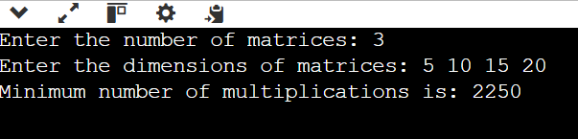

**Code:**

#include <limits.h>

#include <stdio.h>

#include <time.h> // Include time.h for clock()

int MatrixChainOrder(int p[], int i, int j) {

if (i == j) return 0;

int k, min = INT_MAX, count;

for (k = i; k < j; k++) {

count = MatrixChainOrder(p, i, k) + MatrixChainOrder(p, k + 1, j) + p[i - 1] * p[k] * p[j];

if (count < min) min = count;

}

return min;

}

int main() {

int arr[] = {1, 2, 3, 4, 3};

int N = sizeof(arr) / sizeof(arr[0]);

clock_t start = clock(); // Start clock

printf("Minimum number of multiplications is %d ", MatrixChainOrder(arr, 1, N - 1));

clock_t end = clock(); // End clock

double time_taken = ((double)(end - start)) / CLOCKS_PER_SEC * 1000; // Time in ms

printf("\nTime taken: %.4f ms\n", time_taken); // Output time

return 0;

}

**Output:**

**Learning Outcome:**

**PROGRAM 6**

**AIM :** To implement Dijkstra algorithm and analyse its time complexity

**THEORY:**

### Code:

#include <stdio.h>

#include <limits.h>

#include <time.h> // Include time.h for clock()

#define MAX_VERTICES 100

int minDistance(int dist[], int sptSet[], int vertices) {

int min = INT_MAX, minIndex;

for (int v = 0; v < vertices; v++) {

if (!sptSet[v] && dist[v] < min) {

min = dist[v];

minIndex = v;

}

}

return minIndex;

}

void printSolution(int dist[], int vertices) {

printf("Vertex \tDistance from Source\n");

for (int i = 0; i < vertices; i++) {

printf("%d \t%d\n", i, dist[i]);

}

}

void dijkstra(int graph[MAX_VERTICES][MAX_VERTICES], int src, int vertices) {

int dist[MAX_VERTICES], sptSet[MAX_VERTICES];

for (int i = 0; i < vertices; i++) {

dist[i] = INT_MAX;

sptSet[i] = 0;

}

dist[src] = 0;

for (int count = 0; count < vertices - 1; count++) {

int u = minDistance(dist, sptSet, vertices);

sptSet[u] = 1;

for (int v = 0; v < vertices; v++) {

if (!sptSet[v] && graph[u][v] && dist[u] != INT_MAX && dist[u] + graph[u][v] < dist[v]) {

dist[v] = dist[u] + graph[u][v];

}

}

}

printSolution(dist, vertices);

}

int main() {

int vertices;

printf("Input the number of vertices: ");

scanf("%d", &vertices);

if (vertices <= 0 || vertices > MAX_VERTICES) {

printf("Invalid number of vertices. Exiting...\n");

return 1;

}

int graph[MAX_VERTICES][MAX_VERTICES];

printf("Input the adjacency matrix for the graph (use INT_MAX for infinity):\n");

for (int i = 0; i < vertices; i++) {

for (int j = 0; j < vertices; j++) {

scanf("%d", &graph[i][j]);

}

}

int source;

printf("Input the source vertex: ");

scanf("%d", &source);

if (source < 0 || source >= vertices) {

printf("Invalid source vertex. Exiting...\n");

return 1;

}

clock_t start = clock(); // Start clock

dijkstra(graph, source, vertices);

clock_t end = clock(); // End clock

double time_taken = ((double)(end - start)) / CLOCKS_PER_SEC * 1000; // Time in ms

printf("Time taken: %.4f ms\n", time_taken); // Output time

return 0;

}

**Output:**

**Learning Outcome:**

**PROGRAM 7**

**AIM :** To implement Bellman Ford algorithm and analyse its time complexity.

**THEORY:**

### Code:

#include <limits.h>

#include <stdio.h>

#include <stdlib.h>

#include <time.h> // Include time.h for clock()

#define MAX_VERTICES 1000

#define INF INT_MAX

void bellmanFord(int graph[MAX_VERTICES][MAX_VERTICES], int vertices, int edges, int source) {

int distance[MAX_VERTICES];

for (int i = 0; i < vertices; ++i) distance[i] = INF;

distance[source] = 0;

for (int i = 0; i < vertices - 1; ++i) {

for (int j = 0; j < edges; ++j) {

if (graph[j][0] != -1 && distance[graph[j][0]] != INF && distance[graph[j][1]] > distance[graph[j][0]] + graph[j][2])

distance[graph[j][1]] = distance[graph[j][0]] + graph[j][2];

}

}

for (int i = 0; i < edges; ++i) {

if (graph[i][0] != -1 && distance[graph[i][0]] != INF && distance[graph[i][1]] > distance[graph[i][0]] + graph[i][2]) {

printf("Negative cycle detected\n");

return;

}

}

printf("Vertex Distance from Source\n");

for (int i = 0; i < vertices; ++i)

printf("%d \t\t %d\n", i, distance[i]);

}

int main() {

int vertices = 6;

int edges = 8;

int graph[MAX_VERTICES][MAX_VERTICES] = {{0, 1, 5}, {0, 2, 7}, {1, 2, 3}, {1, 3, 4}, {1, 4, 6}, {3, 4, -1}, {3, 5, 2}, {4, 5, -3}};

clock_t start = clock(); // Start clock

bellmanFord(graph, vertices, edges, 0);

clock_t end = clock(); // End clock

double time_taken = ((double)(end - start)) / CLOCKS_PER_SEC * 1000; // Time in ms

printf("Time taken: %.4f ms\n", time_taken); // Output time

return 0;

}

**Output:**

**Learning Outcome:**

**PROGRAM 8**

**AIM :** To implement N Queen’s problem using backtracking.

**THEORY:**

### Code:

#include <stdio.h>

#include <stdlib.h>

#include <math.h>

#include <time.h> // Include time.h for clock

int board[20], count = 0; // Initialize count to 0

void print(int n);

int place(int row, int column);

void queen(int row, int n);

int main() {

int n;

printf(" - N Queens Problem Using Backtracking -\n\n");

printf("Enter number of Queens: ");

scanf("%d", &n);

clock_t start = clock(); // Start clock

queen(1, n);

clock_t end = clock(); // End clock

double time_taken = ((double)(end - start)) / CLOCKS_PER_SEC * 1000; // Time in ms

printf("\nTime taken: %.4f ms\n", time_taken); // Output time

return 0;

}

// Function for printing the solution

void print(int n) {

int i, j;

printf("\n\nSolution %d:\n\n", ++count);

for (i = 1; i <= n; ++i) printf("\t%d", i);

for (i = 1; i <= n; ++i) {

printf("\n\n%d", i);

for (j = 1; j <= n; ++j) { // for nxn board

if (board[i] == j) printf("\tQ"); // queen at i,j position

else printf("\t-"); // empty slot

}

}

}

// Function to check conflicts

int place(int row, int column) {

int i;

for (i = 1; i <= row - 1; ++i) {

// Checking column and diagonal conflicts

if (board[i] == column) return 0;

else if (abs(board[i] - column) == abs(i - row)) return 0;

}

return 1; // no conflicts

}

// Function to check for proper positioning of queen

void queen(int row, int n) {

int column;

for (column = 1; column <= n; ++column) {

if (place(row, column)) {

board[row] = column; // No conflicts, so place queen

if (row == n) // All queens are placed

print(n); // Print the board configuration

else // Try queen with the next position

queen(row + 1, n);

}

}

}

**Output:**

**Learning Outcome:**

**PROGRAM 9**

**AIM :** To implement Longest Common Subsequence problem and analyse its time complexity.

**THEORY:**

The Longest Common Subsequence (LCS) problem identifies the longest sequence of characters that appear in the same order in both input strings, not necessarily contiguously. This problem is efficiently solved using dynamic programming.

**Algorithm :**

1. Create a 2D array, LCS table, where LCS table[i][j] stores the length of the LCS for substrings S1[0...i-1] and S2[0...j-1].
2. Initialize the first row and column to 0 for cases where one string is empty.
3. For each character comparison:
   * If characters match (S1[i-1] == S2[j-1]), set LCS table[i][j] = LCS table[i-1][j-1] + 1.
   * If they don’t match, set LCS table[i][j] = max(LCS table[i-1][j], LCS table[i][j-1]).
4. The length of the LCS is found in LCS table[m][n].

Traceback to Find LCS:

* Start from the bottom-right of LCS table and trace back to reconstruct the LCS:
  + If S1[i-1] == S2[j-1], add this character to the LCS and move diagonally up-left.
  + If not, move in the direction of the higher value (left or above) until reaching the top-left cell.

**Time Complexity:** O(m × n), where m and n are the lengths of the two strings, due to the nested loops filling LCS table.

**Space Complexity:** O(m × n), as LCS table stores intermediate values for each substring combination.

**Program:**

#include <iostream>

#include <cstring>

using namespace std;

void lcsAlgo(char *S1, char *S2, int m, int n) {

int LCS_table[m + 1][n + 1];

for (int i = 0; i <= m; i++) {

for (int j = 0; j <= n; j++) {

if (i == 0 || j == 0)

LCS_table[i][j] = 0;

else if (S1[i - 1] == S2[j - 1])

LCS_table[i][j] = LCS_table[i - 1][j - 1] + 1;

else

LCS_table[i][j] = max(LCS_table[i - 1][j], LCS_table[i][j - 1]);}

}

int index = LCS_table[m][n];

char lcsAlgo[index + 1];

lcsAlgo[index] = '\0';

int i = m, j = n;

while (i > 0 && j > 0) {

if (S1[i - 1] == S2[j - 1]) {

lcsAlgo[index - 1] = S1[i - 1];

i--;

j--;

index--;}

else if (LCS_table[i - 1][j] > LCS_table[i][j - 1])

i--;

else

j--;}

cout << "S1 : " << S1 << "\nS2 : " << S2 << "\nLCS: " << lcsAlgo << "\n";}

int main() {

char S1[50], S2[50];

cout << "Enter the first string: ";

cin >> S1;

cout << "Enter the second string: ";

cin >> S2;

int m = strlen(S1);

int n = strlen(S2);

lcsAlgo(S1, S2, m, n);

return 0;}

**Output:**

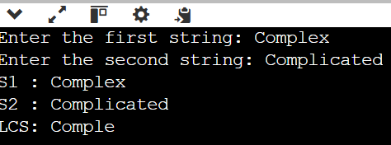

### Code:

#include <stdio.h>

#include <string.h>

#include <time.h> // Include time.h for clock()

int max(int x, int y) { return x > y ? x : y; }

// Returns length of LCS for s1[0..m-1], s2[0..n-1]

int lcs(char *s1, char *s2, int m, int n) {

if (m == 0 || n == 0) return 0; // Base case: If either string is empty, LCS length is 0

if (s1[m - 1] == s2[n - 1]) // If last characters match

return 1 + lcs(s1, s2, m - 1, n - 1); // Include character and recurse

else

return max(lcs(s1, s2, m, n - 1), lcs(s1, s2, m - 1, n)); // Recur without last character

}

int main() {

char s1[] = "AGGTAB";

char s2[] = "GXTXAYB";

int m = strlen(s1);

int n = strlen(s2);

clock_t start = clock(); // Start clock

printf("%d\n", lcs(s1, s2, m, n)); // Call LCS function and print result

clock_t end = clock(); // End clock

double time_taken = ((double)(end - start)) / CLOCKS_PER_SEC * 1000; // Time in ms

printf("Time taken: %.4f ms\n", time_taken); // Output time

return 0;

}

**Output:**

**Learning Outcome:**

**PROGRAM 10**

**AIM :** To implement Naive String-Matching algorithm, Rabin Karp algorithm and knuth Morris Pratt algorithm and analyse its time complexity**.**

**THEORY:**

### Code:

### Naive String-Matching algorithm

#include <stdio.h>

#include <string.h>

#include <time.h> // Include time.h for clock()

void search(char *pat, char *txt) {

int M = strlen(pat);

int N = strlen(txt);

// A loop to slide pat[] one by one

for (int i = 0; i <= N - M; i++) {

int j;

// For current index i, check for pattern match

for (j = 0; j < M; j++) {

if (txt[i + j] != pat[j]) {

break;

}

}

// If pattern matches at index i

if (j == M) {

printf("Pattern found at index %d\n", i);

}

}

}

int main() {

char txt1[] = "AABAACAADAABAABA";

char pat1[] = "AABA";

char txt2[] = "agd";

char pat2[] = "g";

clock_t start = clock(); // Start clock

printf("Example 1:\n");

search(pat1, txt1);

printf("\nExample 2:\n");

search(pat2, txt2);

clock_t end = clock(); // End clock

double time_taken = ((double)(end - start)) / CLOCKS_PER_SEC * 1000; // Time in ms

printf("\nTime taken: %.4f ms\n", time_taken); // Output time

return 0;

}

**Output:**

**2. Rabin Karp algorithm**

#include <stdio.h>

#include <string.h>

#include <time.h> // Include time.h for clock()

// d is the number of characters in the input alphabet

#define d 256

/* pat -> pattern

txt -> text

q -> A prime number

*/

void search(char pat[], char txt[], int q) {

int M = strlen(pat);

int N = strlen(txt);

int i, j;

int p = 0; // hash value for pattern

int t = 0; // hash value for txt

int h = 1;

// The value of h would be "pow(d, M-1)%q"

for (i = 0; i < M - 1; i++)

h = (h * d) % q;

// Calculate the hash value of pattern and first window of text

for (i = 0; i < M; i++) {

p = (d * p + pat[i]) % q;

t = (d * t + txt[i]) % q;

}

// Slide the pattern over text one by one

for (i = 0; i <= N - M; i++) {

// Check the hash values of current window of text and pattern

if (p == t) {

/* Check for characters one by one */

for (j = 0; j < M; j++) {

if (txt[i + j] != pat[j])

break;

}

// if p == t and pat[0...M-1] = txt[i, i+1, ...i+M-1]

if (j == M)

printf("Pattern found at index %d \n", i);

}

// Calculate hash value for next window of text: Remove leading digit, add trailing digit

if (i < N - M) {

t = (d * (t - txt[i] * h) + txt[i + M]) % q;

// We might get negative value of t, converting it to positive

if (t < 0)

t = (t + q);

}

}

}

/* Driver Code */

int main() {

char txt[] = "GEEKS FOR GEEKS";

char pat[] = "GEEK";

int q = 101;

clock_t start = clock(); // Start clock

search(pat, txt, q); // Call search function

clock_t end = clock(); // End clock

double time_taken = ((double)(end - start)) / CLOCKS_PER_SEC * 1000; // Time in ms

printf("\nTime taken: %.4f ms\n", time_taken); // Output time

return 0;

}

**Output:**

**3. knuth Morris Pratt algorithm**

#include <stdio.h>

#include <string.h>

#include <stdlib.h>

#include <time.h> // Include time.h for clock()

void constructLps(char *pat, int *lps) {

int len = 0; // Length of the previous longest prefix suffix

int i = 1;

lps[0] = 0; // lps[0] is always 0

// Build the lps array

while (i < strlen(pat)) {

if (pat[i] == pat[len]) {

len++;

lps[i] = len;

i++;

} else { // Mismatch

if (len != 0) {

len = lps[len - 1];

} else {

lps[i] = 0;

i++;

}

}

}

}

int *search(char *pat, char *txt, int *resCount) {

int n = strlen(txt);

int m = strlen(pat);

int *lps = (int *)malloc(m * sizeof(int));

int *res = (int *)malloc(n * sizeof(int)); // Max possible matches

*resCount = 0;

constructLps(pat, lps);

int i = 0; // Index for txt

int j = 0; // Index for pat

while (i < n) {

if (txt[i] == pat[j]) {

i++;

j++;

if (j == m) {

res[(*resCount)++] = i - j;

j = lps[j - 1];

}

} else {

if (j != 0) {

j = lps[j - 1];

} else {

i++;

}

}

}

free(lps);

return res;

}

int main() {

char txt[] = "aabaacaadaabaaba";

char pat[] = "aaba";

int resCount;

clock_t start = clock(); // Start clock

int *res = search(pat, txt, &resCount); // Call search function

clock_t end = clock(); // End clock

printf("Pattern matched at indexes: ");

for (int i = 0; i < resCount; i++) {

printf("%d ", res[i]);

}

double time_taken = ((double)(end - start)) / CLOCKS_PER_SEC * 1000; // Time in ms

printf("\nTime taken: %.4f ms\n", time_taken); // Output time

free(res);

return 0;

}

**Output:**



**Learning Outcome:**