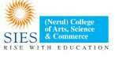

**SIES (NERUL) COLLEGE OF ARTS, SCIENCE AND COMMERCE**

NAAC ACCREDITED ‘A’ GRADE COLLEGE

(ISO 9001:2008 CERTIFIED INSTITUTION)

NERUL, NAVI MUMBAI – 400706

INTERNSHIP REPORT ON

**CUSTOMER SUPPORT DEPARTMENT (ICMR PORTAL**)

SUBMITTED BY

**GEETANJALI PANDURANG SAWANT**

SUBMITTED IN THE PARTIAL FULLFILMENT FOR THE DEGREE OF

**MSc. COMPUTER SCIENCE**

SEMESTER – IV, 2020 - 2021

**SIES (NERUL) COLLEGE OF ARTS SCIENCE AND**

**COMMERCE**

**NAAC ACCREDITED ‘A’ GRADE COLLEGE**

(ISO 9001:2015 CERTIFIED INSTITUTION)

 NERUL NAVI MUMBAI – 400706

THIS IS CERTIFY THAT

**GEETANJALI PANDURANG SAWANT**

HAS NDERTAKEN AN INTERNSHIP IN

**CUSTOMER SUPPORT DEPARTMENT (ICMR PORTAL**)

SEAT NO: **15**

In partial fulfilment of MSc - CS Degree Semester IV Examination in the academic year 2019-2021. It is further certified that he/she has completed 2466 hours of the Internship.

Project Guide External Examiner

Head of Department Principal

|  |
| --- |
|  |

# ***Certificate***

# 

This is to certify that **Miss. Geetanjali Pandurang Sawant** of **SIES** **College**, **Nerul** worked as an intern as part of her MSc course in Computer Science of University of Mumbai. The particulars of internship are given below:

**Internship starting date:** 10 th august, 2020

**Internship ending date:** 25 th May, 2021

**Actual number of days worked:** 274 working days

(excluding week-offs)

**Tentative number of hours worked:** 2466 Hours

**Broad area of work**:

Thyrocare operates with a Centralized Processing Laboratory (CPL) in Mumbai - India for esoteric tests; and Regional Processing Laboratory in major metro cities of India and other parts of Asia.

Intern has worked in a ICMR department as a customer support executive and lead team as well. Our organization have clone of ICMR portal which works similar to ICMR but helps to analyze the covid 19 data properly and helps to reach line-list on time to respective localities.

During the internship she demonstrated good decision skills with a self-motivated attitude to learn new things Her performance exceeded

the expectations and was able to complete task successfully on time.

We wish her all the best for her future endeavours.

Thanking you!

Dr.Caesar Sengupta

Vice-President

**Professional Evaluation of intern**

Name of employee: **Geetanjali Pandurang Sawant**

Institute Name: **SIES College, Nerul**

Department: **ICMR Department**

|  |  |  |  |  |
| --- | --- | --- | --- | --- |
| Performance Evaluation | Excellent | Good | Fair | Poor |
| Job knowledge |  |  |  |  |
| Work Quality |  |  |  |  |
| Technical skills |  |  |  |  |
| Work consistency |  |  |  |  |
| Attitude towards work |  |  |  |  |
| Co-operation |  |  |  |  |
| Initiative |  |  |  |  |
| Punctuality |  |  |  |  |
| Attendance |  |  |  |  |
| Communications skills |  |  |  |  |
| Leadership potential |  |  |  |  |
| Problem solving skills |  |  |  |  |
| Overall rating |  |  |  |  |

\

Dr.Caesar Sengupta

Vice-President

**INDEX**

|  |  |
| --- | --- |
| **SR NO** | **TOPIC** |
| **1.** | OVERVIEW OF THE ORGANISATION |
| **2.** | DESCRIPTION ABOUT THE ACTIVITIES DONE BY THE SECTION WHERE THE INTERN HAS WORKED |
| **3.** | DESCRIPTION OF WORK ALLOTTED AND ACTUALLY DONE BY THE INTERN |
| **4.** | DESCRIPTION OF WORK ALLOTTED AND ACTUALLY DONE BY THE INTERN |

**Description of the organization:**

**Overview:**

Thyrocare is India's first fully automated diagnostic laboratory with a focus on providing quality at affordable costs to laboratories and hospitals in India and other countries.

Thyrocare operates with a Centralized Processing Laboratory (CPL) in Mumbai - India for esoteric tests; and Regional Processing Laboratory in major metro cities of India and other parts of Asia. We have focus on strong technologies, strong brands and strong systems that enable all laboratories to give their clients the best of science and technology at an affordable cost.

## **Our Differentiators**

* Unique concept - Thyrocare operates with a Centralized Processing Laboratory (CPL) in Mumbai - India for esoteric tests; and Regional Processing Laboratory in major metro cities of India and other parts of Asia.
* Unique focus - We focus on clinical chemistry and preventive care diagnosis.
* Unique air-cargo logistics - which ensure the samples reach our laboratory every night, same night, before midnight.
* Unique operations - Our laboratory works 24 x 7 to cater to the needs of our customers.
* Aptio (Siemens)- World’s largest and longest laboratory track automation- 1st Time in India
* India's First preanalytical barcoded vial sorter (MUT) and Sample Sorter (Roche).

**Our Strengths-**

**Systems**:

IT when used ideally to integrate men, machines and methods, it delivers secured, assured, reliable and reproducible solutions even in Diagnostic industry. Analyzers, web-servers and barcodes when integrated, it gives a system that is empowered, controlled and monitored end to end.

**Speed**:

Laboratory functions 24X7. Air-cargo functions 24 X 7 and 95% of the business is air-cargo driven. Barcoded, Bi-directionally interfaced and web server solutions enhance the speed and allow every laboratory in any continent to operate our machines as if they are present in their floor, generating results and reports within 5 hours of flight touching the runway.

**Costs**:

Laboratory functions 24X7. Air-cargo functions 24 X 7 and 95% of the business is air-cargo driven. Barcoded, Bi-directionally interfaced and web server solutions enhance the speed and allow every laboratory in any continent to operate our machines as if they are present in their floor, generating results and reports within 5 hours of flight touching the runway.

**Quality**:

Best of the Global brands.Best of their instruments, Best of the technologies, Best of the reagents, Best of the procedures, Best of systems, Best of IT when available to well - trained and highly focused Pathologists, Biochemists, Scientists and Technologists gives Best of the Quality.

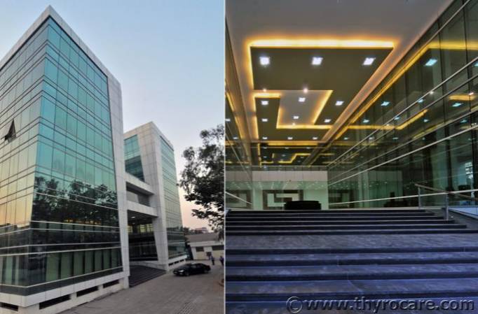

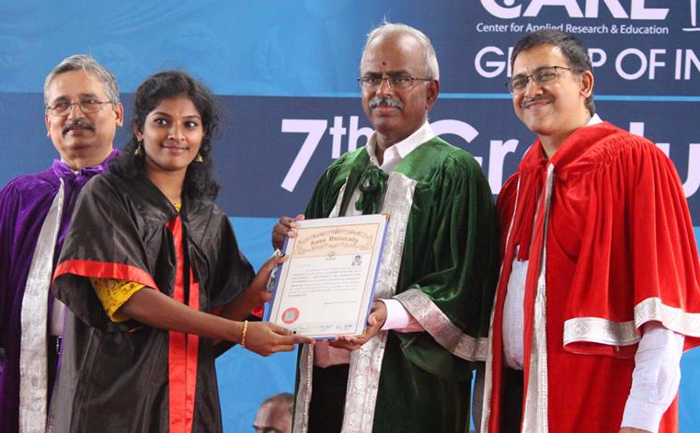

**Description about the activities done by the section where the intern has worked:**

With interactive dashboards and reporting modules to prepare customized reports of covid 19 patients, the IT department can gain complete visibility into help desk operations and make effective decisions regarding staffing levels and handling legal procedures.

**Month 1st:**

In the month of august, intern studied in deep overall management of CRMS department ad various department comes under thyrocare admin office. Simultaneously our organization had CIP(Company Induction) and Departmental training as well in that intern has scored beautiful really appreciating.

**Login Page of Employee: CHARBI PAGE**

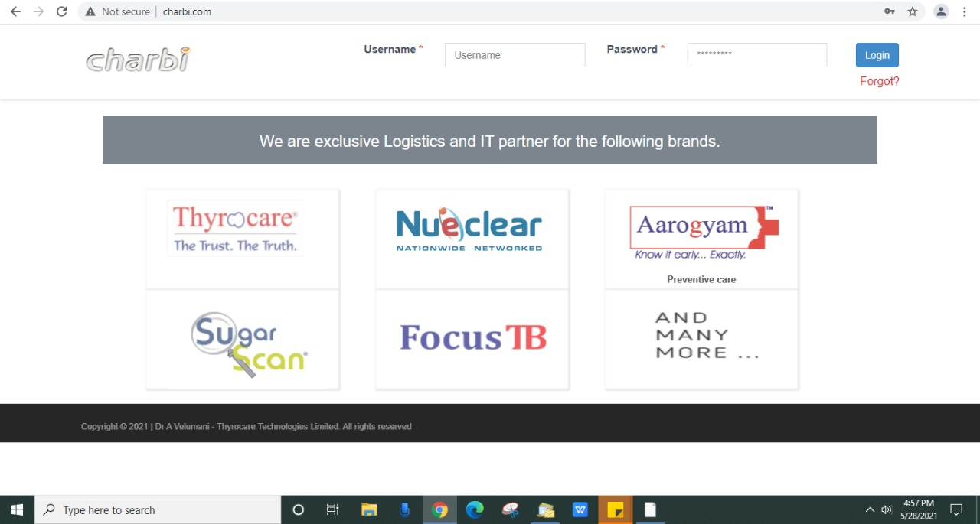

**Month 2nd and 3rd:**

In the month of September and October ,Intern learn how to handle AAROGYAM online portal,which is usually used for booking purpose of test for home collection.

In this portal there are many more packages and offers are available which is only accessible to employee of the company. Initially intern help organization for generating targets and also help to upload reports on various display or you can say push data properly.

Eg: Wellness Portal, ICMR PORTAL, Thyroapp and etc

**Appointment booking page:**

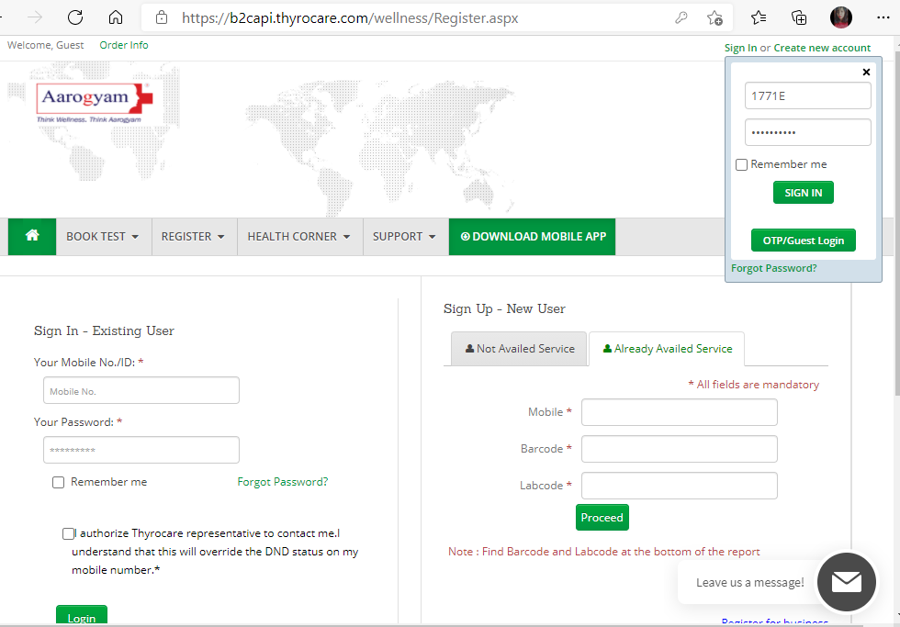

**Appreciation letter:**

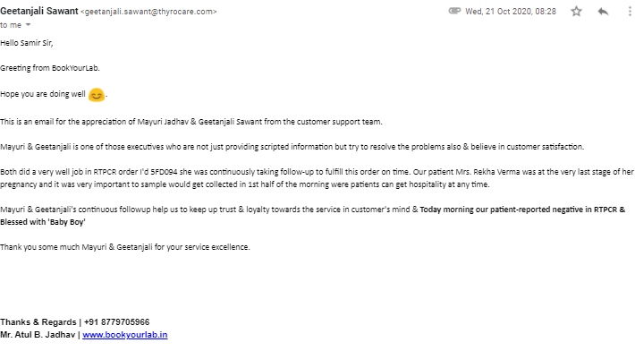

**Thyroapp app login page:**

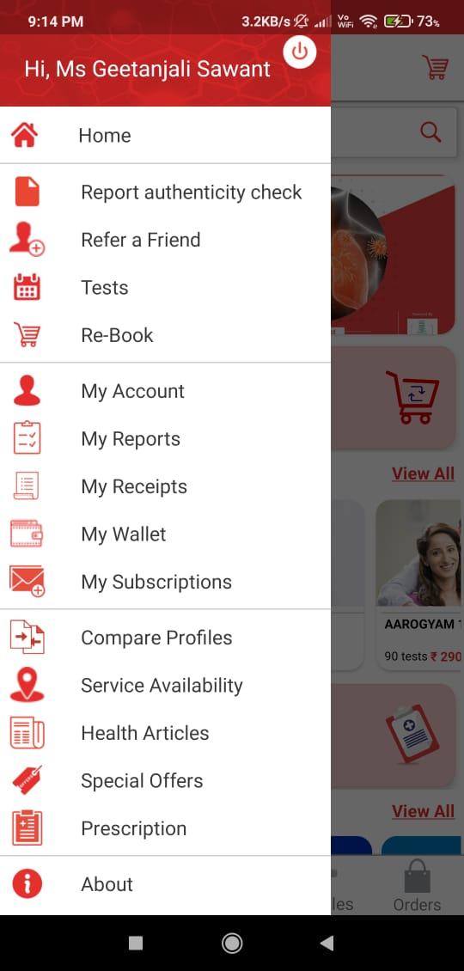 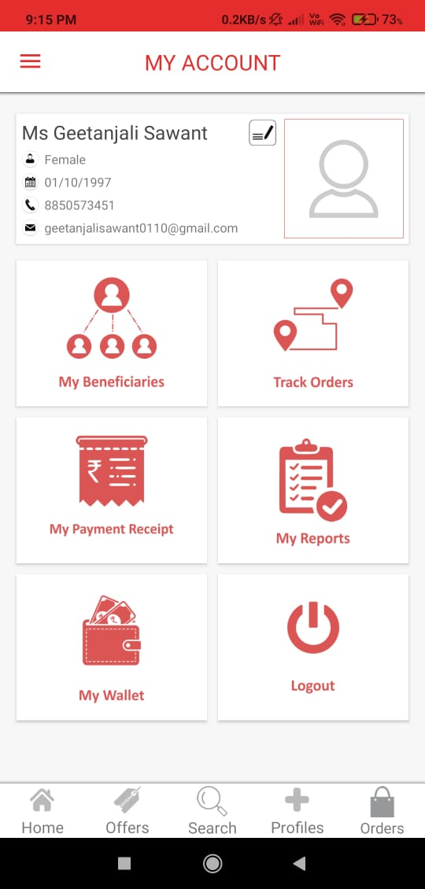

**Main login page of employee:**

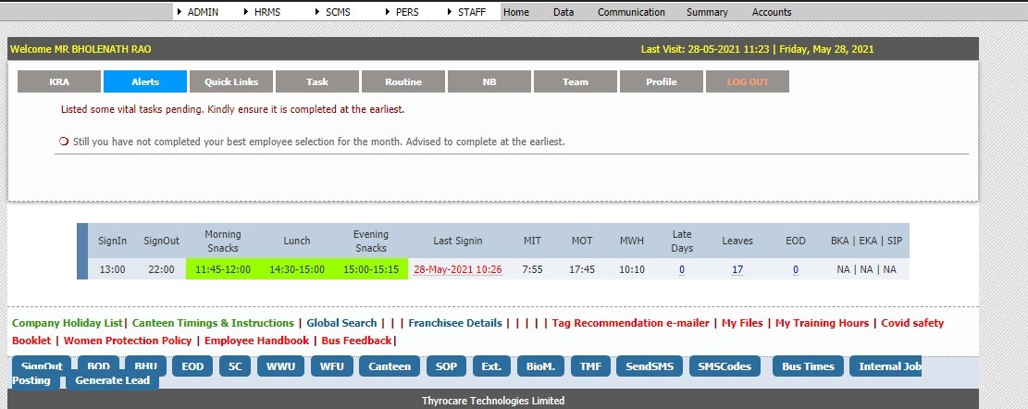

**Month 4th ,5th and 6th:**

In the month of November, December and January, intern temporarily shifted to Order Management department to learn new space under covid department.

Where she used to handle emails, complaint emails and moreover covid data which helps to identify the positive covid 19 reports and simultaneously update covid positive data in Dummy portal which is designed to push and pull covid 19 overall data,later on need to share data to local municipal corporation.

**App which used to control overall appointment:**

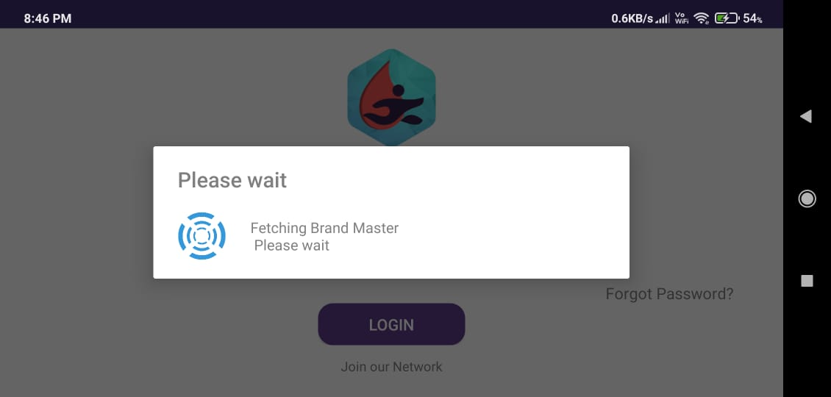

Order management system app:

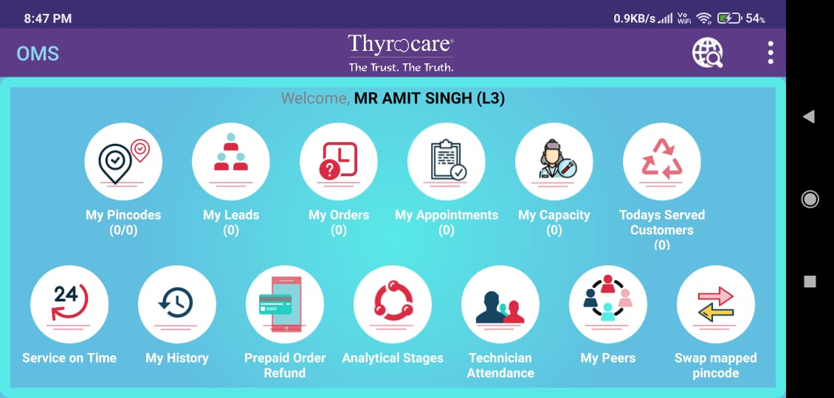

**Month 7th,8th,9th and 10th:**

In the month of feb, march, april and may, intern was trained to handle all etiquette’s(voice 2 email ettiqutte’s) and she also work under invoice 2 department where she used to audit call and also help to improve employee personality, employee call quality.

As well as she design small mailing app for our team under the guidance of her Team Leader(SMITA JADHAV) as a extra activity part.

**GUI:**

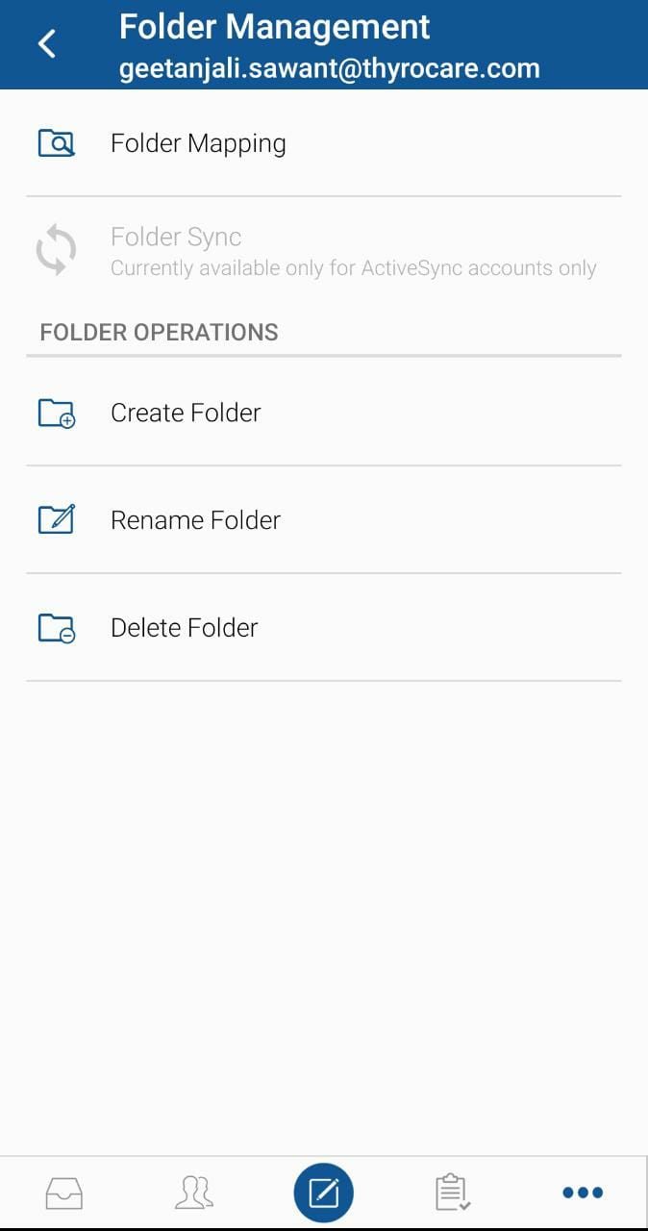

**SELF-ASSESSMENT:**

Internship program was quite beneficial for me. I was not so much confident to work in corporate world but the reporting person, my head and all colleagues made it comfortable. It gave me a broad perspective towards actual working in the industry say a hands-on-experience.

I applied the concepts and strategies of academic study in a live work environment and also learned many things while working. The importance of honouring commitments and time of others was an important thing, which I learnt as intern. Especially, while working as a team it is very important to keep these points in mind. A chance to develop my knowledge and skills set in the field.

Came to know professional ethics for approach, recognizing strength and weakness in working as team. Added deep knowledge of the languages and increased my logical thinking. Experienced different roles and so accordingly decide which to pursue in future.

An opportunity to know some kind of knowledge about software develop related things. Getting insight into the way businesses work and what challenges they face on a daily basis. The technical aspect assimilated during the internship was doing every single thing on your own. Finding out the errors was a strenuous task, but the efforts were commendable.

Getting the daily task and completing them before time limits made me confident and it made me work more effectively. Learning from how to resolve the error to being perfectionist was the journey of my internship. Got chance to enhance my skill sets like adaptability, team work, flexibility, managing the tasks and handling some responsibilities.