STRIDE Threat Modelling and Risk Assessment
IE3142 – Building and Securing a DevSecOps Pipeline
NodeGoat Application

2.2 STRIDE Threat Modelling and Risk Assessment
A STRIDE-based threat model was developed for the NodeGoat application to identify security threats against the application's architecture and data flows. The assessment focuses on realistic threats identified and tested against the locally deployed NodeGoat application. The assignment requires at least four application-specific threats, likelihood and impact ratings, justification for each rating, and a specific control with its location in the codebase or pipeline.

2.2.1 Threat Modelling Approach
The NodeGoat application consists of a Node.js and Express web application, application routes, a data access layer, and a MongoDB database. Users interact with the application through HTTP requests. The application routes process these requests and communicate with MongoDB through the data access layer. Two main trust boundaries were identified: the boundary between the user and the NodeGoat web application, and the boundary between the application and the MongoDB database.
The user-to-application boundary is particularly important because request parameters, form values, URL parameters and other user-supplied data must be considered untrusted. Four application-specific threats were identified at this boundary: missing administrator authorization on the benefits functionality, insecure direct object reference in the allocations functionality, regular expression denial of service in profile validation, and unsafe evaluation of contribution input.
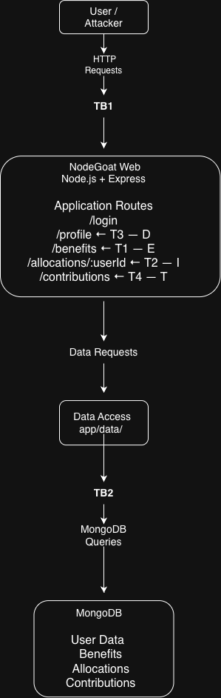
Figure X — NodeGoat STRIDE Threat Model and Trust Boundaries

2.2.2 STRIDE Threat Identification

T1 — Elevation of Privilege: Missing Administrator Authorization
The /benefits functionality is intended to provide administrative benefits-management functionality. However, the current routes apply the isLoggedIn middleware without applying the isAdmin middleware. The source code contains a commented implementation showing that administrator authorization was intended to be applied to both the GET and POST /benefits routes.
An authenticated non-administrator user can therefore directly navigate to /benefits without possessing administrator privileges. During testing, the functionality was successfully accessed using a normal user1 account rather than the administrator account. The benefits handler also accepts userId and benefitStartDate from the request before passing them to the benefits DAO.
STRIDE classification: Elevation of Privilege (E).
Risk: Likelihood = 3, Impact = 3, giving a risk score of 9 (High). The likelihood is rated high because any authenticated user can directly request the endpoint without bypassing the application's authentication mechanism. The impact is rated high because the exposed functionality is intended for administrative use and can modify employee benefit information.
Recommended control: Implement server-side role-based access control by applying the isAdmin middleware to both /benefits routes.
Control location: app/routes/index.js.

T2 — Information Disclosure: IDOR in Allocations
The allocations functionality uses the route /allocations/:userId. Although the route requires the user to be logged in, the user identifier is obtained from the URL parameter and passed to the data access layer. The source code contains a commented fix indicating that the user ID should instead be obtained from the authenticated session.
The attack was demonstrated by logging in as a normal user and modifying the userId value in the URL. The test returned allocation information belonging to another account, including the NodeGoat administrator's allocation information.
STRIDE classification: Information Disclosure (I).
Risk: Likelihood = 3, Impact = 3, giving a risk score of 9 (High). The likelihood is high because the object identifier is directly exposed in the URL and can be manipulated by an authenticated user. The impact is high because the demonstrated attack disclosed another user's financial allocation information.
Recommended control: The application should obtain the authenticated user's ID from the server-side session rather than trusting a user-controlled URL parameter.
Control location: app/routes/allocations.js.

T3 — Denial of Service: Regular Expression Denial of Service
The profile functionality validates the bankRouting value using the regular expression /([0-9]+)+\#/. The source code explicitly documents that the expression is vulnerable to catastrophic backtracking and that specially crafted input can consume excessive CPU resources. It also identifies a safer pattern without the nested quantifier as the intended fix.
A controlled test was performed against the locally deployed application using specially crafted input. Following the request, the NodeGoat web container reached approximately 100% CPU utilisation, while a subsequent request to localhost:4000 timed out after five seconds. The container itself remained running, but the web application was no longer responding normally.
STRIDE classification: Denial of Service (D).
Risk: Likelihood = 2, Impact = 3, giving a risk score of 6 (High). The likelihood is rated medium because the attacker needs to provide specially crafted input to trigger the vulnerable expression. The impact is high because the test demonstrated excessive CPU consumption and loss of application responsiveness.
Recommended control: Replace the vulnerable regular expression with a safe validation pattern that avoids nested quantifiers. The intended safe pattern is /([0-9]+)\#/.
Control location: app/routes/profile.js.

T4 — Tampering: Unsafe Evaluation of Contribution Input
The contributions functionality processes the preTax, afterTax, and roth request parameters using JavaScript eval(). The source code explicitly identifies this as an insecure use of eval() and provides parseInt() as the intended alternative.
The vulnerability was demonstrated using the locally deployed application. The preTax value was submitted as 1+1, while the other values were set to zero. The application accepted the submission and processed the pre-tax contribution as 2%, demonstrating that the input was evaluated as a JavaScript expression rather than being restricted to a simple numeric value.
STRIDE classification: Tampering (T).
Risk: Likelihood = 2, Impact = 3, giving a risk score of 6 (High). The likelihood is rated medium because the attacker needs authenticated access to the contributions functionality and must provide crafted input. The impact is rated high because attacker-controlled input is being evaluated as JavaScript, allowing unintended manipulation of application processing and creating potentially more serious security consequences.
Recommended control: Replace eval() with strict numeric parsing and input validation.
Control location: app/routes/contributions.js.

2.2.3 Risk Assessment Methodology
A simple 3×3 risk matrix was used to assess the identified threats. Likelihood and impact were each assigned a value from 1 to 3. The overall risk score was calculated as: Risk Score = Likelihood × Impact.
Likelihood / Impact | 1 — Low | 2 — Medium | 3 — High
1 — Low | 1 — Low | 2 — Low | 3 — Medium
2 — Medium | 2 — Low | 4 — Medium | 6 — High
3 — High | 3 — Medium | 6 — High | 9 — High

2.2.4 Threat-to-Control Mapping
ID | STRIDE | Threat | Likelihood | Impact | Risk | Security Control | Location
T1 | E | Missing administrator authorization on /benefits | 3 | 3 | 9 — High | Server-side RBAC using isAdmin | app/routes/index.js
T2 | I | IDOR exposes another user's allocation information | 3 | 3 | 9 — High | Obtain user ID from authenticated session | app/routes/allocations.js
T3 | D | ReDoS causes excessive CPU usage and application unavailability | 2 | 3 | 6 — High | Safe regular-expression/input validation | app/routes/profile.js
T4 | T | eval() evaluates attacker-controlled contribution input | 2 | 3 | 6 — High | Strict numeric parsing and validation | app/routes/contributions.js

2.2.5 Summary
The STRIDE assessment identified four application-specific threats across the NodeGoat architecture: Elevation of Privilege through missing administrator authorization, Information Disclosure through an IDOR vulnerability, Denial of Service through a vulnerable regular expression, and Tampering through unsafe evaluation of contribution input. The threats were validated against the locally deployed application where practical, including successful demonstrations of unauthorized benefits access, cross-user allocation disclosure, CPU exhaustion during the ReDoS test, and evaluation of a mathematical expression in the contribution functionality.
The assessment also identified specific controls that can be implemented directly within the affected application routes. This provides a clear relationship between the threat model, observed attack behaviour, risk level, and proposed mitigation. The resulting threat-to-control mapping can subsequently be used alongside the secure-coding and CI/CD work completed by the other group members.

Evidence References
- T1 — T1_Elevation_of_Privilege_Benefits_Access.png
- T2 — T2_IDOR_Information_Disclosure_Allocations.png
- T3 — T3_ReDoS_Denial_of_Service_Evidence.png
- T4 — T4_Eval_Tampering_Contribution_Update.png
- Architecture — NodeGoat_STRIDE_Threat_Model_Architecture.png

