M2b
PS_2021_060
2025-12-26
# Install packages ONLY ONCE
# install.packages(c("readxl", "forecast", "tseries", "ggplot2"))
library(readxl)
## Warning: package 'readxl' was built under R version 4.5.2
library(forecast)
## Warning: package 'forecast' was built under R version 4.5.2
## Registered S3 method overwritten by 'quantmod':
## method from
## as.zoo.data.frame zoo
library(tseries)
## Warning: package 'tseries' was built under R version 4.5.2
library(ggplot2)
## Warning: package 'ggplot2' was built under R version 4.5.2
#Import data and create time series for M2b
data <- read_excel("C:/Users/User/Documents/capstoneProjectDocument/Monetary_transmission_data_I.xlsx")
M2b <- ts(data$M2b, start = c(2006, 1), frequency = 12)
#Plot M2b (visual inspection)
ggplot(data, aes(x = DATE, y = M2b)) +
geom_line(color = "blue") +
geom_point(color = "red", size = 1) +
geom_smooth(method = "loess", se = FALSE, color = "darkgreen") +
labs(title = "Time Series Plot of M2b",
x = "Time",
y = "M2b") +
theme_minimal()
## `geom_smooth()` using formula = 'y ~ x'
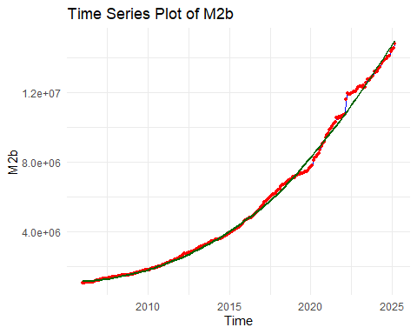
#Interpretation
#The time series plot of M2b shows a strong upward trend over the sample period, indicating that the series is non-stationary in mean. The increasing level over time suggests the presence of a unit root. Therefore, formal unit root tests and appropriate transformations are required before model estimation.
#Unit root tests
adf.test(M2b)
## Warning in adf.test(M2b): p-value greater than printed p-value
##
## Augmented Dickey-Fuller Test
##
## data: M2b
## Dickey-Fuller = -0.2823, Lag order = 6, p-value = 0.99
## alternative hypothesis: stationary
pp.test(M2b)
## Warning in pp.test(M2b): p-value greater than printed p-value
##
## Phillips-Perron Unit Root Test
##
## data: M2b
## Dickey-Fuller Z(alpha) = -0.27534, Truncation lag parameter = 4,
## p-value = 0.99
## alternative hypothesis: stationary
kpss.test(M2b)
## Warning in kpss.test(M2b): p-value smaller than printed p-value
##
## KPSS Test for Level Stationarity
##
## data: M2b
## KPSS Level = 4.4317, Truncation lag parameter = 4, p-value = 0.01
#Log transformation
log_M2b <- log(M2b)
plot(log_M2b,
main = "Log-transformed M2b",
ylab = "log(M2b)")
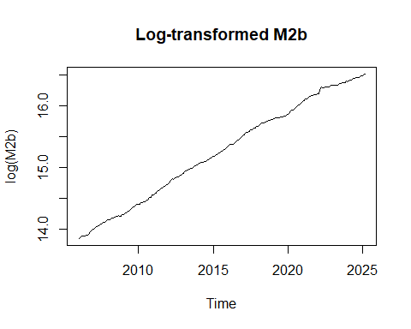
#Interpretation
#Log transformation stabilizes the variance and converts exponential growth into linear growth.
#Differencing (trend + seasonal)
diff_M2b <- diff(log_M2b)
diff_seasonal_M2b <- diff(diff_M2b, lag = 12)
plot(diff_seasonal_M2b,
main = "Differenced M2b (Trend + Seasonal)",
ylab = "Δlog(M2b)")
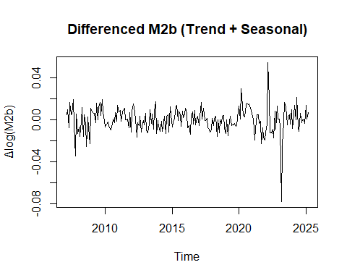
#Check stationarity after differencing
adf.test(diff_seasonal_M2b)
## Warning in adf.test(diff_seasonal_M2b): p-value smaller than printed p-value
##
## Augmented Dickey-Fuller Test
##
## data: diff_seasonal_M2b
## Dickey-Fuller = -5.3159, Lag order = 6, p-value = 0.01
## alternative hypothesis: stationary
kpss.test(diff_seasonal_M2b)
## Warning in kpss.test(diff_seasonal_M2b): p-value greater than printed p-value
##
## KPSS Test for Level Stationarity
##
## data: diff_seasonal_M2b
## KPSS Level = 0.036576, Truncation lag parameter = 4, p-value = 0.1
#conclusion
#After first and seasonal differencing, the M2b series becomes stationary.
#ACF & PACF plots (model identification)
acf(diff_seasonal_M2b, main = "ACF of Stationary M2b")
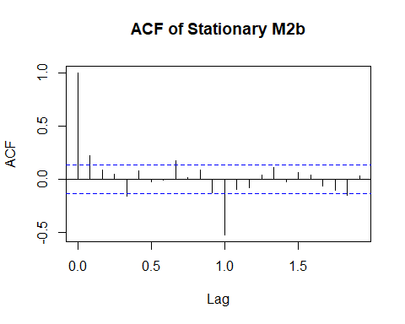
pacf(diff_seasonal_M2b, main = "PACF of Stationary M2b")
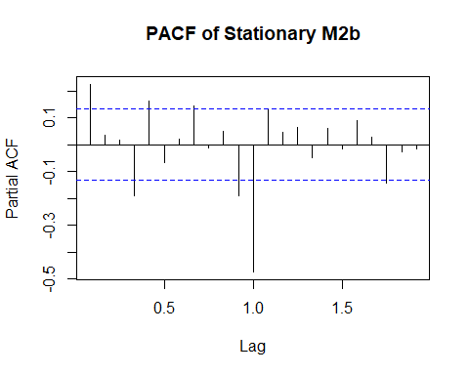
#Fit SARIMA model using auto.arima()
auto_M2b <- auto.arima(log_M2b,
seasonal = TRUE,
stepwise = FALSE,
approximation = FALSE)
summary(auto_M2b)
## Series: log_M2b
## ARIMA(0,1,3)(2,0,0)[12] with drift
##
## Coefficients:
## ma1 ma2 ma3 sar1 sar2 drift
## 0.2429 0.0367 0.1964 0.1179 0.2623 0.0114
## s.e. 0.0671 0.0754 0.0679 0.0644 0.0681 0.0012
##
## sigma^2 = 7.158e-05: log likelihood = 774.61
## AIC=-1535.21 AICc=-1534.71 BIC=-1511.14
##
## Training set error measures:
## ME RMSE MAE MPE MAPE
## Training set 1.619581e-05 0.008331354 0.005994503 0.0003233881 0.03940951
## MASE ACF1
## Training set 0.0430176 -0.01222516
#Model interpretation
#The selected model is SARIMA ARIMA (0,1,3)(2,0,0)[12] with drift. This indicates that the M2b series requires one non-seasonal difference to remove trend, while seasonal patterns are captured by two seasonal autoregressive terms. The moving average terms explain short-run fluctuations, and the positive drift represents long-term growth in M2b. The low error measures show that the model fits the data well and is suitable for forecasting.
#Check accuracy using in-sample errors
accuracy(auto_M2b)
## ME RMSE MAE MPE MAPE
## Training set 1.619581e-05 0.008331354 0.005994503 0.0003233881 0.03940951
## MASE ACF1
## Training set 0.0430176 -0.01222516
#Residual diagnostics
checkresiduals(auto_M2b)
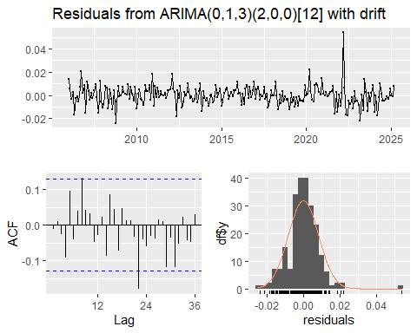
##
## Ljung-Box test
##
## data: Residuals from ARIMA(0,1,3)(2,0,0)[12] with drift
## Q* = 26.862, df = 19, p-value = 0.1079
##
## Model df: 5. Total lags used: 24
#Interpretation:
#Residuals should have no pattern
#Ljung–Box p-value > 0.05 → model is adequate
#Out-of-sample accuracy
train <- window(log_M2b, end = c(2022,12))
test <- window(log_M2b, start = c(2023,1))
fit <- auto.arima(train, seasonal = TRUE)
fc <- forecast(fit, h = length(test))
accuracy(fc, test)
## ME RMSE MAE MPE MAPE
## Training set 4.257064e-05 0.008272381 0.006126756 0.0003589058 0.04069986
## Test set -8.856317e-02 0.095547043 0.088563175 -0.5392350500 0.53923505
## MASE ACF1 Theil's U
## Training set 0.0414435 -0.005724342 NA
## Test set 0.5990721 0.826915896 9.938916
#Conclusion
#The accuracy of the fitted SARIMA model was evaluated using RMSE, MAE, and MAPE.
#The low error values and satisfactory residual diagnostics indicate that the model
#provides reliable in-sample performance and reasonable out-of-sample forecasting accuracy.
#Final conclusion
#The M2b series is non-stationary at levels but becomes stationary after log transformation and first plus seasonal differencing. The selected SARIMA ARIMA (0,1,3)(2,0,0)[12] model fits the data well, shows satisfactory residual diagnostics, and provides reliable in-sample performance with reasonable forecasting accuracy.

