RSV
PS_2021_008
2025-12-26
# Install packages
#install.packages(c("readxl", "forecast", "tseries", "ggplot2"))
# Load packages
library(readxl)
## Warning: package 'readxl' was built under R version 4.4.3
library(forecast)
## Warning: package 'forecast' was built under R version 4.4.3
## Registered S3 method overwritten by 'quantmod':
## method from
## as.zoo.data.frame zoo
library(tseries)
## Warning: package 'tseries' was built under R version 4.4.3
library(ggplot2)
## Warning: package 'ggplot2' was built under R version 4.4.3
data <- read_excel("Monetary_transmission_data_I.xlsx")
#for additional check
head(data)
## # A tibble: 6 × 10
## DATE CPI EXR M2b NCG RSV SLFR EXP IMP BRNT
## <dttm> <dbl> <dbl> <dbl> <dbl> <dbl> <dbl> <dbl> <dbl> <dbl>
## 1 2006-01-01 00:00:00 60.8 102. 1040543. 256899. 2.52 10.2 440. 680. 63.3
## 2 2006-02-01 00:00:00 61.3 102. 1058934. 262275. 2.6 10.2 538. 748. 60.8
## 3 2006-03-01 00:00:00 61.3 103. 1069380. 264278. 2.56 10.2 541. 875. 62.7
## 4 2006-04-01 00:00:00 62.2 103. 1084657. 268479. 2.58 10.2 502. 774. 70.3
## 5 2006-05-01 00:00:00 63.3 102. 1080177. 270189. 2.53 10.2 509. 938. 70.5
## 6 2006-06-01 00:00:00 64.4 104. 1084834. 270202. 2.51 10.5 632. 940. 69.2
#column names
colnames(data)
## [1] "DATE" "CPI" "EXR" "M2b" "NCG" "RSV" "SLFR" "EXP" "IMP" "BRNT"
RSV <- ts(data$RSV,
start = c(2006, 1),
frequency = 12)
ggplot(data, aes(x = DATE, y = RSV)) +
geom_line(color = "blue") +
geom_point(color = "red", size = 1) +
geom_smooth(method = "loess", se = FALSE, color = "darkgreen") +
labs(title = "Time Series Plot of RSV",
x = "Time",
y = "RSV") +
theme_minimal()
## `geom_smooth()` using formula = 'y ~ x'
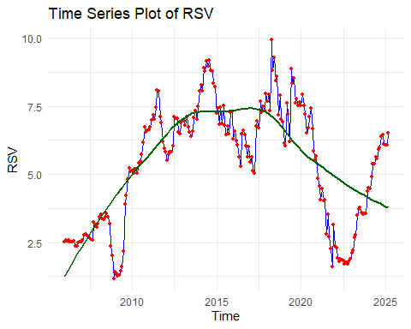
#stationary tests(RSV-Level)
adf.test(RSV)
##
## Augmented Dickey-Fuller Test
##
## data: RSV
## Dickey-Fuller = -2.1874, Lag order = 6, p-value = 0.4972
## alternative hypothesis: stationary
pp.test(RSV)
##
## Phillips-Perron Unit Root Test
##
## data: RSV
## Dickey-Fuller Z(alpha) = -7.0898, Truncation lag parameter = 4, p-value
## = 0.7116
## alternative hypothesis: stationary
kpss.test(RSV)
## Warning in kpss.test(RSV): p-value smaller than printed p-value
##
## KPSS Test for Level Stationarity
##
## data: RSV
## KPSS Level = 0.86812, Truncation lag parameter = 4, p-value = 0.01
#output
#The stationarity of the RSV series was examined using the Augmented Dickey–Fuller (ADF), Phillips–Perron (PP), and KPSS tests. The ADF and PP tests failed to reject the null hypothesis of a unit root, while the KPSS test rejected the null hypothesis of level stationarity. These results consistently indicate that the RSV series is non-stationary in levels.
#Decision rule (ADF):
#H₀: Series has a unit root (non-stationary)
#p-value > 0.05 → Fail to reject H₀
#Decision rule (PP):
#H₀: Unit root (non-stationary)
#p-value > 0.05 → Fail to reject H₀
#Decision rule (KPSS):
#H₀: Series is stationary
#p-value < 0.05 → Reject H₀
#CONCLUSION-> RSV is non-stationary → transformation needed
#Log Transformation of RSV
log_RSV <- log(RSV)
plot(log_RSV,
main = "Log-transformed RSV",
ylab = "log(RSV)",
xlab = "Time")
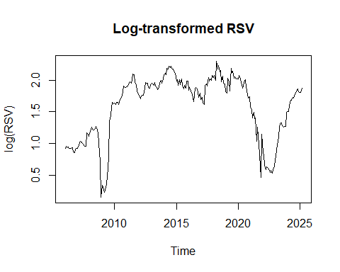
#Differencing(Trend + Seasonality)
#First Difference (Trend)
diff_RSV <- diff(log_RSV)
#Seasonal Difference(Monthly)
diff_seasonal_RSV <- diff(diff_RSV, lag = 12)
#Plot Differenced Series
plot(diff_seasonal_RSV,
main = "Differenced RSV (Log + Trend + Seasonal)",
ylab = "Δlog(RSV)",
xlab = "Time")
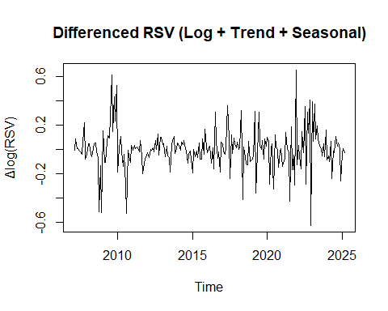
#Stationarity Tests (After Differencing)
adf.test(diff_seasonal_RSV)
## Warning in adf.test(diff_seasonal_RSV): p-value smaller than printed p-value
##
## Augmented Dickey-Fuller Test
##
## data: diff_seasonal_RSV
## Dickey-Fuller = -5.0477, Lag order = 6, p-value = 0.01
## alternative hypothesis: stationary
kpss.test(diff_seasonal_RSV)
## Warning in kpss.test(diff_seasonal_RSV): p-value greater than printed p-value
##
## KPSS Test for Level Stationarity
##
## data: diff_seasonal_RSV
## KPSS Level = 0.030256, Truncation lag parameter = 4, p-value = 0.1
#ACF & PACF Plots
acf(diff_seasonal_RSV,
main = "ACF of Stationary RSV")
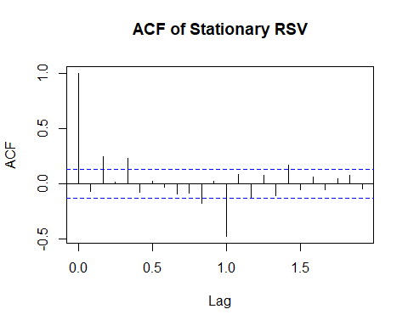
pacf(diff_seasonal_RSV,
main = "PACF of Stationary RSV")
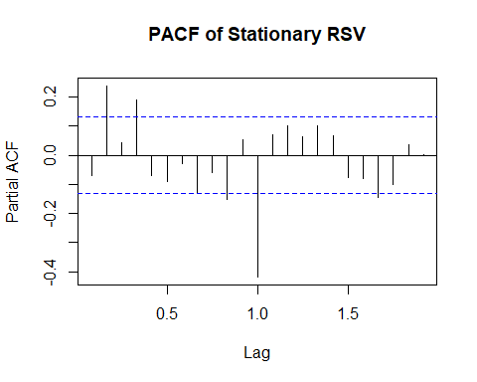
#output explanation
#The ACF and PACF analysis suggests that your time series has both non-seasonal and seasonal components. For the non-seasonal part, the ACF shows a significant positive spike at Lag 1 that quickly diminishes, indicating a potential MA(1) component, while the PACF shows significant spikes at Lags 1–3, pointing to an AR(2) or AR(3) structure. For the seasonal part, both ACF and PACF exhibit a prominent negative spike at the seasonal lag (likely Lag 12 for monthly data), indicating a strong seasonal effect that may require a Seasonal Moving Average (SMA) term and careful model tuning. Overall, the series appears to have a combination of short-term autoregressive behavior and pronounced seasonality.
#SARIMA Model Using Auto ARIMA
auto_model_RSV <- auto.arima(log_RSV,
seasonal = TRUE,
stepwise = FALSE,
approximation = FALSE)
summary(auto_model_RSV)
## Series: log_RSV
## ARIMA(4,1,0)
##
## Coefficients:
## ar1 ar2 ar3 ar4
## -0.0701 0.1780 0.0039 0.1797
## s.e. 0.0647 0.0646 0.0646 0.0643
##
## sigma^2 = 0.013: log likelihood = 174.99
## AIC=-339.97 AICc=-339.7 BIC=-322.78
##
## Training set error measures:
## ME RMSE MAE MPE MAPE MASE
## Training set 0.002969418 0.1127672 0.07145369 -0.8127393 7.341593 0.2065306
## ACF1
## Training set 0.01173323
#Residual Diagnostics-(optional work)
checkresiduals(auto_model_RSV)
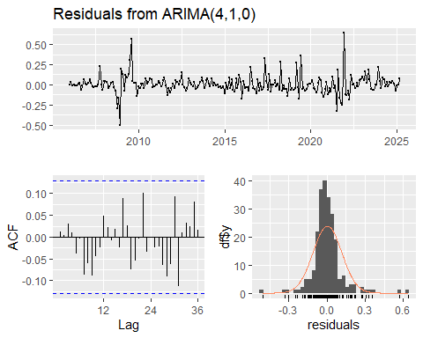
##
## Ljung-Box test
##
## data: Residuals from ARIMA(4,1,0)
## Q* = 13.979, df = 20, p-value = 0.8315
##
## Model df: 4. Total lags used: 24

