**Description:**

This script will check the user license. After script execution Teacher license users will assigned with “Education Teacher”. Student license users assigned with “Education_SecondaryStudent” policy packages.

**Prerequisites:**

1. As an Administrator, type PowerShell in the start menu. Right-click Windows PowerShell, then select Run as Administrator. Click Yes at the UAC prompt.
2. Keep the Below details in info.json file
3. "client_Id": "please paste App provider application id here"
4. "Client_Secret": "please paste App provided client secret here"
5. "Tenantid": "please provide requester tenant id here"

**Note**: Client id and client secret will be same for every tenant. Only tenant id must be changed to requester tenant id

Run the script.

It will execute connect-microsoftteams command. Provide teams admin credentials.

Then it will open webpage for grant permissions.

Please login with your tenant *USER ID* and *PASSWORD*.

[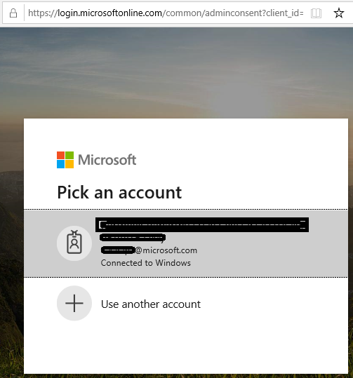](https://github.com/Geetha63/MS-Teams-Scripts/blob/master/Images/Siginin.png)

Once you are login it will shows the below image for Grant permissions for the app to perform the operations

[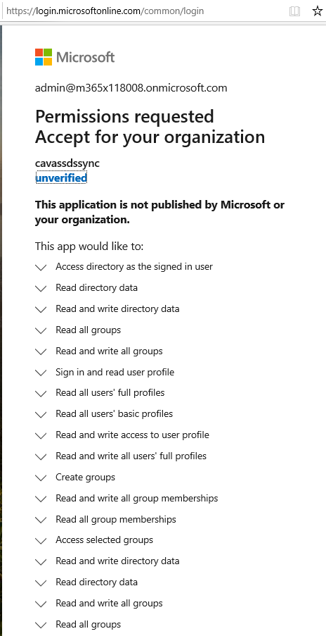](https://github.com/Geetha63/MS-Teams-Scripts/blob/master/Images/GrantPermissions.png)[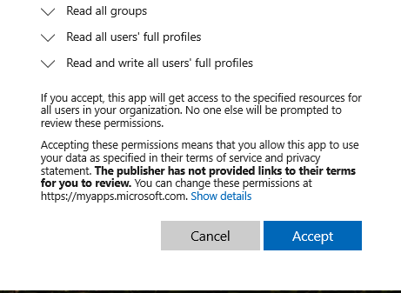](https://github.com/Geetha63/MS-Teams-Scripts/blob/master/Images/GrantPermissions2.png)

**Click Accept**

If you provided correct credentials it will through success status admin_consent = True

[Admin Consent](https://github.com/Geetha63/MS-Teams-Scripts/blob/master/Images/AdminConsent.png)

Now press Y to proceed further in script. Script will create provides one output file. It contains no license users.

Output file:

| UserName | Userid |