Creating the policy by following below steps:

Login into the Teams Admin centre : [https://admin.teams.microsoft.com](https://admin.teams.microsoft.com/)

Click on **Teams apps 🡪 Setup policies**

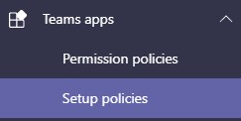

Click **Add**



Choose options for policy

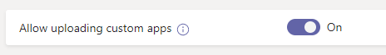

Choose Pinned apps by clicking Add apps

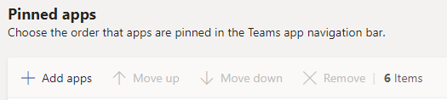

Search apps

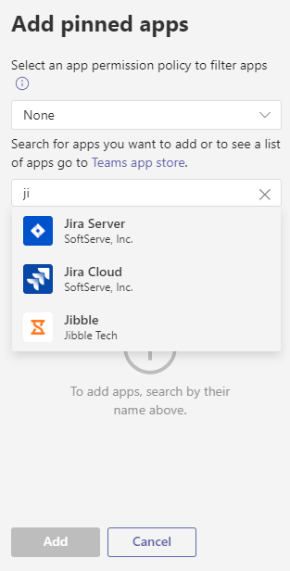

Click save.

Now we can apply Teams app setup policy using script

**1)**For single user use **TeamsAppsetuppolicy assign**

Run the script it will ask for

**Policyname:**

**User:**

Provide the details like below screenshot.

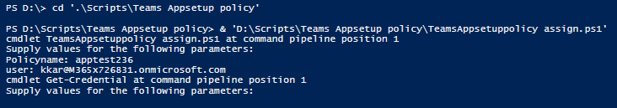

**Supply credentials**

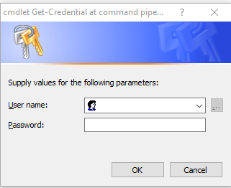

**It will assign the policy to user.**

**2)**For Bulk users use **TeamsAppsetuppolicy - Bulk users**

Provide the input in **TeamsAppsetup Excel file.** Run the **TeamsAppsetuppolicy - Bulk users** script

It will ask for credentials, provide it.

