**Description:**

This script will check each Tenant user license. In license script will check Teams subscription of any one license. If it is in disabled mode script will enable. If user don’t have any of teams license it will print the user name in output file.

**Prerequisites:**

1. As an Administrator, type PowerShell in the start menu. Right-click Windows PowerShell, then select Run as Administrator. Click Yes at the UAC prompt.
2. Keep the Below details in info.json file
3. "client_Id": "please paste App provider application id here"
4. "Client_Secret": "please paste App provided client secret here"
5. "Tenantid": "please provide requester tenant id here"

**Note**: Client id and client secret will be same for every tenant. Only tenant id must be changed to requester tenant id

Run the script.

It will execute connect-msolservice command. Provide admin credentials.

Then it will open webpage for grant permissions.

Please login with your tenant *USER ID* and *PASSWORD*.

[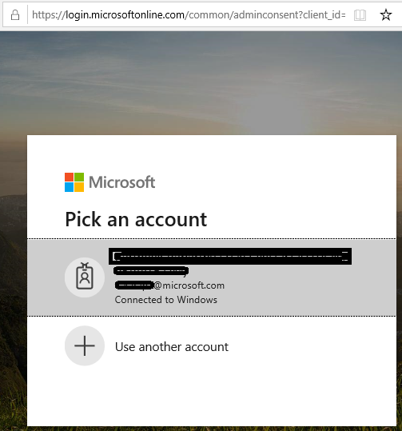](https://github.com/Geetha63/MS-Teams-Scripts/blob/master/Images/Siginin.png)

Once you are login it will shows the below image for Grant permissions for the app to perform the operations

[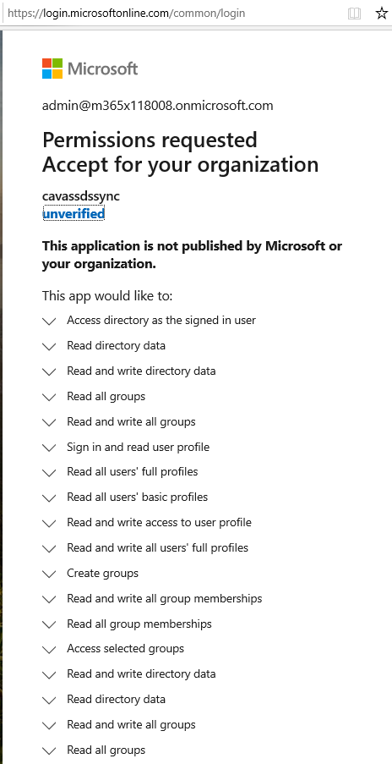](https://github.com/Geetha63/MS-Teams-Scripts/blob/master/Images/GrantPermissions.png)[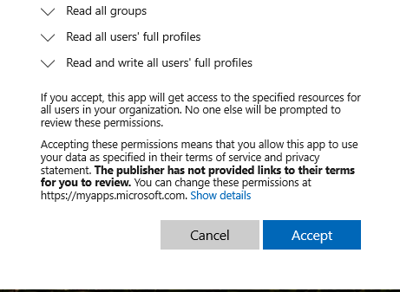](https://github.com/Geetha63/MS-Teams-Scripts/blob/master/Images/GrantPermissions2.png)

**Click Accept**

If you provided correct credentials it will through success status admin_consent = True

[Admin Consent](https://github.com/Geetha63/MS-Teams-Scripts/blob/master/Images/AdminConsent.png)

Now press Y to proceed further in script. Script will create provides one output file. It contains no license users.

Output file:

| UserName | Userid | Status