**RestfulMicroservicesWithDB**

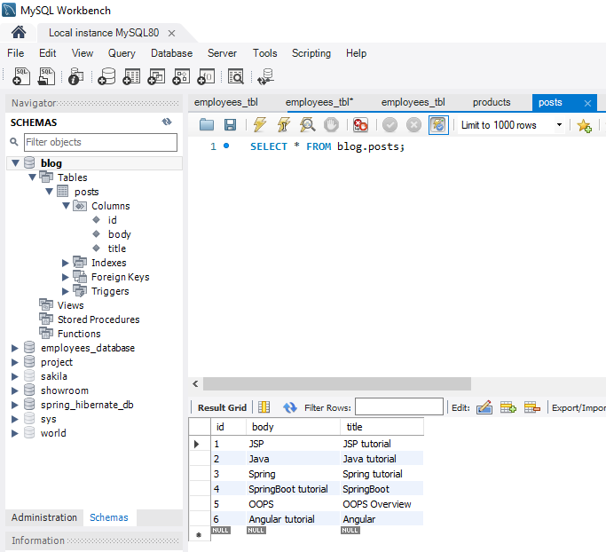

Execute the application -> Run as Spring Boot App

1. **ViewAll the post**

Url : <http://localhost:8080/posts>

Action: GET

Header: Content-Type

Value: application/json

And click Send button

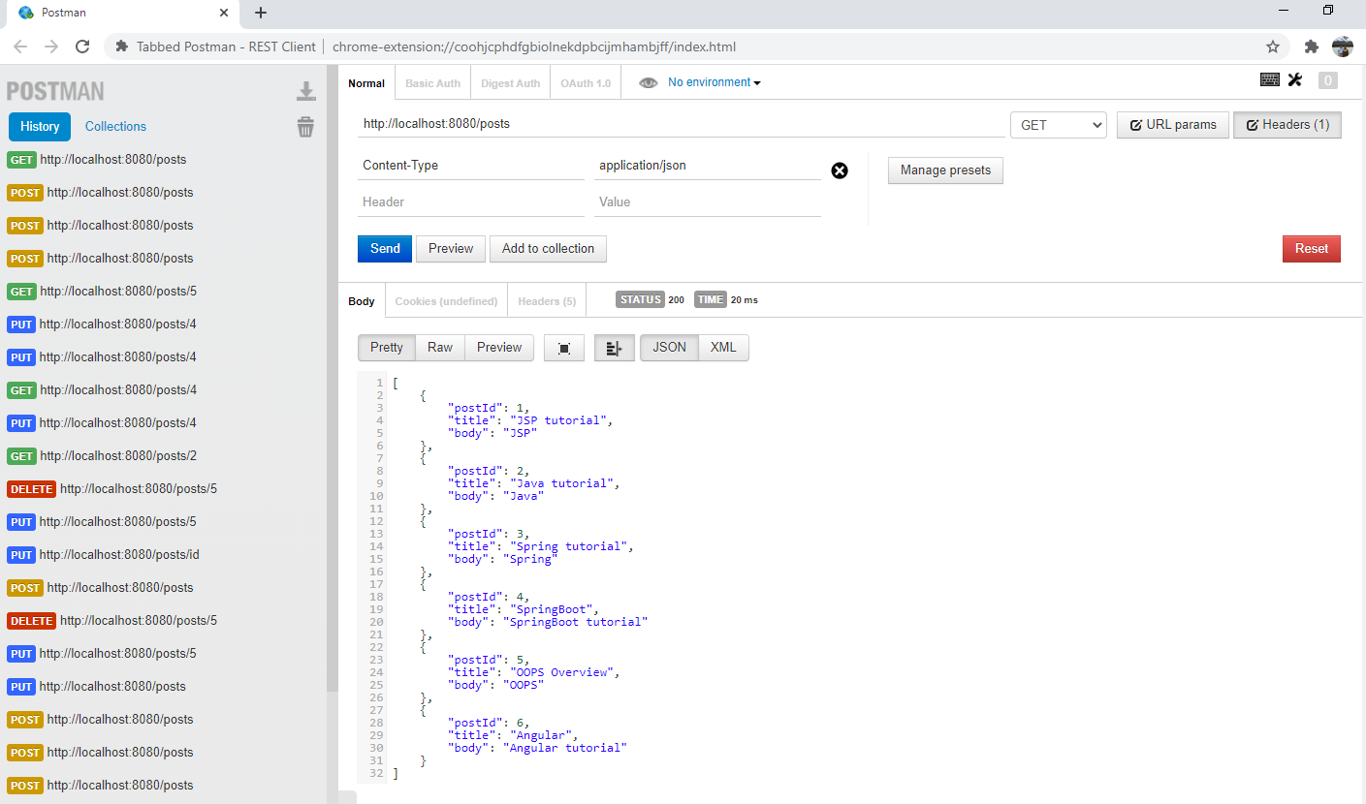

1. **View the specific post**

Url: <http://localhost:8080/posts/1>

Action: GET

Header: Content-Type

Value: application/json

And click Send button

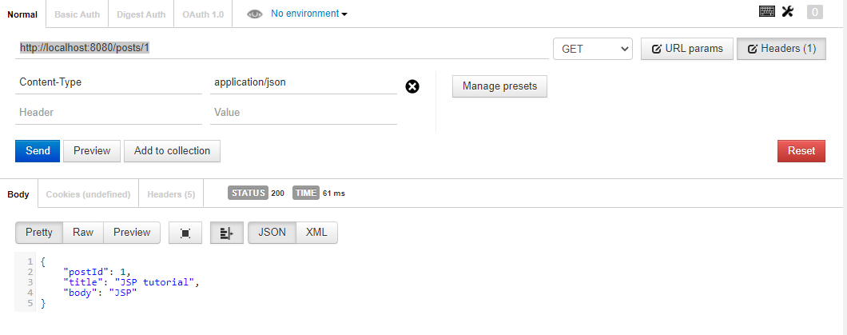

1. **Add the post**

Url: http://localhost:8080/posts

Action: POST

Header: Content-Type

Value: application/json

Select raw, Json and add the details in json format

{

"postId": 7,

"title": "Microservices",

"body": "Microservices tutorial"

}

And click Send button

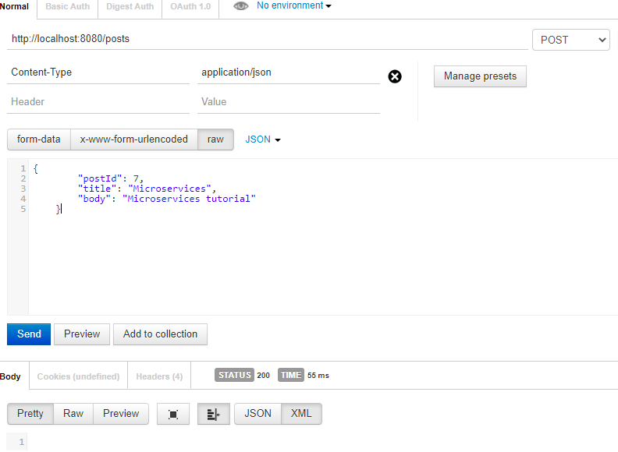

1. **Update the post**

Url: http://localhost:8080/posts/7

Action: PUT

Header: Content-Type

Value: application/json

Select raw, Json and add the details in json format

{

"postId": 7,

"title": "Restful",

"body": "Restful tutorial"

}

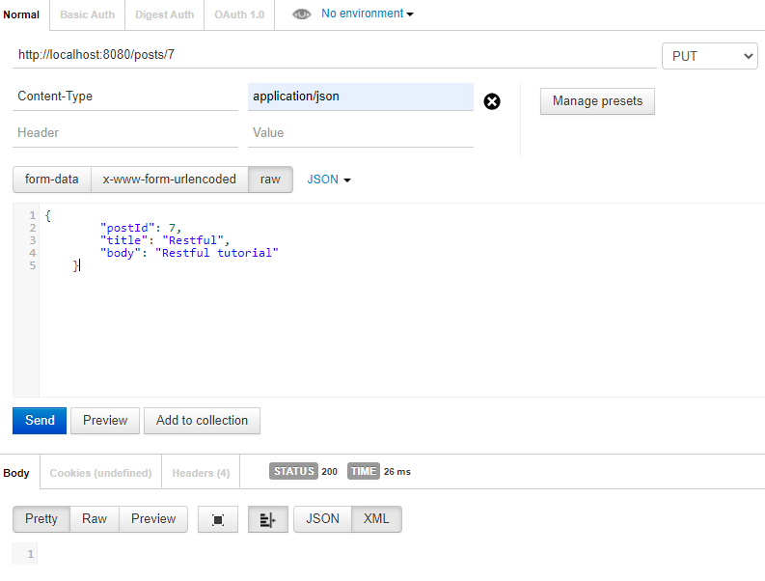

1. **Delete the post**

Url: http://localhost:8080/posts/7

Action: DELETE

