**Introduction Templates & Controllers**

1. **Currency Converter in angular**

<html ng-app>

<head>

<script src="https://ajax.googleapis.com/ajax/libs/angularjs/1.2.19/angular.min.js"></script>

</head>

<body>

Cost: <input type="text" ng-model="cost" name="" placeholder="Cost" />

<p>

This is your cost: {{cost|currency}}

</p>

</body>

</html>

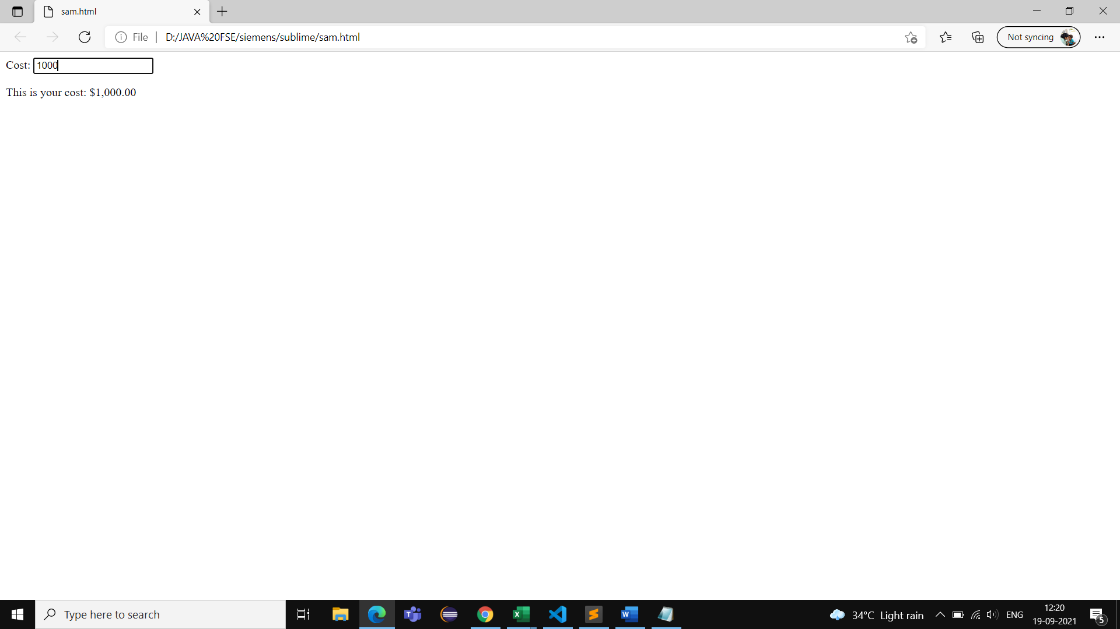

1. **Currency converter in jQuery**

<!DOCTYPE html>

<html>

<head>

<script src="https://ajax.googleapis.com/ajax/libs/jquery/3.6.0/jquery.min.js"></script>

<script>

$(function(){

function formatCost(){

var cv = Math.floor(parseFloat($('#cost').val()) * 100.0).toString();

if(cv.length === 0) cv = '0.00';

$('#fmtCost').text('$'+cv.substr(0,cv.length-2)+'.'+cv.substr(cv.length-2,2)

)

}

$('#cost').keyup(formatCost);

});

</script>

</head>

<body>

cost:<input type="text" id="cost" placeholder="cost" />

<p>

This is your cost:<span id="fmtCost"></span>

</p>

</body>

</html>

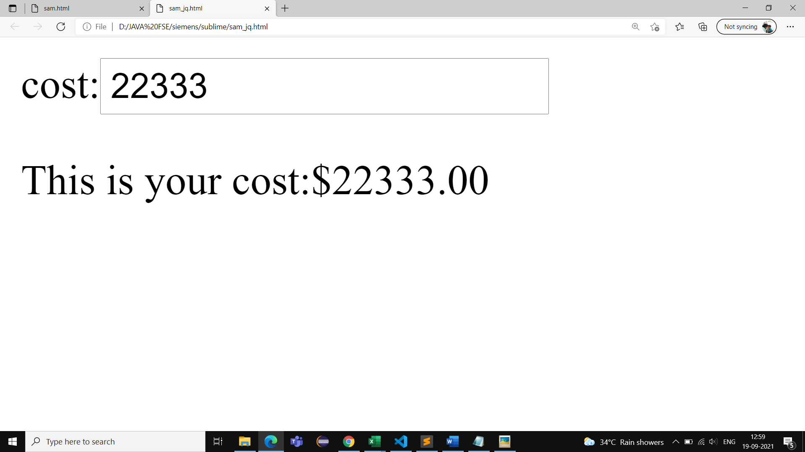

**3.Controller Angular**

<html ng-app>

<head>

<script src="https://ajax.googleapis.com/ajax/libs/angularjs/1.2.19/angular.js"></script>

<script type="text/javascript">

function CostCtrl($scope){

$scope.cost = 1000.1;

}

</script>

</head>

<body ng-controller="CostCtrl">

Cost: <input type="text" ng-model="cost" name="" placeholder="Cost" />

<p>

This is your cost: {{cost|currency}}

</p>

<div ng-controller="CostCtrl">

Cost: <input type="text" ng-model="cost" name="" placeholder="Cost" />

<p>

This is your cost: {{cost|currency}}

</p>

</div>

</body>

</html>

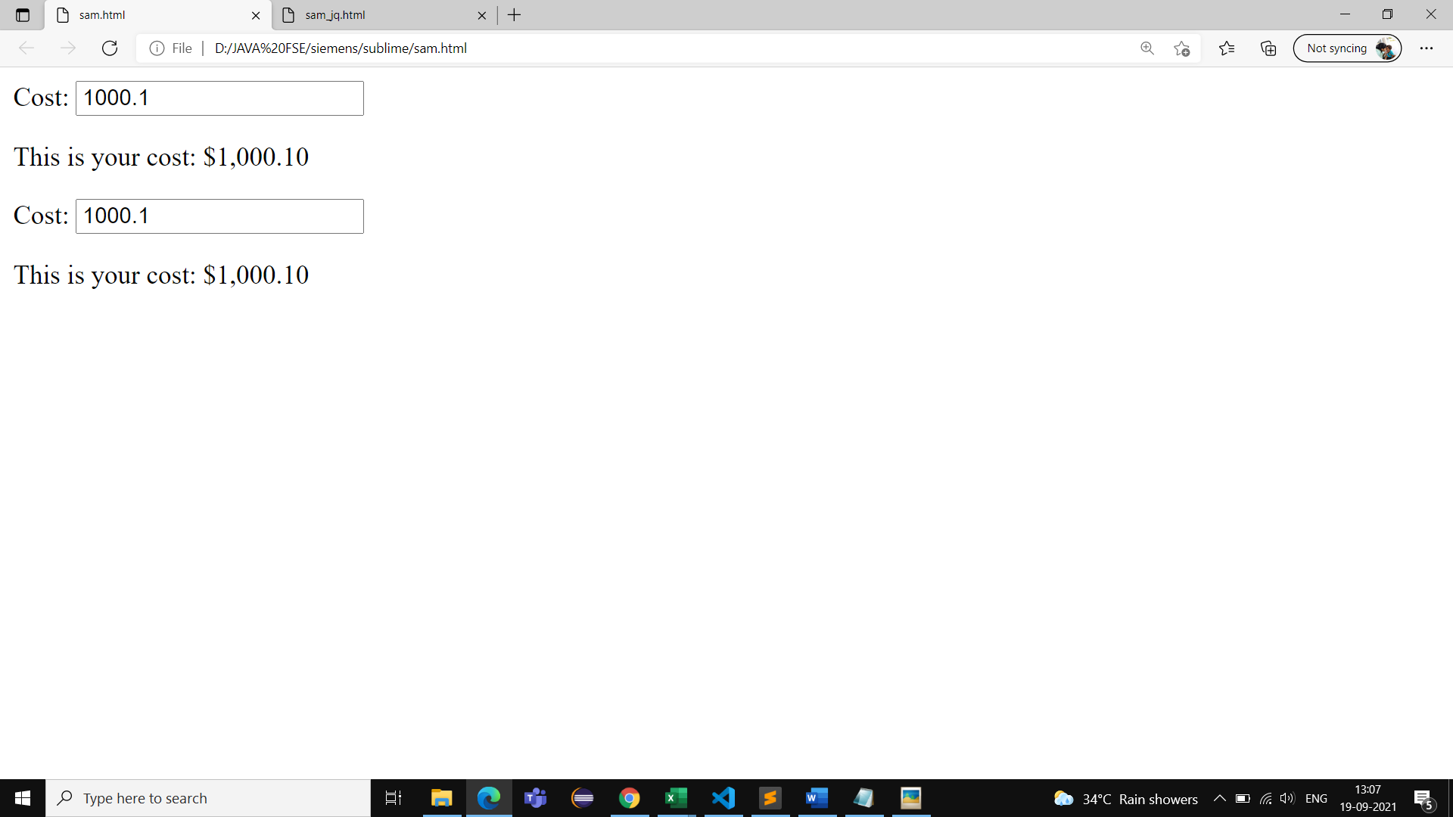

1. **Controller Angular with tax**

<html ng-app>

<head>

<script src="https://ajax.googleapis.com/ajax/libs/angularjs/1.2.19/angular.js"></script>

<script type="text/javascript">

function CostCtrl($scope){

$scope.cost = 1000.1;

$scope.tax = $scope.cost * 0.15;

}

</script>

</head>

<body ng-controller="CostCtrl">

Cost: <input type="text" ng-model="cost" name="" placeholder="Cost" />

<p>

This is your cost: {{cost|currency}}

</p>

<p>

This is your tax: {{tax|currency}}

</p>

<div ng-controller="CostCtrl">

Cost: <input type="text" ng-model="cost" name="" placeholder="Cost" />

<p>

This is your cost: {{cost|currency}}

</p>

</div>

</body>

</html>

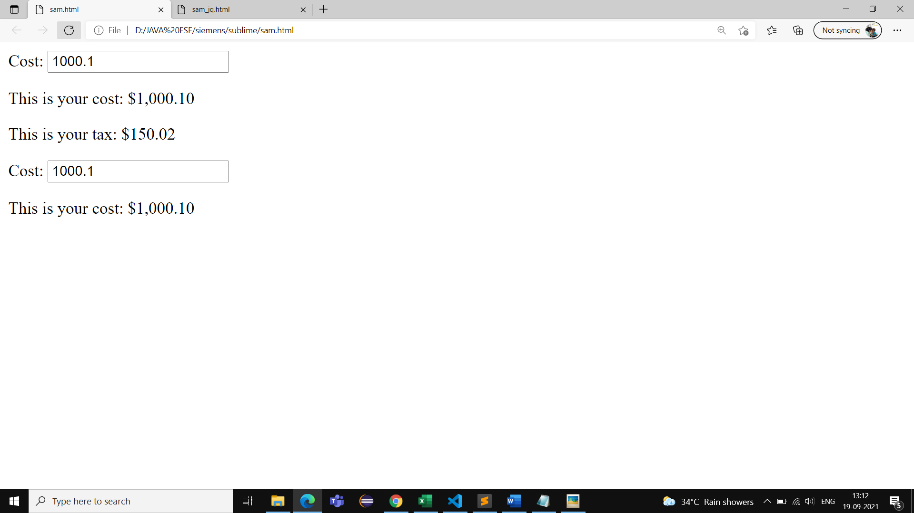

1. **Controller tax total**

<html ng-app>

<head>

<script src="https://ajax.googleapis.com/ajax/libs/angularjs/1.2.19/angular.js"></script>

<script>

function CostCtrl($scope){

$scope.cost = 1000.1;

$scope.$watch('cost',function(nv,ov){

if (nv != ov) {

$scope.tax = $scope.cost * 0.15;

}

});

$scope.$watch('tax',function(){

$scope.total = parseFloat($scope.cost) + $scope.tax;

});

}

</script>

</head>

<body>

<div ng-controller="CostCtrl">

Cost: <input type="text" ng-model="cost" name="" placeholder="Cost" />

<p>

This is your cost: {{cost|currency}}

</p>

<p>

This is your tax: {{tax|currency}}

</p>

<p>

This is your total: {{total|currency}}

</p>

</div>

</body>

</html>

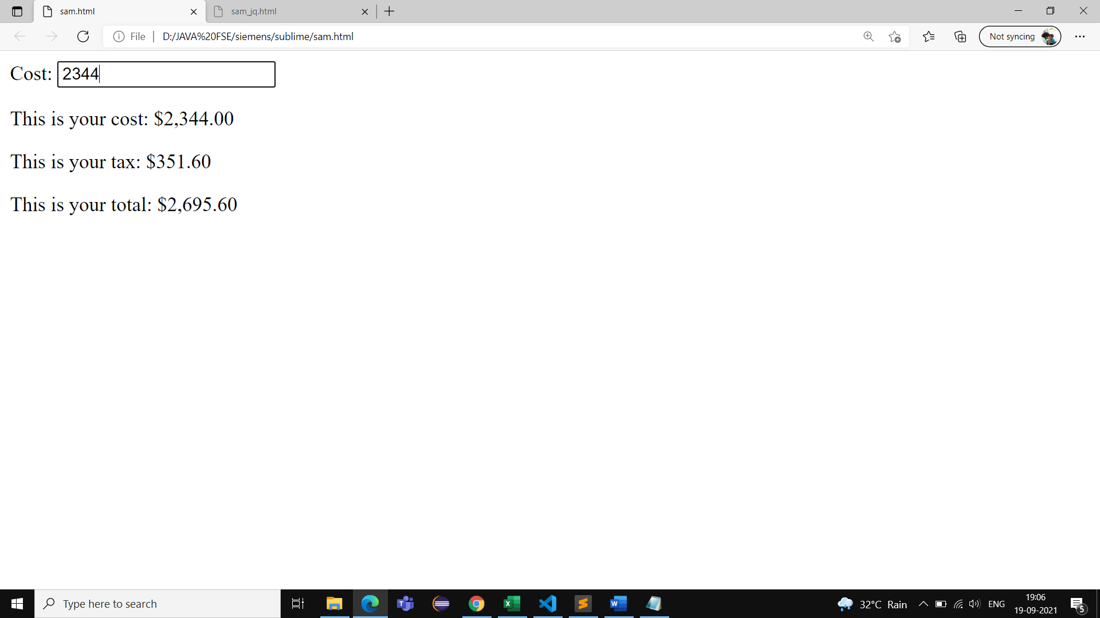

**4.Interaction**

<html ng-app>

<head>

<script src="https://ajax.googleapis.com/ajax/libs/angularjs/1.2.19/angular.js"></script>

<script>

function CostCtrl($scope){

$scope.cost = 1000.0;

$scope.add_tax = true;

function update()

{

$scope.tax = $scope.add_tax ? $scope.cost * 0.15 : 0.0;

$scope.total = parseFloat($scope.cost) + $scope.tax;

}

$scope.$watch('cost+add_tax', update);

$scope.$watch('cost+tax', update);

$scope.$watch('total_bill', function(){

$scope.bill_display = $scope.total_bill ? 'block' : 'none';

});

$scope.final_bill += $scope.total;

}

</script>

</head>

<body>

<div ng-controller="CostCtrl">

<input type="checkbox" ng-model="add_tax">Add Tax

<input type="checkbox" ng-model="total_bill">Show Total

</div>

Cost: <input type="text" ng-model="cost" name="" placeholder="Cost" />

<p>

This is your cost: {{cost|currency}}

</p>

<p>

This is your tax: {{tax|currency}}

</p>

<p>

This is your total: {{total|currency}}

</p>

</div>

</body>

</html>

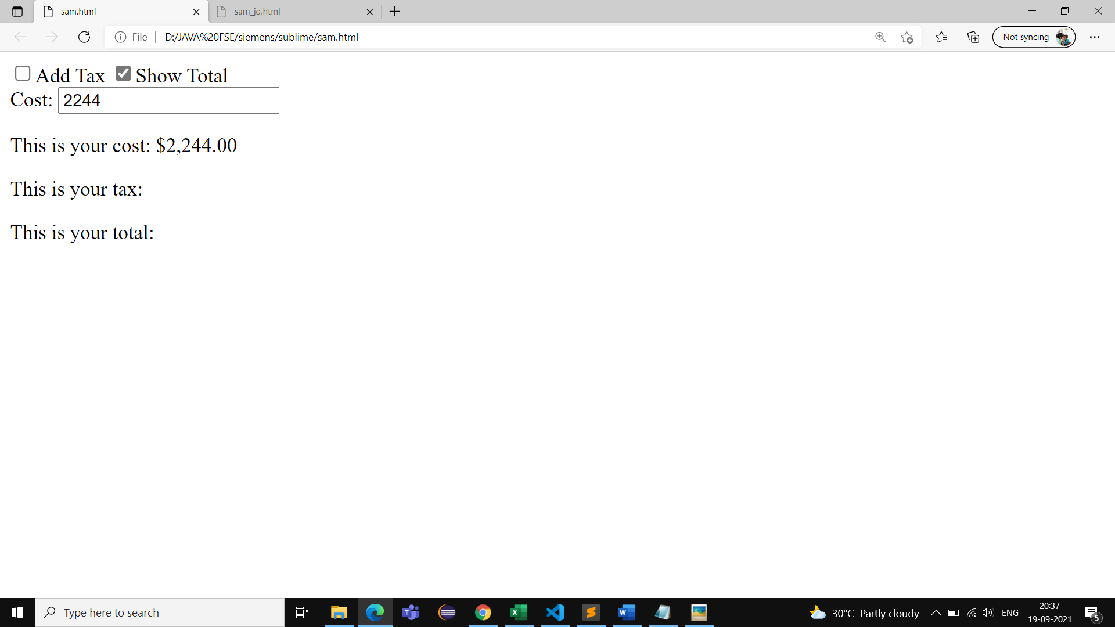

**More Complex Templates**

1. **Adding DS to our application**

**Sample-1**

**<html ng-app>**

**<head>**

**<script src="https://ajax.googleapis.com/ajax/libs/angularjs/1.2.19/angular.js"></script>**

**<script >**

**function StudentDetails($scope)**

**{**

**$scope.student = [**

**{name:'geetha',collegeDep: ['GIT college' ,'CSE'],phone: ['8883856678']},**

**{name:'sanjith',collegeDep: ['NIIT college','ECE'],phone: ['9876345678']}**

**];**

**}**

**</script>**

**</head>**

**<body ng-controller="StudentDetails">**

**<div ng-repeat = "person in student">**

**{{person.name}}**

**<span ng-repeat="collegeDep in person.collegeDep">**

**{{collegeDep}}**

**</span>**

**<span ng-repeat="phone in person.phone">**

**{{phone}}**

**</span>**

**</div>**

**</body>**

**</html>**

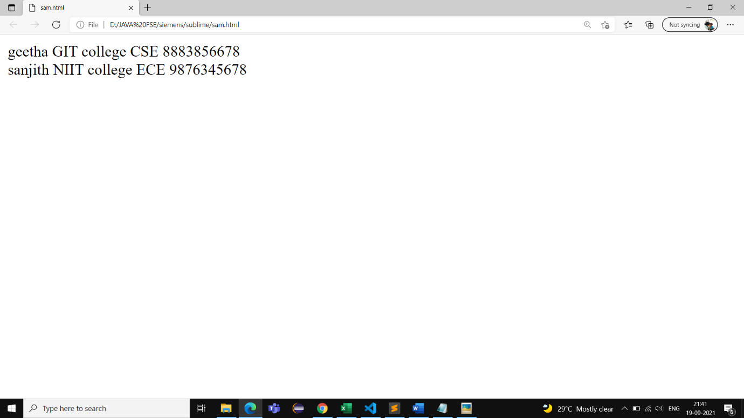

**Sample-2**

**<html ng-app>**

**<head>**

**<script src="https://ajax.googleapis.com/ajax/libs/angularjs/1.2.19/angular.js"></script>**

**<script >**

**function StudentDetails($scope)**

**{**

**$scope.student = [**

**{name:'geetha',collegeDep: ['GIT college' ,'CSE'],phone: ['8883856678']},**

**{name:'sanjith',collegeDep: ['NIIT college','ECE'],phone: ['9876345678']}**

**];**

**}**

**</script>**

**</head>**

**<body ng-controller="StudentDetails">**

**<div ng-repeat = "person in student">**

**{{person.name}}**

**(**

**<span ng-repeat="collegeDep in person.collegeDep">**

**<span ng-if="$index>0">,</span>**

**{{collegeDep}}**

**</span>**

**)**

**<span ng-repeat="phone in person.phone">**

**<span ng-if="$index>0">,</span>**

**{{phone}}**

**</span>**

**)**

**</div>**

**</body>**

**</html>**

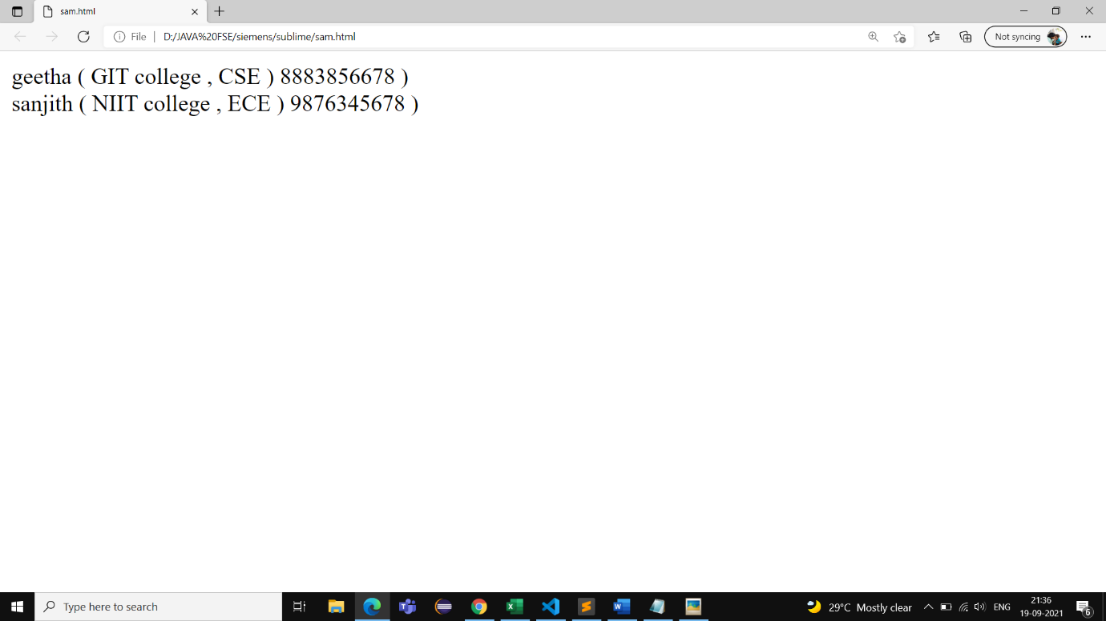

**Sample-3**

**<html ng-app>**

**<head>**

**<script src="https://ajax.googleapis.com/ajax/libs/angularjs/1.2.19/angular.js"></script>**

**<script >**

**function StudentDetails($scope)**

**{**

**$scope.student = [**

**{name:'geetha',collegeDep: ['GIT college' ,'CSE'],phone: ['8883856678']},**

**{name:'sanjith',collegeDep: ['NIIT college','ECE'],phone: ['9876345678']}**

**];**

**}**

**</script>**

**</head>**

**<body ng-controller="StudentDetails">**

**<div ng-repeat = "person in student">**

**{{person.name}}**

**[**

**<a href="#" ng-click="person.show_collegeDep=true">Show College Department</a>**

**<a href="#" ng-click="person.show_collegeDep=false">Hide College Department</a>**

**<a href="#" ng-click="person.show_phone=true">Show Contact</a>**

**<a href="#" ng-click="person.show_phone=false">Hide Contact</a>**

**]**

**<div style="margin-left:50px;" ng-show="person.show_collegeDep">**

**<div ng-repeat="collegeDep in person.collegeDep">**

**{{collegeDep}}**

**</div>**

**</div>**

**<div style="margin-left:50px;" ng-show="person.show_phone">**

**<div ng-repeat="phone in person.phone">**

**{{phone}}**

**</div>**

**</div>**

**</body>**

**</html>**

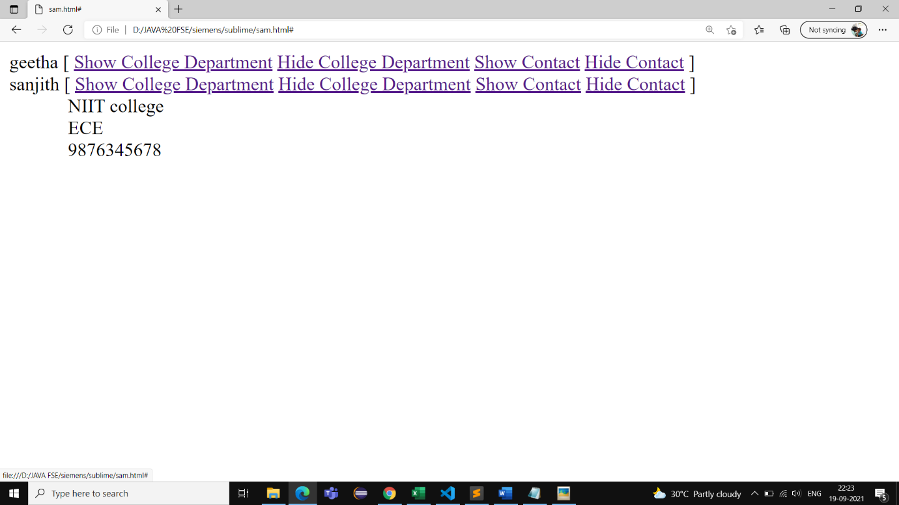

1. **How nested controller helps us**

**<html ng-app>**

**<head>**

**<script src="https://ajax.googleapis.com/ajax/libs/angularjs/1.2.19/angular.js"></script>**

**<script >**

**function StudentDetails($scope)**

**{**

**$scope.student = [**

**{name:'geetha',collegeDep: ['GIT college' ,'CSE'],phone: ['8883856678']},**

**{name:'sanjith',collegeDep: ['NIIT college','ECE'],phone: ['9876345678']}**

**];**

**}**

**function StudentCtrl($scope){**

**$scope.show = function() {**

**$scope.person.show_collegeDep= true;**

**}**

**$scope.hide = function() {**

**$scope.person.show_collegeDep= false;**

**}**

**$scope.show1 = function() {**

**$scope.person.show_phone= true;**

**}**

**$scope.hide1 = function() {**

**$scope.person.show_phone= false;**

**}**

**}**

**</script>**

**</head>**

**<body ng-controller="StudentDetails">**

**<div ng-repeat = "person in student" ng-controller="StudentCtrl">**

**{{person.name}}**

**[**

**<a href="#" ng-click="show()" nd-hide="person.show_collegeDep">Show College Department</a>**

**<a href="#" ng-click="hide()" nd-show="person.show_collegeDep">Hide College Department</a>**

**<a href="#" ng-click="show1()" ng-hide="person.show_phone">Show Contact</a>**

**<a href="#" ng-click="hide1()" ng-show="person.show_phone">Hide Contact</a>**

**]**

**<div style="margin-left:50px;" ng-show="person.show_collegeDep">**

**<div ng-repeat="collegeDep in person.collegeDep">**

**{{collegeDep}}**

**</div>**

**</div>**

**<div style="margin-left:50px;" ng-show="person.show_phone">**

**<div ng-repeat="phone in person.phone">**

**{{phone}}**

**</div>**

**</div>**

**</body>**

**</html>**

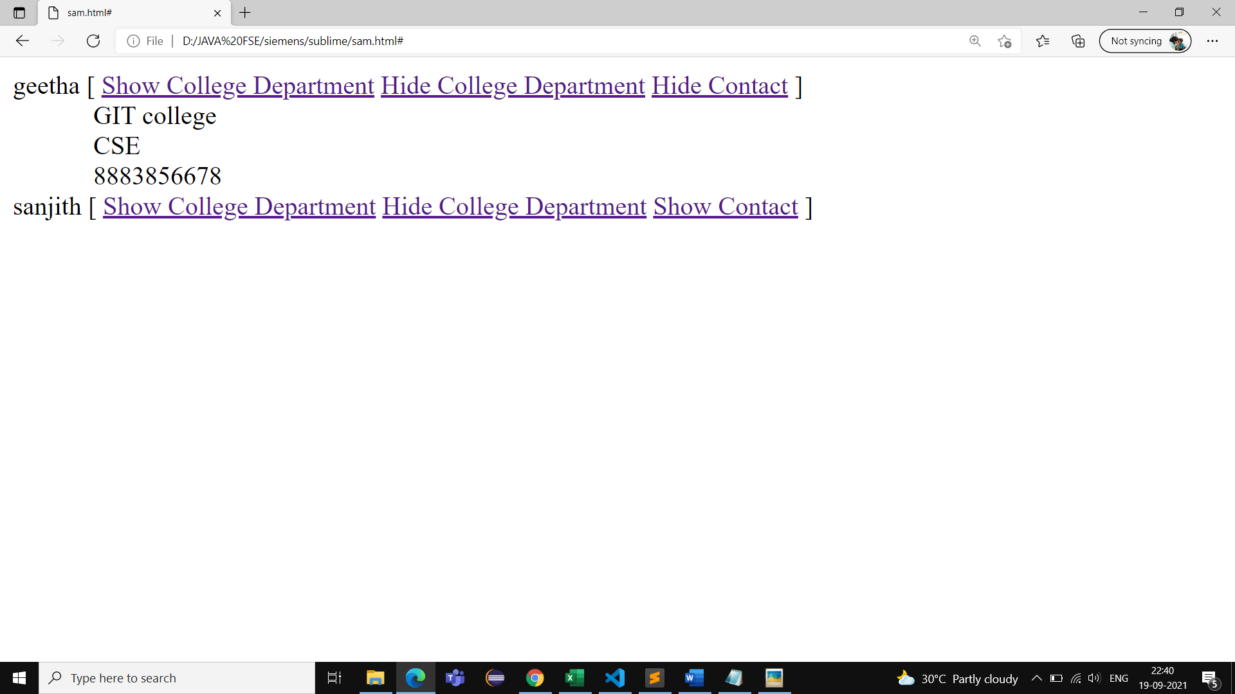

1. **Shared Data**
2. **Sample-1: By using rootScope variable**

**<!DOCTYPE html>**

**<html>**

**<head>**

**<title>**

**Angular JS sharing data using rootScope**

**</title>**

**<script src=**

**"https://ajax.googleapis.com/ajax/libs/angularjs/1.3.14/angular.min.js">**

**</script>**

**</head>**

**<body>**

**<h1 style="color:green;">**

**This Example Helps You guys to Understand Shared data inAngular**

**</h1>**

**<div ng-app="mainApp">**

**<div ng-controller="firstcontroller">**

**<h2>First controller</h2>**

**<p>{{firstvalue}}</p>**

**</div>**

**<div ng-controller="secondcontroller">**

**<h2>Second controller</h2>**

**<p>{{secondvalue}}</p>**

**</div>**

**</div>**

**<script>**

**var mainApp = angular.module("mainApp", []);**

**mainApp.run(function($rootScope) {**

**$rootScope.value =**

**'A Computer Science Portal for all Controller using Shared data';**

**});**

**mainApp.controller('firstcontroller',**

**function($scope, $rootScope) {**

**$scope.firstvalue = $rootScope.value;**

**});**

**mainApp.controller('secondcontroller',**

**function($scope, $rootScope) {**

**$scope.secondvalue = $rootScope.value;**

**});**

**</script>**

**</body>**

**</html>**

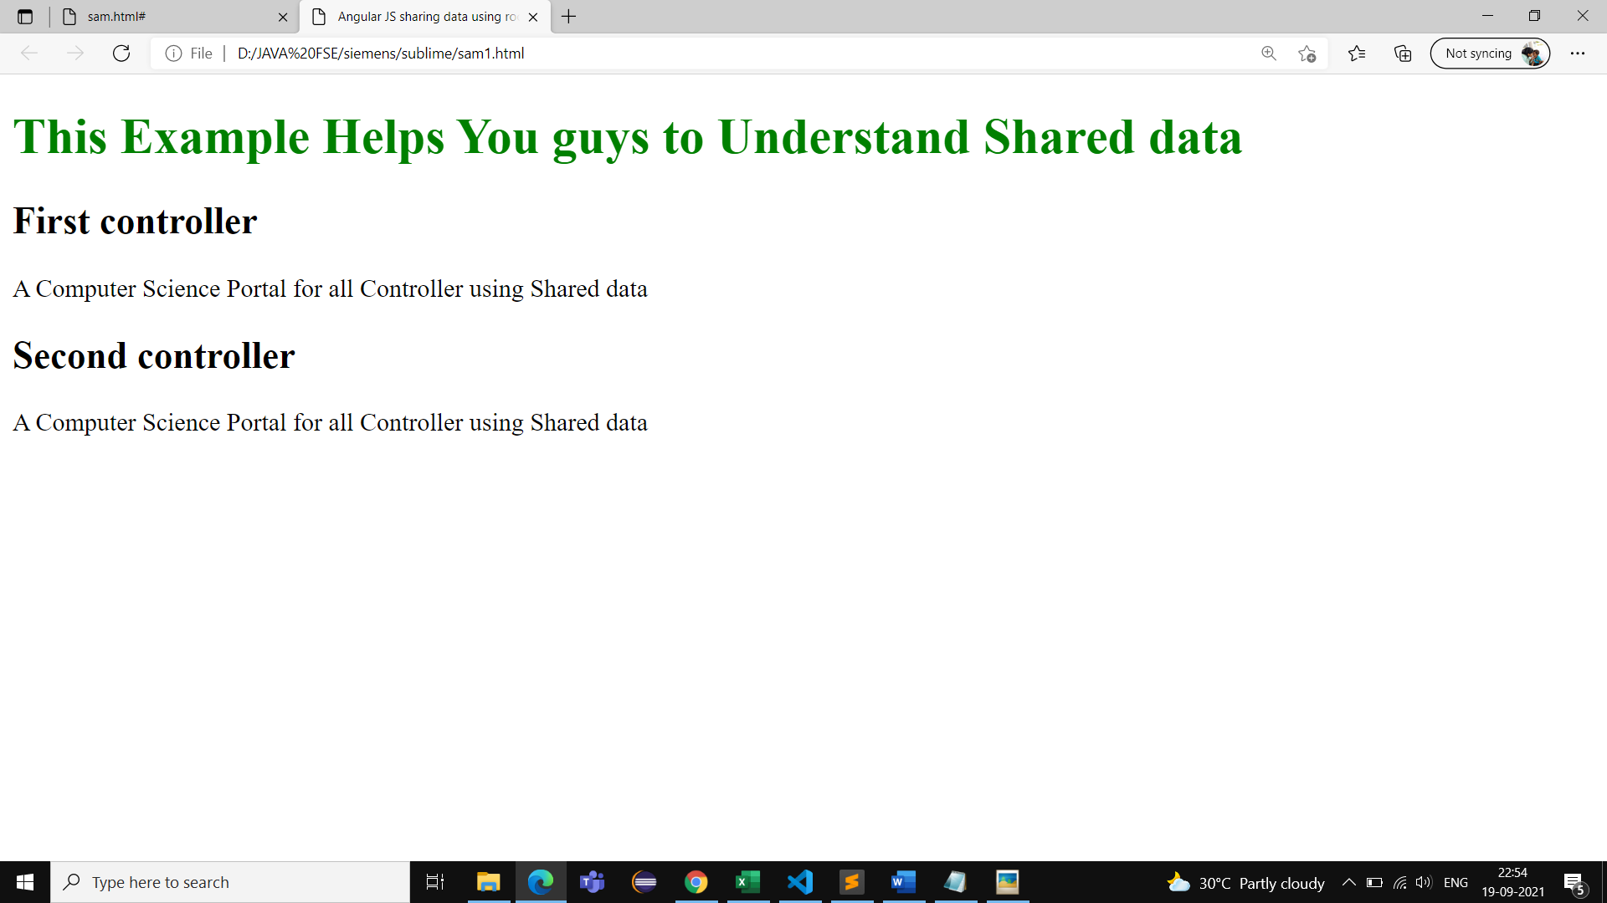

1. **Sample-2: By using factory or service**

**<!DOCTYPE html>**

**<html>**

**<head>**

**<title>**

**Angular JS sharing data using factory**

**</title>**

**<script src=**

**"https://ajax.googleapis.com/ajax/libs/angularjs/1.3.14/angular.min.js">**

**</script>**

**</head>**

**<body>**

**<h1 style="color:green;">**

**This Example Helps You guys to Understand Shared data inAngular**

**</h1>**

**<div ng-app="mainApp">**

**<div ng-controller="FirstController">**

**<input type="text" ng-model="value.name">**

**<br> Input in first controller is : {{value.name}}**

**</div>**

**<hr>**

**<div ng-controller="SecondController">**

**Input in second controller is : {{value.name}}**

**</div>**

**</div>**

**<script>**

**var mainApp = angular.module("mainApp", []);**

**mainApp.factory('Fact', function() {**

**return {**

**name: ''**

**};**

**});**

**mainApp.controller('FirstController',**

**function($scope, Fact) {**

**$scope.value = Fact;**

**});**

**mainApp.controller('SecondController',**

**function($scope, Fact) {**

**$scope.value = Fact;**

**});**

**</script>**

**</body>**

**</html>**

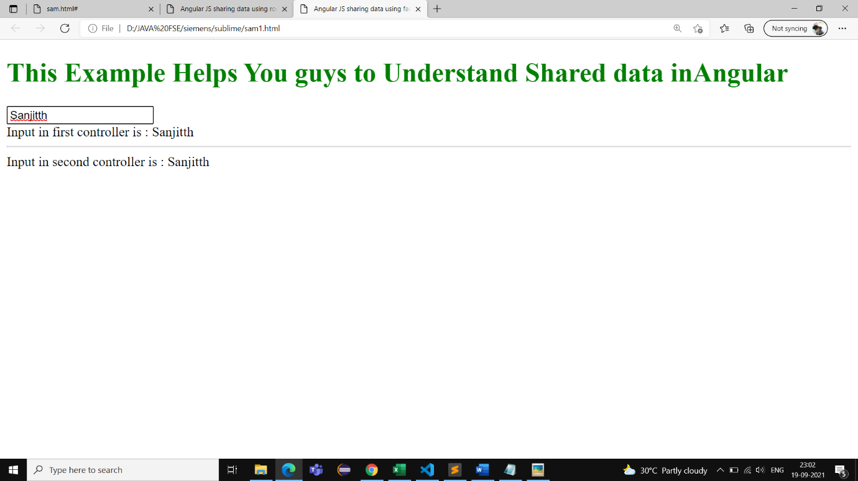

**AJAX**

**1.Yoman**

**1.Check versions by (refer https://yeoman.io/codelab/setup.html)**

* Node.js 6 or higher
* npm 3 or higher (which comes bundled with Node)
* Git
* node --version && npm --version

2. The [npm](https://www.npmjs.com/) package manager is bundled with Node, although you might need to update it. Some Node versions ship with rather old versions of npm. You can update npm using this command:

npm install --global npm@latest

3. You can check if you have Git installed by typing:

git --version

## Install the Yeoman toolset

## Once you’ve got Node installed, install the Yeoman toolset:

npm install --global yo

## 4. Confirm installation

It is a good idea to check that everything is installed as expected by running commonly used Yeoman commands like yo with the --version flag as follows:

yo --version

5.Install generator using following command

npm install -g generator-angular

6.create dir

-> Mkdir dirname eg: mkdir yang

-> Cd yang

7.To get into yoman use the command

-> Yo angular

->give bootstrap yes

->remaining no

8.Install karma:app generator(http://yeoman.io/generators/)

-> npm install generator-karma

9.After installing karma use command

-> Yo angular

10. grunt serve

11.grunt test:unit