**React - Hello World**

**React**. **js** is an open-source JavaScript library that is **used for** building user interfaces specifically for single-page applications. It's **used for** handling the view layer for web and mobile apps. **React** also allows us to create reusable UI components.

Design an simple Hello World page using Reactjs.

**Basic Structure:**

import React from 'react';  
class App extends React.Component {  
   
    render() {  
        return ();  
    }  
};  
export default App;

**Constraints:**

The app.js is the main page.  
The div id="header" should be present.  
The h2 tag "Hello World" should be present.

**Note :**

* Content of the page should be present as shown in the screenshot.
* Start working on the template code which is provided. Template code will provide the base template or format in which the end solution is expected from you. Template code is not an executable code and will only help you to add code on top of it to ensure your submissions are in the right format. If the submission is NOT as per the template code format, then the submissions will not be accepted.

**Screenshot 1:**

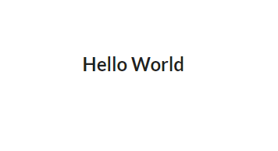

**Screenshot 2:**

