Problem Description

**Celebration Invitation**

The SVL sr. sec school has planned to celebrate their Silver Jubilee on October 26th.  The school has decided to call Mr K. Kamal, a motivational speaker, as the chief guest for this function. The management has an idea to celebrate their Silver Jubilee in a grand way. In order to that, the school management preferred the school SPL, Akil to design the invitation for this function. Let us help him in designing an invitation model using ReactJS.

Hint: Curly braces { } are special syntax in JSX. It is used to evaluate a expression during compilation. An expression can be a variable, function, an object, or any code that resolves into a value. EX:let name=’Rose’ {name} is a beautiful flower

**Content**:  
The Students, Staff and Principal of SVL SR. SEC SCHOOL invite you on the SILVER JUBILEE CELEBRATIONS of their school on SUNDAY, THE 26th AUGUST 20XX at 10 a.m in the School Auditorium MR K.KAMAL A Public Speaker has kindly consented to be the Chief Guest and to give away prizes.

**Constraints**:

The id of the div tag should be 'invitation'.  
The content inside 'h1' tag should be 'SILVER JUBILEE CELEBRATIONS'.  
The content inside 'h3' tag should be 'SVL SR. SEC SCHOOL'.  
The name of the Chief guest should be defined as a constant and used within the { } inside ‘h2’ tag.

**Note** :  
Content of the page should be present as shown in the screenshot.  
Kindly refer the content which is given as a part of the description.  
Start working on the template code which is provided. Template code will provide the base template or format in which the end solution is expected from you. Template code is not an executable code and will only help you to add code on top of it to ensure your submissions are in the right format. If the submission is NOT as per the template code format, then the submissions will not be accepted.

Sample Screenshot 1 :  
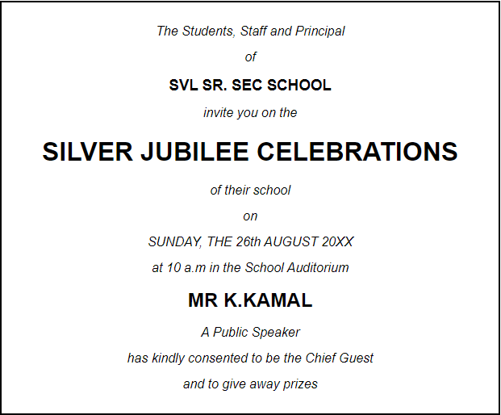

Sample Screenshot 2 :

