**------------------------------------------------------------------------------------------------**

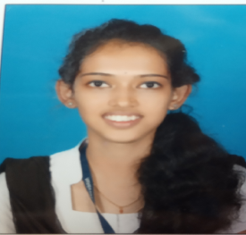**GEETHANJALI**

D/OSesappa

Kallakatta House,

Vittal Post & Village

Bantwal Taluk D.K, Karntaka – 574243

**Email-id**: [geethanjaliks001@gmail.com](mailto:geethanjaliks001@gmail.com)

**PH.NO**: 7996201371

**PROFESSIONAL OBJECTIVE**

My sole objective is to build my career in a progressive organization that will provide me existing opportunities to learn more and utilize my skill and experience.

|  |  |  |  |  |
| --- | --- | --- | --- | --- |
| **ACADEMIC RECORD** | | | | |
| **Course** | **Name of the Institute** | **Board/University** | **Year of**  **passing** | **Percentage** |
| MCA | Vivekananda college of engineering and Technology | Visvesvaraya Technological University | Pursuing |  |
| BCA | Vivekananda degree college, Puttur | Mangalore  University | September-2021 | 85.78% |
| PUC  (Commerce-CEBA) | Vitala Pre-University college, vittal | Department of Pre-University Education Karnataka | March -2018 | 83.20% |
| S.S.L.C | Vitala high school vittal | Karnataka Secondary Education Board | April-2016 | 82.83% |

**EXPERIENCE:**

Excess food distribution project done based on web development.

**SKILLS :**

C, HTML,CSS,MYSQL

**CERTIFICATE:**

* Computer Hardware and networking Course
* Attend internship Mobile Application Development .

**LANGUAGES KNOWN**

**Written :** English, Kannada

**Spoken :** English, Kannada, Tulu

**PERSONAL PROFILE**

Name               : Geethanjali

Father Name : Sesappa

Mother Name : Vasanthi

Date of Birth : 21 March 2001

Nationality : India

Gender : Female

Marital Status : Single

**DECLARATION:**

I hereby declare that the above information furnished by me is correct and true to the best of my knowledge.

Signature

Date:14/7/2022

Place:Vittal

