**Task Description:**

Create a windows Vm machine in AWS and connect with RDP open CMD in windows share the about system info.

Step 1: Launched a Windows instance with name: MyFirstWindowsEC2 and with key pair downloaded in my local to generate password later and provide while connecting to the windows machine via RDP.

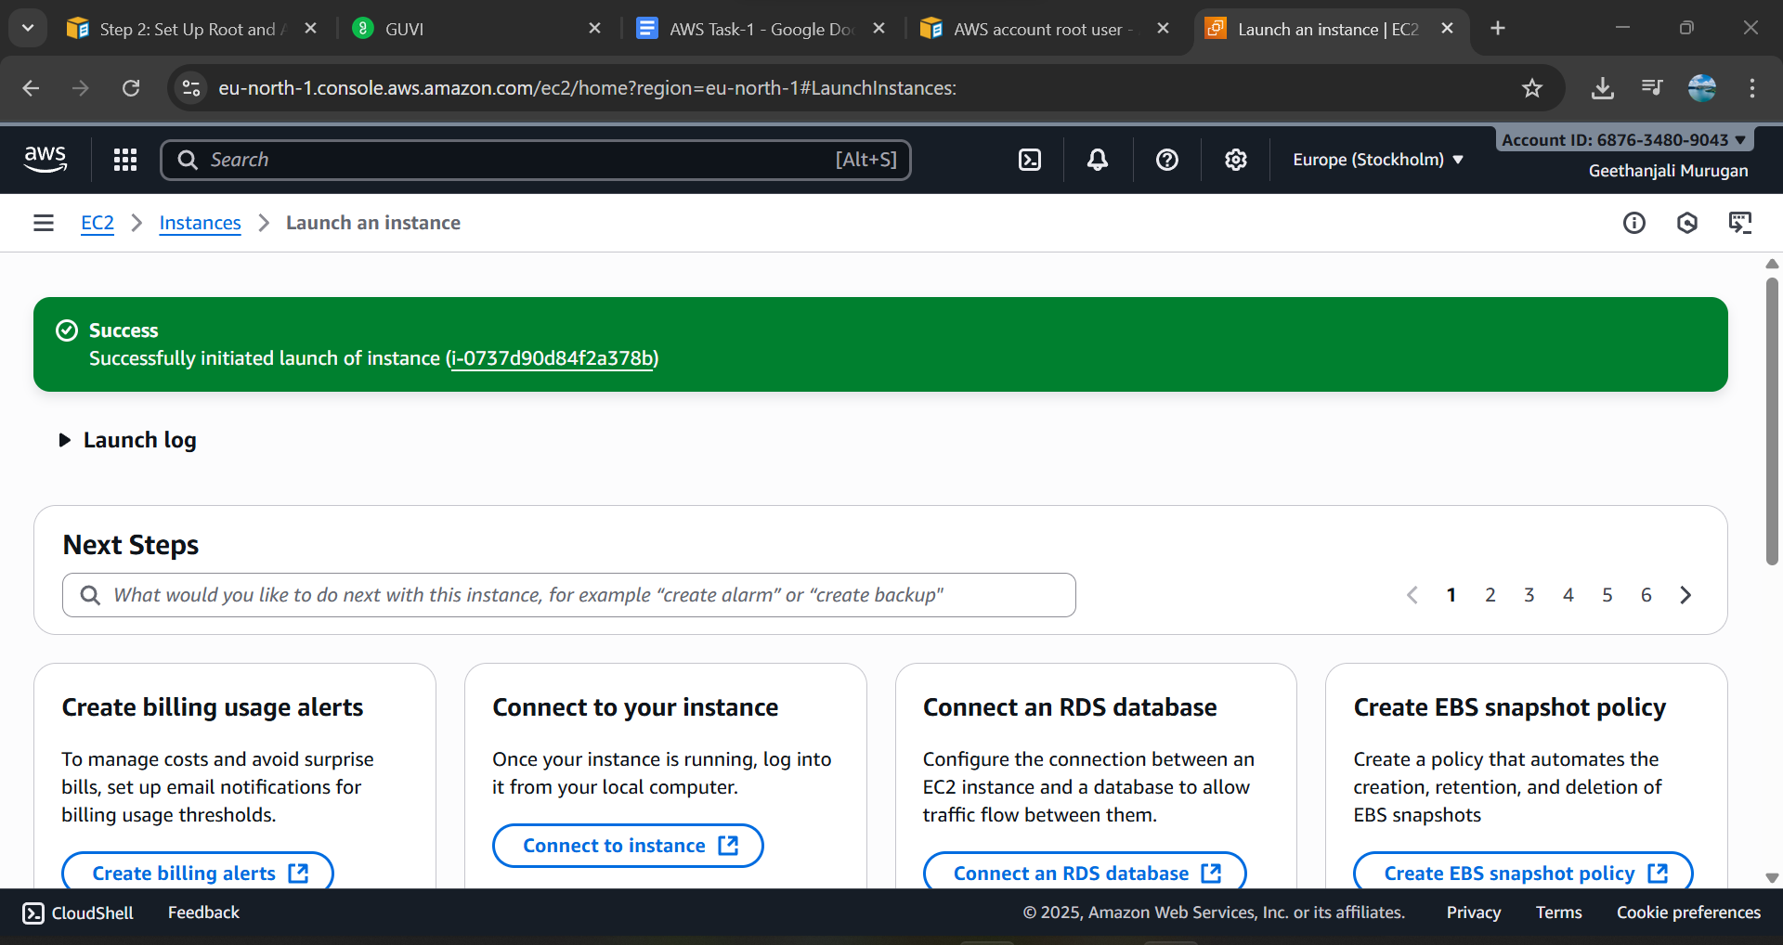

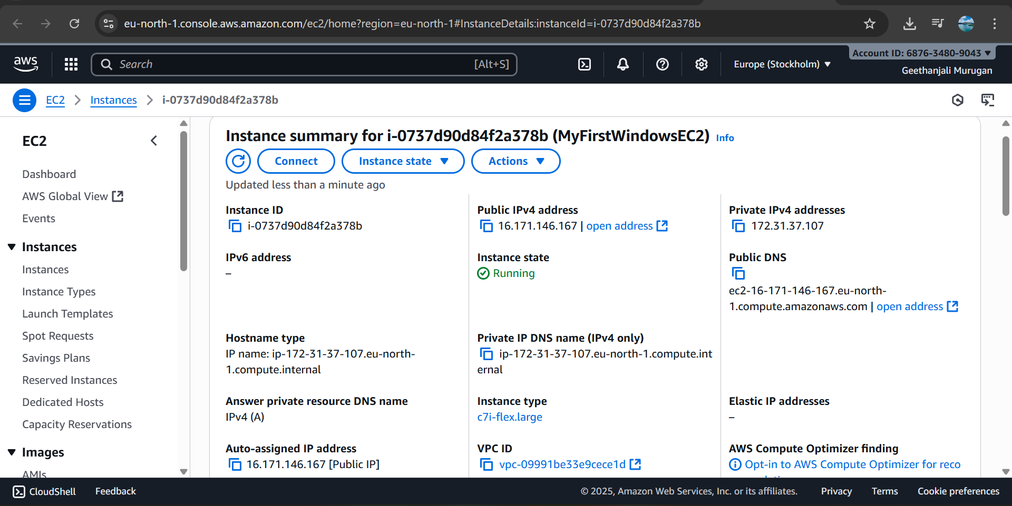

Step 2 : After the windows machine is up and running. Clicked the “connect” - > “RDP Client” and downloaded the remote desktop file highlighted in the below snap. Then clicked on the “Get password” and provided the key file to generate the password and decrypted it 😊 . And provided the password to connect to my machine .

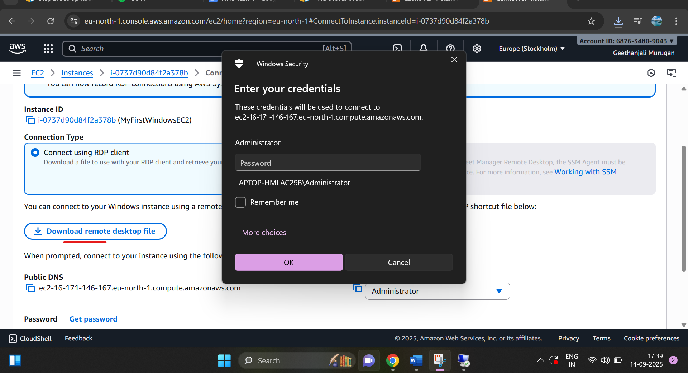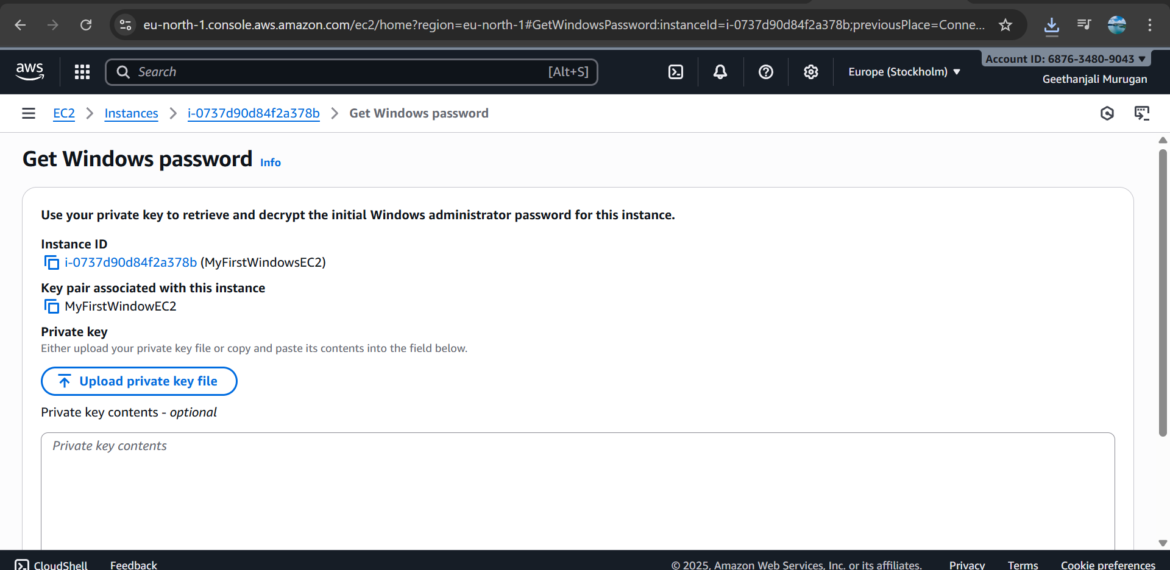

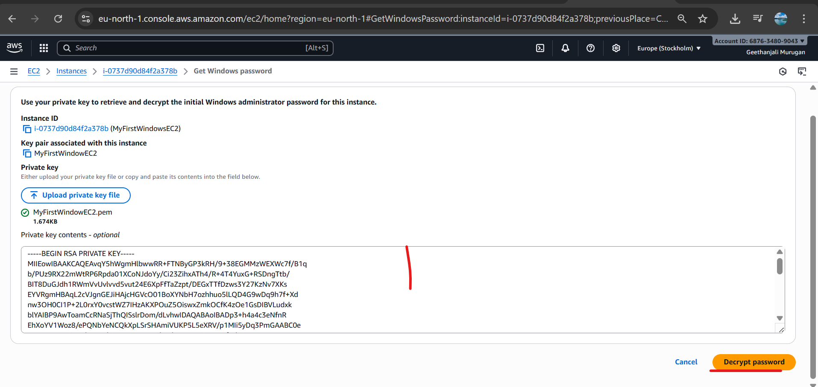

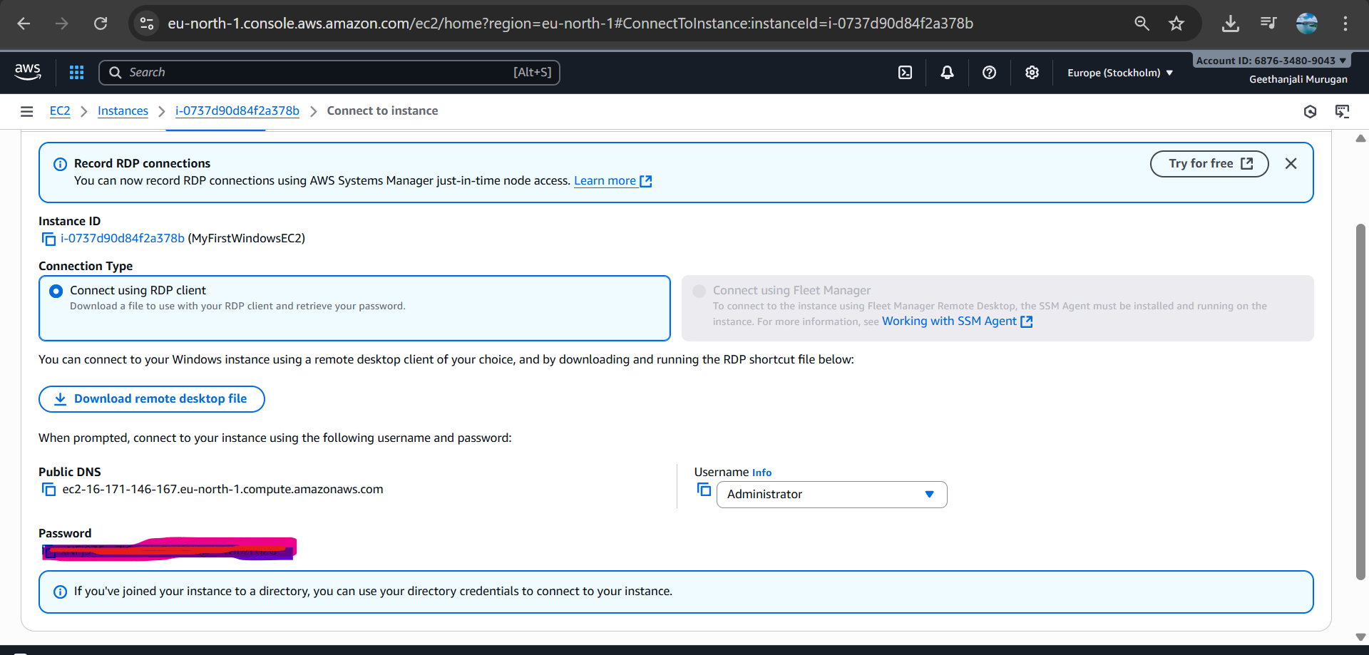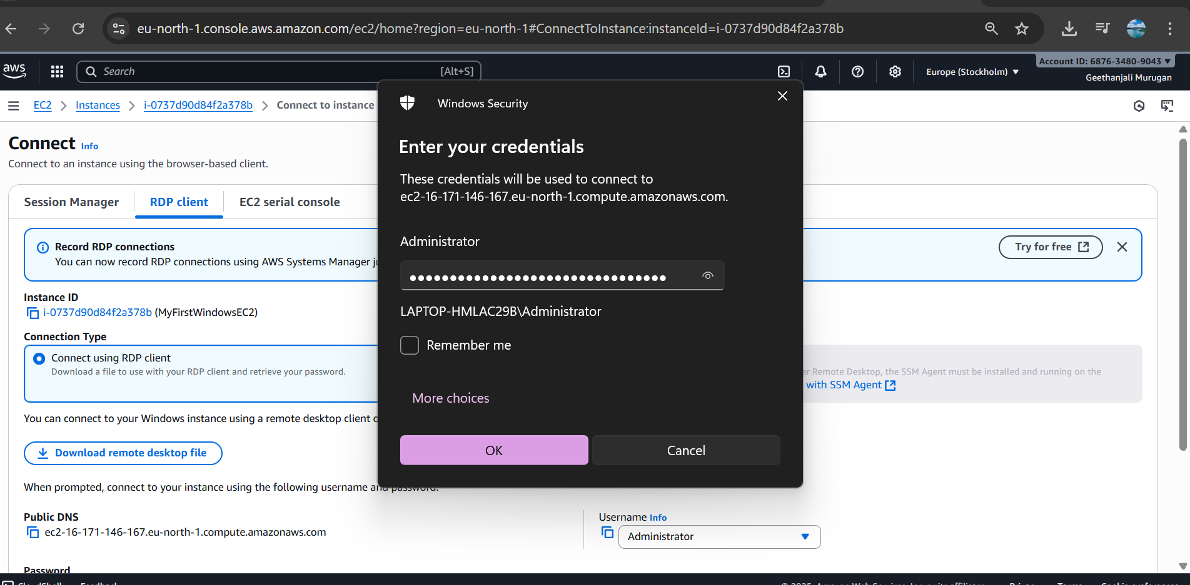

Step 3: Inside the new windows EC2, in command prompt given “systeminfo” to get the system information.

