**Task – 3**

**1.Get me the IP address of a particular domain (guvi.in).**

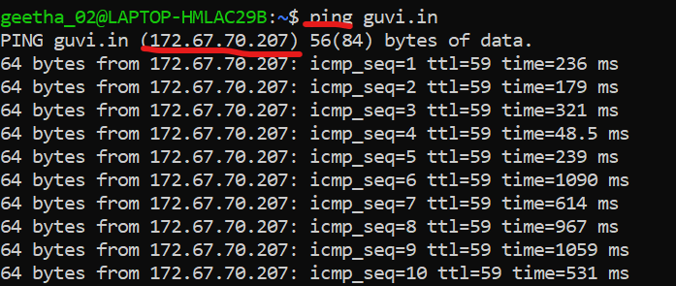

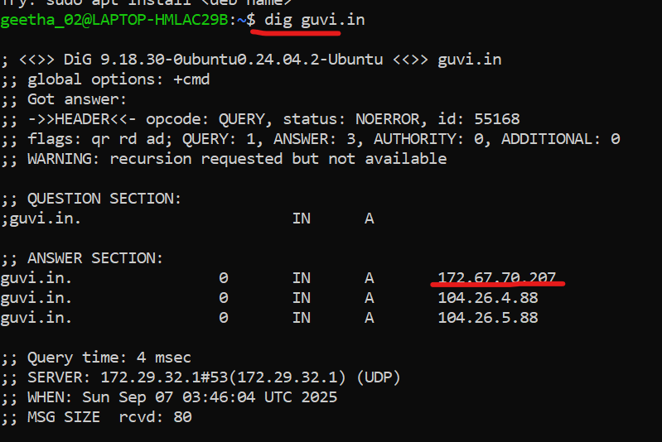

**How do I find my CPU/memory usage of my server?**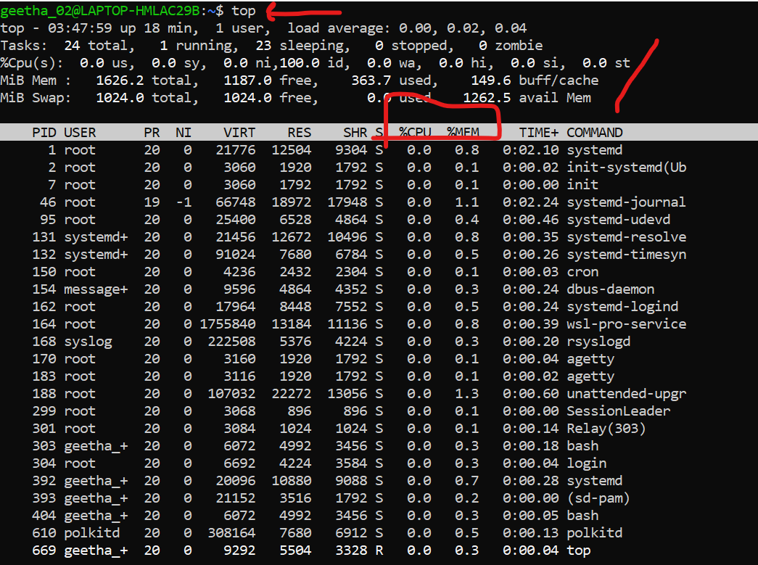

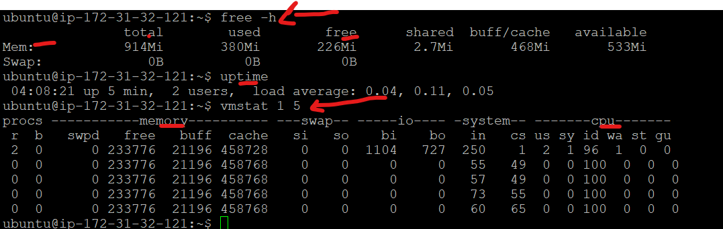

**Test the connectivity between 2 nodes?**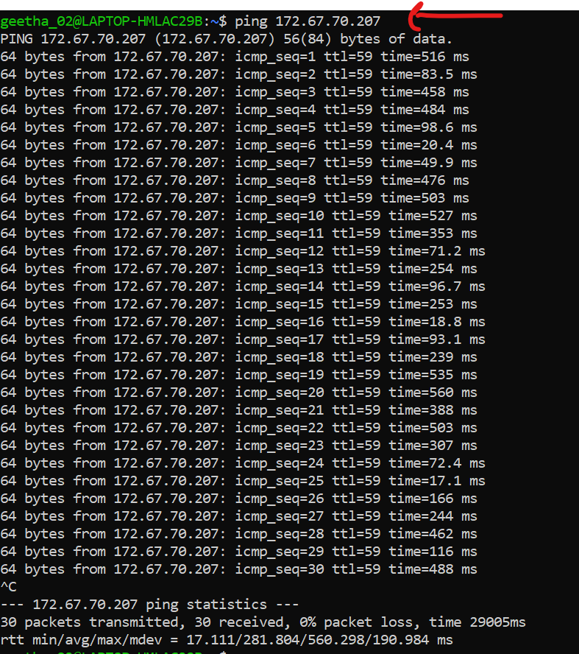

**2.I have deployed an application in guvi.com:9000, and logs show my app is running, but I am unable to view the page. Check whether my port is open or not?**

**Netstat -tuln | grep 9000 and sudo ss -tulnp | grep 9000 (alternate command)**

**Returned no output means nothing is listening on the port 9000.**

**To check the client machine connectivity:**

**telnet guvi.com 9000**

**o/p – connection timed out and network is unreachable.**

**Issue is : Application is not bounded to port 9000**

