Jenkins Task - 2
Task Description:
Create a simple script file and push it to repo. Create a project in Jenkins connected to your GitHub repository. When a commit is made to your repo, automatically build must get triggered from Jenkins and the output must be shared to me via email.
- EC2 instance:
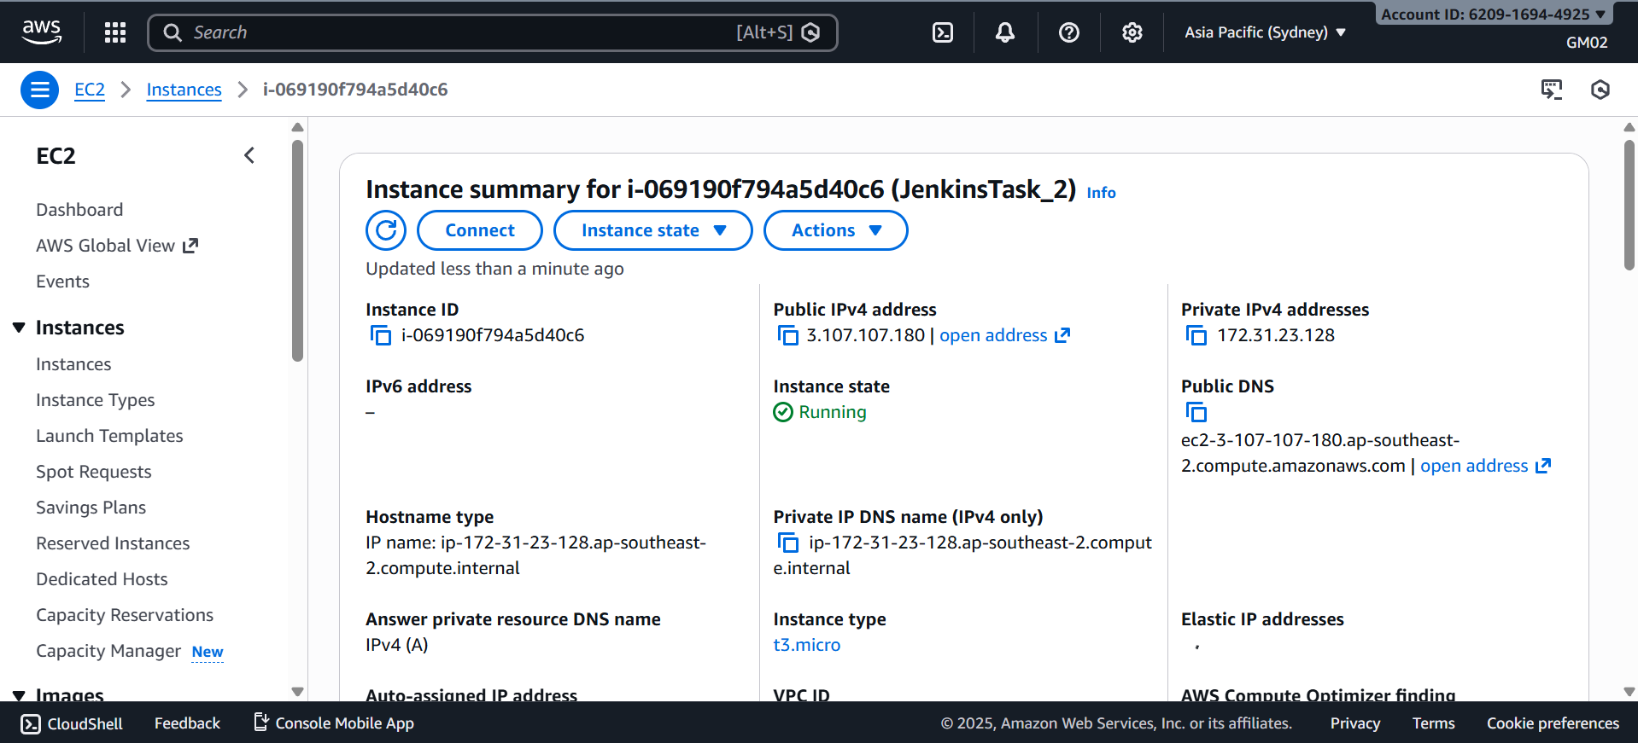
- Jenkins installation:
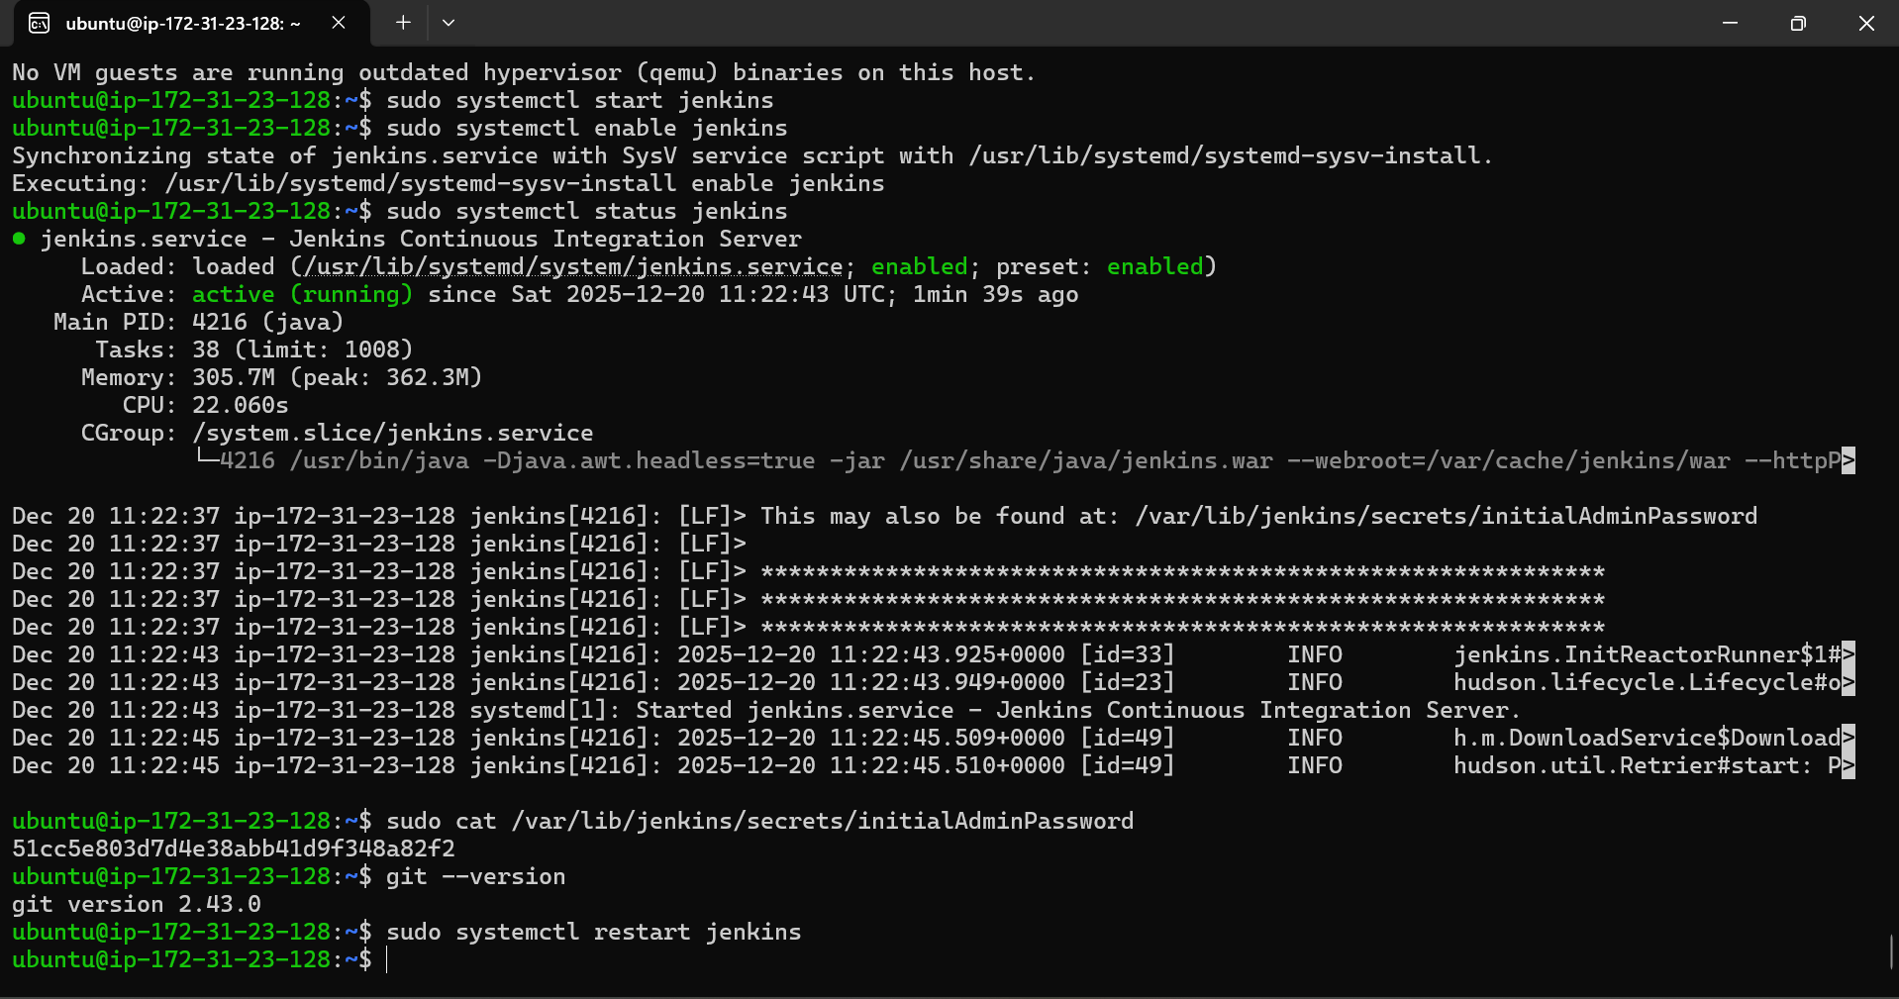
3.Jenkins build job setup: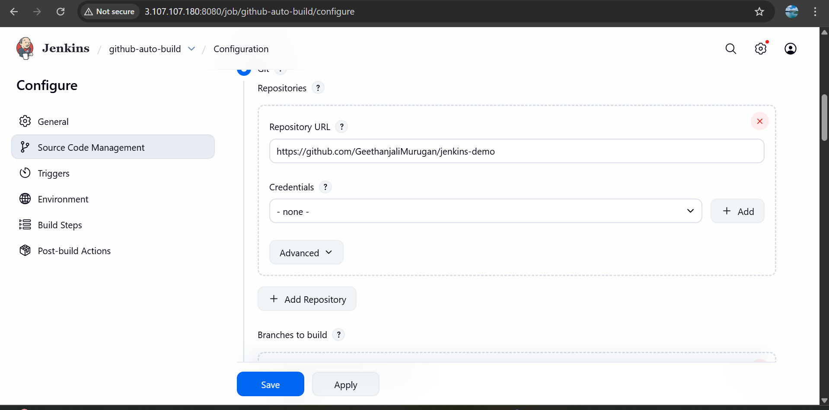
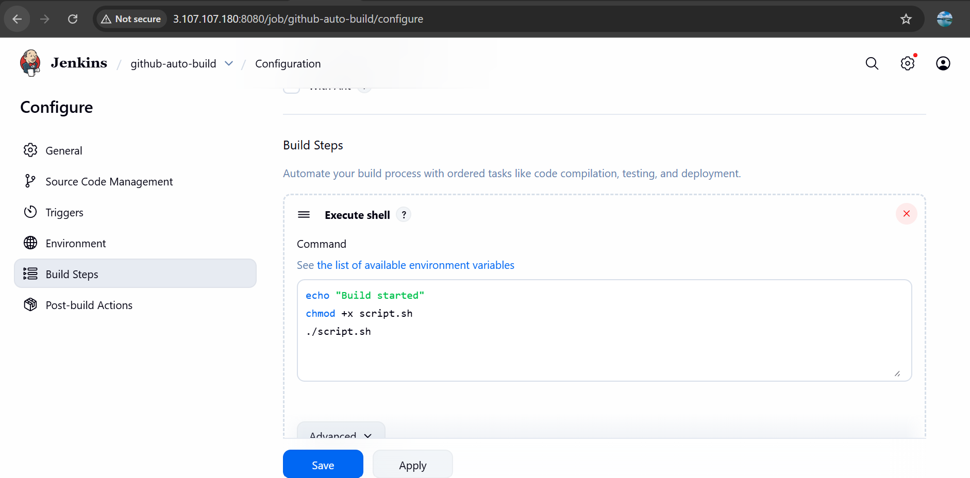
4.Email notification was added
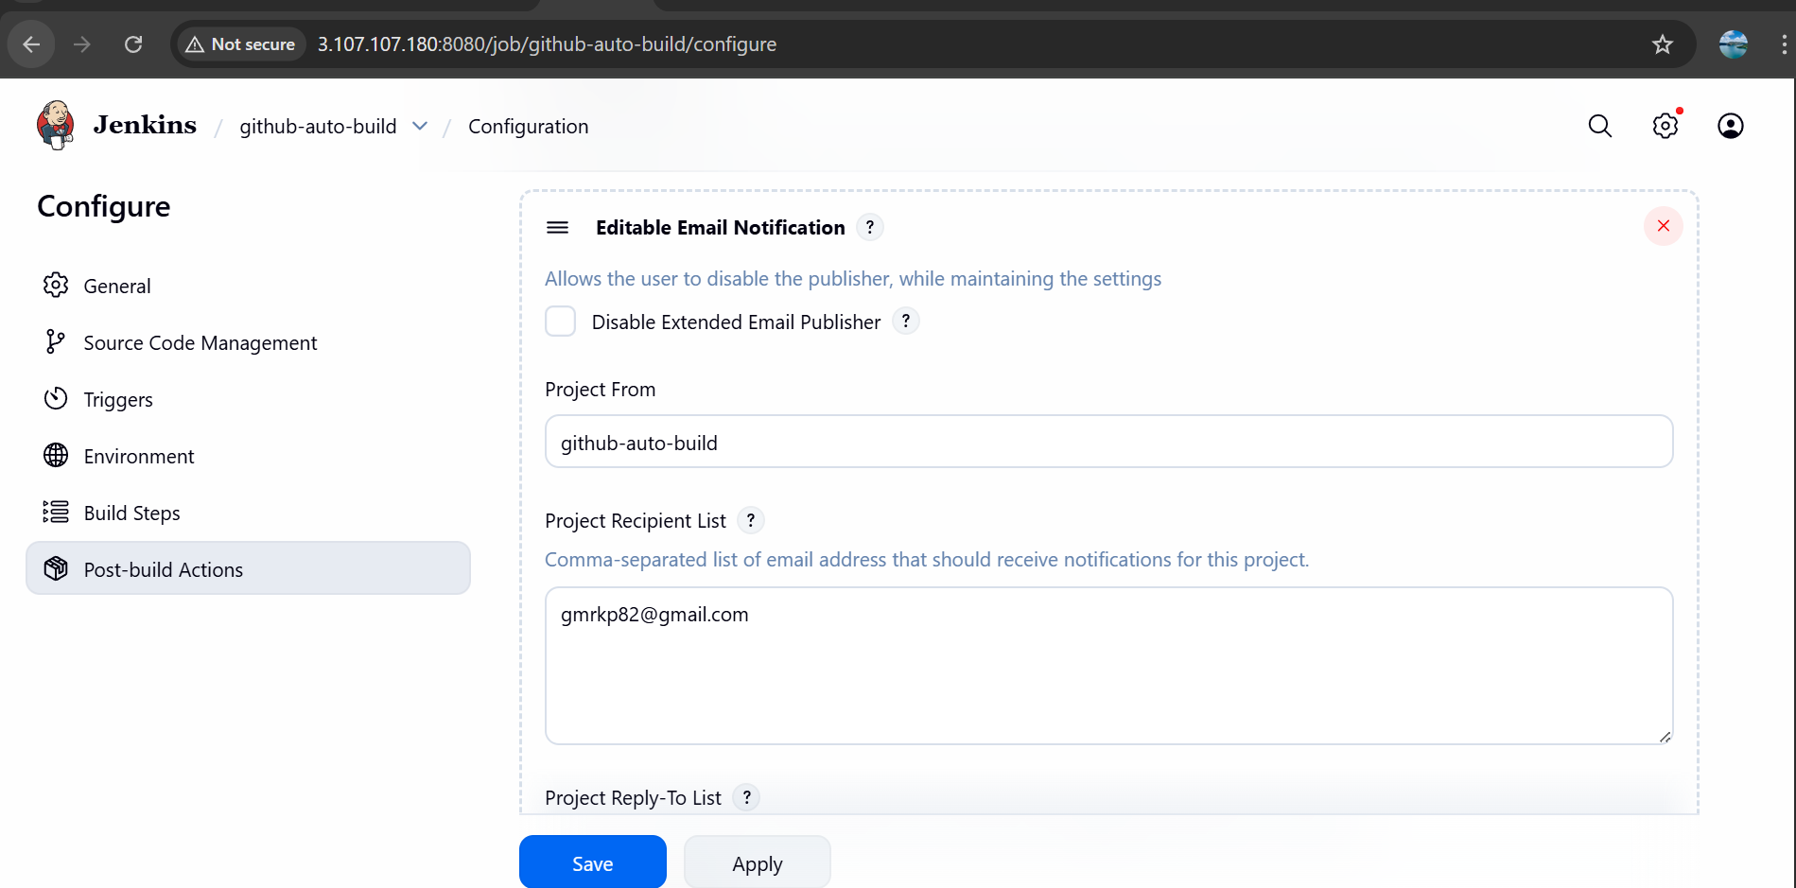

5.Github Repo and webhook:
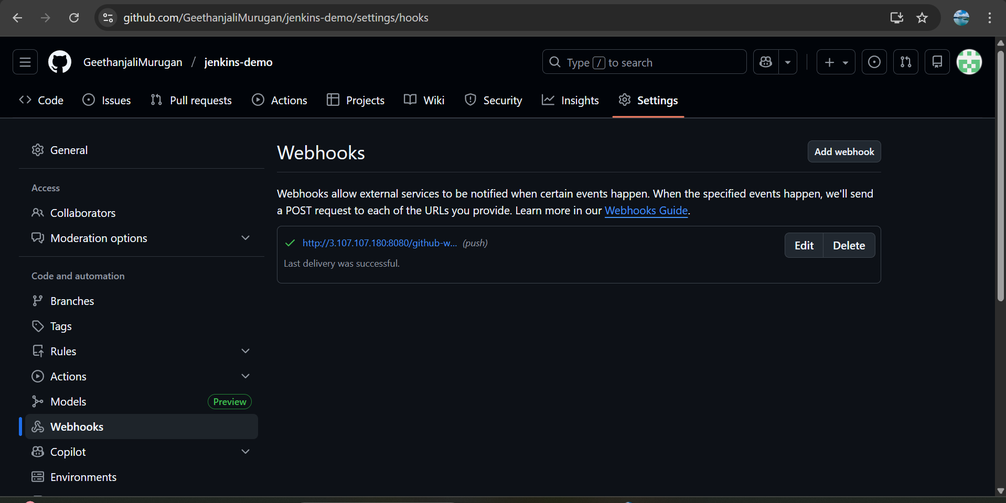
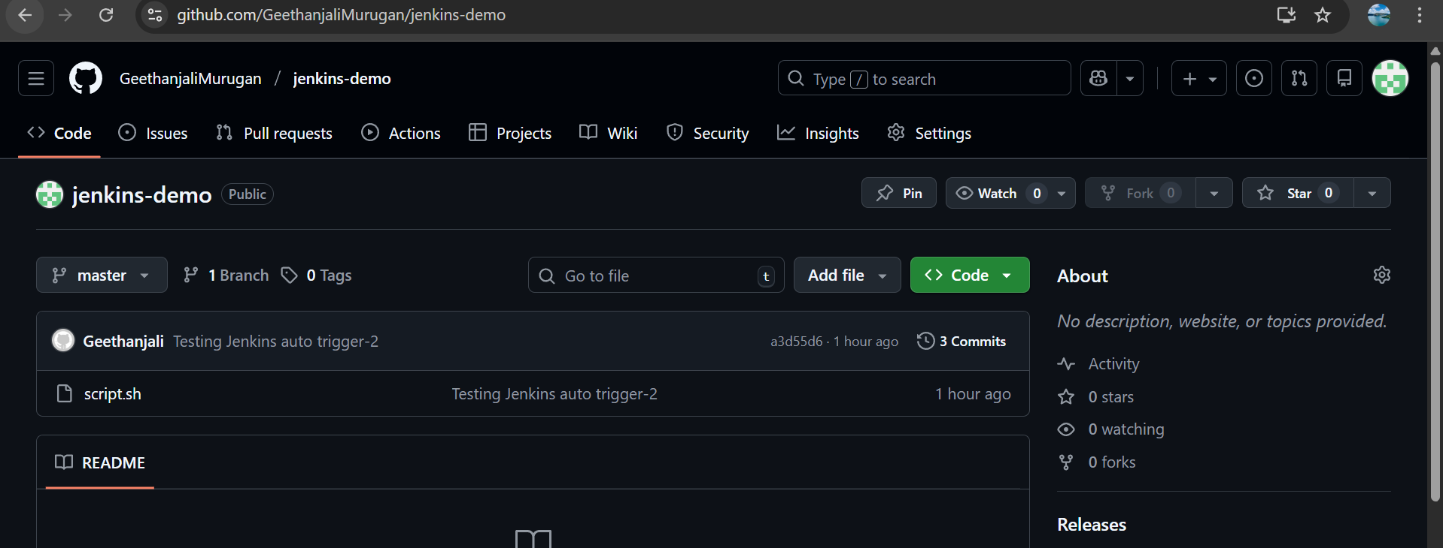
6. Triggered Build and email received
