Kubernetes Task
Task Description:
Setup minikube at your local and explore creating namespaces (Go through official documentation).
- My local machine is not having enough space for the Kubernetes installation, so used EC2.
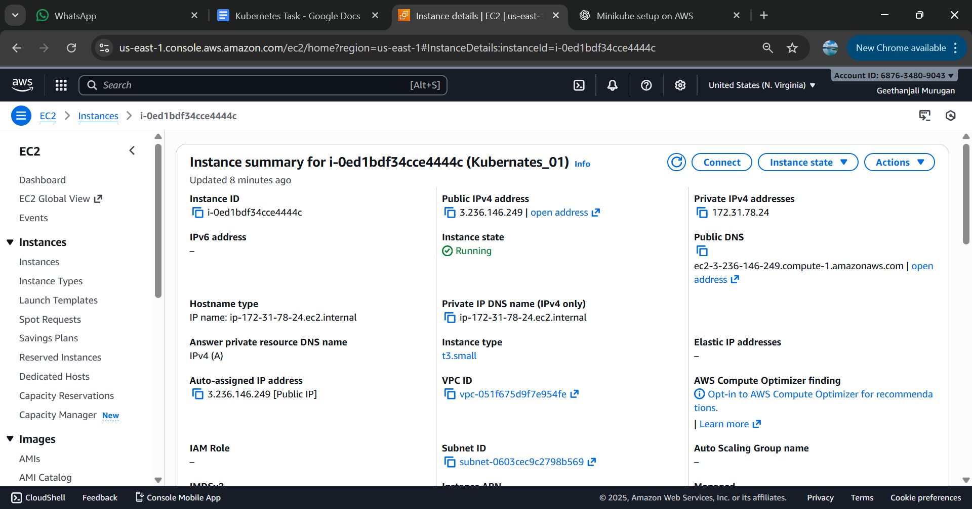
Docker installed:
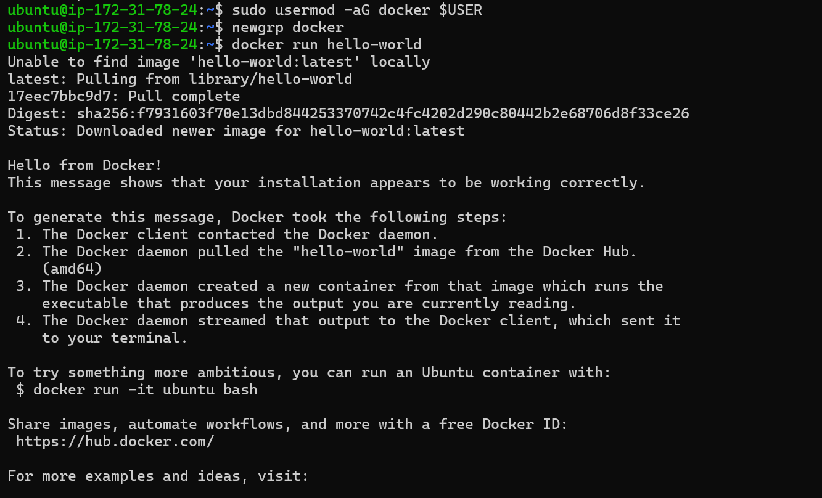
3.Installed Kubernetes and tried minikube install ,received memory insufficient message , so in EC2 have updated the instance type and proceeded further .
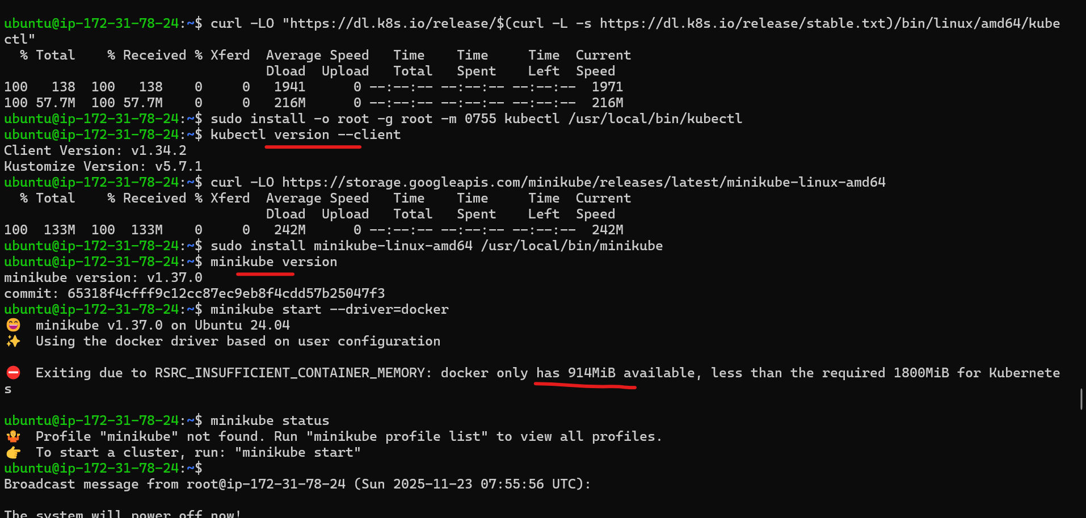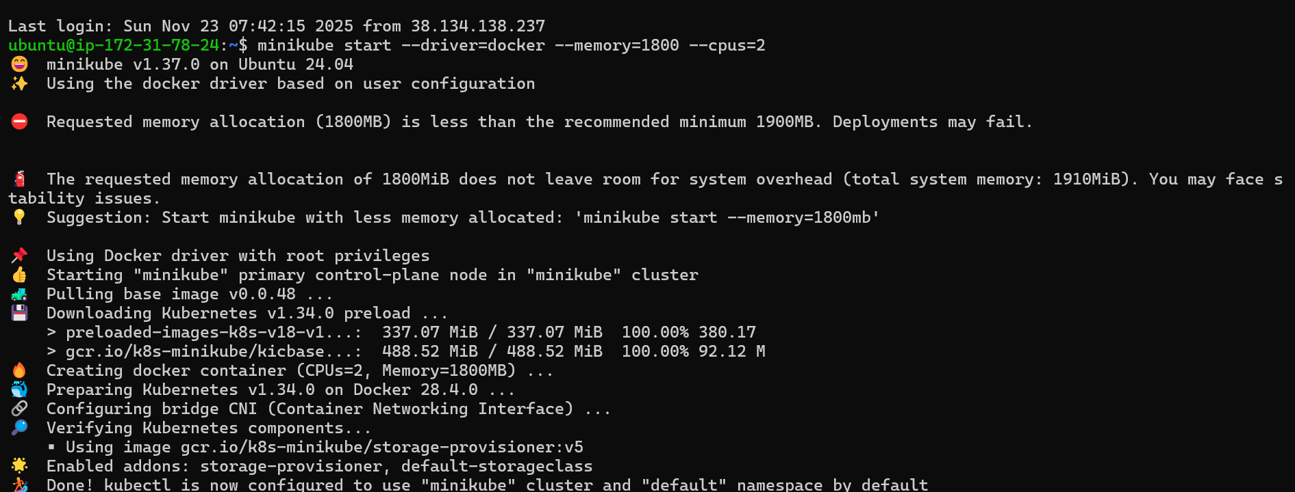Created namespace:DEV