CLASSIFICATION_REPORT DOCUMENTATION

1) RANDOM FOREST CLASSIFIER
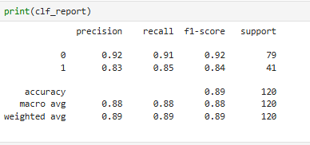
S.NO | QUESTIONS TO BE RAISED FROM THE CLF_REPORT | ANSWER
1. | i) What is the Overall performance of the model?  ii) What is the Percentage of correct classification of Purchased and Non-Purchased to the total input of the test set? | 0.89
2. | What is the Percentage of correct classification of Purchased to the total input of Purchased in the test set? | 0.85
3. | What is the Percentage of correct classification of Non- Purchased to the total input of Purchased in the test set? | 0.91
4. | What is the percentage of correct classification of Purchased to sum of correctly classified as Purchased and wrongly classified as Purchased in the set? | 0.83
5. | What is the percentage of correct classification of Non-Purchased to sum of correctly classified as Non-Purchased and wrongly classified as Non- purchased in the set? | 0.92
6. | What is the Overall Performance of Purchased? | 0.84
7. | What is the Overall Performance of Non-Purchased? | 0.92
8. | What is the Average Performance of Precision (Correctly & Wrongly classified)? | 0.88
9. | What is the Average Performance of Recall (Correctly & Wrongly classified)? | 0.88
10. | What is the Average Performance of F1-Measure (Correctly & Wrongly classified)? | 0.88
11. | What is the Sum of Product of proportion rate (Weight) of each Class? | 0.89

2. DECISION TREE CLASSIFIER

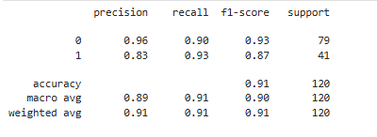

S.NO | QUESTIONS TO BE RAISED FROM THE CLF_REPORT | ANSWER
1. | i) What is the Overall performance of the model?  ii) What is the Percentage of correct classification of Purchased and Non-Purchased to the total input of the test set? | 0.91
2. | What is the Percentage of correct classification of Purchased to the total input of Purchased in the test set? | 0.93
3. | What is the Percentage of correct classification of Non- Purchased to the total input of Purchased in the test set? | 0.90
4. | What is the percentage of correct classification of Purchased to sum of correctly classified as Purchased and wrongly classified as Purchased in the set? | 0.83
5. | What is the percentage of correct classification of Non-Purchased to sum of correctly classified as Non-Purchased and wrongly classified as Non- purchased in the set? | 0.96
6. | What is the Overall Performance of Purchased? | 0.87
7. | What is the Overall Performance of Non-Purchased? | 0.93
8. | What is the Average Performance of Precision (Correctly & Wrongly classified)? | 0.89
9. | What is the Average Performance of Recall (Correctly & Wrongly classified)? | 0.91
10. | What is the Average Performance of F1-Measure (Correctly & Wrongly classified)? | 0.90
11. | What is the Sum of Product of proportion rate (Weight) of each Class? | 0.91

3. SUPPORT VECTOR MACHINE CLASSIFIER

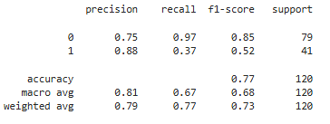

S.NO | QUESTIONS TO BE RAISED FROM THE CLF_REPORT | ANSWER
1. | i) What is the Overall performance of the model?  ii) What is the Percentage of correct classification of Purchased and Non-Purchased to the total input of the test set? | 0.77
2. | What is the Percentage of correct classification of Purchased to the total input of Purchased in the test set? | 0.37
3. | What is the Percentage of correct classification of Non- Purchased to the total input of Purchased in the test set? | 0.97
4. | What is the percentage of correct classification of Purchased to sum of correctly classified as Purchased and wrongly classified as Purchased in the set? | 0.88
5. | What is the percentage of correct classification of Non-Purchased to sum of correctly classified as Non-Purchased and wrongly classified as Non- purchased in the set? | 0.75
6. | What is the Overall Performance of Purchased? | 0.52
7. | What is the Overall Performance of Non-Purchased? | 0.85
8. | What is the Average Performance of Precision (Correctly & Wrongly classified)? | 0.81
9. | What is the Average Performance of Recall (Correctly & Wrongly classified)? | 0.67
10. | What is the Average Performance of F1-Measure (Correctly & Wrongly classified)? | 0.68
11. | What is the Sum of Product of proportion rate (Weight) of each Class? (For Precision) | 0.79
12. | What is the Sum of Product of proportion rate (Weight) of each Class? (For Recall) | 0.77
13. | What is the Sum of Product of proportion rate (Weight) of each Class? (For F1-Measure) | 0.73

