**Week_2_JUnit_Testing**

**Exercise 1: Setting Up JUnit:**

CalcTool.java:

public class CalcTool {

public int add(int a, int b) {

return a + b;

}

}

CalcToolTest.java:

import org.junit.Test;

import static org.junit.Assert.assertEquals;

public class CalcToolTest {

@Test

public void testAdd() {

CalcTool calcTool = new CalcTool();

int result = calcTool.add(5,4);

assertEquals(10, result);

}

}

**Output:**

**Exercise 2: Writing Basic JUnit Tests:**

MyMath.java:

public class MyMath {

public int add(int a, int b) {

return a + b;

}

public int multiply(int a, int b) {

return a * b;

}

public boolean isEven(int number) {

return number % 2 == 0;

}

}

MyMathTest.java:

import org.junit.Test;

import static org.junit.Assert.*;

public class MyMathTest {

@Test

public void testAdd() {

MyMath myMath = new MyMath();

int result = myMath.add(5, 4);

assertEquals(10, result);

}

@Test

public void testMultiply() {

MyMath myMath = new MyMath();

int result = myMath.multiply(2, 8);

assertEquals(18, result);

}

@Test

public void testIsEven() {

MyMath myMath = new MyMath();

assertTrue(myMath.isEven(20));

assertFalse(myMath.isEven(31));

}

}

**Output:**

**Exercise 3: Assertions in JUnit:**

**AssertionsTest.java:**

import org.junit.Test;

import static org.junit.Assert.*;

public class AssertionsTest {

@Test

public void testAssertions() {

assertEquals(3, 1 + 2);

assertTrue(10 > 2);

assertFalse(7 < 1);

Object obj1 = null;

assertNull(obj1);

Object obj2 = new Object();

assertNotNull(obj2);

}

}

**Output:**

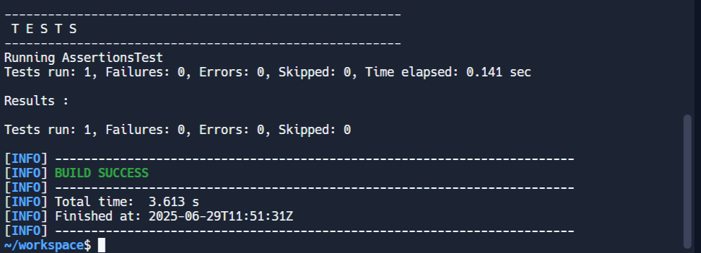

**Exercise 4: Arrange-Act-Assert (AAA) Pattern, Test Fixtures, Setup and Teardown Methods in JUnit:**

CalcTool.java:

public class CalcTool {

public int add(int a, int b) {

return a + b;

}

public int subtract(int a, int b) {

return a - b;

}

}

CalcToolTest.java:

import org.junit.Before;

import org.junit.After;

import org.junit.Test;

import static org.junit.Assert.*;

public class CalcTooltest {

private CalcTool calcTool;

@Before

public void setUp() {

System.out.println("Setting up...");

calcTool = new CalcTool();

}

@After

public void tearDown() {

System.out.println("Tearing down...");

calcTool = null;

}

@Test

public void testAdd() {

int a = 5;

int b = 3;

int result = calcTool.add(a, b);

assertEquals(8, result);

}

@Test

public void testSubtract() {

int a = 10;

int b = 4;

int result = calcTool.subtract(a, b);

assertEquals(6, result);

}

}

**Output:**

