FACTORIAL
OF A GIVEN NUMBER

EXP NO: 9

AIM:To find the factorial of a given number using
8085 microprocessor.

ALGORITHM:

1)
Load the data into register B

2)
To start multiplication set D to 01H

3)
Jump to step 7

4)
Decrements B to multiply previous number

5)
Jump to step 3 till value of B>0

6)
Take memory pointer to next location and store
result

7)
Load E with contents of B and clear accumulator

8)
Repeatedly add contents of D to accumulator E times

9)
Store accumulator content to D

10) Go to
step 4

PROGRAM:

LDA 2001

MOV B,A

MVI C,01H

MVI E,01H

LOOP: MOV D,C

MVI A,00H

LP: ADD E

DCR D

JNZ LP

MOV E,A

INR C

DCR B

JNZ LOOP

MOV A,E

STA 2010

HLT

INPUT:

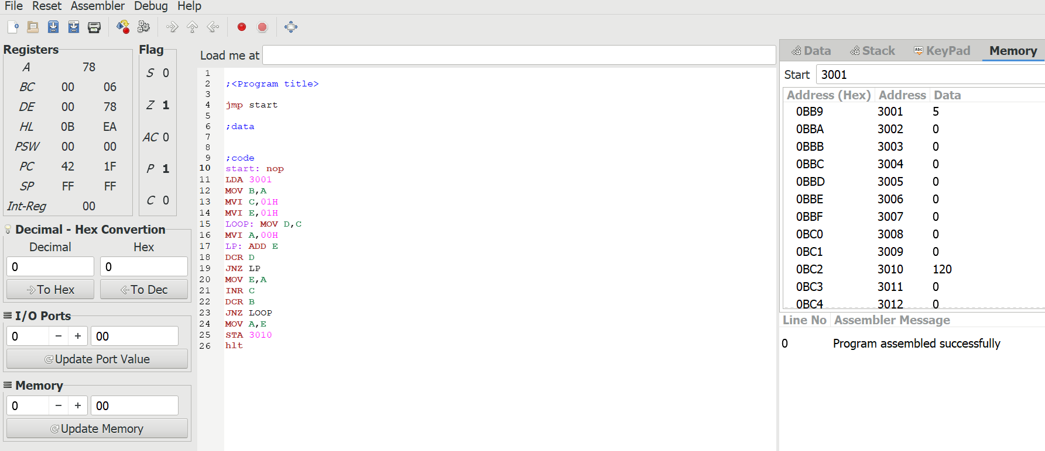

OUTPUT:

RESULT: Thus the program was executed successfully using 8085
processor simulator.

