LARGEST
NUMBER IN AN ARRAY

EXP NO: 10

AIM:
To find the largest number from an array
using 8085 processor.

ALGORITHM:

1) Load the address of the first element of the array in HL
pair.

2) Move the count to B register.

3) Increment the pointer.

4) Get the first data in A register.

5) Decrement the count.

6) Increment the pointer.

7) Compare the content of memory addressed by HL pair with that
of A register.

8) If carry=0, go to step 10 or if carry=1 go to step 9

9) Move the content of memory addressed by HL to A register.

10) Decrement the count.

PROGRAM:

LXI H,2050

MOV C,M

DCR C

INX H

MOV A,M

LOOP1: INX H

CMP M

JNC LOOP

MOV A,M

LOOP: DCR C

JNZ LOOP1

STA 2058

HLT

INPUT:


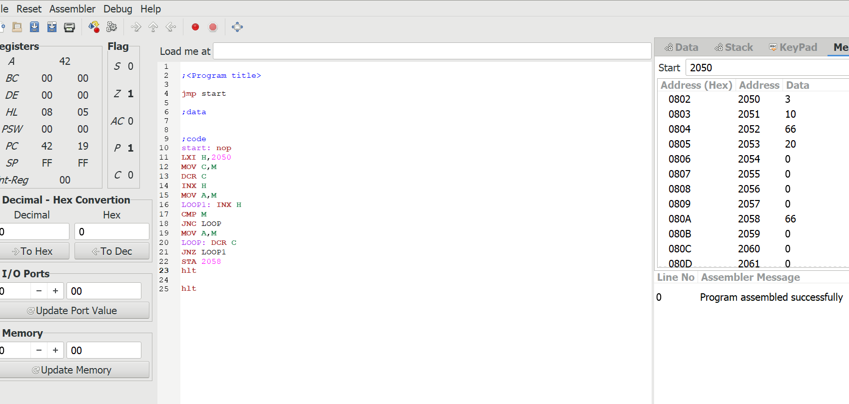

OUTPUT:

RESULT: Thus
the program was executed successfully using 8086 processor simulator.

