Figure 1 | Design-based area estimates
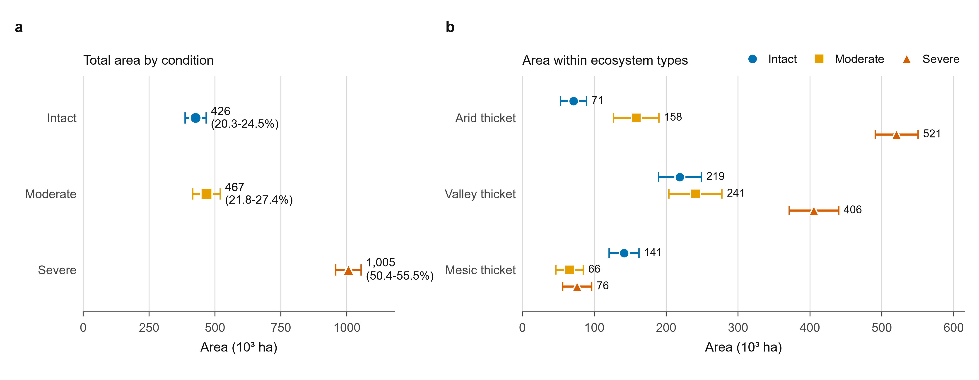
Figure 1 | Design-based area estimates for thicket condition and ecosystem type. a, Total mapped area in each reference-condition class; parenthetical values give the corresponding 95% confidence interval as a percentage of the mapped domain. b, Reference-condition area within Arid, Valley and Mesic thicket. Points show stratified design-based estimates and horizontal bars show 95% confidence intervals calculated following the Olofsson estimator. At all locations with two conflicting labels (n = 35 of 92), one submitted source label was selected randomly; unsure labels were ineligible, and locations with no determinate label (n = 25) were excluded. Reference observations labelled as no thicket were grouped with the severe class. The reference sample comprised 821 independently labelled points (Arid, n = 315; Valley, n = 385; Mesic, n = 121) across a mapped domain of 1,898,600 ha.

Figure 2 | Map accuracy
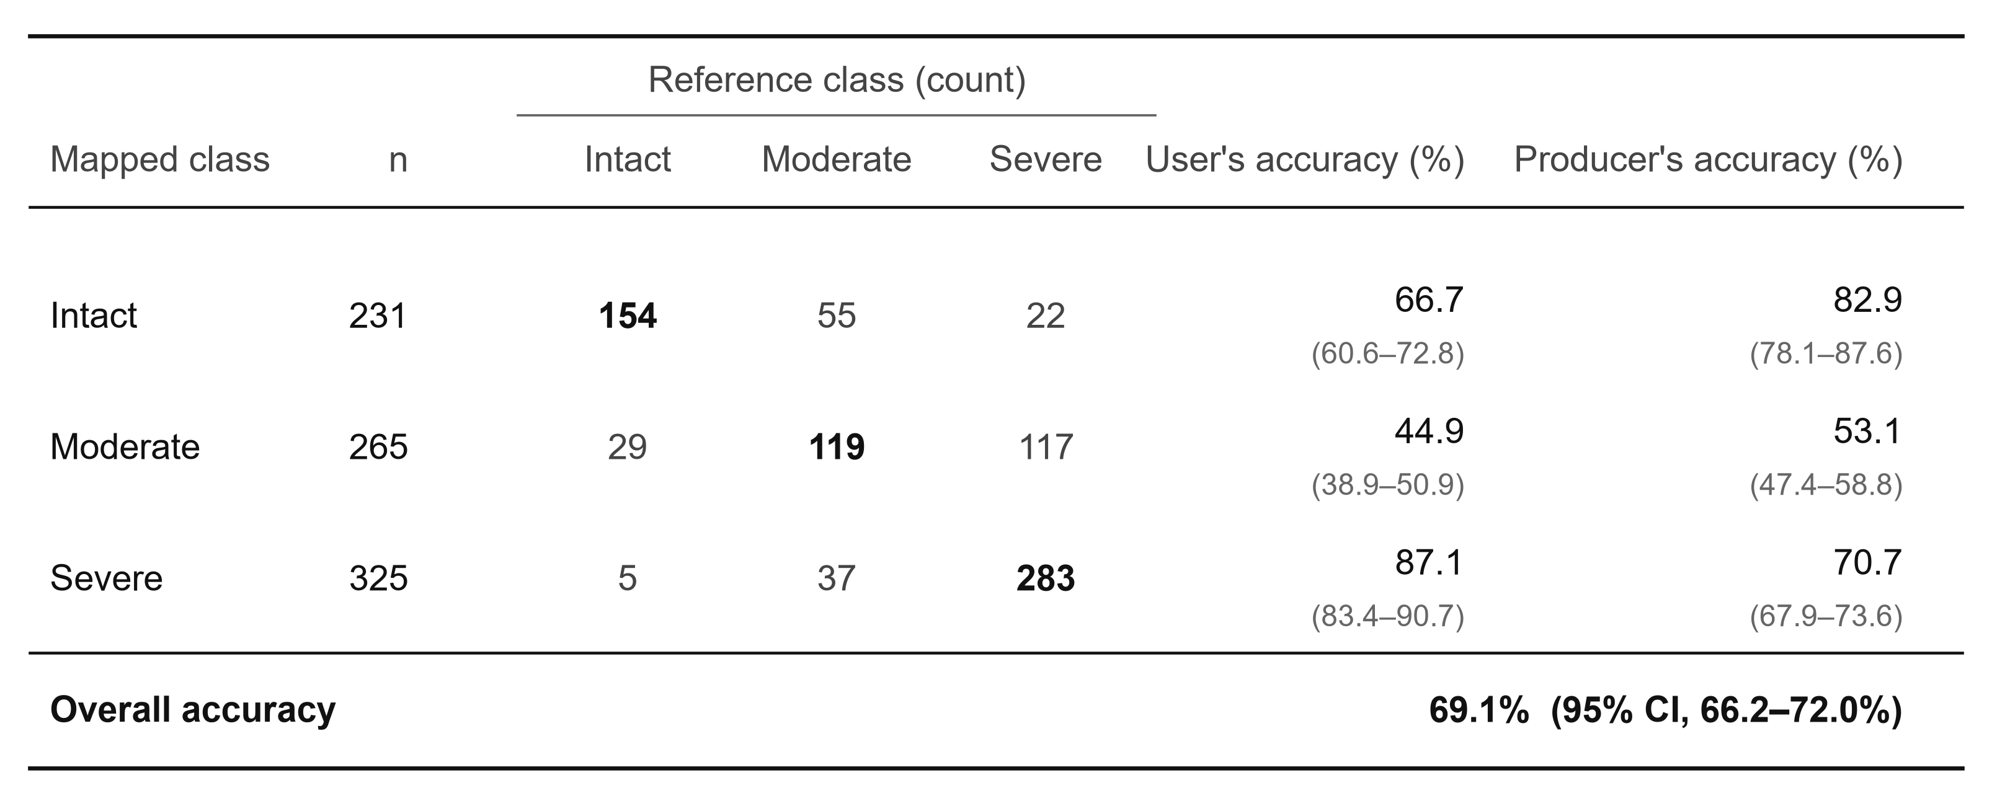
Figure 2 | Design-based accuracy of the three-class thicket-condition map. Rows represent mapped classes and columns represent reference classes. Confusion-matrix cells and n values are unweighted reference-point counts; user's, producer's and overall accuracies are area-adjusted design-based estimates. Accuracy values are percentages, with 95% confidence intervals in parentheses. At all locations with two determinate labels (n = 35), one submitted source label was selected randomly; unsure labels were ineligible, and locations with no determinate label (n = 25) were excluded. Reference observations labelled as no thicket were grouped with the severe class. Estimates use 821 independently labelled reference points.

Figure 3 | Single- versus multi-layer intact-class scores
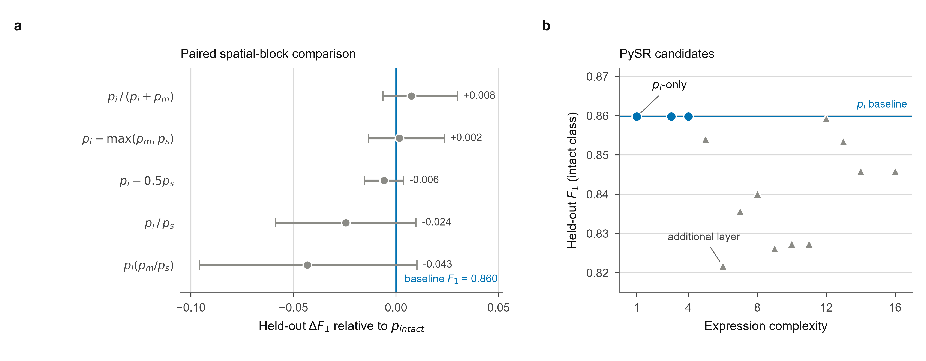
Figure 3 | Held-out evaluation of single- and multi-layer intact-class scores. a, Difference in held-out intact-class F₁ between each fixed multi-layer score and the p_{intact} baseline. Points show observed differences and horizontal bars show percentile 95% confidence intervals from 10,000 paired bootstrap resamples of the 27 held-out 0.2° spatial blocks (n = 704 observations). The vertical line denotes no difference; all displayed intervals include zero. Rule thresholds were selected using the training folds only (n = 1,379). b, Held-out F₁ for every expression on the PySR training-loss/complexity front. Circles denote expressions containing p_{i} only and triangles denote expressions that additionally contain p_{m} or p_{s}; the horizontal line is the p_{i} baseline. Here p_{i}, p_{m} and p_{s} are the intact, moderate and severe Random Forest probability layers.

