Iteration 0 report

# Team roles

Scrum master: Wenrui Zhang

Product owner: Xiaopei Xu

# Customer meeting date/time/place

Meeting on Friday 4:30 pm at CBGSE (101 Gateway, Suite A, College Station).

# Summary

The goal of this project is to design a website which serves as a basic framework for crowdsourcing of biodata curation. Specifically, this website should have 3 main features (more detailed requirements and feedbacks will be provided as the project evolves). First, an interested individual should be able to register on the website as a data curator. They can either set up a new account or login in with their social account like Facebook or Google+. Secondly, tutorial for this websites should be rendered to the curators in a user-friendly fashion (It should be a dynamic instruction. It’s better to instruct user in a game way) so that even people without much biological background will be able to easily learn the necessary curation skills. Third and the most important, the website should record the curation results of these registered data curators which will be accessed both automatically (by comparing the results among curators using, for example, weighted majority vote) and manually (for the cases that are hard to be solved automatically). There should be a way to evaluate curators based on their past performance. Thus, the results from curators who have good curation history should be trusted more in deriving the correct results.

In order to emphasis the pain point of this project, in the follow, I’ll show the main stream of this websites. After logging in, curators are given several datasets which are assigned by administrator with a few questions set by administrator. These datasets are extracted from Array Express or GEO automatically with the term for searching provided by administrator. Curator can answer the questions by simply choosing yes or no. The website judges the correction of these questions by either taking the most frequent choice of curators’ answers or using the answers given by administrator. After getting correct answers, the website can automatically define the performance of each curators. For administrator, he can search term for related datasets. This terms are defined by the answers of questions. Also administrator can choose to only display the answers of curators who have high performance. Other features like improving database will be considered if time is possible.

# Lo-Fi UI

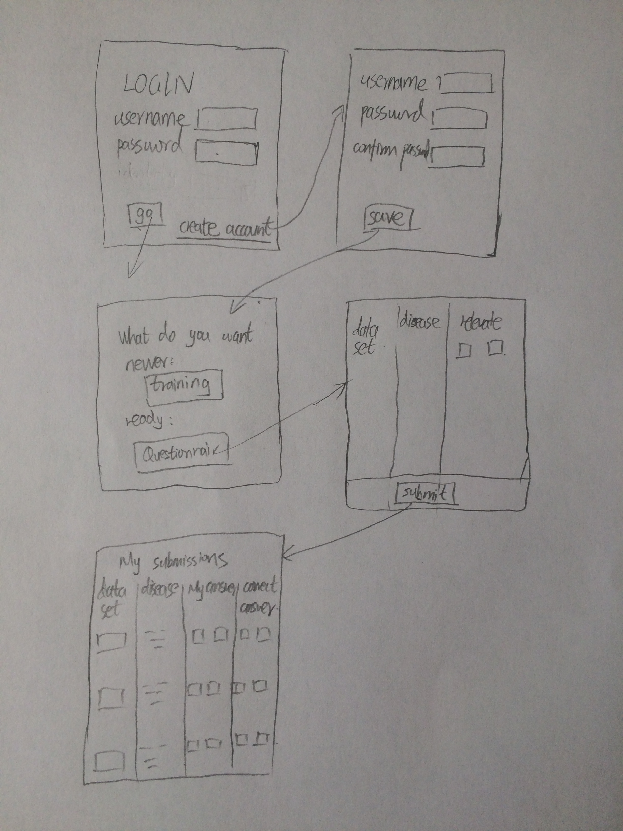

# Legacy

# Pivotal Tracker

<https://www.pivotaltracker.com/n/projects/1887551>

# GitHub

<https://github.com/xvxiaopei/CSCE606-project>

# Video

<https://youtu.be/YVqrbsdxi5M>