CSCE 606 Iteration 1

Team: Flyer

Customer meeting date to demo this iteration:

10/21/2016 Friday afternoon

User stories implemented in this iteration:

Feature: Add new login methods

To provide easier login routine and support wide users' range

As a admin, I would like to have more users

I want to add a third-party login function

Additional documentation related to the user stories:

Improve the login page: The login page could still be visited even logged in before. We advanced it and make sure that the login page would be directed to profile page when logged in.

BDD & TDD of the scenarios:

We use Rspec together with Capybara to do both BDD and TDD tests. The tests for iteration 1 scenarios is given as below:

login_rspec_whole.rb

require 'rails_helper'

require 'date'

describe "On the homepage, users"

it 'can sign in with correct Email and Password'

it 'can be rejected if provide invalid credentials'

it "can sign in with their Facebook Accounts"

it "can be redirected to the Log in page if Facebook authenticated failed"

it "can sign with their Google Accounts"

it "can be redirected to the Log in page if Google authenticated failed"

BDD & TDD results:

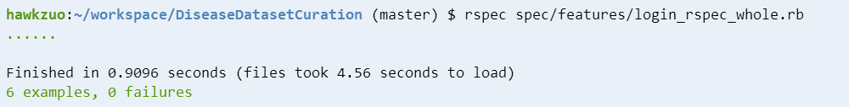

Pivotal Tracker, Github repo, and Heroku links:

Pivotal: <https://www.pivotaltracker.com/n/projects/1887551>

Github: <https://github.com/xvxiaopei/CSCE606-project>

Heroku: <http://disease.herokuapp.com/>