CSCE 606 Iteration 2

Team: Flyer

# Customer meeting date to demo this iteration:

11/04/2016 Friday afternoon at CBGSE (<http://cbgse.tamu.edu/831/)>

# User stories implemented in this iteration:

Feature: Extracting the data set from public websites

As an administrator

So that I can automatically assign the data set to users

I want to provide the term for searching in ArrayExpress (<https://www.ebi.ac.uk/arrayexpress/)>

Note: This function has not been completed and will continue in next iteration.

Feature: Assigning Questions with dataset

As an administrator

So that I can assign 1-5 Yes or No questions to a set of dataset

I want to ask user to show their curation results related to these questions

Feature: Assigning datasets to a certain group

As an administrator

So that I can assign datasets to a group of students

I want to choose which group the datasets are sent to.

Feature: Answering Administrator’s questions

As a user

So that I can answer questions of each dataset according to my curation results.

I want to choose the answer to Administrator’s question.

Feature: Training

As a new user to this website

So that I can easily learn the necessary steps to conduct curation on the websites

I want to receive training materials rendered in a user-friendly fashion

# Views

User view for answering questions:

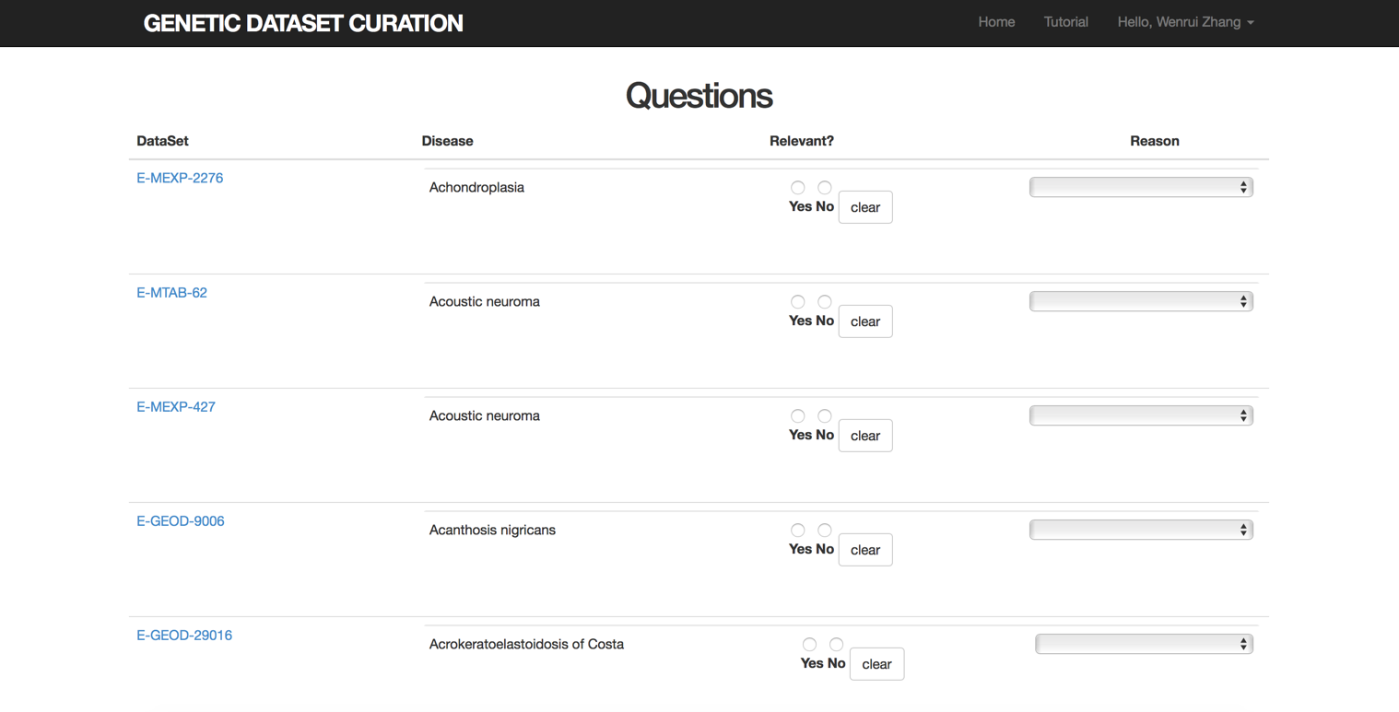

Tutorial page:

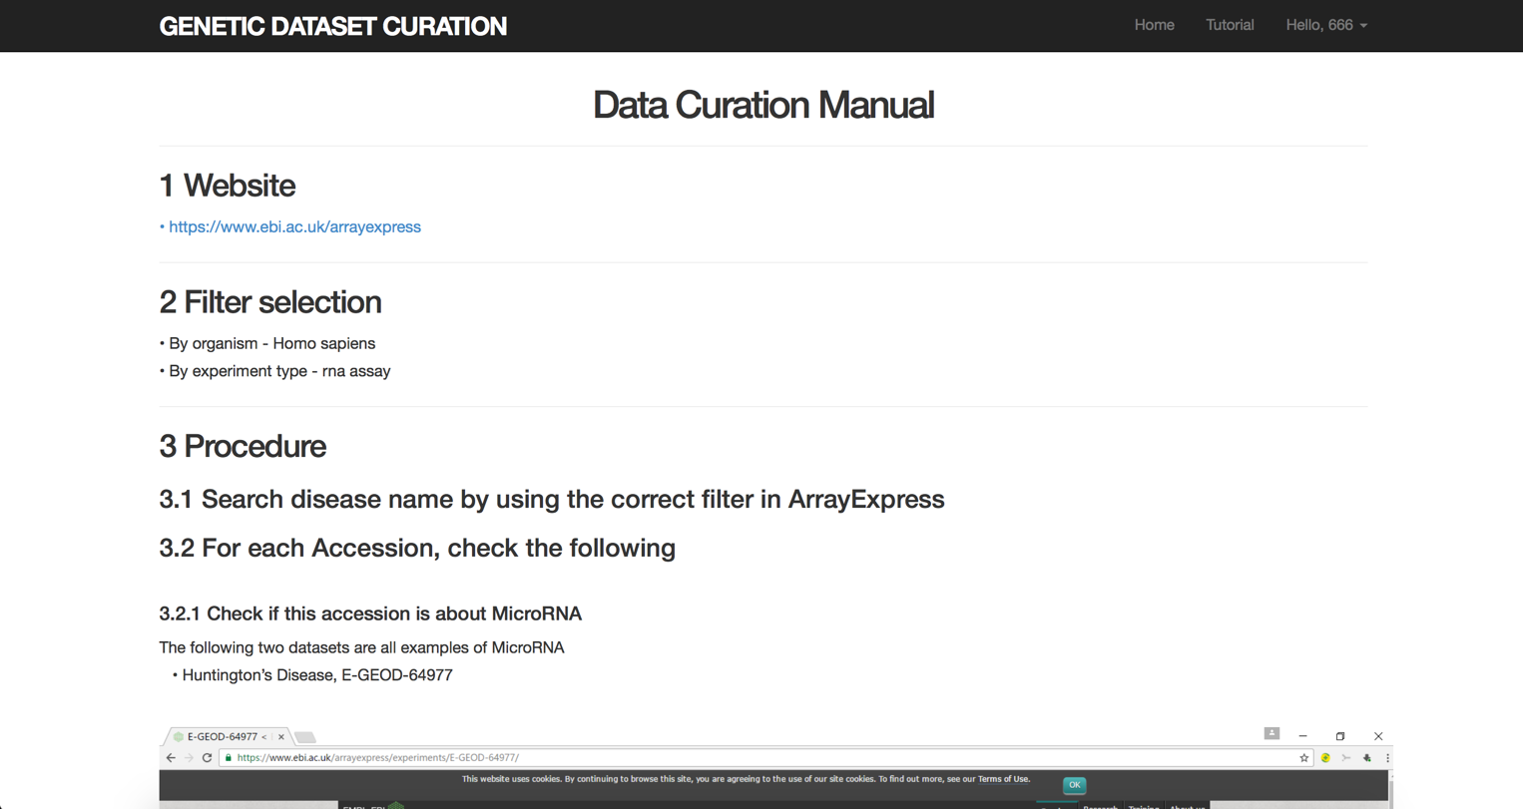

# BDD&TDD test

For training feature:

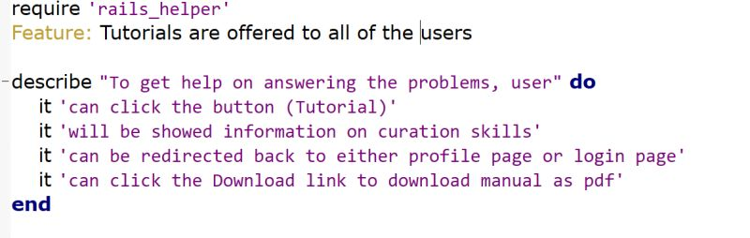

it 'can click the button (Tutorial)' do

visit '/'

expect(page).to have_link('Tutorial')

click_link('Tutorial')

end

# BDD & TDD results:

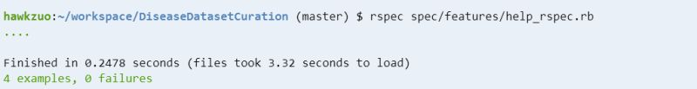

# Pivotal Tracker, Github repo, and Heroku links:

Pivotal: <https://www.pivotaltracker.com/n/projects/1887551>

Github: <https://github.com/xvxiaopei/CSCE606-project>

Heroku: <http://disease.herokuapp.com/>