CSCE 606 Iteration 3

Team: Flyer

# Customer meeting date to demo this iteration:

We tried to meet on 11/18/2016 Friday afternoon. However, our custom is not free. We’ll try to schedule another time to demonstrate and discuss current work.

# User stories implemented in this iteration:

Feature: Extracting the data set from public websites

As an administrator

So that I can automatically assign the data set to users

I want to provide the term for searching in ArrayExpress (<https://www.ebi.ac.uk/arrayexpress/)>

Feature: Assigning Questions with dataset

As an administrator

So that I can assign 1-5 Yes or No questions to a set of dataset

I want to ask user to show their curation results related to these questions

Feature: Assigning datasets to a certain group

As an administrator

So that I can assign datasets to a group of students

I want to choose which group the datasets are sent to.

Feature: Adding Groups Mechanism to the System

As a stakeholder (power admin),

So that I can manage groups(CRUD) and promote/demote users to become a group admin.

I want the group admin to be able to manage his/her own group, too.

# Views

## User view for searching dataset:

Search for keywords:

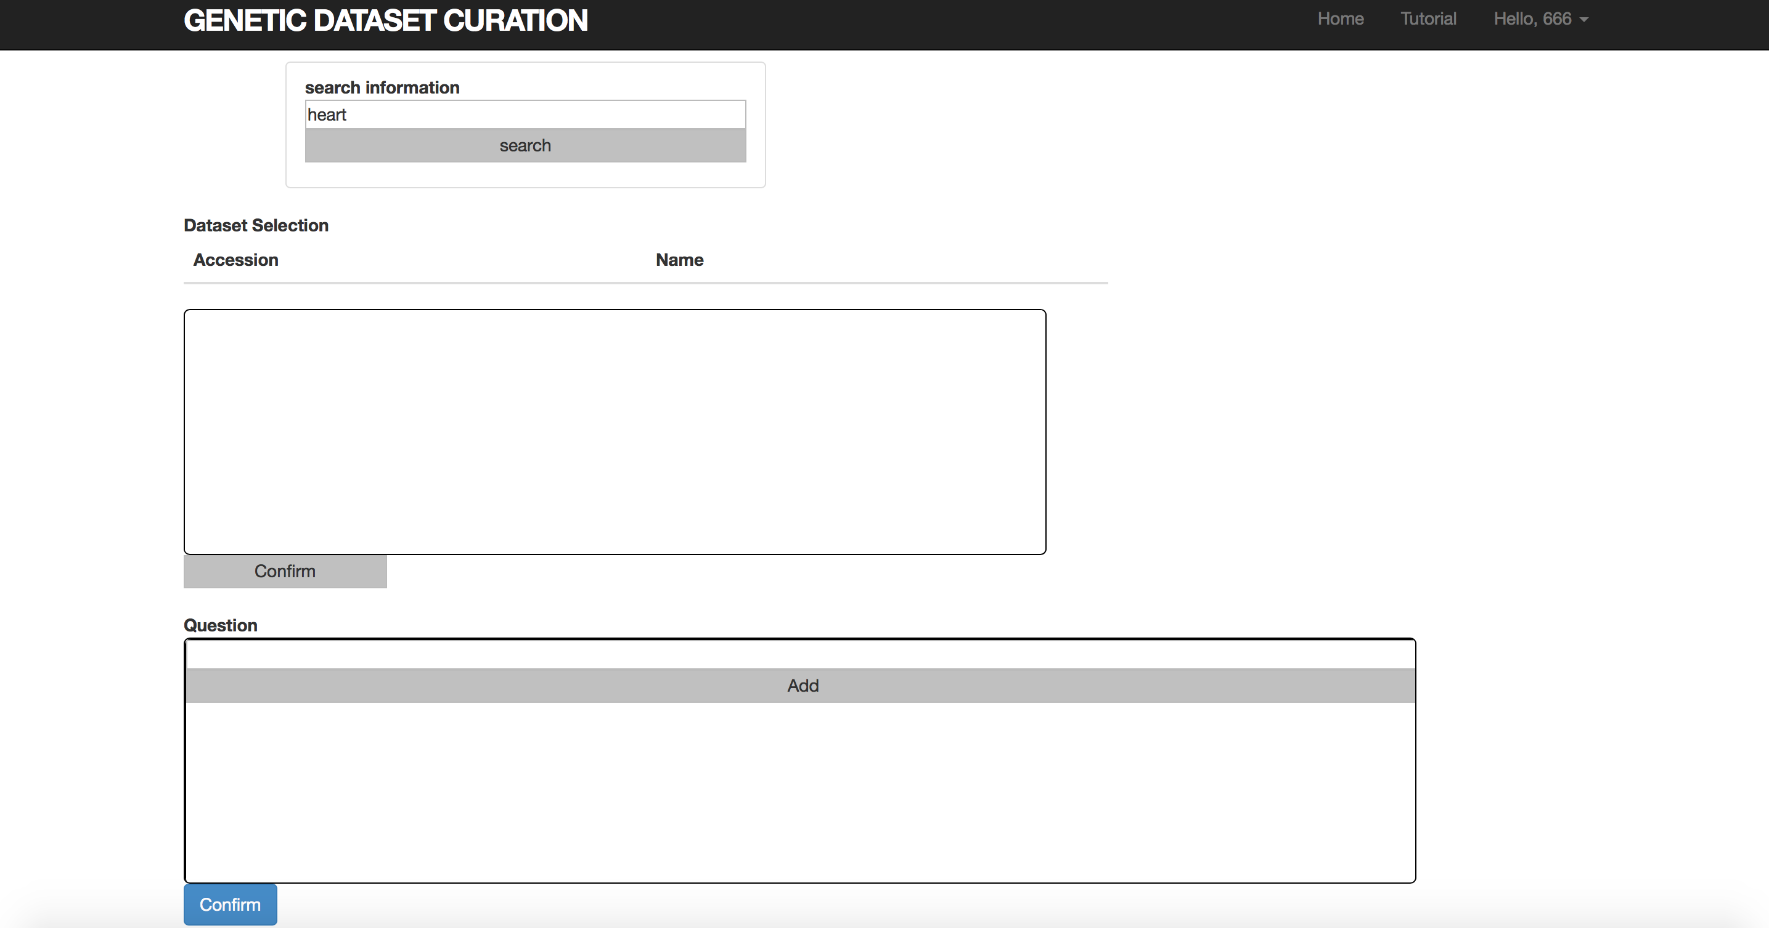

show search results:

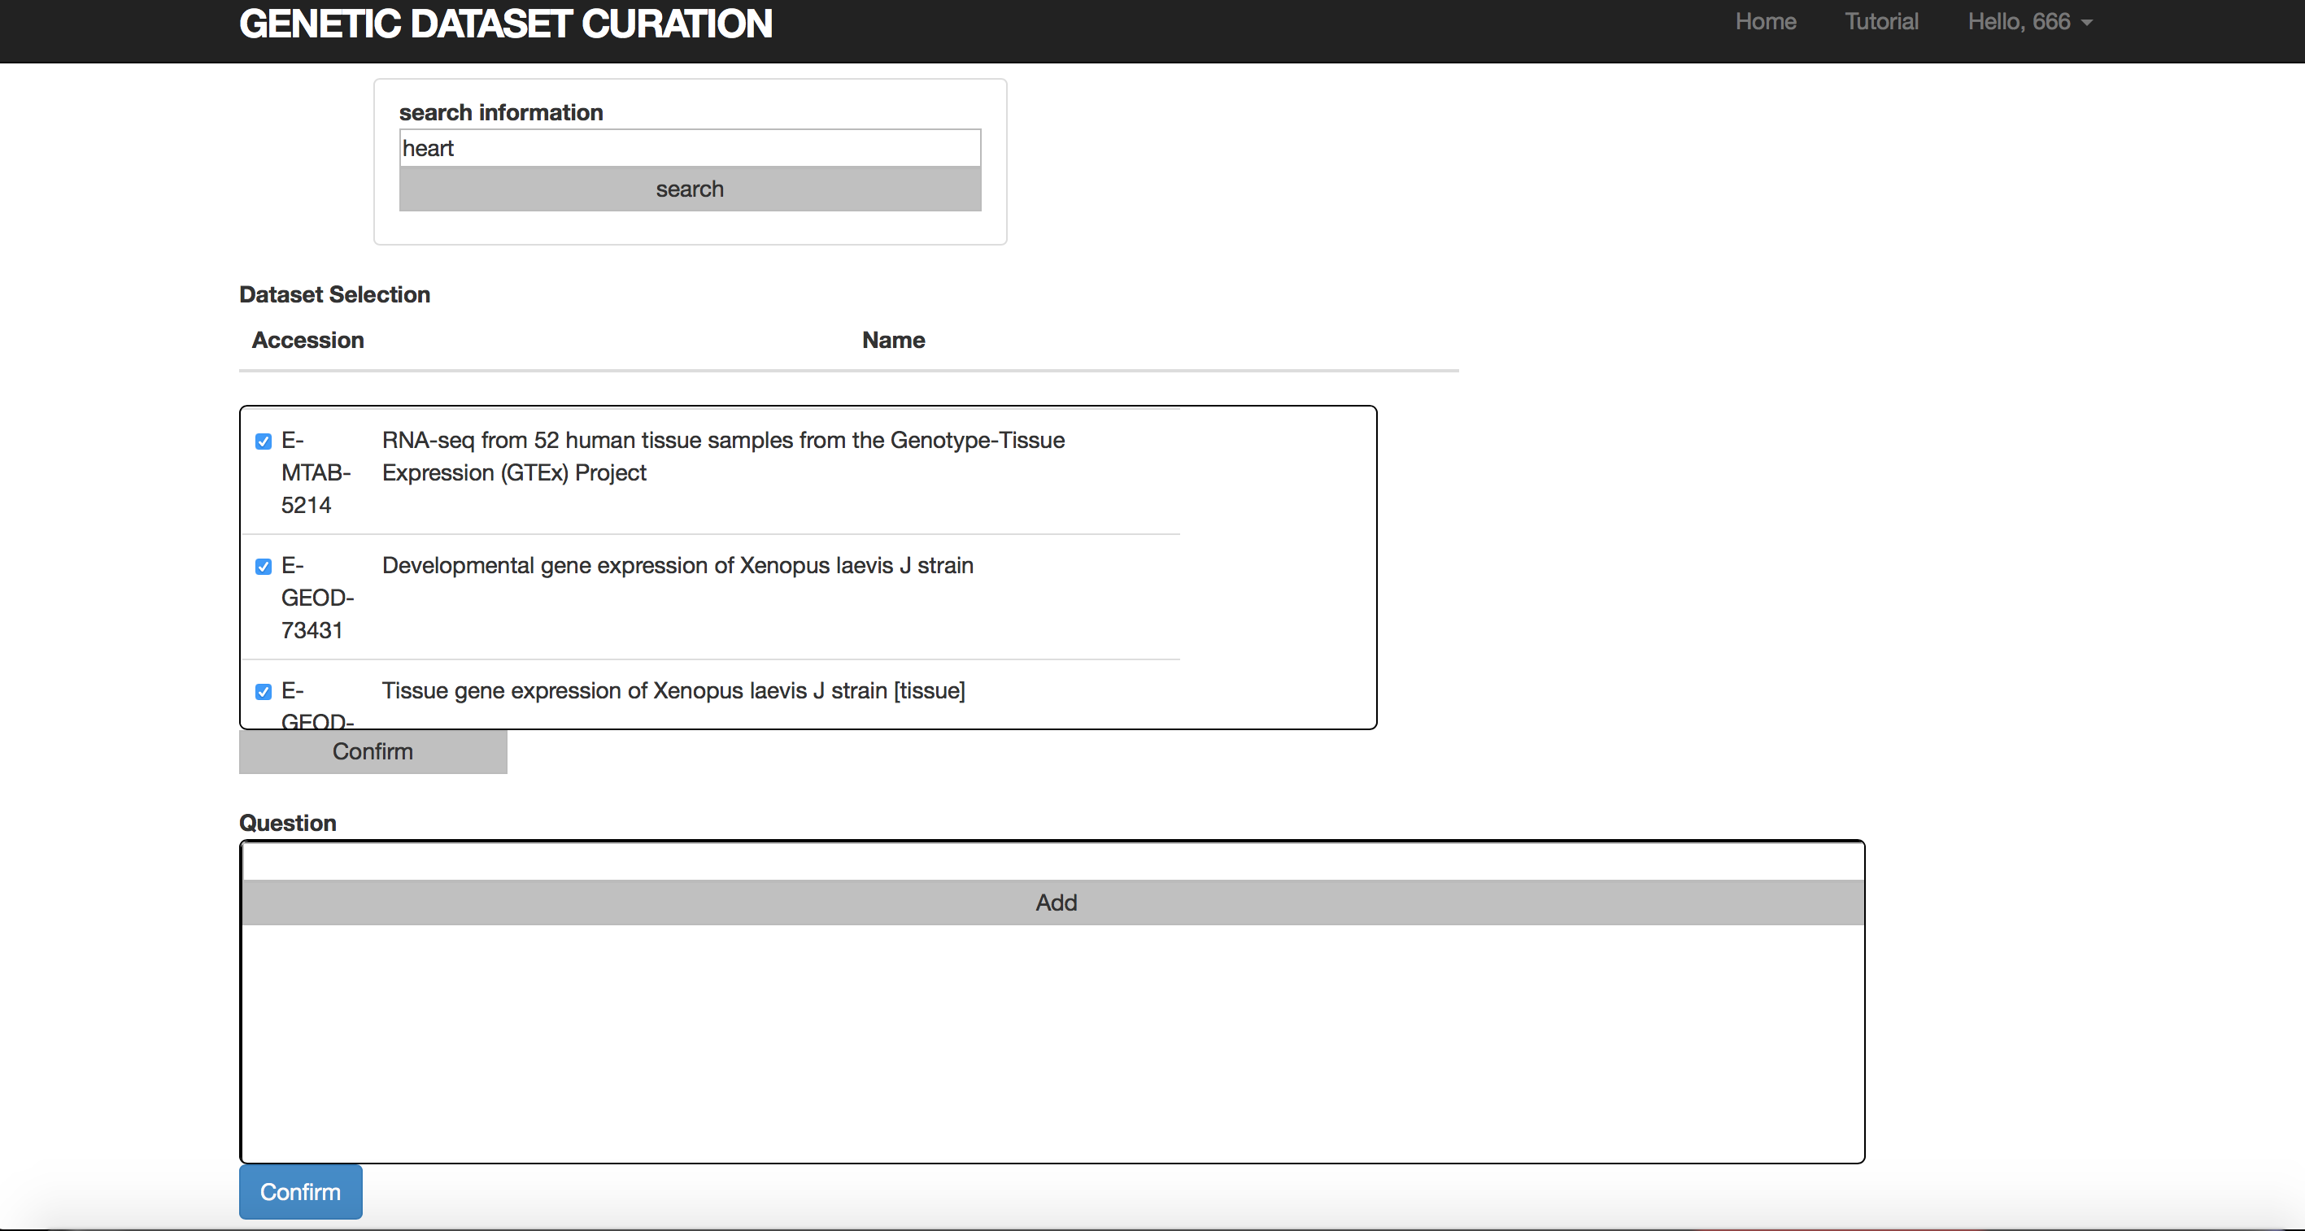

## Group Function:

Links to the group index page (only available to admins):

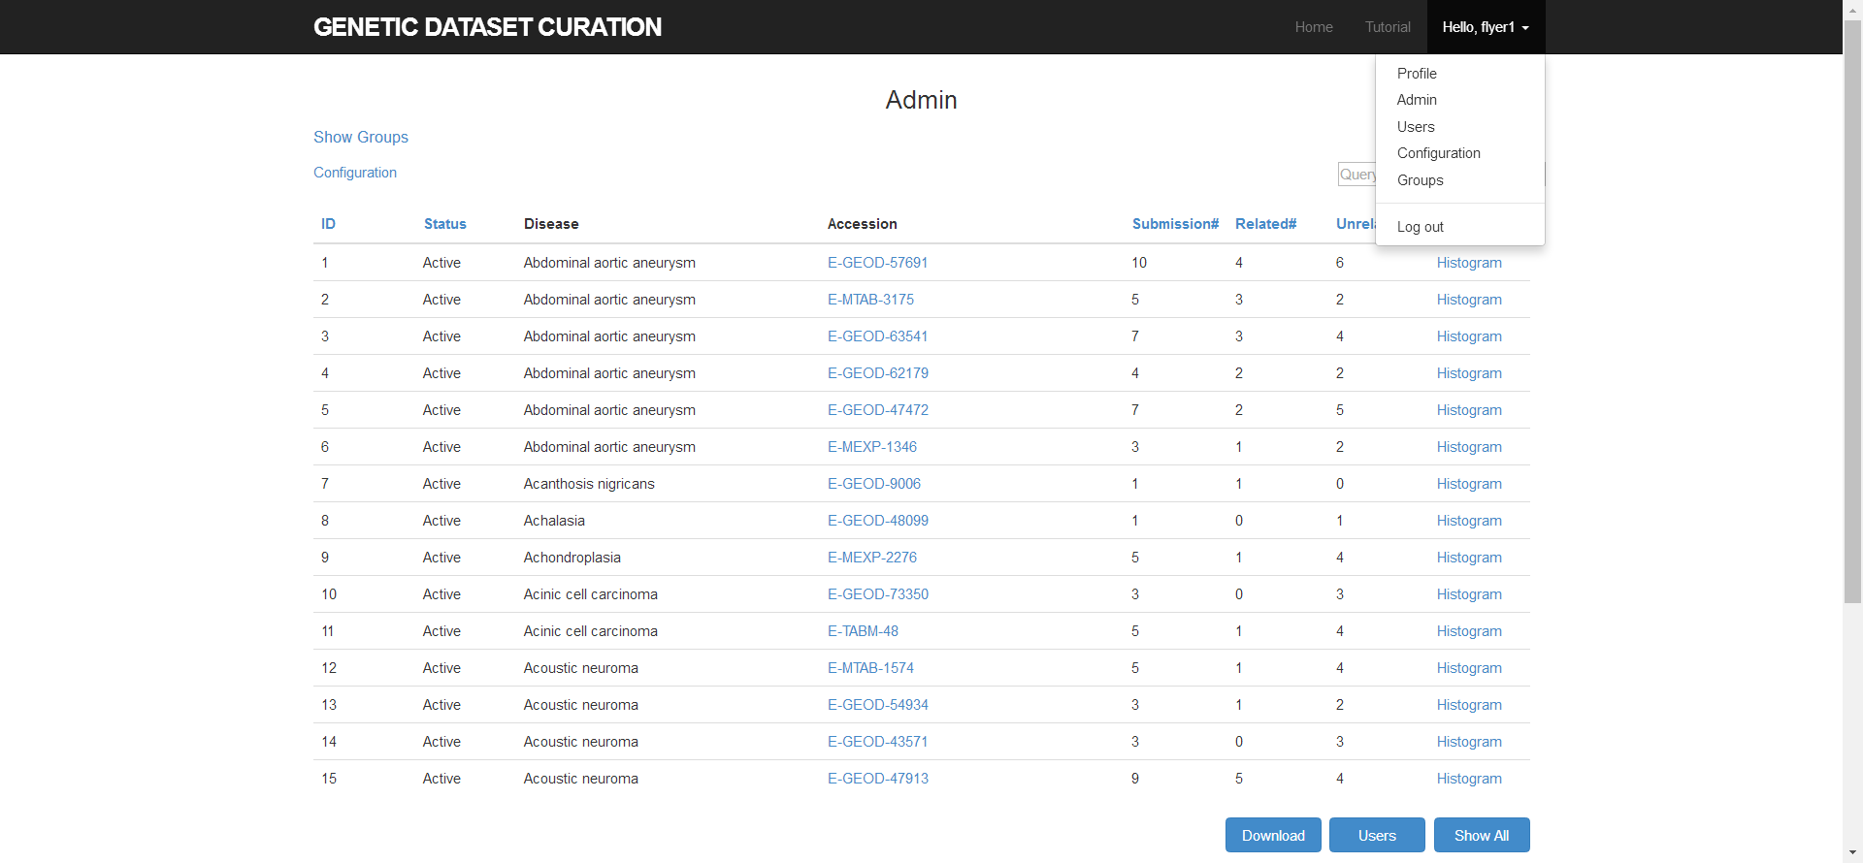

## Group index pages:

For group admins:

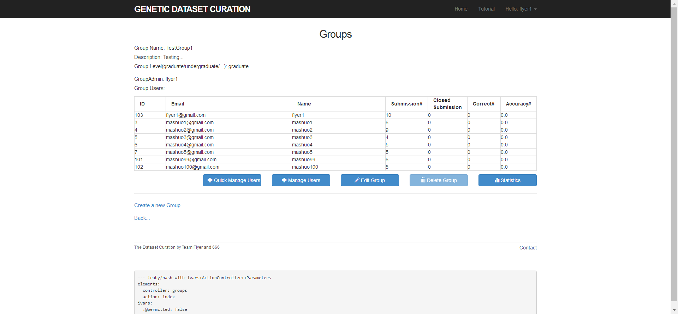

For power admins:

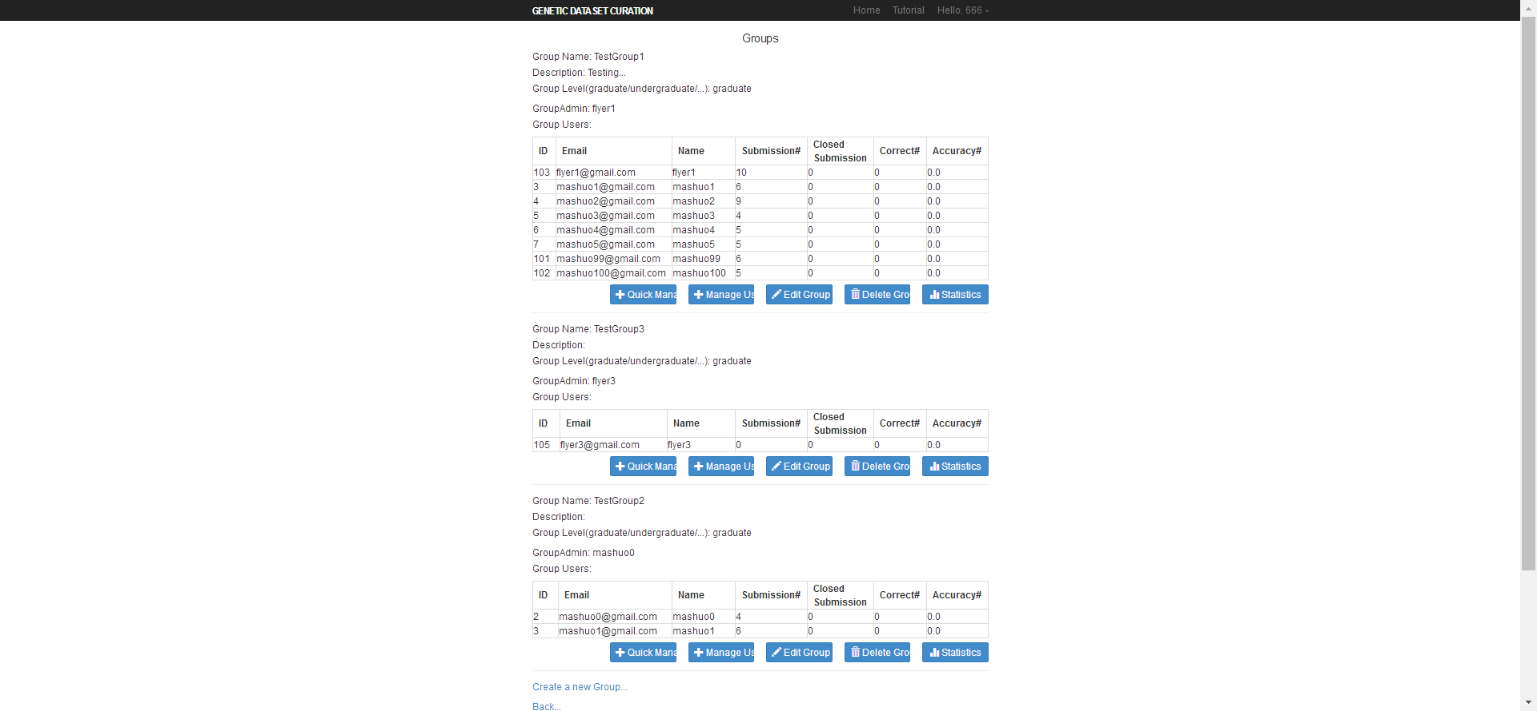

## Groups CRUD pages:

Create:

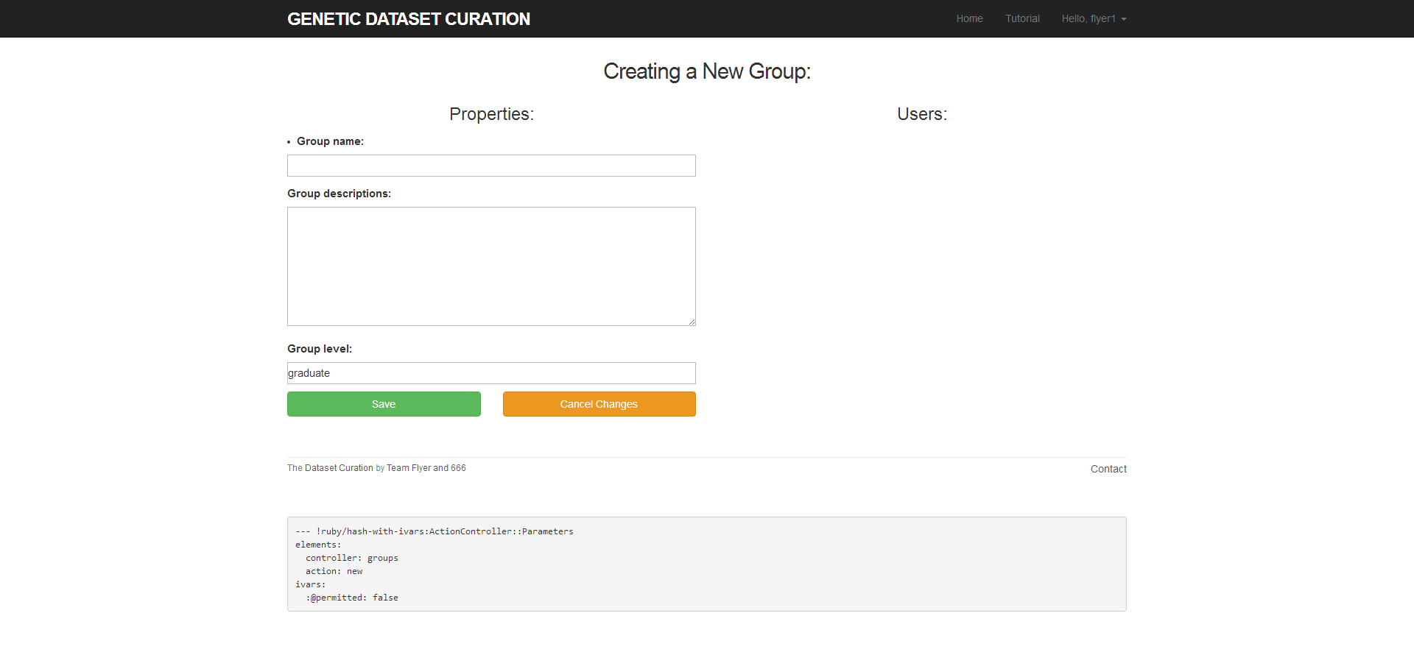

The right half is reserved for future development.

Update:

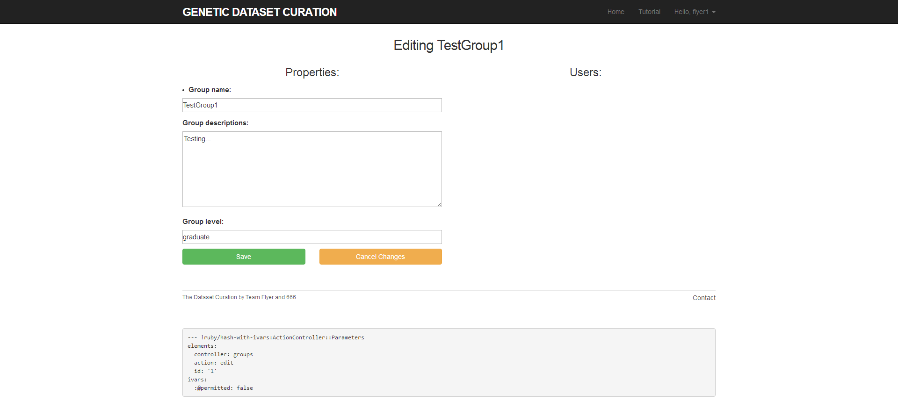

Delete:

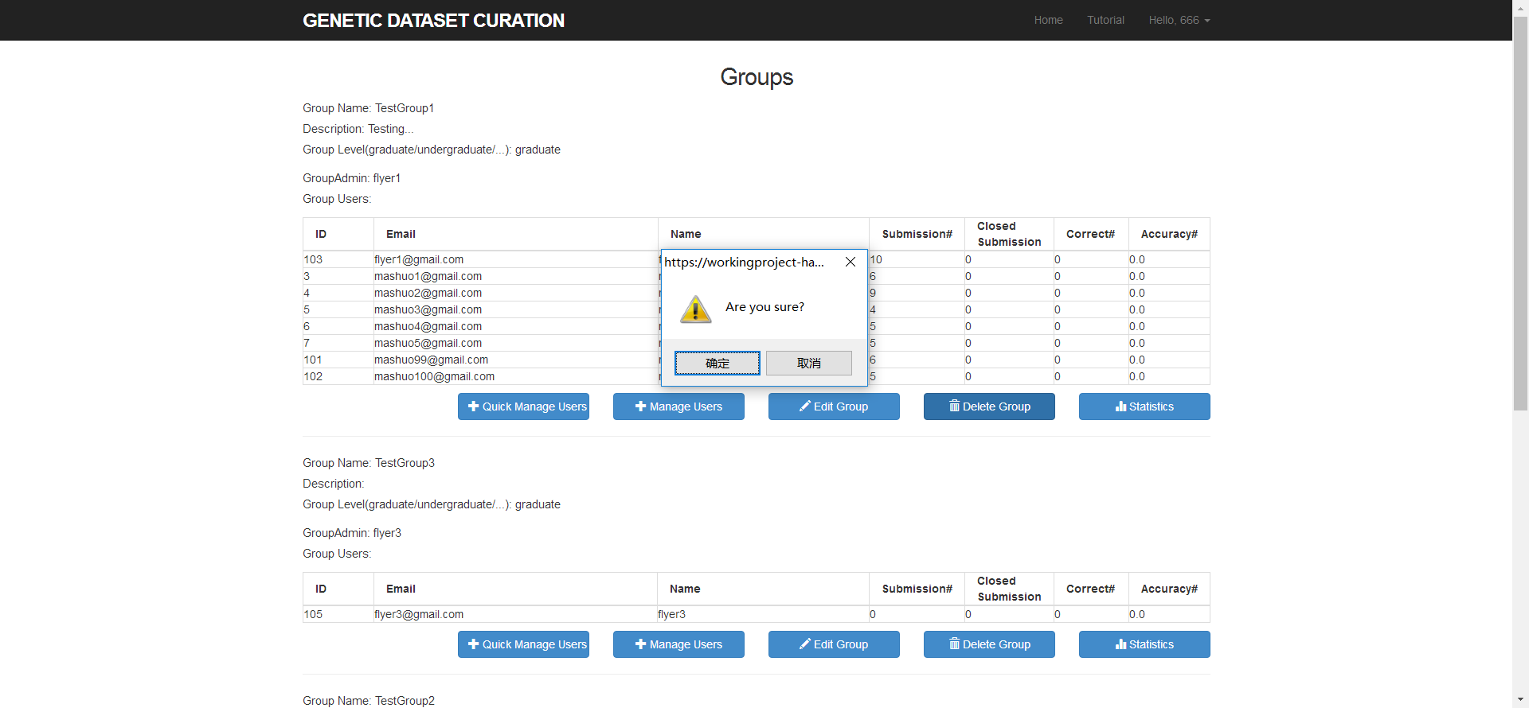

Add users to group with detailed user information:

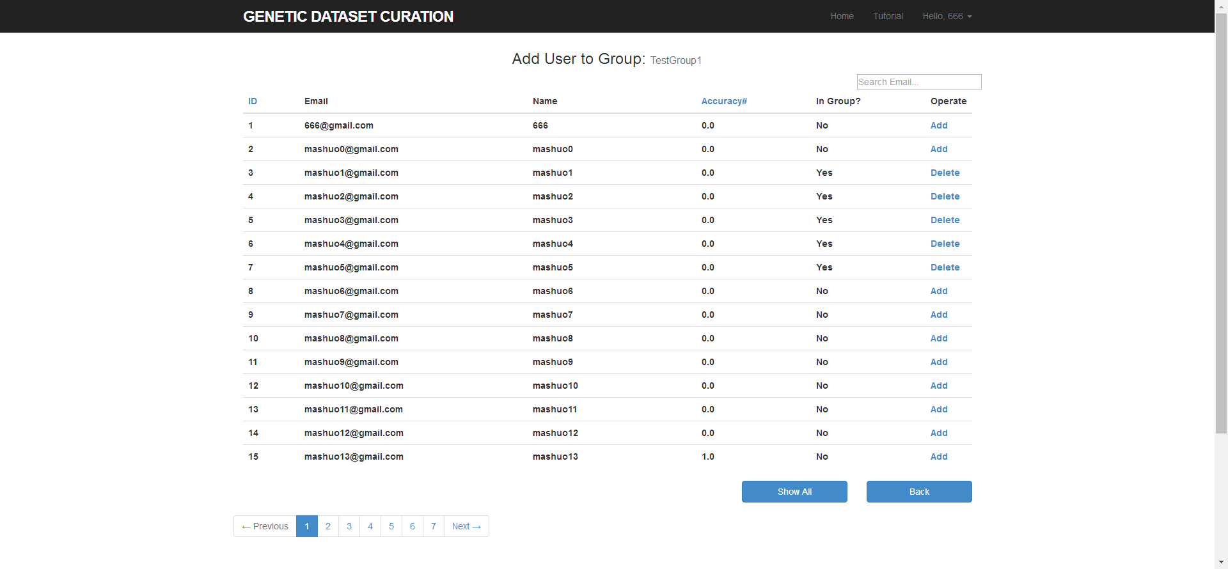

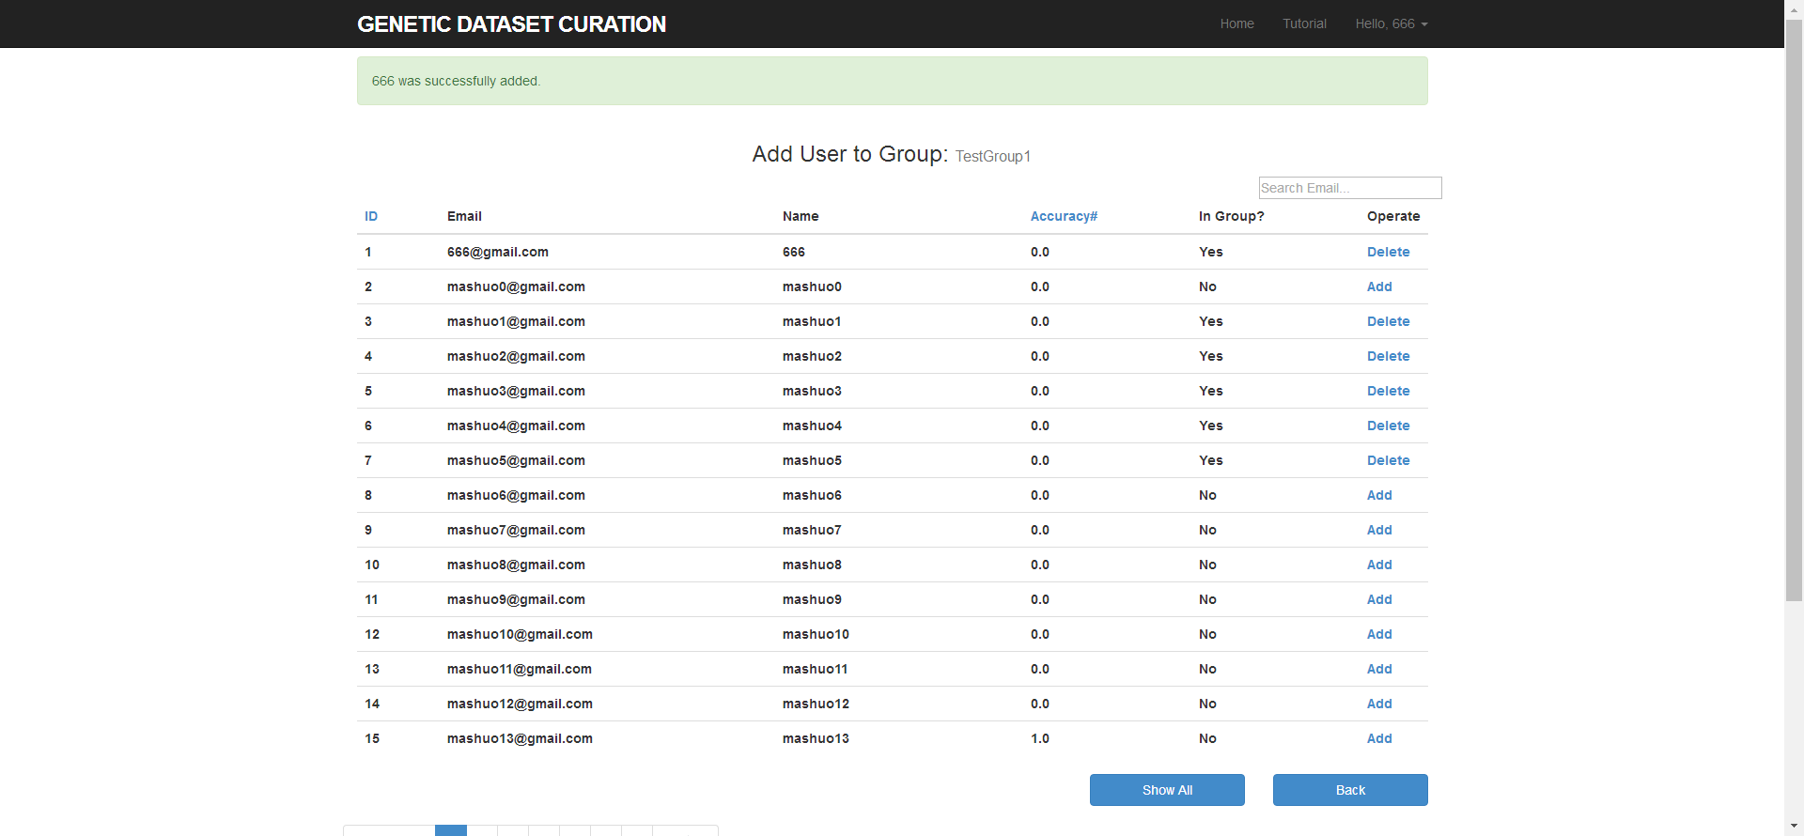

Add users to group simultaneously with concise user information:

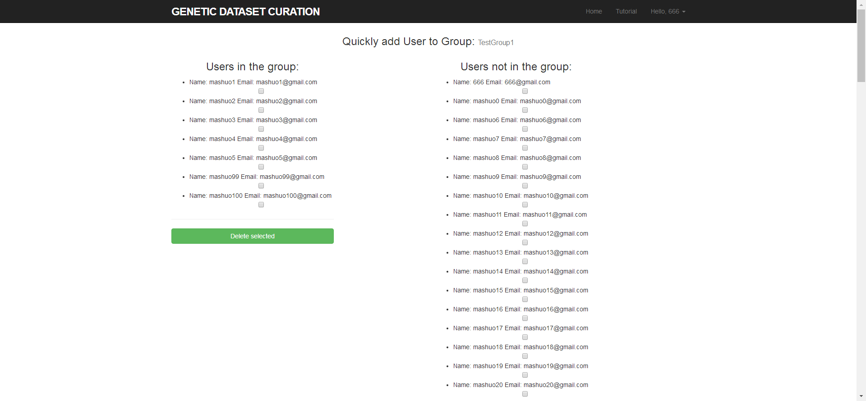

Promote user to be a group admin (only power admin can do this):

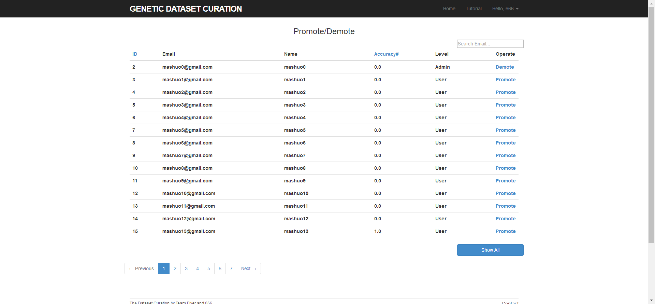

For now, basic functions are achieved.

# TDD test

## Group Model test:

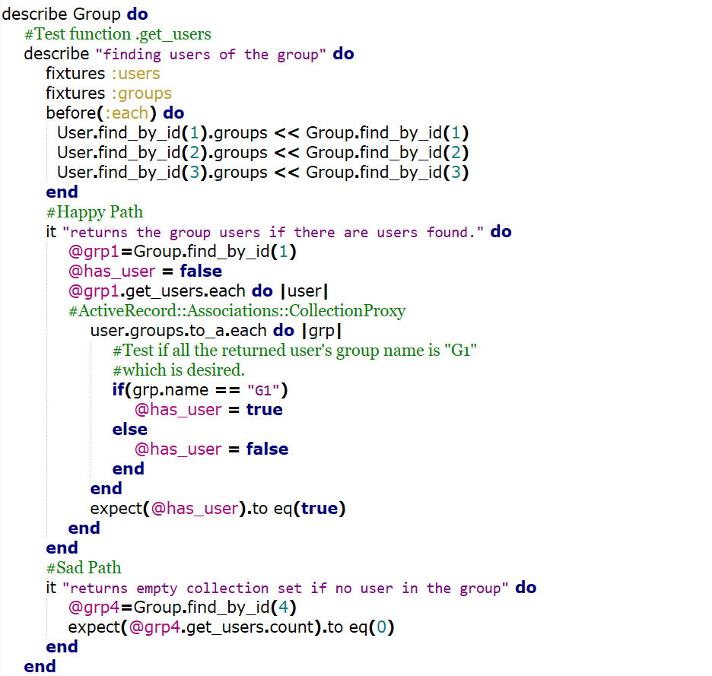

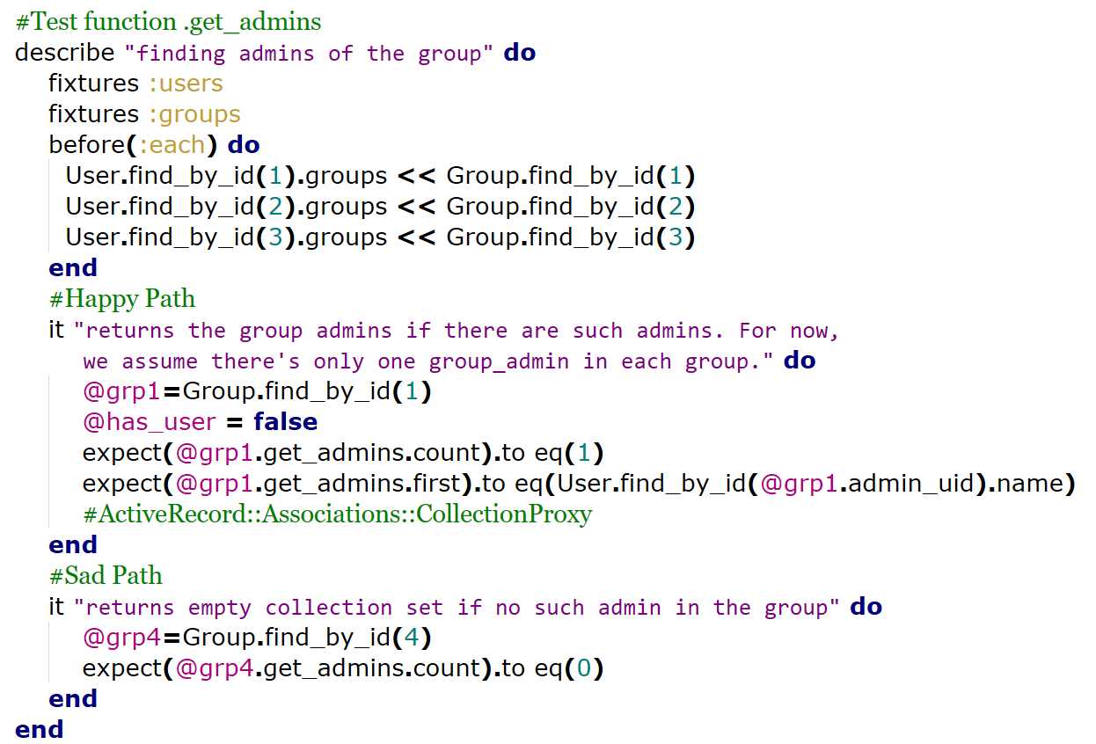

## Group Controller test:

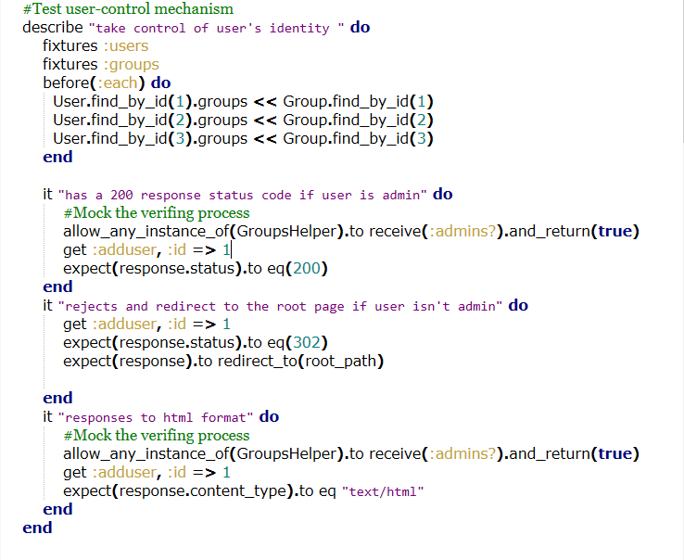

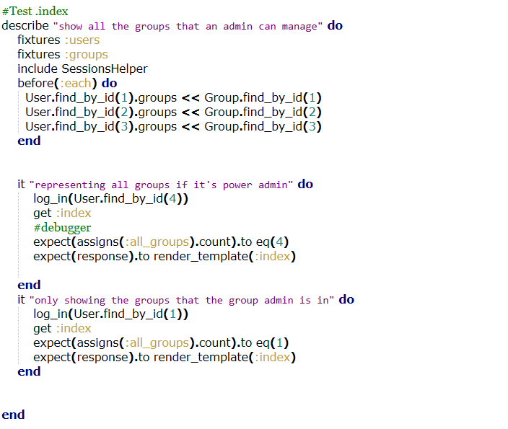

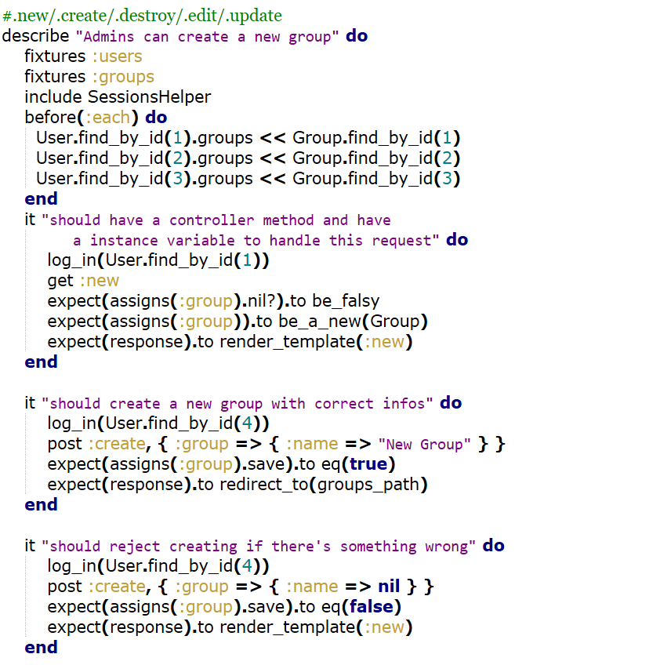 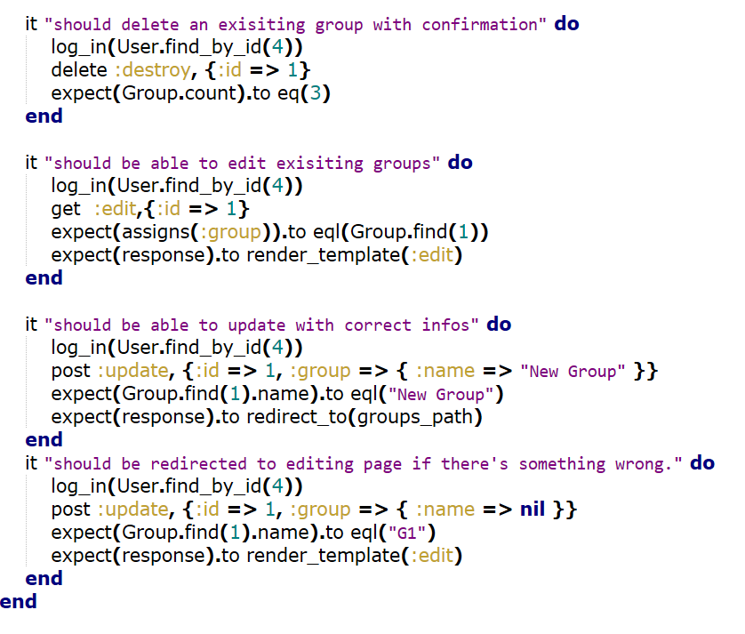

# RSpec Results:

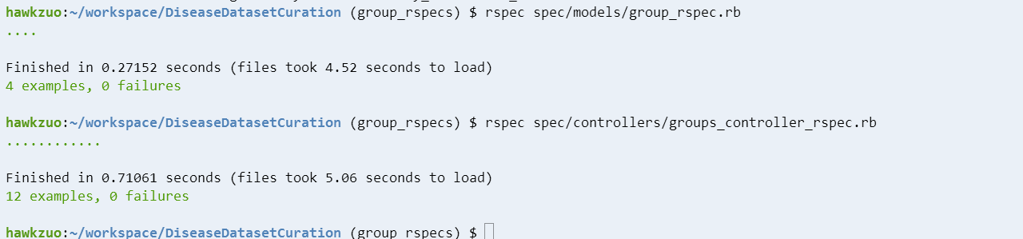

# Pivotal Tracker, Github repo, and Heroku links:

Pivotal: <https://www.pivotaltracker.com/n/projects/1887551>

Github: <https://github.com/xvxiaopei/CSCE606-project>

Heroku: <http://disease.herokuapp.com/>