Feature: Adding Groups Mechanism to the System

As a stakeholder (power admin),

So that I can manage groups(CRUD) and promote/demote users to become a group admin.

I want the group admin to be able to manage his/her own group, too.

**Views for Group Function:**

Links to the group index page (only available to admins):

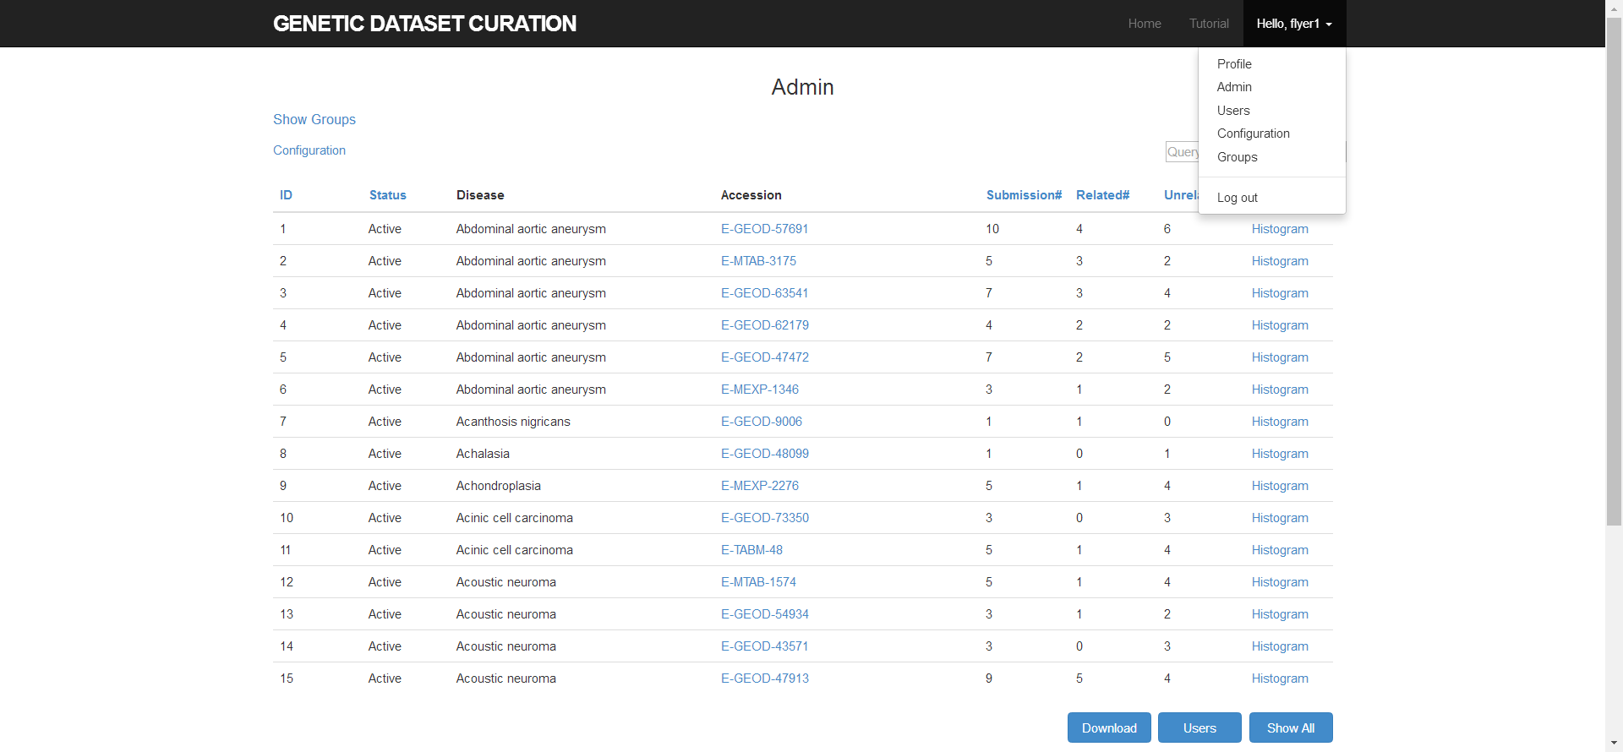

Group index pages:

For group admins:

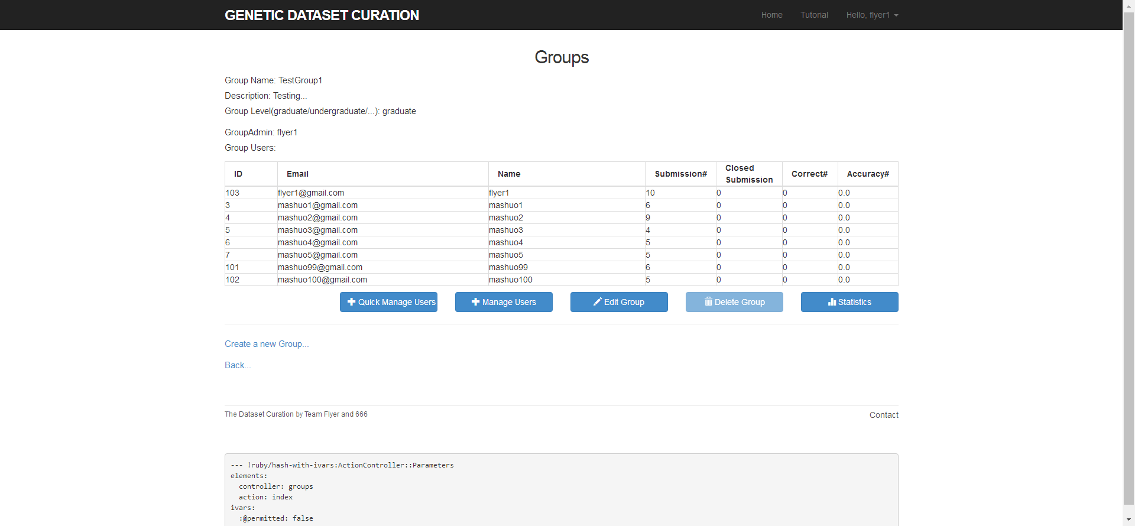

For power admins:

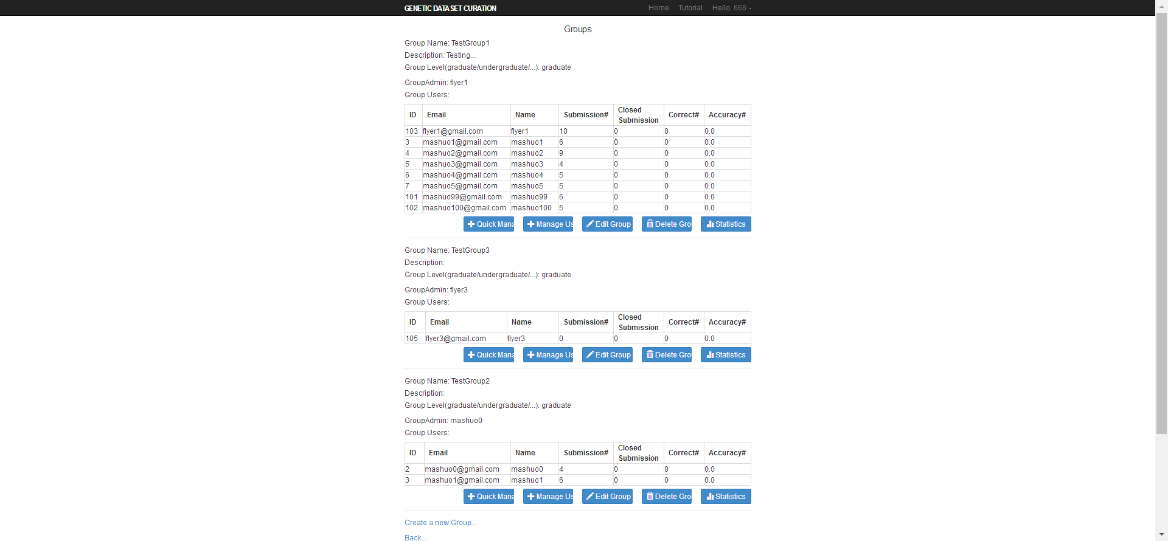

Groups CRUD pages:

Create:

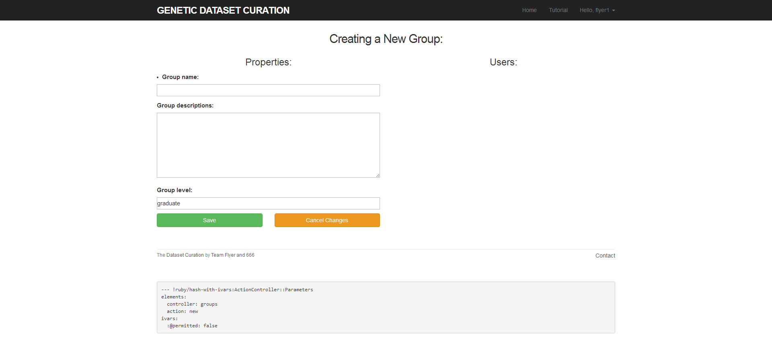

The right half is reserved for future development.

Update:

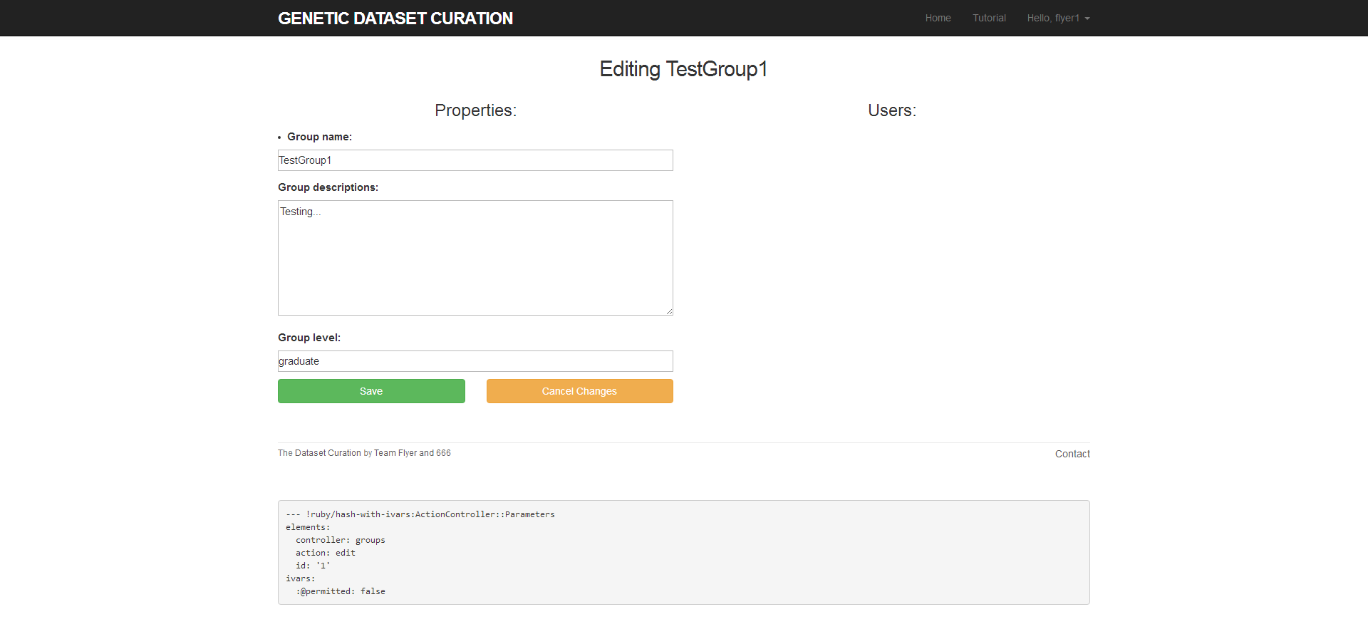

Delete:

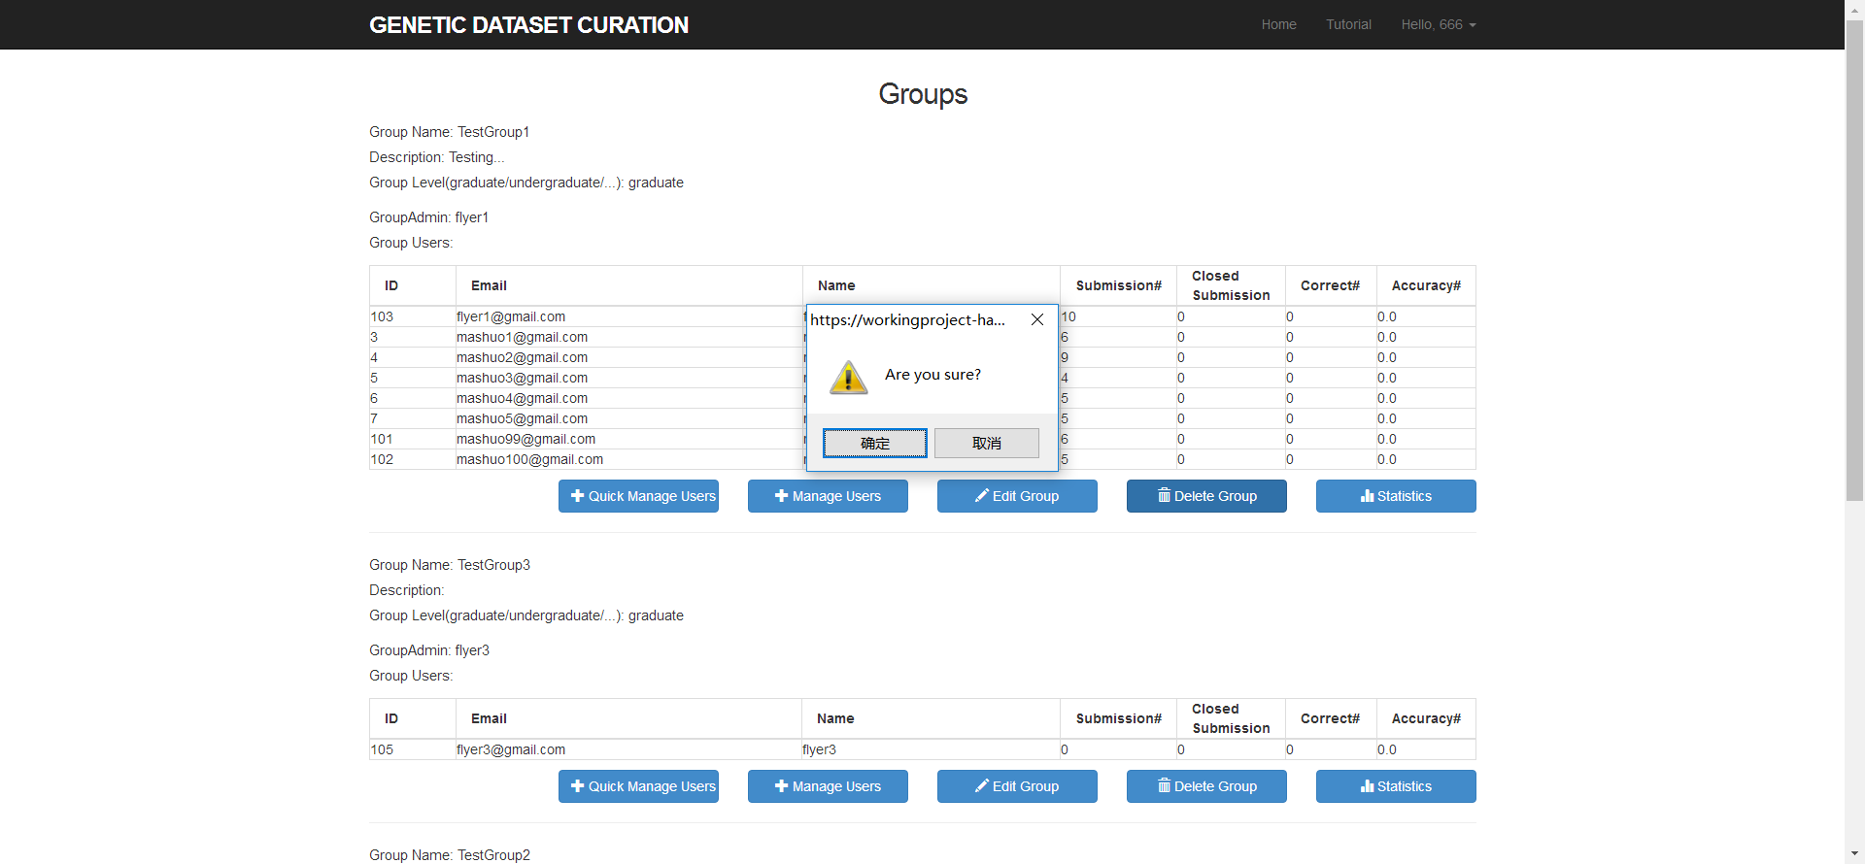

Add users to group with detailed user information:

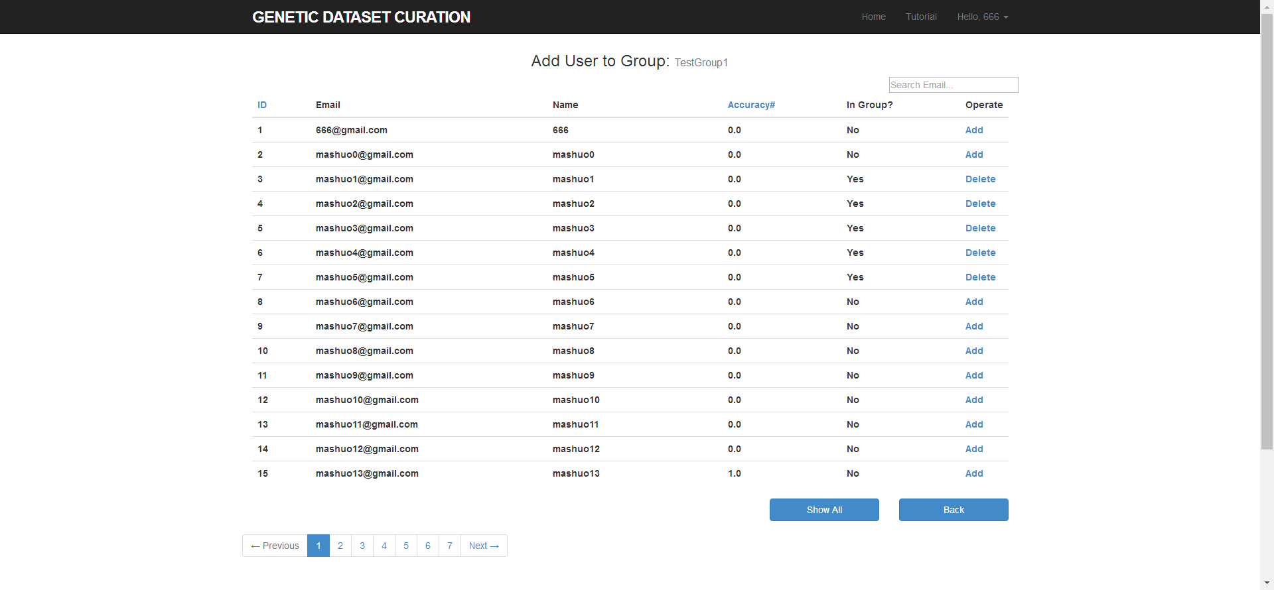

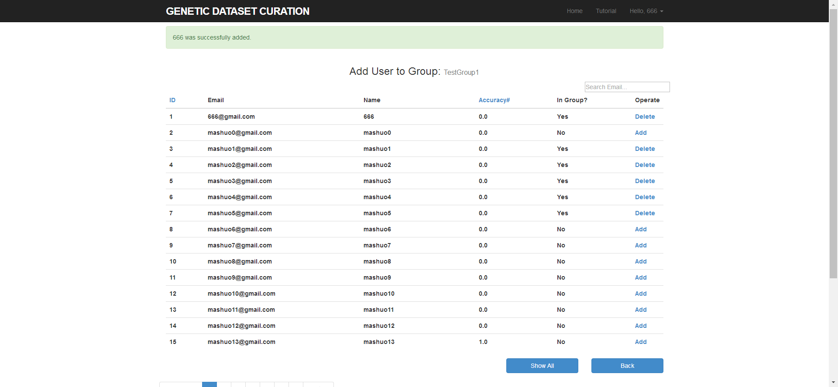

Add users to group simultaneously with concise user information:

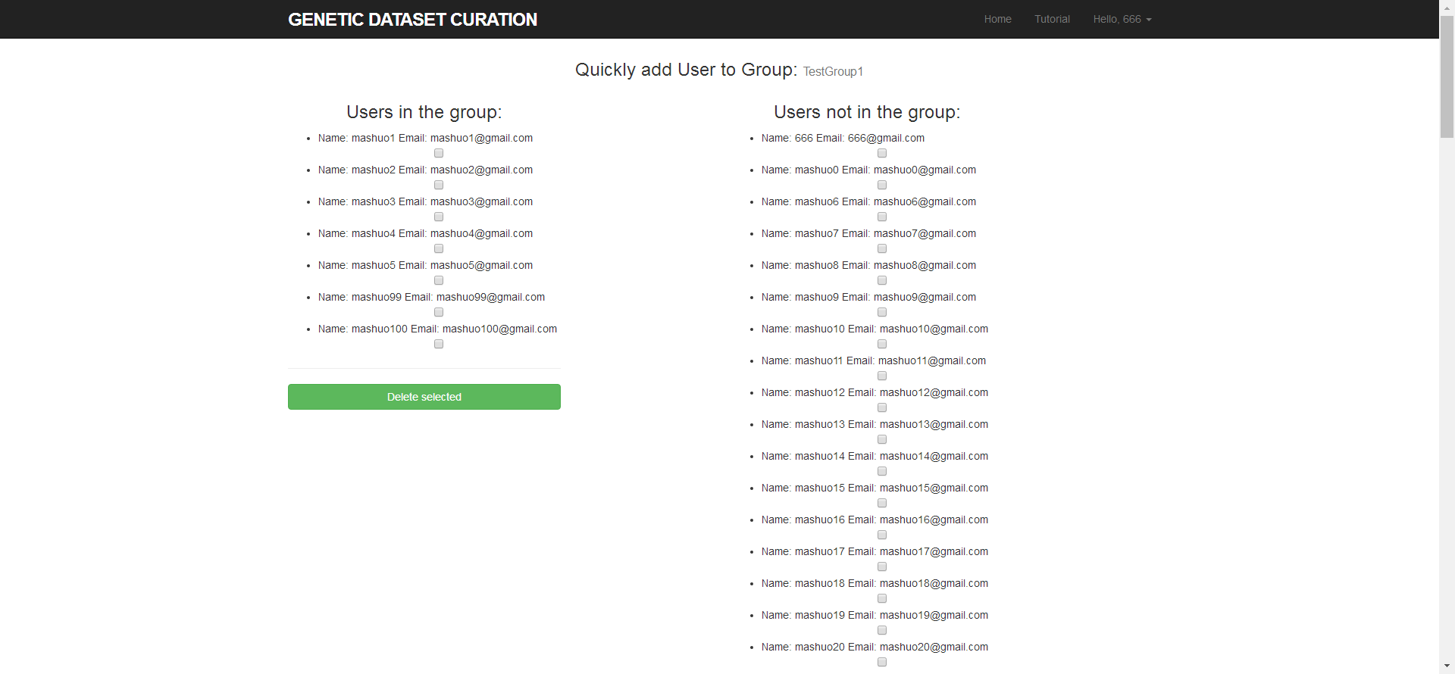

Promote user to be a group admin (only power admin can do this):

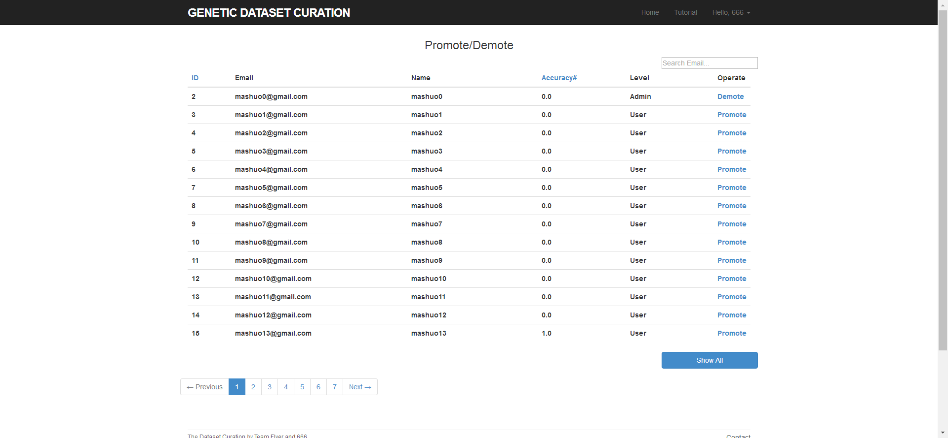

For now, basic functions are achieved.

TDD test

Group Model test:

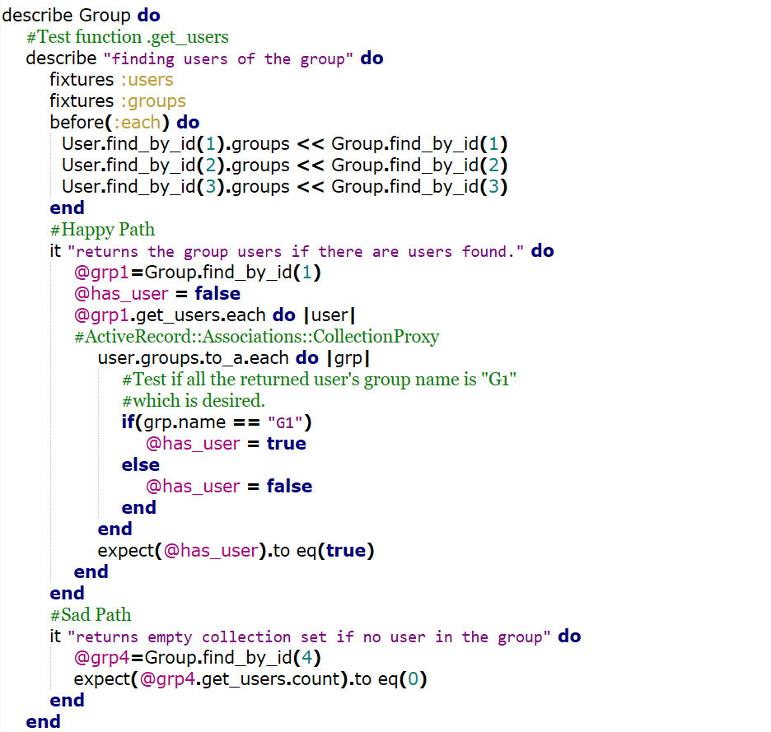

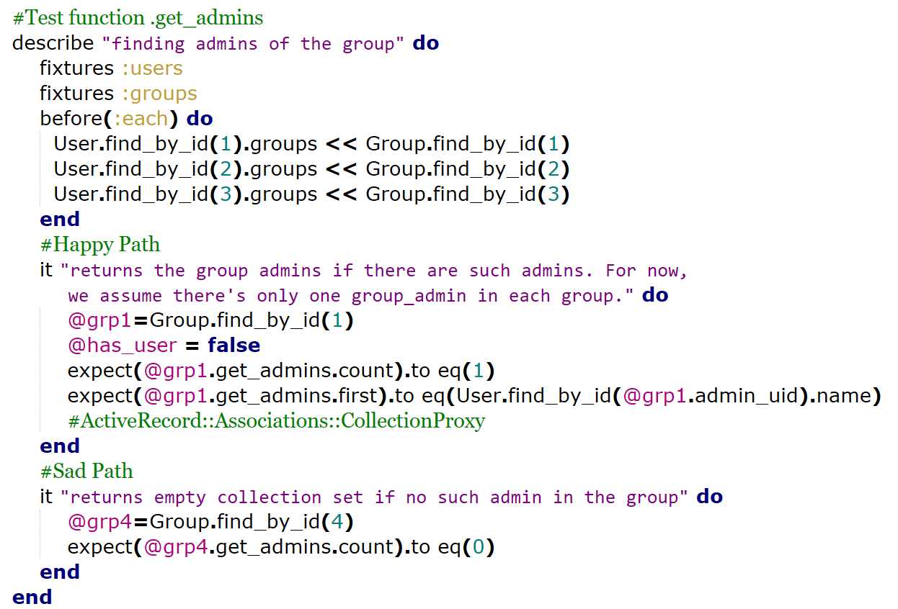

Group Controller test

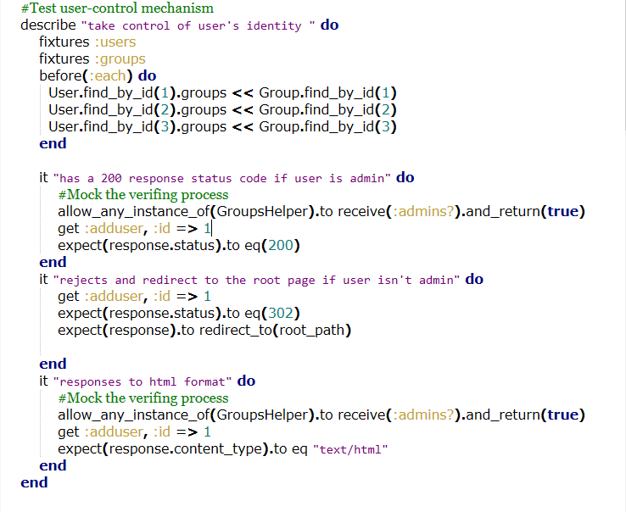

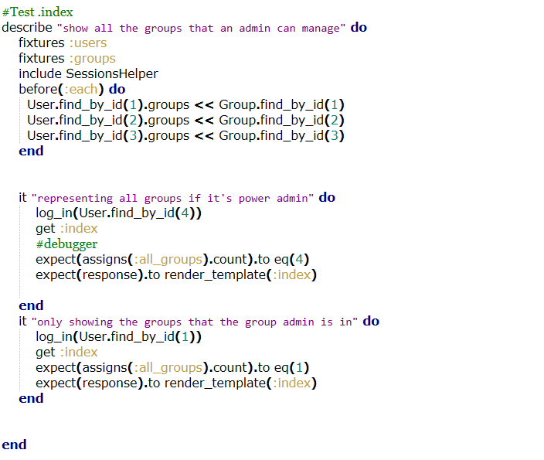

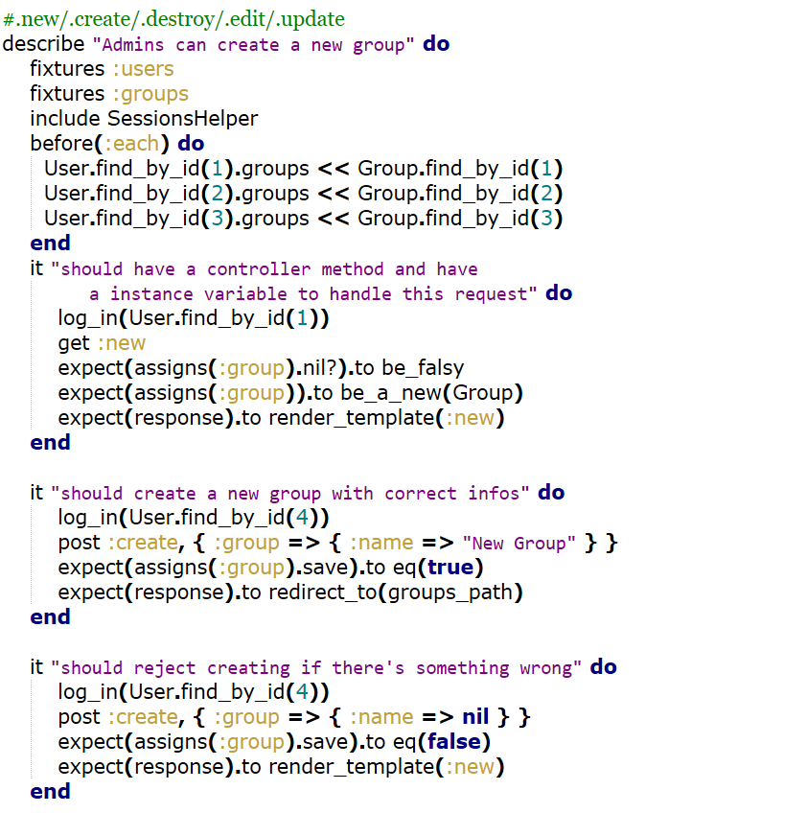 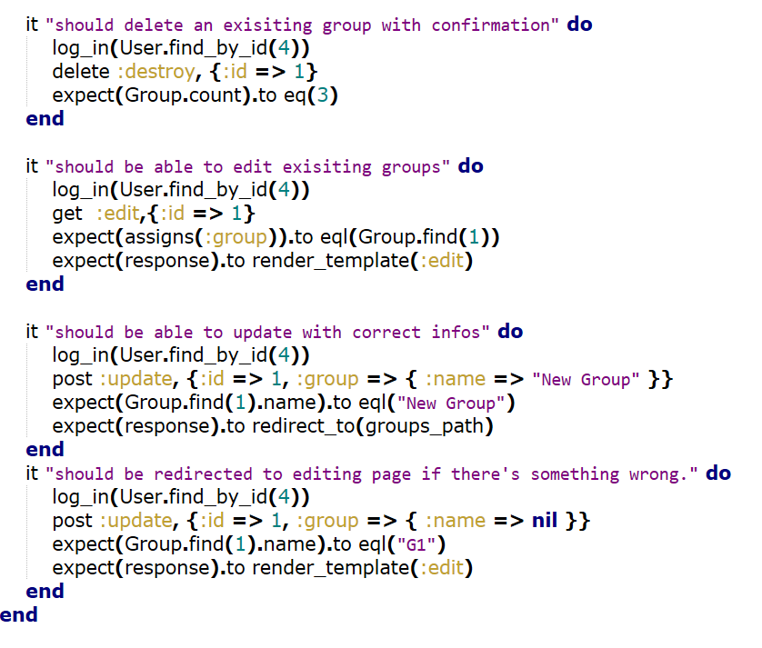

RSpec Results:

