DAY-2 LABORATORY

CLOUD COMPUTING AND BIG DATA ANALYTICS

CSA1568

GEETHIKA MN

192121108

IT

6)Demonstrate virtualization by Installing Type-2 Hypervisor in your device, create and configure VM image with a Host Operating system (Either Windows/Linux).

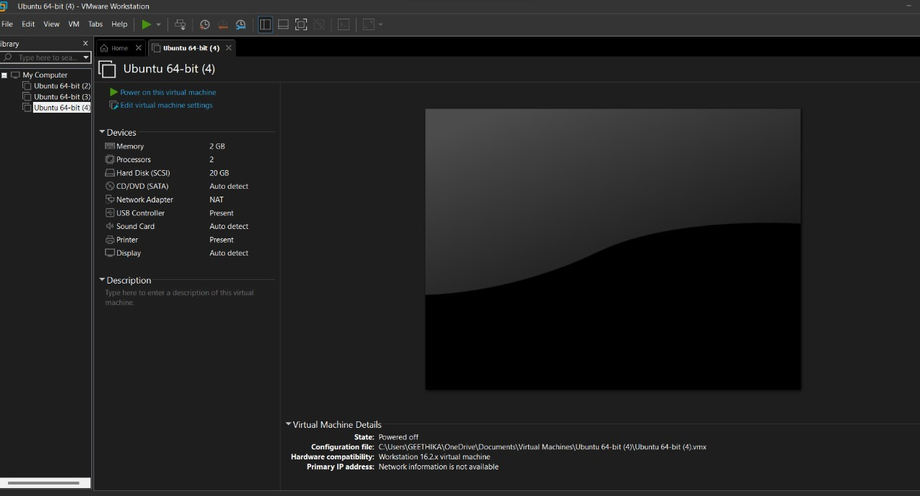

7)Create a Virtual Machine with 1 CPU, 2GB RAM and 15GB storage disk using a Type 2 Virtualization Software.

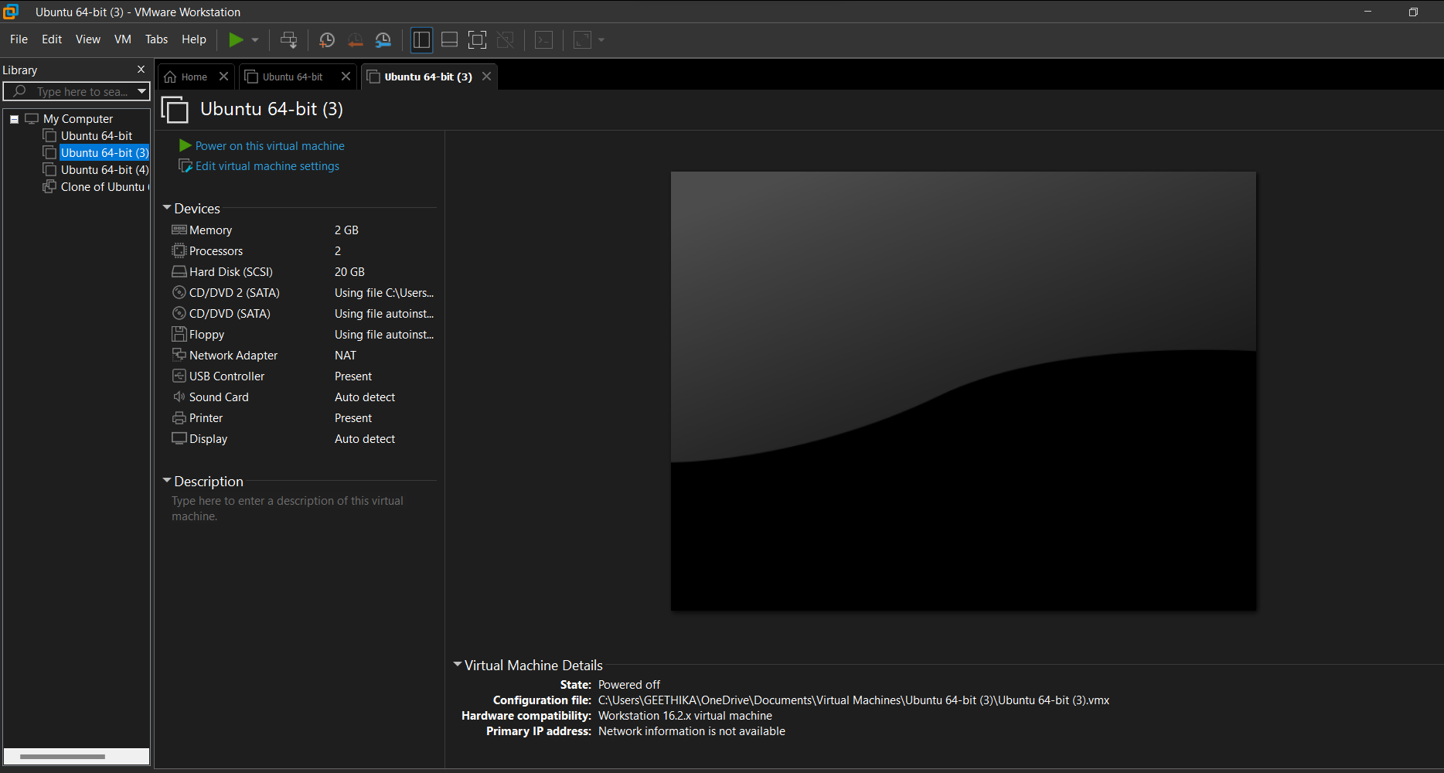

8)Create a Virtual Hard Disk and allocate the storage using VM ware Workstation

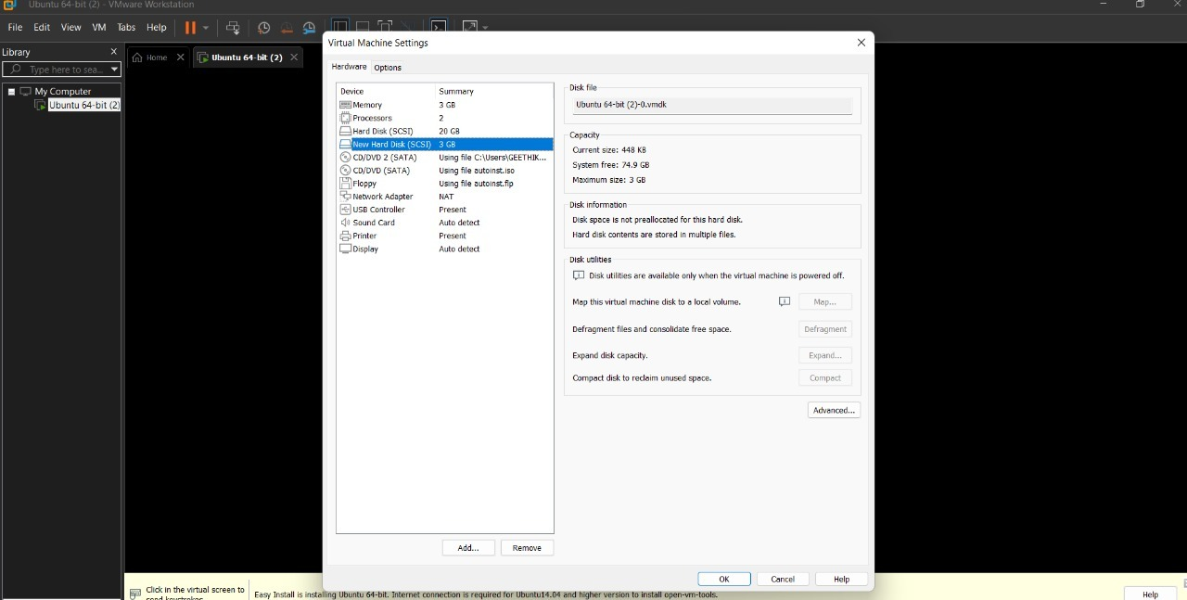

9)Create a Snapshot of a VM and Test it by loading the Previous Version/Cloned VM

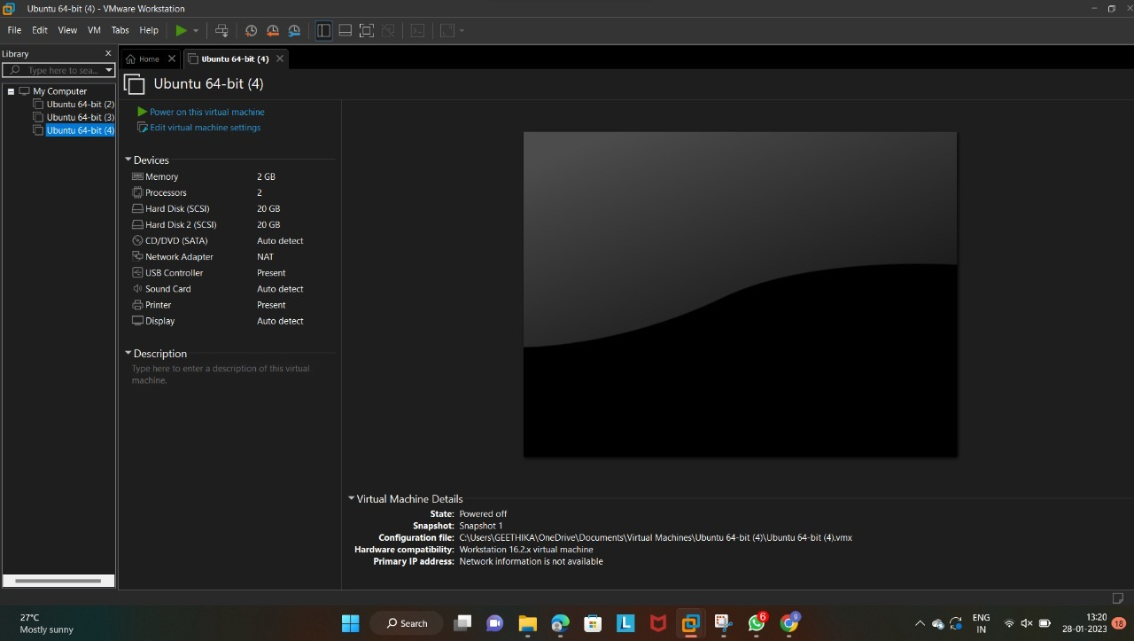

10) Create a Cloning of a VM and Test it by loading the Previous Version/Cloned VM

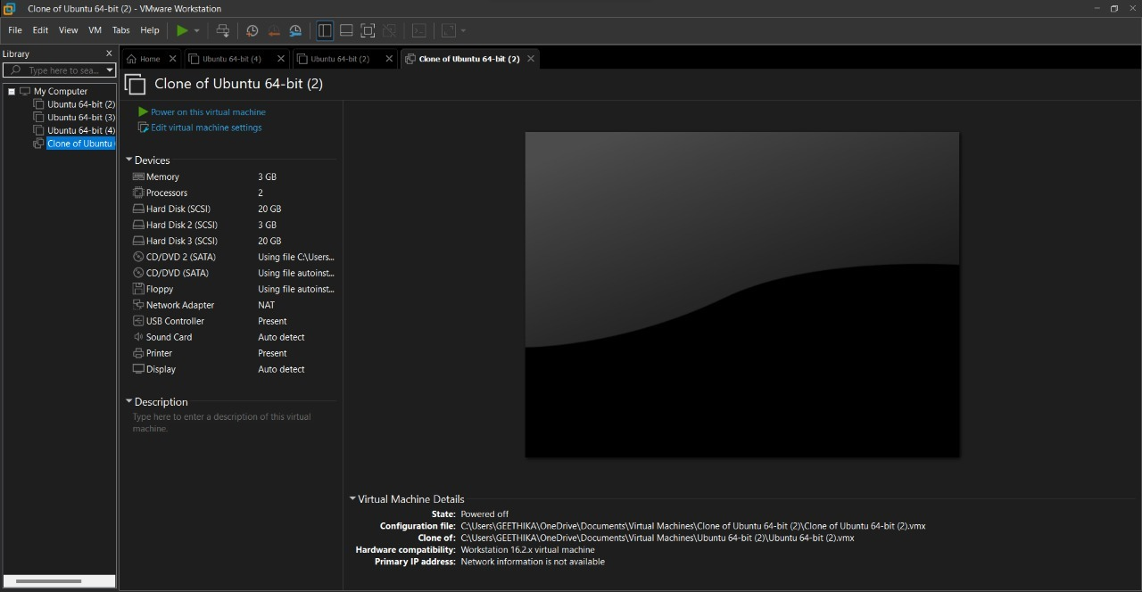

11) Change Hardware compatibility of a VM (Either by clone/create new one) which is already created and configured.

