**Microcontroller based Industrial Applications**

Project Report

**Problem statement:**

To develop a simple prototype that will mimic a real-time occupancy detection system which ultimately offers energy efficiency using TinkerCad.

**Scope of the Solution:**

* This prototype implements a real-time occupancy system, which gives the instantaneous count of the number of occupants in a particular room at any point of time.
* It uses an Arduino board with 2 PIR sensor (one at entry and one at exit) to detect the number of people entering and the number of people exiting a room. It increments a counter variable for entry and decrements it for exit.
* A 16x2 LCD displays this count along with the blinking of the green LED upon entry and the red LED upon exit.
* This system is meant to improve efficient use of energy by turning off a light bulb in the room when it is empty.
* The applications of this solution include: classrooms, conference halls, labs and offices as a smart, simple, inexpensive and sustainable system.

**Required components:**

**IDE:** Arduino IDE

**Simulation software:** TinkerCad

**Hardware components:**

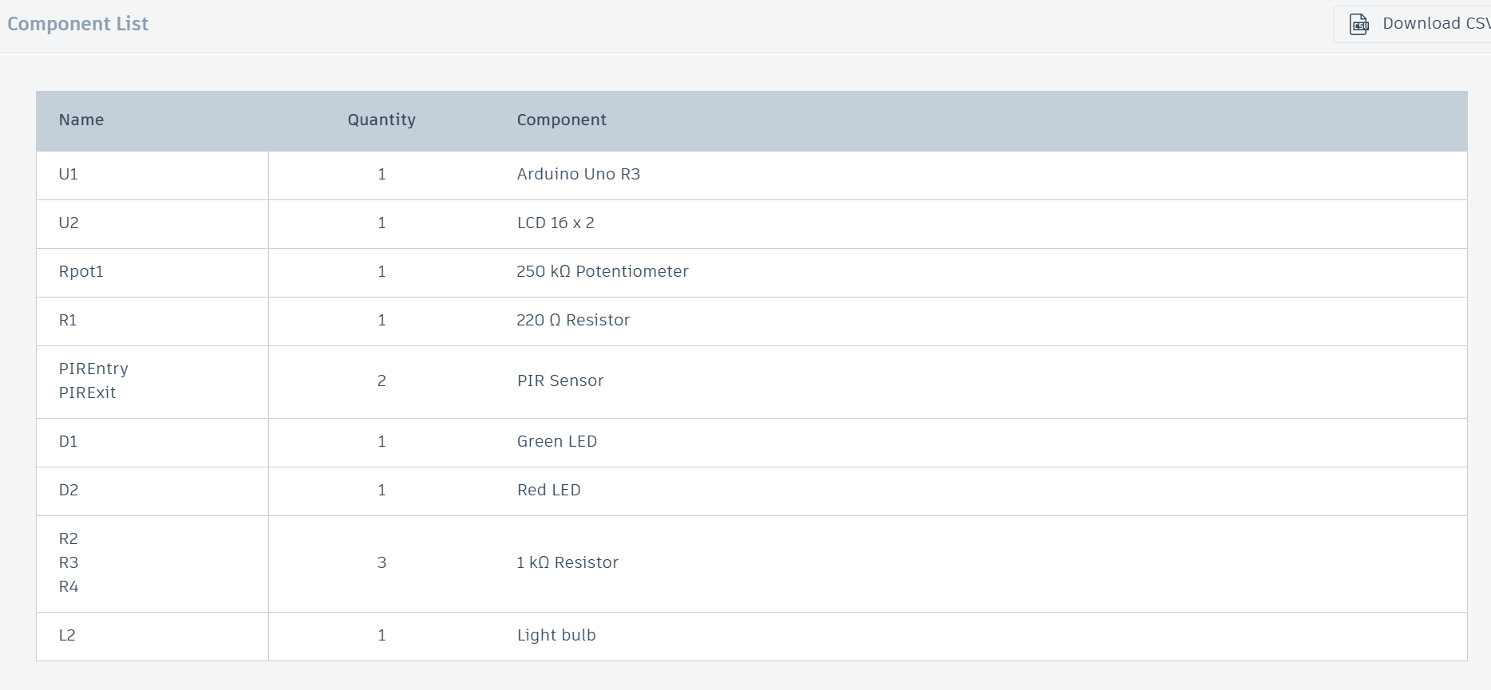

**Simulated Circuit:**

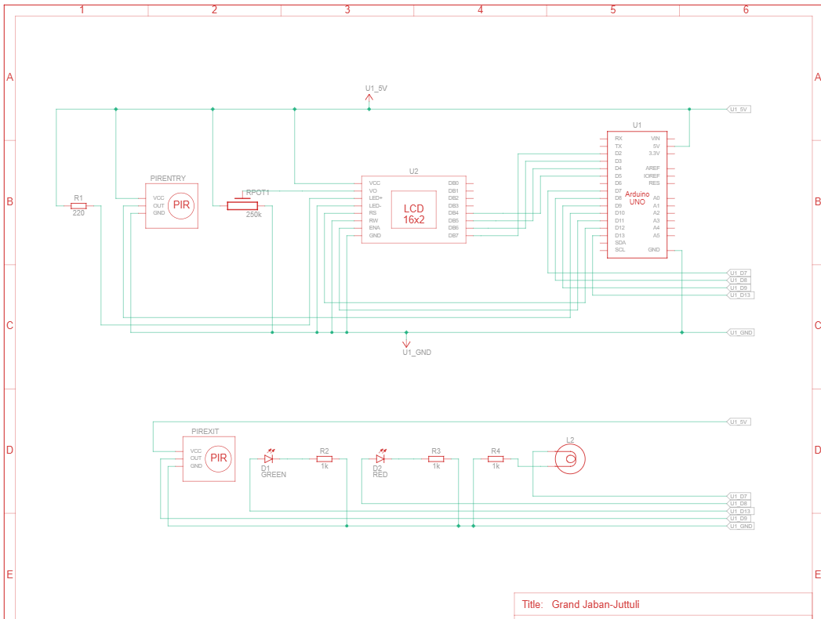

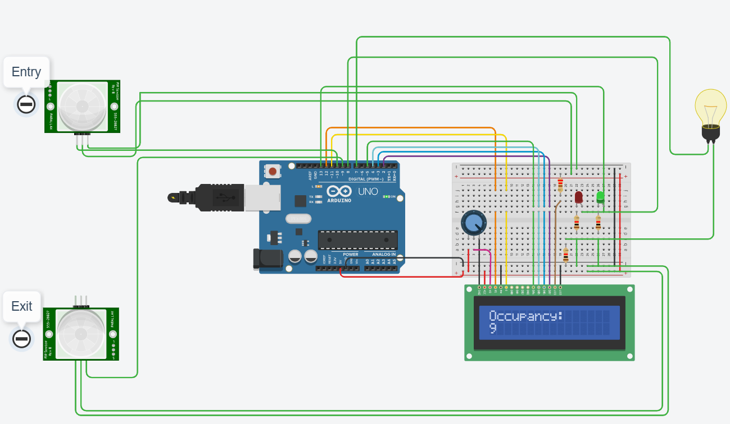

**Code for the solution:**

// C++ code

//

/*

LiquidCrystal Library

The circuit:

* LCD RS pin to digital pin 12

* LCD Enable pin to digital pin 11

* LCD D4 pin to digital pin 5

* LCD D5 pin to digital pin 4

* LCD D6 pin to digital pin 3

* LCD D7 pin to digital pin 2

* LCD R/W pin to ground

* LCD VSS pin to ground

* LCD VCC pin to 5V

* 10K resistor:

* ends to +5V and ground

* wiper to LCD VO pin (pin 3)

*/

#include <LiquidCrystal.h>

int count=0;

LiquidCrystal lcd_1(12, 11, 5, 4, 3, 2);

void setup()

{

pinMode(10,INPUT);

pinMode(9,INPUT);

pinMode(13,OUTPUT);

pinMode(8,OUTPUT);

pinMode(7,OUTPUT);

lcd_1.begin(16, 2); // Set up the number of columns and rows on the LCD.

// Print a message to the LCD.

lcd_1.print("Occupancy:");

}

void loop()

{

if(digitalRead(10)==HIGH){

digitalWrite(13,HIGH);

delay(2000);

digitalWrite(13,LOW);

count++;

}

if(digitalRead(9)==HIGH){

digitalWrite(8,HIGH);

delay(2000);

digitalWrite(8,LOW);

if (count>0)

{

count--;

}

}

// set the cursor to column 0, line 1

// (note: line 1 is the second row, since counting

// begins with 0):

lcd_1.setCursor(0, 1);

lcd_1.print(" ");

lcd_1.setCursor(0, 1);

lcd_1.print(count);

if (count==0){

digitalWrite(7,LOW);}

else{

digitalWrite(7,HIGH);}

delay(1000); // Wait for 1000 millisecond(s

}